

**CHALIMBANA UNIVERSITY**

***Integrity, Service and excellence***

**DIRECTORATE OF DISTANCE EDUCATION**

**MIS 2101: MANAGEMENT INFORMATION SYSTEMS**

**FIRST EDITION 2018**

**CHALIMBANA UNIVERSITY**

**PRIVATE BAG E 1**

**LUSAKA**

**Author: Dr. William Phiri**

**Mr. C. M. Sinyangwe**

# All rights reserved.

# No part of this publication may be reproduced, stored in retrieval system or transmitted in any form by any means electronic, mechanical, photocopying, recording or otherwise, without prior written permission of the publisher.

# Copyright © 2019 CHAU

TABLE OF CONTENT

Acknowledgement: ………………………………………………………………………..…ii

Module Aim: …………………………………………………………………………………vi

1. Overview of computer hardware: ……………………………………………………….9
   1. Types of computer system: ……………………………………………………..9
   2. Input Devices: …………………………………………………………………...11
   3. Storage Devices: …………………………………………………………...........19
   4. Output Devices: …………………………………………………………………19
   5. Data transmission: …………………………………………………………..…22
2. Software: ……………………………………………………………………………..…32
   1. Systems Software: ………………………………………………………………32
   2. Application software: ………………………………………………………..…33
   3. Acquisition of software: ……………………………………………………..…35
   4. Programming language and principles: ………………………………………36
   5. Computerised Information Systems: …………………………………………37
   6. Role and use of computer in Electronic Data Processing: ……………………38
   7. Computer files and structures: ……………………………………………..…38
   8. LANs and WANs: ………………………………………………………………39
   9. Batch, on-line and real-time processing: ………………………………………40
3. Organisation and Control: …………………………………………………………..…42
   1. Staff Roles and Responsibilities in EDP: ………………………………………42
   2. Security: …………………………………………………………………………44
   3. Documentation in an EDP department: …………………………………….…48
4. Application and analysis of systems: ……………………………………………….…51
   1. Application packages: …………………………………………………………52
   2. Systems analysis: ………………………………………………………………..52
   3. Requirements and objectives of a systems: ……………………………………54
   4. Design of data process systems: …………………………………………….......54
   5. Design concepts and principles: …………………………………………….…55
   6. Practice design: …………………………………………………………………55
   7. Implementation of new system: ………………………………………..………55
5. Organisations, management and networked enterprise: ……………………………..56
   1. Information systems in global business today: …………………………….…60
   2. Global e-business and collaborations: …………………………………………61
   3. Information systems, organizations and strategy: ……………………………62
   4. Ethical and social issues in information systems: ……………………….……64
6. Information technology infrastructure: ………………………………………………67
   1. **IT infrastructure and emerging technologies**: ……………………………………67
   2. **Foundations of business intelligence**: ………………………………………………68
   3. **Databases and information management**: ……………………………………...…69
   4. **Telecommunications, the internet and wireless technology**: ……………………72
   5. **Securing information systems**: ……………………………………………………..73
7. **Key system applications for the digital age**: ………………………………………………79
   1. **Achieving operational excellence and customer intimacy: …………………..…79**
   2. **E-commerce, digital markets, digital goods: …………………………………..…89**
   3. **Managing knowledge: ……………………………………………………………….92**
   4. **Enhancing decision making: ……………………………………………………..…94**
8. **Building and managing systems**: ………………………………………………………….100
   1. **Building information systems**: ……………………………………………………103
   2. **Managing projects**: …………………………………………………………………107
   3. **Managing global systems**: …………………………………………………………110
9. **Security Information System: ………………………………………………………..121**
   1. **Information system security: ………………………………………………....121**
   2. **Information system security process: ………………………………………..122**
   3. **Information System security policy and procedure: ………………………..122**

**Internet –Related Threats: ……………………………………………………122**

# **Acknowledgement:**

On behalf of Chalimbana University, the Directorate of distance education we would like to sincerely thank the author and editors of this module. We hope you will be able to continue to render your services when called up on in the near future.

Aim of the Module

The aim of the course is to equip students with an understanding of information systems, their management and their utilisation in organisations

Outcomes

By the end of this course, students should be able to:

* Demonstrate an appreciation of the uses of computers across business and associated industries.
* Use standard packages such as word processing, databases and spread sheets.
* Analyse various management information system responsibilities

Method of teaching

Teaching strategies that focus on learner centeredness will be used in order to ensure effective transfer of knowledge, skills and positive attitudes to the trainees. Such methodologies will include the following:

* Group and pair work
* Research
* Field trips
* Presentation
* Observation
* Inquiry
* Problem solving
* Demonstration

**MODE OF TEACHING**

3 lecture hours per week.

1 Tutorial per week

**ASSESSMENT**

**Continuous Assessment 50%**

Proposal 30%

Tests: 20%

**Final Examination 50%**

**Total 100%**

Prescribed Reading:

Laudon C. K. and Laudon P. J. (2014). Management Information Systems: Managing the Digital Firm, 13th Edition, Prentice Hall, Cloth.

French C. S. (2003). Computer Science. 5th Edition. Continuum International Publishing Group: London

Recommended Reading:

Oliver E. C. and Chapman R. J. (1990). Data Processing and Information Technology. 8th Edition. Letts Educational: London.

Phiri, W. (2016). Research Based ICT Education. Lusaka; MP Publishers

UNIT ONE

**OVERVIEW OF COMPUTER HARDWARE**

**1.0 Introduction**

In Unit One, we discuss hardware components, storage capacity of the computer, types of computers and factors that a manager should take into account when acquiring hardware. Computer software is also discussed taking into account system software, application software and development software. We further help you to understand the five computer hardware components and the general categories of computer software. We explain how the Central Processing Unit (CPU) works. The types of computers as well as the storage types are explained.

**1.1 Unit Objectives**

Upon completion, students should be able to:

* Identify the major standard hardware components of computers and how they interact with one another
* Describe the function of the Central Processing Unit
* Describe main types of primary and secondary computer memory and storage
* Discussion of computer history and how it can relate to the future of computing.
* Obtain an overview of computer architecture and organization.
* Demonstrate an understanding of the role and function of computers and use the computer to solve problems.

1.2 Types of Computer Systems

Computers are available in many sizes and types. Some can fit in the palms of the hand or can occupy an entire room; single user computers can be used by hundreds of users simultaneously. Based on their data processing capabilities, computers can be differentiated with this. Hence, computers can be classified according topurpose,data handling and functionality.

**1.3 Classification According to purpose**

Computers are designed for different purposes. Either for general purpose or Specific Purposes.

1. **General-purpose -** These are designed to perform a range of tasks. They have the ability to store numerous programs and can be used for various applications, ranging from scientific as well as business purpose applications. A downside is that they generally lack speed and efficiency even though they are versatile. Such computers are used in schools and homes.
2. **Special/Specific-Purpose -** These are designed to handle a specific problem or perform a single specific tasks. The instructions for that specific task are built into the machine. Therefore, they cannot be used for other applications only if their instructions and circuits are redesigned. These lack versatility, but they can provide results very quickly and efficiently. These computers are used for satellite tracking, air traffic control and airline reservations.

**1.4 Classification According to Type of Data-Handled Techniques**

Different types of computers process data in a different manner. The basic data handling principle classifies computers into three categories:

1. **Analog**

These are computers that work on the principle of measuring, in which measurements are translated into desired data. They represent data as a variable across a continuous range of values. The measuring parameters vary continuously in real time such as temperature, pressure and voltage. For example, a petrol pump may have an analog computer that converts the flow of pumped petrol into two measurements - the quantity of petrol and the price for that quantity. One of the characteristics is that they give approximate results and one main feature is that they are very fast in operations as all calculations are done in “Parallel mode”.

1. **Digital Computers**

These computers use distinct values to represent data internally. Such computers process data (Including text, sound, graphics and video) into a digital value (0s and 1s). In these computers if the input is analog and desired output is digital, the analog quantities must be converted into digital quantity for processing. If analog output is desired, the digital output has to be converted into analog quantity.

Digital computers are able to give more accuracy at a faster rate. The accuracy is determined by the size of the registers and memory.

1. **Hybrid Computers**

These incorporate the features of analog computers and the counting feature of digital computers. For computational purposes they use the analog components and for the storage of intermediate results, digital memories are used. To bind these powers, hybrid computers use analog-to-digital and digital-to-analog converters.

**1.5 Classification According to Functionality**

Based on physical size, performance and application areas, computers can be generally divided into four major categories: ***micro, mini, mainframe,*** and ***super computers.***

1. **Micro Computers -** These are small, low cost digital computers which consist of a microprocessor, storage unit, an input channel and an output channel, all of which may be on one chip inserted into or several PC boards. Micro computers are generally the smallest of the computer family. Examples of microcomputers include **Desktop, Laptop** and **Hand-held** computers.

* **Desktop Computer -**  Desktop computer or Personal Computer (PC) is the most common microcomputer. Its intended for standalone use by an individual. Consists of a system unit, display monitor, keyboard, internal hard disk and other peripheral devices.
* **Laptop -** A portable computer that can be carried around. They are small computers enclosing all the basic features of a normal desktop computer with a rechargeable battery that is self-contained in them.
* **Hand-held Computers -** Also known as **Personal Digital Assistant (PDA)**, are computers that can conveniently be stored in a pocket (of sufficient size) and used while the user is holding them. The generally use a pen or electronic stylus instead of a keyboard for input. Monitor is small and is the only apparent form of output. The have small cards instead of disk drives to store data or programs. They less powerful as compared to desktop computers due to limited memory.

1. **Mini Computers -** Sometimes called **mid-range computer**, is a small digital computer which is able to process and store data that is less than a mainframe but more than a microcomputer, while doing less rapidly than a mainframe but more rapidly than a microcomputer. Micro computers are designed to meet computing needs for several people simultaneously in a small medium sized environment. They are capable of supporting 4 to about 200 simultaneous users. They are multi-user systems used for interactive application industries, research organizations, colleges and universities.
2. **Mainframe Computers -** These are ultra-high performance computers that are made for high-volume, processor-intensive computing. They consist of high-end computer processors, with related peripheral devices, are capable of supporting large volumes of data processing, high performance on-line transactions processing systems and extensive data storage and retrieval. Mainframes are able to process and store more data than mini and **microcomputers**. They can execute many programs simultaneously at a high speed, allows its users to maintain large information storage at a centralized location and able to access and process this data from different computers located at different locations. Large business and scientific projects use these computers.
3. **Super Computers -** These are special purpose machines designed to maximize the number of FLOPS (Floating Point Operation Per Second). Computers below one gigaflop/sec is not considered as a super computer. They contain a number of CPU’s that operate in parallel to make them faster. Due to these features, the process a great deal of information and make extensive calculations very, very quickly such as resolving complex mathematical equations in a few hours, which could have taken a scientist with pen and paper a lifetime or years using a basic calculator. They are the fastest and costliest and most powerful machines. These are used by military strategist to simulate defense scenarios, solve multi-variant mathematical problems of existent physical processes such as aerodynamics, meteorology and plasma physics.

**1.6 Structure of a computer system**

A computer can be viewed as a system, which consists of a number of interrelated components that work together with the aim of converting data into information. To attain information, data is entered through input unit, processed by central processing unit (CPU), and displayed through output unit. In addition, computers require memory to process data and store output. All these parts (the central processing unit, input, output, and memory unit) are referred to as **hardware** of the computer.

There are several computer systems in the market with a wide variety of makes, models, and peripherals. In general, a computer system comprises the following components:

1. Input Unit: This unit accepts instructions and data.
2. Central Processing Unit (CPU): This unit performs processing of instructions and data inside the computer.
3. Output Unit: This unit communicates the results to the user.
4. Memory/Storage Unit: This unit stores temporary and final results.

**1.7 INPUT**

The input unit is formed by attaching various input devices such as keyboard, mouse, light pen, and so on to a computer. An input device is an electromechanical device that accepts instructions and data from the user. Since the data and instructions entered through different input devices will be in different form, the input unit converts them into the form that the computer can understand. After this, the input unit supplies the converted instructions and data to the CPU for further processing.

***1.7.1 Types of Input Devices***

Some of the commonly used input devices are keyboard, pointing devices like mouse, trackball and joystick, digital camera, and scanners.

1. **Keyboard** - the most common data entry device. Using a keyboard, the user can type text and commands. The keyboard is built into laptop computers but is a separate item if used with a Desktop computer. They can be connected via cables or may be wireless.
2. **Pointing Devices** - Pointing devices are used for providing the input to computer by moving the device to point to a location on computer monitor. The input data is not typed; instead, the data is entered by moving the pointing device. The cursor on the computer monitor moves with the moving pointing device. Operations like move, click and drag can be performed using the pointing devices.

* **Mouse** - Mouse is a small hand-held pointing device. a mouse contains two or three buttons, which can be used to input commands or information. It may be classified as a mechanical mouse or an optical mouse, based on the technology it uses. A mechanical mouse uses a rubber ball at the bottom surface, which rotates as the mouse is moved along a flat surface, to move the cursor. It is the most common and least expensive pointing device. An optical mouse uses a light beam instead of a rotating ball to detect movement across a specially patterned mouse pad. The mouse cannot easily be used with laptop (notebook) or palmtop computers. These types of computers need a track ball or a touch sensitive pad called a touchpad.
* **Trackball** - trackball is another pointing device that resembles a ball nestled in a square cradle and serves as an alternative to a mouse. In general, a trackball is as if a mouse is turned upside down. It has a ball, which when rotated by fingers in any direction, moves the cursor accordingly. Since it is a static device, instead of rolling the mouse on the top of the table the ball on the top is moved by using fingers, thumbs, and palms.

1. **Touch Screen** - A touch screen is a special kind of input device that allows the direct selection of a menu item or the desired icon with the touch of finger. Essentially, it registers the input when a finger or other object is touched to the screen. It is normally used when information has to be accessed with minimum effort. However, it is not suitable for input of large amounts of data.
2. **Optical Input Devices** - Optical input devices allow computers to use light as a source of input. Scanner is an example of optical input device. Other common optical input devices are magnetic ink character reader used for Magnetic Ink Character Recognition (MICR), optical mark reader used for Optical Mark Recognition (OMR), optical character reader for Optical Character Recognition (OCR) and Barcode Reader.

* **Scanner** - A scanner is an input device that converts a document into an electronic format that can be stored on the disk. The electronic image can be edited, manipulated, combined, and printed by using the image editing software. The scanners are also called optical scanners as they use a light beam to scan the input data.
* **Optical Character Recognition (OCR)** - As stated earlier, a scanner converts an input document into an electronic format that can be stored on the disk. If the document to be scanned contains an image, it can be manipulated using image editing software. However, if the document to be scanned contains text, you need optical character recognition (OCR) software. The OCR software translates the bitmap image of text to the ASCII codes that the computer can interpret as letters, numbers, and special characters.
* **Optical Mark Recognition (OMR)** - Optical mark recognition is the process of detecting the presence of intended marked responses. A mark registers significantly less light than the surrounding paper. Optical mark reading is done by a special device known as optical mark reader. In order to be detected by the OMR reader, a mark has to be positioned correctly on the paper and should be significantly darker than the surrounding paper. Generally, this technology is used to read answer sheets (objective type tests). In this method, special printed forms/documents are printed with boxes, which can be marked with dark pencil or ink. These forms are then passed under a light source and the presence of dark ink is transformed into electric pulses, which are transmitted to the computer. OMR has a better recognition rate than OCR because fewer mistakes are made by machines to read marks than in reading handwritten characters.
* **Magnetic Ink Character Reader (MICR)** - You must have seen special magnetic encoding using characters, printed on the bottom of a cheque. The characters are printed using special ink, which contains iron particles that can be magnetized. To recognize these magnetic ink characters, a magnetic ink character reader (MICR) is used. It reads the characters by examining their shapes in a matrix form and the information is then passed on to the computer. MICR gives extra security against forgeries such as colour copies of payroll cheques or hand-altered characters on a cheque. If a document has been forged, say a counterfeit check produced using a colour photocopying machine, the magnetic-ink line will either not respond to magnetic fields, or will produce an incorrect code when scanned using a device designed to recover the information in the magnetic characters.
* **Bar Code Reader**- Bar code is a machine-readable code in the form of a pattern of parallel vertical lines of varying widths. It is commonly used for labelling goods that are available in super markets and numbering books in libraries. This code is sensed and read by a bar code reader using reflective light. The information recorded in bar code reader is then fed into the computer, which recognises the information from the thickness and spacing of bars. Bar code readers are either hand-held or fixed-mount.

1. **Visual Display Unit (VDU)** - One typical keyboard input device. It has really two devices in one; one for input, one for output. Data is fed via a keyboard, which is like a typewriter keyboard, and both passed into the computer and displayed on the screen. The main way of using a VDU is to connect it directly to the computer which is knows as on-line data entry. Any device used for on-line data entry in this manner is called a terminal. **Although** VDUs look rather like PCs, they do not have the same processing capabilities and sometimes are called dumb terminals.
2. **Point Of Sale System** - POS: essentially an electronic cash register which is linked to a computer or which records data onto a cartridge. In its simplest form, it may simply transmit the details of a transaction to the computer for processing but the more complex terminals can communicate with the computer for such purposes as checking the credit position of a customer, obtain prices from file and ascertain the availability of stock.
3. **On-line systems** - On-Line Systems: data collection in which the computer is directly linked to the source of the data.
4. **Key-to-disk/ tape system** - This is a popular alternative to on-line systems in some organizations. Key-to-Disk/Tape system are microcomputer-based systems which take in data from the VDU and store it on disk/tape.
5. **Tags** - The use of tags as a data collection technique is usually associated with clothing retailing applications although they are also used to some extent in other applications. Uses a special code and data such as price of garment, type and size, branch/dept are recorded on the tag.
6. **Direct input devices** - Voice Data Entry Devices: data can be spoken into these devices through receptors such as microphones and other audible sound sensors and relayed to the CPU for processing.

**1.8.1Central Processing Unit**

CPU is the most important component of a computer. It typically consists of a control unit, an arithmetic and logical unit and a primary storage. CPU is the brain of a computer and all processing takes place in the CPU. The central processing unit consists of three main subsystems, the Arithmetic/Logic Unit (ALU), the Control Unit (CU), and the Registers. The three subsystems work together to provide operational capabilities to the computer.

* ALU performs the arithmetic and logic operations on the data that is made available to it. The data required to perform the arithmetic and logical functions are inputs from the designated registers. ALU comprises the following two units:

1. **Arithmetic unit**: The arithmetic unit contains the circuitry that is responsible for performing the actual computing and carrying out the arithmetic calculations, such as addition, subtraction, multiplication, and division. It can perform these operations at a very high speed.
2. **Logic unit:** The logic unit enables the CPU to perform logical operations based on the instructions provided to it. These operations are logical comparison between data items. The logic unit can compare numbers, letters, or special characters and can then take action based on the result of the comparison. Logical operations of Logic unit test for three conditions: equal-to condition, less-than condition, and greater-than condition.

* Control Unit is responsible for organizing the processing of data and instructions. Control Unit controls and coordinates the activity of the other units of computer. This unit checks the correctness of sequence of operations. It fetches program instructions from the primary storage unit, interprets them, and ensures correct execution of the program. It also controls the input/output devices and directs the overall functioning of the other units of the computer.
* Registers are special-purpose, high-speed temporary memory units that hold various types of information such as data, instructions, addresses, and the intermediate results of calculations. Essentially, they hold the information that the CPU is currently working on. Registers can be thought of as CPU's working memory, a special additional storage location that offers the advantage of speed. They work under the direction of the control unit to accept, hold, and transfer instructions or data and perform arithmetic or logical comparisons at high speed.

**1.8 Output Unit**

Output is data that has been processed into useful information. It can be displayed or viewed on a monitor, printed on a printer, or listened through speakers or a headset.

1. **Printers**

A printer prints information and data from the computer onto a paper. Generally, the printer prints 80 or l32 columns of characters in each line, and prints either on single sheets, or on a continuous roll of paper, depending upon the printer itself. The quality of a printer is determined by the clarity of a print it can produce, that is, its resolution. Resolution is used to describe the sharpness and clarity of an image. The higher the resolution, the better the image. Printers are divided into two basic categories: impact printers and non-impact printers. As their names specify, impact printers work by physically striking a head or needle against an ink ribbon to make a mark on the paper. This includes dot matrix printers, daisy wheel printers, and drum printers. In contrast, inkjet and laser printers are non-impact printers. They use techniques other than physically striking the page to transfer ink onto the page.

1. **Dot Matrix Printer** - Dot matrix printer (also known as the wire matrix printer) uses the oldest printing technology and it prints one character at a time. It prints characters and images as pattern of dots. The speed of dot matrix printers is measured in characters per second (cps). The print quality is determined by the number of pins (the mechanisms that print the dots), which can vary from 9 to 24. The more pins per inch, the higher the print resolution.
2. **Daisy Wheel Printer** - Daisy wheel printer is named so because the print head of this printer resembles a daisy flower, with the printing arms that appear like the petals of the flower. These printers are commonly referred to as letter quality printers as the print quality is as good as that of a high-quality typewriter. Daisy wheel printers produce high-resolution output and are more reliable than dot matrix printers. They can have speed up to 90 cps. These printers are also called smart printers because of its bidirectional printing and built-in microprocessor control features. However, daisy wheel printers give only alphanumeric output. They cannot print graphics and cannot change fonts unless the print wheel is physically replaced.
3. **Ink-jet Printer** - The most common type of printer found in homes today is the ink-jet printer. An ink-jet printer is a printer that places extremely small droplets of ink onto paper to create an image. Being a non-impact printer, it does not touch the paper while creating an image. Instead, it uses a series of nozzles to spray drops of ink directly onto the paper.
4. **Laser Printer** - A laser printer provides the highest quality text and images for personal computers today. It is a very fast printer, which operates on the same principle as that of a photocopy machine. Most laser printers can print text and graphics with a very high quality resolution. They are also known as page printers because they process and store the entire page before they actually print it. Laser printers can print in excess of 2000 lines per minute. Furthermore, they can print in different fonts, that is, type styles and sizes. Laser printers are often faster than ink-jet printers.
5. **Plotters** - A plotter is a pen-based output device that is attached to a computer for making vector graphics, that is, images created by a series of many straight lines. It is used to draw high-resolution charts, graphs, blueprints, maps, circuit diagrams, and other line-based diagrams. It is similar to printer, but it draws lines using a pen. As a result, it can produce continuous lines, whereas printer can only simulate lines by printing a closely spaced series of dots.

**1.9 Storage**

Computer storage or memory can be of two types: primary and secondary. Primary memory provides very fast access and is used for storing frequently used programs and data. But, primary storage is expensive and also volatile. Hence it is used for storing data and instructions mostly temporarily. Large files and databases are stored on secondary storage devices. Data and instructions from the secondary storage are moved into the primary memory for the CPU to access them. A revolution is taking place in data storage technologies. The storage devices are getting smaller and, at the same time, the storage capacity is getting larger. The popular secondary storage devices are magnetic disk, magnetic tape and CD-ROM.

1. **Magnetic Tape** - Magnetic tape appears similar to the tape used in music cassettes. It is a plastic tape with magnetic coating on it. The data is stored in the form of tiny segments of magnetised and demagnetised portions on the surface of the material. Magnetised portion of the surface refers to the bit value ‘1’ whereas the demagnetised portion refers to the bit value ‘0’. Tapes. are ideally suited for large storage for serial processing of data. They are generally used for backing up large volumes of data required for serial processing. They are low cost and reliable storage devices. They can store fairly large volumes of data and are ideal for batch processing applications, storing historical data and backing up of important files. The amount of data or the number of binary digits that can be stored on a linear inch of tape is the recording density of the tape. The magnetic tape is divided into vertical columns (frames) and horizontal rows (channels or tracks). The data is stored in a string of frames with one character per frame and each frame spans multiple tracks (usually 7 or 9 tracks). Thus, a single bit is stored in each track, that is, one byte per frame. The remaining track (7th or 9th) stores the parity bit. When a byte is written to the tape, the number of 1s in the byte is counted, the parity bit is then used to make number of 1s even (even parity) or odd (odd parity). When the tape is read again, the parity bit is checked to see if any bit has been lost. In case of odd parity, there must be an odd number of 1s represented for each character and an even number of 1s in case of even parity. Magnetic tape drive uses two reels, supply reel and take-up reel. Both reels are mounted on the hubs and the tape moves from the supply reel to the take-up reel. Figure 1.54 shows the basic tape drive mechanism. The magnetic oxide coated side of the tape passes directly over the read/write head assembly, thus making contact with the heads. As the tape passes under the read/write head, the data can be either read and transferred to the primary memory or read from primary memory and written onto the tape.
2. **Magnetic Disks** - Magnetic disks are made of rigid metals or synthetic plastic material. The disk platter is coated on both the surfaces with magnetic material and both the surfaces can be used for storage. The magnetic disk provides direct access and is popular for both small and large computer systems. The magnetic disk comes in two forms: hard disks and floppy disks.
3. **Hard Disk** - also called the hard drive or fixed disk, is the primary storage unit of the computer. It consists of a stack of disk platters that are made up of aluminium alloy or glass substrate coated with a magnetic material and protective layers. They are tightly sealed to prevent any dust particle, which causes head crash, from getting inside. Hard disk can be external (removable) or internal (fixed) and can hold a large amount of data. The capacity that is the amount of information that a hard disk can store is measured in bytes. The hard disk speed is measured in terms of access time (typically in milliseconds). A hard disk with lower access time is faster than a hard disk with higher access time; the lower the access time, the faster the hard disk.The access time is determined by two factors: the seek time and the rotational delay. The seek time is the time required to locate the track on the recording surface. Rotational delay involves positioning the read/write arm at the right track of the surface for reading/writing.
4. **Floppy Disk** - A floppy disk is a round, flat piece of Mylar plastic coated with ferric oxide (a rust like substance containing tiny particles capable of holding a magnetic field) and encased in a protective plastic cover (disk jacket). It is a removable disk and is read and written by a floppy disk drive (FDD), which is a device that performs the basic operation on a disk, including rotating the disk and reading and writing data onto it. The disk drive's read/write head alters the magnetic orientation of the particles, where orientation in one-direction represents ‘1’ and orientation in the other represents ‘0’. floppies were introduced in the early 1970s and became very popular with the arrival of microcomputers. Earlier, 5¼-inch floppy disks were used. Later, a new format of 3½-inch floppy disk came into existence, which has larger storage capacity and supports faster data transfer as compared to 5¼-inch floppy disks.
5. **Optical storage**

Optical storage technology uses light as the medium for representing data. Laser beams are used to store and retrieve data. Commonly used optical storage devices include CD-ROM, CD-R, CD-RW and DVD.

* CD-ROM - Compact-disk Read-Only Memory (CD-ROM) is the most exciting development that has taken place in secondary storage in recent years. CD-ROM can store huge quantity of data, of about 650 MB, which is equivalent to 200,000 pages of ordinary text on a single disk. It is relatively inexpensive and is used in both small and large computer systems. A special feature of CD-ROM is its ability to store different kinds of data such as text, pictures, animation, sound, video and graphics. This makes it valuable for certain industries like travel, entertainment and motion pictures.
* CD-R - This is Compact Disk -Recordable. It can be used to write data on it once. The data on it can be retrieved as and when needed.
* CD-RW - Compact Disk Re-writable (CD-RW) is an optical disk that can be rewritten many times. The data stored on it can be read, erased and re-written as frequently as needed.
* DVD - Digital Versatile Disk (earlier known as Digital Video Disk.) is a large capacity secondary storage device. It stores seven times CD capacity on a single side. Double-sided or dual layer DVDs are also available with much larger storage capacity. DVD uses a 5-inch disc for storage. That is, it is of the same size as a CD ROM. Single layer, single-sided DVD has a storage capacity of 4.7 GB. Wtih double-layer, double sided disc, it can store 17 GB of data on a single disk. (Single sided DVDs can store 4.7GB for single layer and 8.5GB for dual-layer disks. Double sided DVDs can store 9.40GB for single layer and 17GB for dual-layer disks). With such huge storage capacity, DVDs are used to store full-length commercial motion pictures, video albums etc. And its viewing quality is much better than tape storage. DVD system delivers a picture with over twice the definition of traditional storage like VHS.

1. **USB** - As an independent memory device, flash memory takes two main forms: as a memory card (often used in digital cameras and other portable devices), and as a USB drive, sometimes called a thumb drive or USB flash drive. USB drives are about the size of an adult’s thumb, and act as portable storage. (The name “drive” is a misnomer; there are no moving parts or disks in flash memory). They plug into the computer through a USB port. As USB ports become standard in most computers, it is easy to use a thumb drive to save data or transfer data between computers.

1.10 Data Communication / Transmission

Data communication is the exchange of data between two devices using some form of wired or wireless transmission medium. It includes the transfer of data, the method of transfer and the preservation of the data during the transfer process. To initiate data communication, the communicating devices should be a part of an existing communication system. For data communication to be effective, the following three fundamental characteristics should be considered:

1. **Delivery:** The system must deliver data to the correct or the intended destination.
2. **Accuracy:** The system must deliver data accurately (error free).
3. **Timeliness:** The system must deliver data in a timely manner without enough time lags.

**1.10.1 Components of Data Transmission / Communication**

There are five basic components in data communication system.

1. **Message:** It is the information that is to be communicated.
2. **The sender:** is the device that sends the message.
3. **Receiver:** The receiver is the device that receives the message.
4. **Medium:** The transmission medium is the physical path that communicates the message from sender to receiver.
5. **Protocol:** Protocol refers to a set of rules that coordinates the exchange of information. Both sender and receiver should follow the same protocol to communicate data. Without the protocol, the sender and receiver cannot communicate with each other; just as a person speaking English cannot be understood by a person who speaks only Hindi.

**1.10.2 Data Transmission Mode**

Data transmission mode refers to the direction of signal flow between two linked devices. There are three types of transmission modes: *simplex*, *half*-*duplex*, and *full*-*duplex*.

1. ***Simplex -*** Simplex transmission is unidirectional. The information flows in one direction across the circuit, with no capability to support response in the other direction. Only one of the communicating devices transmits information, the other can only receive it. Television transmission can be considered as an example of simplex mode of transmission where the satellite only transmits the data to the television, vice versa is not possible.
2. ***Half-duplex -*** In half-duplex mode, each communicating device can receive and transmit information, but not at the same time. When one device is sending, the other can only receive at that point of time. In half-duplex transmission mode, the entire capacity of the transmission medium is taken over by the device, which is transmitting at that moment. For example, two-way radio was the first to use half-duplex where one party spoke and the other party listened.
3. ***Full-duplex -*** Full-duplex transmission mode, also known as the **duplex mode**, allows both communicating devices to transmit and receive data simultaneously. A full-duplex mode can be compared to a two-way road with traffic flowing in both directions. A standard voice telephone call is a full-duplex call because both parties can talk at the same time and be heard.

**1.10.3 Multiplexing**

In a network environment, it is common that the transmission capacity of a medium linking two devices is greater than the transmission needs of the connected devices. Hence, the medium can be shared so that it can be used fully. This can be done by multiplexing. Multiplexing is a technique used for sending several signals simultaneously over a common medium. An analogy of multiplexing can be made with a multilane highway. Just as a multilane highway can carry increased volumes of traffic in multiple lanes at higher speeds and at relatively low incremental cost per lane, higher-capacity circuit can carry multiple conversations in multiple channels at relatively low incremental cost per channel.

***Multiplexers***

In a multiplexed system, several devices share the capacity of one link called **common medium**. The figure shows the three devices on the left communicating to the devices on the right through the common medium. The communication device that multiplexes (combines) several signals from the devices on the left for transmission over the common medium is called a **multiplexer** (**MUX**). At the receiving end, a **demultiplexer**(**DEMUX**) completes the communication process by separating multiplexed signals from a transmission line and distributing it to the intended receiver.

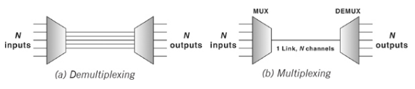

Signals are multiplexed using two basic techniques: *Frequency Division Multiplexing* (*FDM*) and *Time Division Multiplexing* (*TDM*).

* ***Frequency Division Multiplexing -*** Frequency division multiplexing (FDM) is used when the bandwidth of the transmission medium between the multiplexer and demultiplexer is much greater than the requirements from any one stream being multiplexed.
* ***Time Division Multiplexing*** - Time division multiplexing (TDM) divides the main signal into time-slots, with each time-slot carrying a separate signal. It is used for digital communication and can be applied when the data rate capacity of the transmission medium is greater than the data rate required by the sending and receiving devices.

**Switching**

On a network, switching means routing traffic by setting up temporary connections between two or more network points. This is done by devices located at different locations on the network, called switches (or exchanges). In a switched network, some switches are directly connected to the communicating devices while others are used for routing or forwarding information. Switching traditionally employs three methods: circuit switching, packet switching, and message switching. Out of these, only circuit and packet switching are in use nowadays, message switching has been phased out in general communications.

***Circuit Switching***

When a device wants to communicate with another device, circuit switching technique creates a fixed-bandwidth channel, called a **circuit**, between the source and the destination. This circuit is reserved exclusively for a particular information flow, and no other flow can use it. Other circuits are isolated from each other, and thus their environment is well controlled.

***Packet Switching***

Circuit switching was designed for voice communication. For example, in voice communication such as a telephonic conversation, once a circuit is established it remains busy for the duration of the conversation session. Packet switching introduces the idea of breaking data into packets, which are discrete units of potentially variable length blocks of data. Apart from data, these packets also contain a header with control information like the destination address, priority of the message, and so on. These packets are passed by the source point to its local Packet Switching Exchange (PSE). When the PSE receives a packet, it inspects the destination address contained in the packet. Each PSE contains a navigation directory specifying the outgoing links to be used for each network address. On receipt of each packet, the PSE examines the packet header information and then either removes the header or forwards the packet to another system. If the channel is not free, then the packet is placed in a queue until the channel becomes free. As each packet is received at each transitional PSE along the route, it is forwarded on the appropriate link mixed with other packets. At the destination PSE, the packet is finally passed to its destination. Note that not all packets travelling between the same two points, even those from a single message, will necessarily follow the same route. Therefore, after reaching their destination, each packet is put into order by a Packet Assembler and Disassembler (PAD).

***Message Switching***

Message switching technique employs the ‘store and forward’ mechanism. In this mechanism, a special device (usually a computer system with large memory storage) in the network receives the message from a communicating device and stores it into its memory. Then it finds a free route and sends the stored information to the intended receiver. In this kind of switching, a message is always delivered to one device where it is stored and then rerouted to its destination.

**1.11 Communication Networks**

Computer networking is the process of inter connecting two or more computers so that the users can communicate with each other, share resources and overcome other limitations of stand-alone systems. The network can be established with a variety of combinations of computers such as a network of only microcomputers, microcomputers and one or more minicomputers, and a set of microcomputers connected to a mainframe computer. The computers in a typical network are autonomous in the sense that they have processing capability independent of the network.

**1.11.1 Types of Networks**

Computer networks are classified according to their reach and complexity. The three basic types of networks are LANs (local area networks), which connect computers, printers, and other computer equipment for an office, several adjacent offices, an entire building or a campus; MANs (metropolitan area networks), which span a greater distance than LANs and usually have more complicated networking equipment for midrange communications; and WANs (wide area networks), which connect systems in an entire nation, continent, or worldwide. Some people also include a fourth category: PANs (personal area networks), which encompass connections between personal digital devices such as a computer and its keyboard or mouse, or a mobile phone and a hands-free headset

***LANs***

A computer network within a building, or a campus of adjacent buildings, is called a local area network, or LAN. LANs are usually established by a single organization with offices within a radius of roughly 5–6 kilometers (3–4 miles). LANs are set up by organizations to enhance communications among employees and to share IT resources. Households might set up LANs to share a broadband link to the Internet and to transmit digital music, pictures, and video from one part of a home to another.

In office LANs, one computer is often used as a central repository of programs and files that all connected computers can use; this computer is called a server. Connected computers can store documents on their own disks or on the server, can share hardware such as printers, and can exchange email. When a LAN has a server, the server usually has centralized control of communications among the connected computers and between the computers and the server itself.

***MANs***

A metropolitan area network (MAN) usually links multiple LANs within a large city or metropolitan region and typically spans a distance of up to 50 kilometers (about 30 miles). For example, the LAN in a chemistry lab might be linked to a research hospital’s LAN and to a pharmaceutical company’s LAN several miles away in the same city to form a MAN. The individual LANs that compose a MAN might belong to the same organization or to several different organizations. The high-speed links between LANs within a MAN typically use fiber optic or wireless broadband connections

***WANs***

A wide area network (WAN) is a far-reaching system of networks. One WAN is composed of multiple LANs or MANs that are connected across a distance of more than approximately 48 kilometers (or 30 miles). Large WANs might have many constituent LANs and MANs on different continents.The simplest WAN is a dial-up connection to a network provider’s services over basic telephone lines. A more complex WAN is a satellite linkup between LANs in two different countries. The most well-known WAN is the Internet. WANs can be public or private. The telephone network and the Internet are examples of public WANs. A private WAN might use either dedicated lines or satellite connections.

***PANs***

A personal area network (PAN) is a wireless network designed for handheld and portable devices such as smartphones and tablet or laptop computers, and is intended for use by only one or two people. Transmission speed is slow to moderate, and the maximum distance between devices is generally 10 meters (33 feet).

**1.12 Network Topology**

The design of network requires selection of a particular topology and an architecture for the interconnection of network components. Topology refers to the way the computers are physically connected into the network. There are five basic topologies: Bus, Ring, Star, Tree, and Mesh. There are two main types of processing set ups. Centralized, decentralized and hybrid

processing.

***Centralization***

* Star Topology - In star topology, devices are not directly linked to each other but they are connected via a centralised network component known as hub or concentrator. The hub acts as a central controller and if a node wants to send data to another node, it boosts up the message and sends the message to the intended node. This topology commonly uses twisted pair cable; however, coaxial cable or fibre optic cable can also be used.

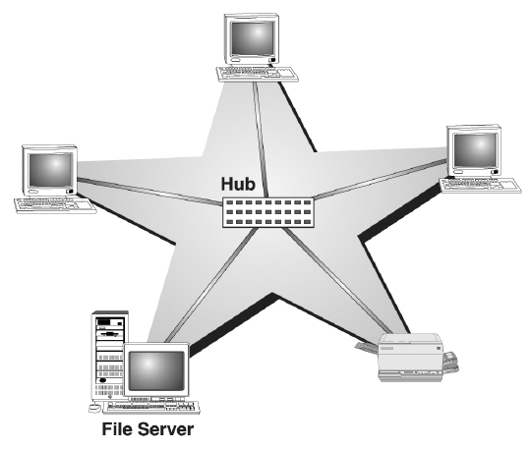

* Tree Topology - A tree topology combines characteristics of linear bus and star topologies. It consists of groups of star-configured workstations connected to a bus backbone cable. Not every node plugs directly to the central hub. The majority of nodes connect to a secondary hub that, in turn, is connected to the central hub. Each secondary hub in this topology functions as the originating point of a branch to which other nodes connect

. 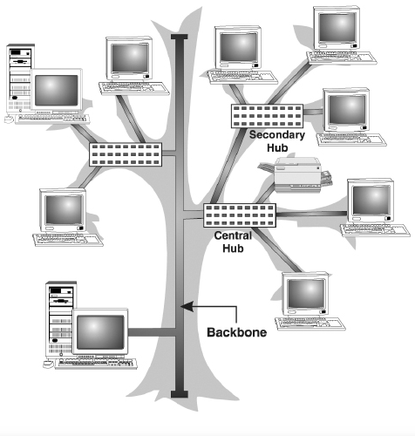

***Decentralization***

* Mesh Topology - In a mesh topology, every node has a dedicated point-to-point link to every other node. Messages sent on a mesh network can take any of several possible paths from source to destination. A fully connected mesh network has n(n-1)/2 physical links to link n devices. For example, if an organisation has 5 nodes and wants to implement a mesh topology, 5(5-1)/2, that is, 10 links are required. In addition, to accommodate that many links, every device on the network must have n-1 communication (input/output) ports.

***Hybrids***

Hybrid networks use a combination of any two or more topologies in such a way

that the resulting network does not have one of the standard forms. Two common examples for Hybrid network are: *star ring network* and *star bus network.*

* Bus Topology - Bus topology uses a common bus or backbone (a single cable) to connect all devices with terminators at both ends. The backbone acts as a shared communication medium and each node (file server, workstations, and peripherals) is attached to it with an interface connector. Whenever a message is to be transmitted on the network, it is passed back and forth along the cable, past the stations (computers) and between the two terminators, from one end of the network to the other. As the message passes each station, the station checks the message's destination address. If the address in the message matches the station's address, the station receives the message. If the addresses do not match, the bus carries the message to the next station, and so on.

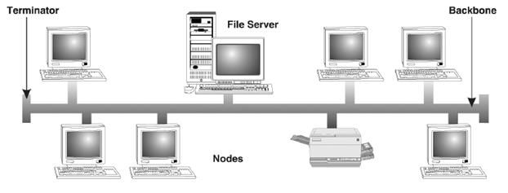

* Ring Topology - In ring topology, computers are placed on a circle of cable without any terminated ends since there are no unconnected ends. Every node has exactly two neighbours for communication purposes. All messages travel through a ring in the same direction (clockwise or counter-clockwise) until it reaches its destination. Each node in the ring incorporates a repeater. When a node receives a signal intended for another device, its repeater regenerates the bits and passes them along the wire.

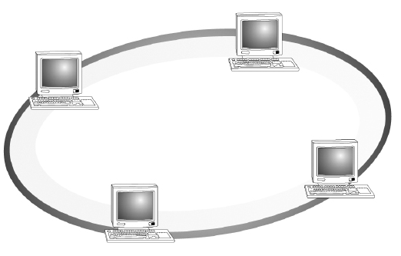

* Mesh Topology - In a mesh topology, every node has a dedicated point-to-point link to every other node. Messages sent on a mesh network can take any of several possible paths from source to destination. A fully connected mesh network has n(n-1)/2 physical links to link n devices. For example, if an organisation has 5 nodes and wants to implement a mesh topology, 5(5-1)/2, that is, 10 links are required. In addition, to accommodate that many links, every device on the network must have n-1 communication (input/output) ports.

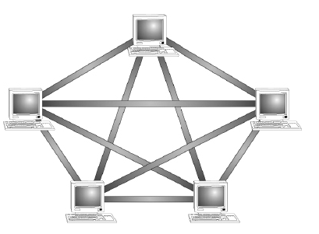

1.13 Unit Summary

This unit discussed computer hardware covering critical components such as types of computers, input devices, storage devices output devices and data transmission among others. Illustrations, diagrams and relevant figures have been employed for easy understanding of the domain under discussion. Unit activities below have deliberately been made highly interactive and student centred. We appeal to all our students to go through these video lectures in order to attain optimal skills acquisition.

1.14 Unit Activity

1. Follow this link and do the practical activities <https://www.youtube.com/watch?v=aW3qCcH6Dao>
2. Chapter4 page93-94, Review Exercises,” An Overview of System Components” by Glen E. Clarke and Ed Tetz

UNIT TWO

SOFTWARE

1. Introduction

Software refers to computer programs: sequences of instructions for the computers processor that control everything that the computer does. Without software, a computer would be useless. It is responsible for controlling, integrating, and managing the hardware components of a computer as well as to accomplish the specific tasks. In other words, software tells the computer what to do and how to do it.Software can be categorised as system software and application software. System software is a generic term for referring to any computer program whose purpose is to help the user to run the computer system, whereas application software employs the capabilities of a computer directly to a task that the user wishes to perform.

2.1Unit Objectives

By the end of this unit, you should be able to:

* Define and explain systems software
* Differentiate between operating and application software
* Identify and employ technical and appropriate considerations when acquiring software
* Explain and apply programming languages and principles
* Design and employ computerised information systems
* Identify and explain the role of computers in Electronic Data Processing (EDP)
* Explain and apply computer files and structures
* Explain and apply LANs and WANs in organisations such as a school
* Explore on-line and real time processing

2.2 System Software

System software consists of several programs, which are directly responsible for controlling, integrating, and managing the individual hardware components of a computer system. Some examples of system software are operating systems, device drivers, language translators, and system utilities.

**2.2.1 Operating System**

Operating system is the first layer of software loaded into computer memory when it starts up. As the first software layer, all other software that gets loaded after it depends on it for various common core services. These common core services include disk access, memory management, task scheduling, and user interfacing. In addition, the operating system ensures that different programs executing at the same time do not interfere with each other. It provides a software platform on top of which other programs can run. In simple words, the operating system organises and controls the hardware. Examples of operating systems are Windows XP, UNIX, and Linux. The basic functions of an operating system are:

* Process Management: It handles the creation, deletion, suspension, resumption, and synchronisation of processes.
* Memory Management: It handles allocation and de-allocation of memory space as required by various programs.
* File Management: It is responsible for creation and deletion of files and directories. It also organises, stores, retrieves, names, and protects all the files.
* Device Management: It manages all the devices of the computer system such as printers and modems. If any device fails, it detects the device failure and notifies the same to the user.
* Security Management: It protects system resources and information against destruction and unauthorised use.
* User Interface: It provides the interface between the user and the hardware.
* Device Drivers: Device drivers are system programs, which are responsible for proper functioning of devices. Every device, whether it is a printer, monitor, mouse or keyboard, has a driver program associated with it for its proper functioning. Whenever a new device is added to the computer system, a new device driver must be installed before the device is used. Note that each device has its own set of specialised commands that only its driver understands. A device driver is not an independent program; it assists and is assisted by the operating system for the proper functioning of the device.

**2.2.2 Application Software**

The most often seen software by a user is the application software. It is used to accomplish specific tasks rather than just managing a computer system. For a user, the computer system has no specific use without application software. Application software may consist of a single program, such as Microsoft's Notepad (for writing and editing simple text). It may also consist of a collection of programs, often called a software package, which work together to accomplish a task, such as database management software. Application software ranges from games, calculators, and word processors (document creating programs), to programs that “paint” images on screen (image editors).

* Word Processors: A word processor is software used to compose, format, edit, and print electronic documents. Word processing is one of the earliest applications for office productivity and the personal computer. It involves not only typing, but also checking the spelling and grammar of the text and arranging it correctly on a page. A variety of different typefaces is available for a variety of effects. It is possible to include pictures, graphs, charts, and many other things within the text of the document. It also allows for changes in margins, fonts, and colours. Nowadays, virtually all personal computers are equipped with a word processing program, which has the same function as a typewriter for writing letters, reports or other documents, and printing. Examples of some well-known word processors are Microsoft Word and WordPerfect.
* Spreadsheets: One of the first commercial uses of computers was in processing payroll and other financial records. So the programs were designed to generate reports in the standard “spreadsheet” format used by bookkeepers and accountants. A spreadsheet application is a rectangular grid, which allows text, numbers, and complex functions to be entered into a matrix of thousands of individual cells. The spreadsheet provides sheets containing cells each of which may contain text and/or numbers. Cells may also contain equations that calculate results from data placed in other cells or series of cells. Microsoft Excel and Lotus 1-2-3 are examples of spreadsheet applications.
* Image Editors: Image editor programs are designed specifically for capturing, creating, editing, and manipulating images. These graphics programs provide a variety of special features for creating and altering images. In addition to offering a host of filters and image transformation algorithms, some image editors also enable the user to create and superimpose layers. Examples of these programs are Adobe Photoshop, Adobe Illustrator, and CorelDRAW.
* Database Management Systems: Database management software is a collection of computer programs that allow storage, modification, and extraction of information from a database in an efficient manner. It supports the structuring of the database in a standard format and provides tools for data input, verification, storage, retrieval, query, and manipulation.

**2.3 Acquisition of Software**

Different kinds of software are made available for use to users in different ways. The user may have to purchase the software, can download for free from the Internet, or can get it bundled along with the hardware. Nowadays with the advent of Cloud computing, many application software is also available on the cloud for use through the Internet, e.g. Google Docs. The different ways in which the software are made available to users are:

* **Retail Software:** is off-the-shelf software sold in retail stores. It comes with printed manuals and installation instructions. For example, Microsoft Windows operating system.
* **OEM Software** stands for “**Original Equipment Manufacturer**” software. It refers to software which is sold, and bundled with hardware. Microsoft sells its operating system as OEM software to hardware dealers. OEM software is sold at reduced price, without the manuals, packaging and installation instructions. For example, Dell computers are sold with the “Windows 7” OS pre-loaded on them.
* **Demo Software** is designed to demonstrate what a purchased version of the software is capable of doing and provides a restricted set of features. To use the software, the user must buy a fully- functional version.
* **Shareware** is a program that the user is allowed to try for free, for a specified period of time, as defined in the license. It is downloadable from the Internet. When the trial period ends, the software must be purchased or uninstalled.
* **Freeware** is software that is free for personal use. It is downloadable from the Internet. The commercial use of this software may require a paid license. The author of the freeware software is the owner of the software, though others may use it for free. The users abide by the license terms, where the user cannot make changes to it, or sell it to someone else.
* **Public Domain Software** is free software. Unlike freeware, public domain software does not have a copyright owner or license restrictions. The source code is publicly available for anyone to use. Public domain software can be modified by the user.
* **Open-Source Software** is software whose source code is available and can be customized and altered within the specified guidelines laid down by the creator. Unlike public domain software, open-source software has restrictions on their use and modification, redistribution limitations, and copyrights. Linux, Apache, Firefox, OpenOffice are some examples of open-source software.

2.4 Programming Languages

Computers work on a set of instructions called computer program, which clearly specifies the ways to carry out a task. A computer, takes instructions, in the form of computer programs, and carries out the requested task. We, as human beings, use natural languages such as English, Spanish, or French to communicate. Similarly, a user communicates with the computer in a language understood by it. The instructions, provided in the form of computer programs, are developed using computer or programming languages. A Programming Language consists of a set of vocabulary and grammatical rules, to express the computations and tasks that the computer has to perform. Programming languages are used to write a program, which controls the behavior of computer, codify the algorithms precisely, or enables the human-computer interface. Each language has a unique set of keywords (words that it understands) and a special syntax for organizing program instructions. The programming language should be understood, both by the programmer (who is writing the program) and the computer. Programming languages fall into three categories:

1. Machine Language: It is the native language of computers. It uses only 0s and 1s to represent data and the instructions written in this language, consist of series of 0s and 1s. A program written in machine language is a collection of binary digits or bits that the computer reads and interprets. It is a system of instructions and data executed directly by a computer’s CPU. It is also referred to as machine code or object code. Some of the features of a program written in machine language are as follows:

* The computer can understand the programs written in machine language directly. No translation of the program is needed.
* Program written in machine language can be executed very fast (Since no translation is required).
* Machine language is defined by the hardware of a computer. It depends on the type of the processor or processor family that the computer uses, and is thus machine-dependent. A machine- level program written on one computer may not work on another computer with a different processor.
* Computers may also differ in other details, such as memory arrangement, operating systems, and peripheral devices; because a program normally relies on such factors, different computer may not run the same machine language program, even when the same type of processor is used.
* Most machine-level instructions have one or more opcode fields which specify the basic instruction type (such as arithmetic, logical, jump, etc), the actual operation (such as add or compare), and some other fields.
* It is difficult to write a program in machine language as it has to be written in binary code. For e.g., 00010001 11001001. Such programs are also difficult to modify.
* Since writing programs in machine language is very difficult, programs are hardly written in machine language.

1. Assembly Language: It correspondences symbolic instructions and executable machine codes and was created to use letters instead of 0s and 1s to run a machine. This representation is usually defined by the CPU manufacturer, and is based on abbreviations (called mnemonics) that help the programmer remember individual instructions, registers, etc. Some of the features of a program written in assembly language are as follows:

* Assembly language programs are easier to write than the machine language programs, since assembly language programs use short, English-like representation of machine code. For e.g.:  
  ADD 2, 3  
  LOAD A  
  SUB A, B
* The program written in assembly language is the source code, which has to be converted into machine code, also called object code, using translator software, namely, assembler.
* Each line of the assembly language program is converted into one or more lines of machine code. Hence assembly language programs are also machine-dependent.
* Although assembly language programs use symbolic representation, they are still difficult to write.
* Assembly language programs are generally written where the efficiency and the speed of program are the critical issues, i.e. programs requiring high speed and efficiency.

1. High-level Language: These languages are written using a set of words and symbols following some rules similar to a natural language such as English. The programs written in high-level languages are known as source programs and these programs are converted into machine-readable form by using compilers or interpreters. Some of the features of a program written in high-level language are as follows:

* Programs are easier to write, read or understand in high-level languages than in machine language or assembly language. For example, a program written in C++ is easier to understand than a machine language program.
* Programs written in high-level languages is the source code which is converted into the object code (machine code) using translator software like interpreter or compiler.
* A line of code in high-level program may correspond to more than one line of machine code.
* Programs written in high-level languages are easily portable from one computer to another.

Note: Together, machine and assembly language are also known as low-level languages.

**2.5 Basic Programming Principles**

Programming languages are used to carry out arithmetic or logical operations. All programming languages share key characteristics, although individual programming languages can have their own unique features. Thus, the knowledge of the key characteristics learned from one programming language can be applied to other programming languages.

**2.5.1 Syntax, Sentence, Key Word**

Computer programming language have what is known as syntax, these are the rules that govern the structure of sentences of the programs written in the language. In a programming language, a sentence consists of words, numbers, and punctuation. There are two types of words in a programming language: keyword (or reserved word) and user-defined word. A keyword represents a specific meaning of the language (e.g., a specific instruction). A user-defined word is defined by the programmer to name a variable or a module. A word used in a programming language must not contain a space and is usually case is sensitive.

**2.5.2 Variable**

A variable is the name of a piece of CPU memory that holds data. A variable name is defined by the programmer and must be a user-defined word. Clearly, variable names are case sensitive; that is, **A variable** is different from **avariable**. In addition, a name of a variable must be a single user-defined word without a space. A variable has its data type, such as integer, character, etc. The data held by the variable are called the value of the variable. The original value of a variable could be a default value depending on its data type (such as 0 for an integer and space for a character). The value of a variable can be changed through operations, but can never be lost unless the computer program is terminated.

**2.5.3 Arithmetic Operation**

Arithmetic operations in procedural programming are similar to day-to-day arithmetic

Calculations, but use reverse expression. For instance, instead of A+B=C, C=A+B is used in programming; this means: “Let C equal to A plus B.” Multiplication is denoted by the asterisk symbol “*”, and division is denoted by the slash symbol “/”.

**2.5.4 Execution Sequence**

A computer program consists of a set of instructions. During the execution of the procedure of a program, instructions are executed one after another in a sequence (so-called execution sequence) in which they are encountered, but not in the order in which they are listed in the program. Logical instructions (e.g., if-statement and loops) can control the execution sequence of the program, as explained next.

**2.5.5 If-then-else Logic**

An if-then-else statement controls the computer execution sequence based on a conditionthat is defined by the current value of a particular variable(s). The if-then-else logic is illustrated

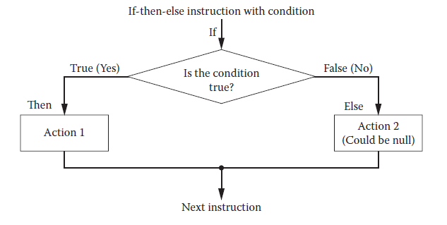

***2.5.6 Loop***

A loop is a group of instructions that are specified once but are executed several timesin succession. A loop statement defines such an iteration procedure. Loop is actually a variation of if-then-else logic. The common loops include for-loop and do-loop. The variable used in a loop to control the execution of the loop is called a counter. This construct allows repeated execution of a set of codes without repeating codes in the program. It saves the trouble ofwriting the same codes again and again in the program.

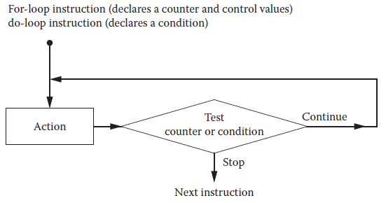

***2.5.7 A Module***

A large program must be divided into modules to make the program easy to debug. Also, a module can be reused. Here, a module could be a paragraph of instructions, an independent function, or a class, depending upon the specific language in discussion. An instruction in a module can call another module to accomplish a specific task carried out by the called module. A module has its name, which is a single user-defined word. The communication between the calling module and the called module can be implemented by passing the values of special variables termed arguments or parameters.

* 1. **Unit Summary**

The unit walked us through systems software, differences between operating and application software, steps taken before acquiring a software, elaboration of programming languages and principles and the use of computerised information systems. Others covered in this unit included but not limited to role of computers in Electronic Data Processing (EDP),computer files and structures, LANs and WANs and on-line and real time processing.

**2.7 Unit Activity**

<https://www.youtube.com/watch?v=ny3cI-5q7ks>

Follow the video lecture using the above link and answer the questions asked at the end of the lecture.

**UNIT THREE**

**ORGANISATION AND CONTROL**

1. **Introduction**

Modern business practice is a complex combination of various elements that are integrated to enhance the enterprise ability to meet its objectives. An element that has become key to organisational success has undoubtedly been information and communications technologies (ICT). Information and communication technology has not only revolutionised how business is conducted today but has also enabled the creation of new business models.

**3.1 Unit Objectives**

By the end of the unit, you will be able to learn:

* Staff roles and responsibilities in a EDP
* Security in IT at all levels (Physical access, programmed access and back-up)
* Documentation in a n EDP

3.2 Staff Roles and Responsibilities

The IT department in an organisation is assigned the task of overseeing all the data processing tasks in the organisation or system. They are also responsible for redesigning the operations in the organisation that are information intensive to incorporate the effective use of digital devices to enhance the organisations ability to achieve its objectives. It is the duty of the IT department to maintain all IT infrastructure and techniques that supports organizations activities. As in any department staff roles and responsibilities are specified to avoid duplication of work and clarity in expectations of the various staff. The following are the description, role and responsibility assigned to each member of a typical IT department.

**3.2.1 IT Manager**

The IT Manager is responsible for the overall management of the IT department. The IT manager must plan, organise, coordinate, control and motivate the resources of the IT department to achieve the departmental aims of the business as a whole. The IT manager also supervises the members of the IT department and spearheads IT development projects.

**3.2.2 System Analyst**

The Systems Analysts main roles are to execute systems development projects initiated by the IT Manager. The Systems Analyst is responsible for managing the system development life cycle. The Systems Analyst is meant to be the bridge between the systems developers and the users. Thus this roles entails a complete understanding of the business process and solutions that are IT based. A systems analyst is responsible for researching, planning, and recommending software and systems choices to meet an organization’s business requirements. Systems analysts are normally responsible for developing cost analyses, design considerations, implementation timelines, and feasibility studies of a computer system before making recommendations to senior management. A big part of this job includes developing alternative system plans based on (1) analyzing system requirements provided by user input, (2) documenting development efforts and system features, and (3) providing adequate specifications for programmers.

**3.2.3 Programmer/ Software Engineer**

The Software Engineer works in conjunction with the Systems Analyst on system projects. The Software Engineer converts the requirements specified by the Systems Analyst into implementable software solutions. The Software Engineer is responsible for writing programs if there is no existing software to be used and testing programs during the design and implementation of a new system.

**3.2.4 Network Administrator**

The modern firm, organisation or business enterprise will usually have or be connected to a computer network. The Network Administrator is responsible for maintaining and upgrading the computer network infrastructure in the organisation. The network administrator is responsible for acquiring, implementing, managing,maintaining, and troubleshooting local area networks throughout the organization and their interfaces with the wide area networks such as the Internet. He or she is also often involved in selecting and implementing network security measures such as firewalls and access codes.

**3.2.5 Web Master**

Organisations that have presence on the Internet will have a Web Master to develop and maintain the firm’s websites and mail servers. The rapid spread of the web, intranets, and extranets has increased the responsibility and stature of the organizational webmaster. A webmaster is responsible for creating and maintaining the organization’s website as well as its intranet and extranet. Webmasters are increasingly involved in creatively deciding how to represent the organization on the web. These decisions involve elements of marketing and graphic design. Since many organizations use the web for commerce, webmasters must also be well-versed in web transaction software, payment-processing software, and security software. In small organizations, the website may be the responsibility of a single person. In large organizations, the webmaster often manages a crew of programmers who specialize in developing and updating code specifically for webpages and their links with other organizational ISs.

**3.2.6 Data Preparation Clerk**

The job of data preparation consists of loading data on a source documents for processing and then storing the data to storage device after the processing is complete. This is typical during batch processing applications such as running a payroll.

**3.2.7 Database Administrator**

The database administrator (DBA) is responsible for the databases and data warehouses of an organization—a very sensitive and powerful position. Since access to information often connotes power, this person must be astute not only technologically but politically as well. He or she must evaluate requests for access to data from managers to determine who has a real “need to know.” The DBA is responsible for developing or acquiring database applications and

must carefully consider how data will be used. In addition, the DBA must adhere to federal, state, and corporate regulations to protect the privacy of customers and employees. In addition to optimizing databases and developing data management applications, this person must oversee the planning and implementation of sophisticated security measures to block unauthorized access but at the same time to allow easy and timely access to authorized users.

**3.4 Control and Security in IT Department**

Control is defined as the ability to exercise restraining constraint on an entity. Information security means protecting information and information systems from unauthorized access, use, disclosure, disruption, modification, or destruction. The terms information security, computer security and information assurance are frequently used interchangeably. These fields are interrelated and share the common goals of protecting the confidentiality, integrity and availability of information; however, there are some subtle differences between them. These differences lie primarily in the approach to the subject, the methodologies used, and the areas of concentration.

**3.5 The Organization and Control**

Information security is concerned with the confidentiality, integrity and availability of data regardless of the form the data may take: electronic, print, or other forms. Information systems controls are both manual and automated and consist of general and application controls.**General controls** govern the design, security, and use of computer programs and the security of data files in general throughout the organization’s information technology infrastructure. On the whole, general controls apply to all computerized applications and consist of a combination of hardware, software, and manual procedures that create an overall control environment. General controls include software controls, physical hardware controls, computer operations controls, data security controls, controls over the systems development process, and administrative controls.

**3.6 Administrative Controls**

Administrative controls consist of approved written policies, procedures, standards and guidelines. Administrative controls form the framework for running the business and managing people. They inform people on how the business is to be run and how day to day operations are to be conducted. Laws and regulations created by government bodies are also a type of administrative control because they inform the business. Some industry sectors have policies, procedures, standards and guidelines that must be followed ‐ the Payment Card Industry (PCI) Data Security Standard required by Visa and Master Card is such an example. Other examples of administrative controls include the corporate security policy, password policy, hiring policies, and disciplinary policies. Administrative controls form the basis for the selection and implementation of logical and physical controls. Logical and physical controls are manifestations of administrative controls. Administrative controls are of paramount importance.

**3.7 Logical Controls**

Logical controls (also called technical controls) use software and data to monitor and control access to information and computing systems. For example: passwords, network and host based firewalls, network intrusion detection systems, access control lists, and data encryption are logical controls.

An important logical control that is frequently overlooked is the principle of least privilege.

The principle of least privilege requires that an individual, program or system process is not granted any more access privileges than are necessary to perform the task. A blatant example of the failure to adhere to the principle of least privilege is logging into Windows as user Administrator to read Email and surf the Web. Violations of this principle can also occur when an individual collects additional access privileges over time. This happens when employees' job duties change, or they are promoted to a new position, or they transfer to another department. The access privileges required by their new duties are frequently added onto their already existing access privileges which may no longer be necessary or appropriate.

**3.8 Physical Controls**

Logical controls (also called technical controls) use software and data to monitor and control access to information and computing systems. For example: passwords, network and host based firewalls, network intrusion detection systems, access control lists, and data encryption are logical controls.

An important logical control that is frequently overlooked is the principle of least privilege.

The principle of least privilege requires that an individual, program or system process is not granted any more access privileges than are necessary to perform the task. A blatant example of the failure to adhere to the principle of least privilege is logging into Windows as user Administrator to read Email and surf the Web. Violations of this principle can also occur when an individual collects additional access privileges over time. This happens when employees' job duties change, or they are promoted to a new position, or they transfer to another department. The access privileges required by their new duties are frequently added onto their already existing access privileges which may no longer be necessary or appropriate.

**3.9 Other Types of Control**

To determine which controls are required, designers and users of systems must identify all of the control points and control weaknesses and perform risk assessment. They must also perform a cost/benefit analysis of controls and design controls that can effectively safeguard systems without making them unusable.

The goal of control is to prevent losses to the organization arising from several possible hazards:

1. wasteful and inefficient use of resources
2. poor management decisions
3. unintentional errors in recording or processing data
4. accidental loss or destruction of records
5. loss of assets through employees’ carelessness
6. lack of compliance of employees with management policies of government regulations
7. embezzlement, which is the is the theft or misappropriation of assets by employees, accompanied by the falsification of records in order to conceal the theft.
8. Other illegal acts by employees, such as the taking of a bribe

**3.10 Control Types Description**

* Software controls

Monitor the use of system software and prevent unauthorized access of software programs, systems software and computer programs. System software is an important control area because it performs overall control functions for the programs that directly process data and data files

* Hardware controls

Ensure that computer hardware is physically secure, and check equipment for malfunction. Computer equipment should be specially protected against fires and extremes of temperature and humidity. Organizations that are critically dependent on their computers also must take provisions for backup or continued operation to maintain constant service.

* Computer operations controls

Oversee the work of the computer department to ensure that programmed procedures are consistently and correctly applied to the storage and processing of data. They include controls over the setup of computer processing jobs and computer operations, and backup and recovery procedures for processing that ends abnormally.

* Implementation controls

Audit the systems development process at various points to ensure that the process is properly controlled and managed

* Data security controls

Ensure that valuable business data files on either disk or tape are not subject to unauthorized access, change, or destruction while they are in use or in storage.

* Administrative controls

Formalized standards, rules procedures and control disciplines to ensure that the organization’s general and application controls are properly executed and enforced.

* Management controls

The process by which managers ensure that resources are obtained and used effectively and efficiently in the accomplishment of the organization’s objectives.

* Application Controls

Application controls: specific controls unique to each computerized application, such as payroll or order processing. They consist all controls applied from the business functional area of a particular system and from programmed procedures. Classifications of application controls are:

1. Input controls: the procedures to check data for accuracy and completeness when they enter the system.
2. ii. Processing controls: the routines for establishing that data are complete and accurate during updating.
3. iii. Output controls: measures that ensure that the results of computer processing are accurate, complete and properly distributed

These controls and mechanisms put together form the basis of ensuring that organisational data is safe from corruption and exposure to error generation.

**3.11 Classification of Files**

The basic building block of computer data is the character. Single characters rarely represent useful information on their own but several are grouped together as a single logical piece of information to form a field such as a customer name, an order number or a description of a product. Even fields are rarely useful on their own and most data processing problems require that a number of related fields be grouped and processed together as a record (a single record might have the following fields: customer name, customer number, order number, salesman, product code, quantity ordered, sales value). Therefore, the most prevalent way of data storage involves the collection of records called files. An organized collection of records is called a file.

* A set of integrated files in a data processing is called the database.
* All the records in a file are usually of the same type; i.e. they contain similar fields.
* Each of the records in a file is discrete and is labelled/identified by a key field (primary key)
* A field might be composed of subfields e.g. subfields of an address field: street name, town, country and postal code.

**3.12 File Classifications**

Files can be classified in one of a number of ways. These classifications enable attributes to be associated to each of the file types. This may be for easy identification or application program association. The following are the main classifications associated with file systems:

* Status – permanent or temporary;
* Contents – data or program, binary or alphanumeric,
* Main file or overflow‐file;
* Role – for input, or output or both;
* Structure and organization of contents;
* Size;
* Frequency of access;
* Volatility (frequency of modification);
* Speed of access required ‐ real‐time use or batch;
* Security and protection required.

**3.13 Master Files and Transaction files**

There are various types of files

1. **Master Files** - A master file is the most important file since it is the most complete and up-to-date version of a file. If a master file is lost or damaged and it is the only copy, the whole system will break down
2. **Transactional Files** - Transactional files are used to hold temporary data which is used to update the master file. Transactions can occur in any order, so it is necessary to sort a transaction file into the same order as the master file before it is used to update the master file.

**3.14 Backup or Security files**

Backup copies of files are kept in case the original is damaged or lost and cannot be used. Because the importance of the, Master file, backup copies of it should be taken at regular intervals in case it is lost, damaged, stolen or corrupt. Looking after your disks is not enough, you should always keep backup copies of all your important data, especially project work such as i tasks and system tasks.

**3.15 Transaction Log files**

Transactions are bit of business such as placing an order, making a payment, updating stock etc. If these transactions are performed in real time, the data input will overwrite the previous data. This makes it impossible to check past transactions and so would make it easy for people to commit fraud. A record of the transactions is kept in a transaction log file which shows all the transactions made over a certain period.

**3.16 File Organisation**

There are several methods you can use to organise files.

1. Serial Files - Records don’t follow each other in a particular order, so if another record needs to be added it can just be added to the end of the file. To read a serial file, a computer has to read each record until it reaches the one required.
2. ii) Sequential Files - These are like serial files expect that the record are held in a certain sequence. In a sequential file, records are arranged one after another, in a predetermined order. For instance, an employee file can be organized by employee ID number. The employee record with the smallest ID number would be the first record.
3. iii) Random Files - As the name says, files are not stored in any order. The OS Keeps a map of the files on the disk and uses the map to go straight to the data. Random access allows data stored to be found extremely quickly.

3.17 Unit Summary

The unit covered Staff roles and responsibilities in an EDP, Security in IT at all levels (Physical access, programmed access and back-up) and documentation in an EDP. Using this link (<https://www.youtube.com/watch?v=feEym_-k1dU>), how best can you summarise this unit within half a page?

3.18 Unit Activity

Carefully listen to the video lecture on this link (<https://www.youtube.com/watch?v=feEym_-k1dU> ). Thereafter, write brief noted within one page on the development and security of Management Information Systems of an organisation of your choice.

**UNIT FOUR**

**APPLICATION AND ANALYSIS OF SYSTEMS**

**4.0 Introduction**

Information systems perform various tasks via a wide spectrum of applications. An application (or app) is a computer program designed to support a specific tasks or business process. Each functional area or department within a business organization uses dozens of application programs.In an organization, there are multiple different computer applications/systems that are in use.

**4.1 Objectives**

By the end of this unit, you will learn, apply and critique:

* different packages such as accounting packages, sales, purchases, stock, payroll and normal ledger
* systems analysis
* identify requirements and objectives of a system

**4.2 Application Systems**

The different systems vary in function and complexity.

**4.2.1 Sales system**

In a sales system, the performance of a salesman, dealers, and retailers can be compiled using information and orders received from the salesman. The data is compiled and analyzed data can be generated using parameters like geographical location, type of product etc. With this application future forecast of sales can be made using past data.

**4.2.2 Purchase System**

The simplest purchase system is one where a computer is used to maintain the purchase ledger and procedure purchase analysis.

**4.2.3 General Ledger System**

This is a system that involves the control of financial aspects of an organization. The data in different financial transactions are recorded, ledgerised and analyzed for effective financial and management control.

Information about bank transactions are recorded on bank vouchers, cash entries recorded on cash vouchers. Other entries that don’t involve bank and cash entries are put in a journal. The entries are ledgerised, i.e posted into different accounts. This helps an organization identify the expenses/incomes earned in different areas.

**4.2.4 Payroll**

This is one of the most common application used by many organizations. The calculations are repetitive and are based on a set of rules formulated by the organization. Payroll is the information system that records details of wages and payments made to its employees

**4.2.5 Stock**

The purpose of a stock application is to minimize warehouse stock holding and achieve an optimum distribution of stock that is available from suppliers and finished goods in warehouses ready to be shipped to customers.

**4.3 Systems Analysis & Design**

Systems analysis consists of those activities that enable a person to understand and specify what the new system should accomplish. Systems analysis describes in detail what a system must do to satisfy the need or solve the problem.

Systems design consists of those activities that enable a person to describe in detail how the information system will actually be implemented to provide the needed solution. In other words, systems design describes how the system will actually work.

Systems analysis and design plays an integral role in the development of information systems.

**4.4 System Development Life Cycle**

Building information systems is similar to building a house. Before building the house (or the information system) you start with a basic idea. Then this idea is converted into a simple drawing that is shown to the customer and refined (often through several drawings, each improving on the last) until the customer agrees to what he or she wants. Thereafter, blueprints are designed that show much more detailed information about the house (e.g., the type of water faucets or where the telephone jacks will be placed). Finally, the house is built following the blueprints, sometimes with some changes directed by the customer as the house is erected.

The SDLC has a set of four fundamental phases: planning, analysis, design, and implementation. Each phase is itself composed of a series of steps, which rely upon techniques that produce deliverables (specific documents and files that provide understanding about the project).

**4.4.1 Planning**

The planning phase is the fundamental process understanding why an information system should be built. It has two steps which are

1. Project Initiation - this is where a system’s value to an organization is identified. Ideas of new systems come from outside the Information system area in the form of a system request. A system request presents a brief summary of a business need. A project sponsor works hand in hand with the Information system department to conduct a feasibility analysis. The system request and feasibility analysis are presented to an information systems approval committee (sometimes called a steering committee), which decides whether the project should be undertaken.
2. When the project is approved, it enters project management where the project manager creates a workplan and puts techniques in place to help the project team control and direct the project through the entire SDLC. The project plan is a deliverable which describes how the project team will go about developing the system.

**4.4.2 Analysis**

This phase answers the questions of who will use the system, what the system will do, and where and when it will be used. There are three steps in this phase

1. Analysts strategy - a strategy is developed to guide the project teams efforts and includes an analysis of the current system (called the as-is system) and its problems and then ways to design a new system (called the to-be system).
2. Requirements Gathering - Through interviews questionaires, etc. Information gathered leads to the development of a concept for the new system. The system concept is then used as a basis to develop a set of analysis models which describe how the business will operate if implemented.
3. System Proposal - the analysis, system concept and models are combined into a document called the system proposal which is presented to the project sponsor and other stake holders who decide if the system can be implemented or not.

**4.4.3 Design**

The design phase decides how the system will operate, in terms of the hardware, software, and network infrastructure; the user interface, forms, and reports; and the specific programs, databases, and files that will be needed. The steps in the design phase determine exactly how the system will operate. The design phase has four steps:

1. The design strategy is first developed. The organization decides whether the system will be developed by its own programmers, whether the system will be outsourced or whether the organization will buy an existing software package.
2. Development - this is where the basic architecture for the system is done describing he hardware, software, and network infrastructure to be used. In most cases, the system will add or change the infrastructure that already exists in the organization.
3. The database and file specifications are developed. These define exactly what data will be stored and where they will be stored
4. The team then develops the program design, which defines the programs that need to be written and exactly what each program will do.

The system specifications are then handed over to the programming team for implementation.

4.4.4 **Implementation**

This is the final phase of the SDLC. system is actually built (or purchased, in the case of a packaged software design). This phase gets the most attention because most systems take long and are expensive during development process. This phase has three steps;

1. System construction is the first step. The system is built and tested to ensure that it performs as designed.
2. The system is installed. Installation is the process by which the old system is turned off and the new one is turned on.
3. The analyst team establishes a support plan for the system.
   1. Unit Summary

The unit discussed various components ranging from different packages such as accounting packages, sales, purchases, stock, payroll, normal ledger, systems analysis to identifying requirements and objectives of a system. Learn more about application and analysis of systems on this link (<https://www.youtube.com/watch?v=pOzSlT2Chi0> )

4.6 Unit Activity

Having listened to the video lecture on this link (<https://www.youtube.com/watch?v=pOzSlT2Chi0> ), identify application systems appropriate to the organisation of your choice.

**UNIT FIVE**

**Organizations, management and the networked enterprise**

* 1. **Introduction**

This Chapter introduces the Organizations, management and the networked enterprise, raising a series of important questions such as; what is an information system and what are its management, organization, and technology dimensions? Why are information systems so essential in businesses today? Why are systems for collaboration and teamwork so important? How can information systems help businesses become more competitive? And what the broader ethical and social issues are raised by widespread use of information systems?

* 1. **Objectives**

After reading this chapter, you will be able to answer the following questions:

* How are information systems transforming business and what is their relationship to globalization?
* The Management of Information Systems
* The importance of Information Systems in the corporate world and its contribution to gaining competitive advantage.
* The technological fit between Information system, organizations and the IT infrastructure.
* Ethical Issues Surrounding the use of Information Systems
  1. **Information systems in global business today**

The use of Information systems has a lot of important effects on business operations today regardless of the size of your business. It has both tangible and intangible benefits that helps businesses thrive, increase profitability and improve the service delivery. The Information System is part of the Technological infrastructure which affects the organisation or business culture, efficiency and relationships (Laudon & Laudon2014).

.

* + 1. **How information systems are transforming business**

Information systems over the past has transformed business processes and some of the transformation includes the following:-

* Increase in wireless technology use
* Use of website
* Increased business use of Web 2.0 technologies
* Cloud computing
* Mobile digital platform allowing more distributed work
* Decision-making, and collaboration
  + 1. **Globalization opportunities**

Information Systems has drastically reduced costs of operating on global scale for Customers and firms globally. Many people are benefiting through the following:-

* Education across borders and continents
* Promoted e-commerce which enables people transact globally through online platforms such as Amazon, Alibaba, eBay etc.
* Imports and Exports of goods and services
* Presents both challenges and opportunities
  1. **Global e-business and collaborations**

In order for any business to operate, it has to deal with many different pieces of information about suppliers, customers, employees, invoices and payments, and of course their products and services. The process by which all the above are used towards the achievement of a particular product or service is referred to as a business process.

* + 1. **Business Processes**

Business processes are the collection of activities required to produce a product or service. The activities include; the flows of material, information, and knowledge among the participants in business processes. Business processes also refer to different ways in which organizations handles their work, information, and knowledge, and the ways in which management chooses to coordinate work. Additionally, the performance of a business firm is highly dependent on how well its business processes are designed and coordinated. Business processes may be tied to functional (departmental) area or can also be cross-functional, therefore Businesses can be seen as collection of business processes and may be assets or liabilities (Laudon & Laudon, 2014).

* + 1. **Examples of functional business processes**

1. **Manufacturing and production**

* How to assembling the product
* How to replace a part
* Etc.

1. **Sales and marketing**

* Identifying customers
* Shipment of product
* Etc.

1. **Finance and accounting**

* Creating financial statements
* Accounts payable run
* Etc.

1. **Human resources**

* Hiring employees
* Promotion
* Education
* Etc.

**EXAMPLE**

The Order Fulfilment Process (cross-function)

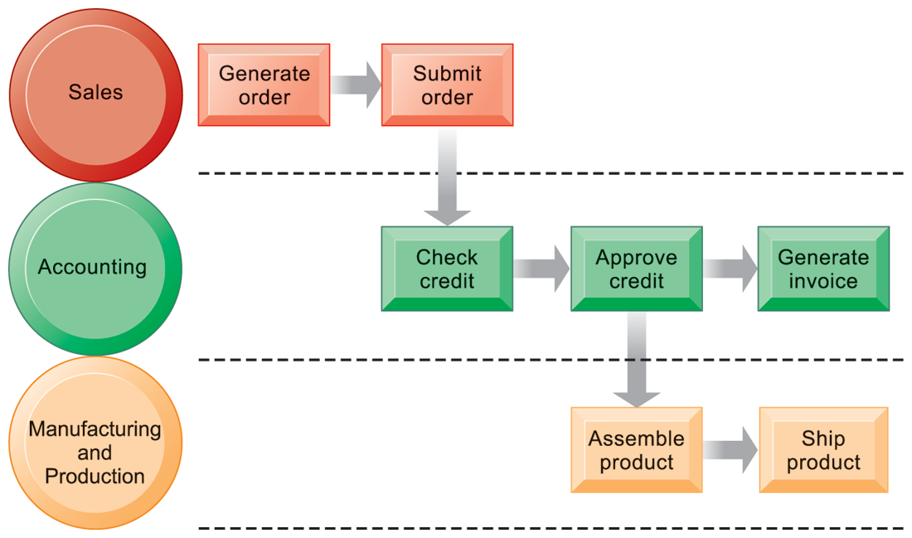

Figure 01: The Order Fulfilment Process (cross-function)

**Note**:

Fulfilling a customer order involves a complex set of steps that requires the close coordination of the sales, accounting, and manufacturing functions.

Information technology enhances business processes by:

1. **Increasing efficiency of existing processes**

* Automating steps that were manual
* Making things happen a lot quicker
* Reducing inaccuracies

1. **Enabling entirely new processes**

* Change flow of information e.g. individualize product
* Replace sequential steps with parallel steps
* Eliminate delays in decision making
* Support new business models e.g. buying over the internet.
  1. **Information systems, organizations/Business and strategy**

We have seen that all business strategies must be responsive to the external environment, but what are the elements of a strategy for managing Business Information Strategy (BIS) and how do they relate? Ward and Peppard (2002) identify three different elements of IS strategy:

* + 1. **Business information strategy.**

The Business Information Strategy also referred to as the Business Strategy (BS) defines how information, knowledge and the applications portfolio will be used to support business objectives.

* + 1. **IS functionality strategy.**

This defines, in more detail, the requirements for e-business services delivered by the range of business applications (the applications portfolio).

* + 1. **IT strategy (IS/IT strategy).**

This defines the software and hardware standards and suppliers which make up the e-business infrastructure.

**The IT strategy** determines the technological infrastructure of the organisation. It ensures the most appropriate technologies and best standards are used in terms of cost, efficiency and supporting the needs of the business users and integration with customers and other partners. A recent strategic decision taken by many companies is to use the Internet protocol (IP) to support deployment of business applications via an intranet. The hardware and software elements of the IT infrastructure were described earlier (in Chapters 3 to 6).

**The IS strategy** determines how IT is applied within an organisation. It should ensure that the IT deployed supports business strategies and that the appropriate resources and processes are in place for the deployment to be effective.

Note that, in reality, there is some overlap between elements of IS and IT strategy. For example, it can be argued that the selection of the optimal portfolio of software applications is an aspect of both IS and IT strategy. For this reason a convention preferred by many authors such as Ward and Peppard (2002) refers to both elements together (IS/IT strategy).

The relationship between these elements is indicated in Figure 000 It is evident that these three elements can be considered to be hierarchical. Here, business information strategy should be driven by the objectives of the business strategy by its information needs. IS functionality, delivered by BIS applications, should in turn be driven by the information requirements of the organisation, and finally IT strategy is the implementation of IS strategy through the delivery of IT infrastructure. Such a model is useful for debate. For example, does this model represent reality in most organisations? Do organisations have separate information, IS and IT strategies? What are the benefits and disadvantages of this approach? Although the top-down approach implies strong control of IS and alignment with business strategy, it may have limited responsiveness in taking advantage of opportunities provided by IS. If IS strategy development identifies a business opportunity it is difficult to feed this back up the hierarchy to be incorporated into the business strategy.

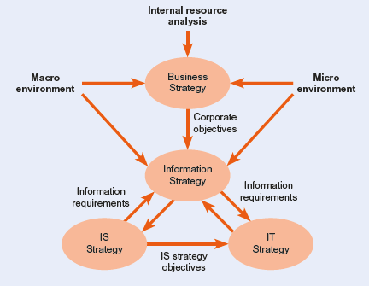

Figure 02: Relationship between business strategy and IS/IT strategies

Source: Bocij et al (2015), pg. 480

The importance of a coherent strategy to manage information is highlighted by Willcocks and Plant (2000) who found in a study of 58 major corporations in the USA, Europe and Australasia that the leading companies were astute at ‘distinguishing the contributions of information and technology, and considering them separately’. They make the point that competitive advantage ‘comes not from technology, but how information is collected stored, analysed and applied’.

* 1. **IS/IT and Business Strategic alignment**

The information System/ Information Technology (IS/IT) and Business alignment is a dynamic state in which a business organization is able to use the Information Systems available aligned perfectly to support the Business strategies. These two components can never function on their own unless they use the Information Technology (IT) as an enabler to support them. The IT in this case refer to the hardware and networking components that are used in support of the IS aligned to the business. Furthermore, to achieve business objectives i.e. improving financial performance or marketplace competitiveness. Some definitions focus more on outcomes (the ability of IT to produce business value) than means (the harmony between IT and business decision-makers within the organizations); e.g. Alignment is the ability to demonstrate a positive relationship between information technologies and the accepted financial measures of performance.

* 1. **IS/IT strategy and an organisation’s environment**

All organisations operate within an environment that influences the way in which they conduct business. Strategy development is strongly influenced by considering the environment the business operates in. Environmental influences can be broken down into:

* The immediate competitive environment (**micro-environment**) which includes customer demand and behaviour, competitor activity, marketplace structure and relationships with suppliers and partners;
* The wider environment (**macro-environment**) in which a company operates includes economic development and regulation by governments in the forms of law and taxes together with social and ethical constraints such as the demand for privacy.

For IS/IT strategy, the most significant environmental influences are those of the immediate marketplace which is shaped by the needs of customers and how services are provided to them through competitors and intermediaries and via upstream suppliers. Wider influences are provided by local and international economic conditions and legislation together with what business practices are acceptable to society. Finally, technological innovations are vital in providing opportunities to provide superior services to competitors or through changing the shape of the marketplace *(refer to the figure 02 above for clear understanding).*

* 1. **Ethical and social issues in information systems**

Ethics are rules of behaviour based on ideas about what is morally good and bad ethics. It is an area of study that deals with philosophies about what is good and bad behaviour or a branch of philosophy that deals with what is morally right or wrong.

The society and organisations expect employees and managers to behave in a professional manner at all times. They are expected to balance the needs of their employer and the requirements of their profession with other demands such as a responsibility to society. The terms ethics, morality and professionalism are often used to describe our expectations of managers and employees:

* **Professionalism** can be described as acting to meet the standards set by a profession in terms of individual conduct, competence and integrity.
* **Ethics** describes beliefs concerning right and wrong that can be used by individuals to guide their behaviour.
* **Morality** is concerned with an individual’s personal beliefs of what is right and wrong.

The IS professional is in a difficult position when undertaking their work since there are a number of constraints affecting their behaviour. These constraints are indicated in Figure 03. These constraints may not necessarily conflict, but the employer may place demands on the manager which go against any of the constraints in Figure 03.

What should a project manager do, for instance, if the company asks them to reduce the time taken for testing on a project (in order to meet a deadline) which may affect public safety? The sections that follow examine some of the responsibilities and values on the IS manager in each of these areas.

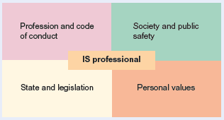

**Figure 03**: *Constraints and potential areas of conflict related to the duties and responsibilities of the IS professional*

Source: Source: Bocij et al (2015), pg. 600

* + 1. **Code of conduct**

A Code of conduct is a set of rules outlining the social norms, religious rules and responsibilities of, or proper practices for, an individual, party or organization. It is established by a professional order as a way to protect the public and the reputation of the professionals of which members of a particular professional associations are expected to abide by a set of principles that set out their minimum standards of competence, conduct and behaviour. The Code of Conduct describes an organization’s ethical standards and requirements.

People who breach their code of ethics incur disciplinary actions that can range from a warning or reprimand to dismissal or expulsion from their professional order. The intention of the code of conduct is not to punish employees but to be as clear and direct as possible in terms of difficult issues employees or individuals may face during the course of performing their job responsibilities. However, the Code of Conduct does not remove the need for the individual to exercise good judgement when dealing with ethical issues.

The code of conduct includes detail on compliance with laws and regulations such as harassment and discrimination on the workplace, conflicts of interest, confidentiality and security matters, fairness and equity, contact with the public and media, values of the business and guidelines on general behaviour.

* + 1. **Importance of Code of conduct**

The benefits of a code of conduct include:-

* Creating an agreed way of behaving and operating for the entire company;
* Improved company performance when linked to the company’s business and strategic objectives;
* Good company culture – employees know what is expected of them in terms of behaviour;
* Good communication with employees having a framework to look up when faced with difficult decisions;
* Having a set of values – having a sense of what the company values are and what the company stands for.

In working with ethical issues it is important for an employee to follow some simple rules such as:

* Making sure one’s actions are within the law as well as within the organization’s own ethical requirements because not doing so increases the risk of things going wrong.
* Being open with regard to ethical issues. If in doubt, a person should talk with their colleagues or raise the issue with their superior.
* Spending sufficient time on difficult decisions. The wrong decisions are often taken when things have not been thought through properly, and the individual allows themselves to be pressured into making a decision too quickly.
  1. **Activity**

|  |  |
| --- | --- |
| **Activity 00** | **Why are environment influences important?** |
|  | *For each of the environment influences shown in Figure 1.3, give examples of why it is import-ant as part of IS/IT strategy to monitor and respond in an information systems strategy context. Environmental influences are clearest for a company operating an e-commerce service.* |
|  | *How can IS/ IT strategies support business strategy?* |
|  | *Discus ethics and their importance to professionals and the organisation* |

**UNIT SIX**

1. **Information technology infrastructure**
   1. **Introduction**

Setting up an IT infrastructure can be seen as a very daunting process simply because, it comprises anything related to the flow and processing of information within a company. However, with a reliable, high quality IT infrastructure, an organisation is able to reduce your ICT costs on the other hand increasing their efficiency. This Chapter looks at the Information Technology Infrastructure; it highlights some emerging technologies, business intelligence, and databases in brief, telecommunications and also discusses the internet technologies.

* 1. **Objectives**

By the end of this chapter, you will understand the following:

* What ICT infrastructure is and what it is consist of.
* Databases and its basic concepts and Business Intelligence including data mining techniques.
* Telecommunications and computer networks
* The internet, intranet & Extranets and how they support businesses.
  1. **ICT infrastructure and emerging technologies**

Information and Communications Technology (ICT) infrastructure refers to the combination of hardware, software, network resources and services required for the existence, operation and management of ICT in an organisation or business environment. It allows an organization to deliver ICT solutions and services to its employees, partners and customers. And it is usually internal and external to an organization and deployed within owned facilities.

The ICT infrastructure consists of all components that somehow play a role in overall ICT and ICT supported operations. It can be used for internal business operations or developing customer ICT or business solutions.

Typically, the components below makes up a standard ICT infrastructure:

* **Hardware**: Servers, computers, switches, printers, scanners, firewalls and routers, and other equipment
* **Software**: Operating System, Enterprise resource planning (ERP), customer relationship management (CRM), productivity applications and more
* **Network**: Inter connection of computers and other hardware devices, internet, and others
* **Users**: Human users, such as network administrators (NA), developers, designers and end users with access to any ICT appliance or service are also part of an ICT infrastructure, specifically with the advent of user-centric ICT service development.
  1. **Databases and Business Intelligence**

A Database is a collection of related information stored in an organised way so that specific items can be selected and retrieved quickly. Data is organized into rows, columns and tables, and it is indexed to make it easier to find relevant information. A database need not involve the use of technology. Examples of manual databases include telephone directories, address books, diaries and card index files.

* + 1. **Basic concepts of a Database**

Below are few notable database concepts

* **Field**: The data in an electronic database are organised by fields and records. A field is a single item of information, such as a name or a quantity.
* **Record**: In an electronic database, a record is a collection of related fields. See Field.
* **Table**: In an electronic database, data are organised within structures known as tables. A table is a collection of many records.
* **A primary key**: it is a special relational database table column (or combination of columns) designated to uniquely identify all table records. A primary key's main features are: It must contain a unique value for each row of data. It cannot contain null values.
* **Foreign (secondary) key fields**: These fields are used to link tables together by referring to the primary key in another database table.
* **Relationship**: In a relational database, data can be combined from several different sources by defining relationships between tables.
* **Compound key**: In a relational database, it is possible to retrieve data from several tables at once by using record keys in combination, often known as a compound key.

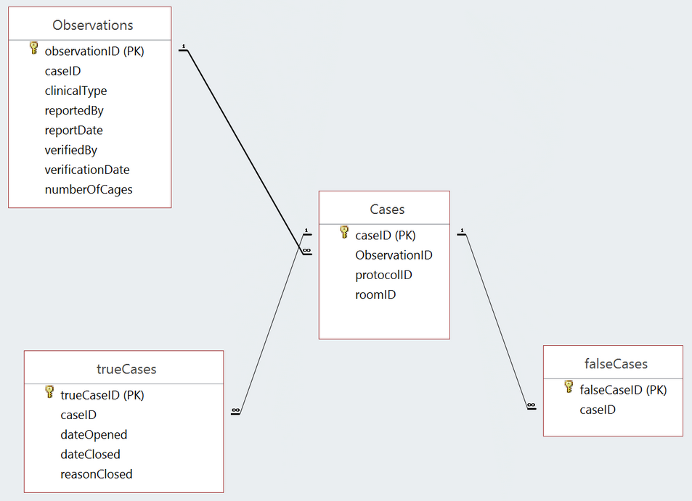

**Figure 04**:***An example of how key fields are used to link information from different database tables***

**Source***:* [*https://dba.stackexchange.com*](https://dba.stackexchange.com)

* + 1. **Database Features**
* **A query**: it is a request for data or information from a database table or combination of tables.
* **Update query**: An update query can be used to change records, tables and reports held in a database management system.
* **Structured query language (SQL)**: A form of programming language that provides a standardised method for retrieving information from databases.
* **Filter**: In a spreadsheet or database, a filter can be used to remove data from the screen temporarily. This allows users to work with a specific group of records. Filters do not alter or delete data but simply hide any unwanted items.
  1. **Business Intelligence and Information Management**

Business intelligence (BI) is an umbrella term that includes the applications, infrastructure and tools, and best practices that enable access to and analysis of information to improve and optimize decisions and performance. BI systems are needed due to the vast amounts of data held in organisational information systems and the need to extract useful information from this in the form of patterns, trends and present this in an understandable way to decision makers.

Figure 05 below shows the main elements of a business intelligence system. Data is gathered from various sources and then held in a special database repository termed a data warehouse in order to support decision-making in the organisation. Repositories of data focused on departmental or subject areas are termed data marts.

**Data warehouses** are large database systems containing current and historical data that can be analysed to produce information to support organisational decision making.

**Data marts** are a smaller, departmental version of a data warehouse which may be easier to manage than a company-scale data warehouse. Data marts do not aim to hold information across an entire company, but rather focus on one department.

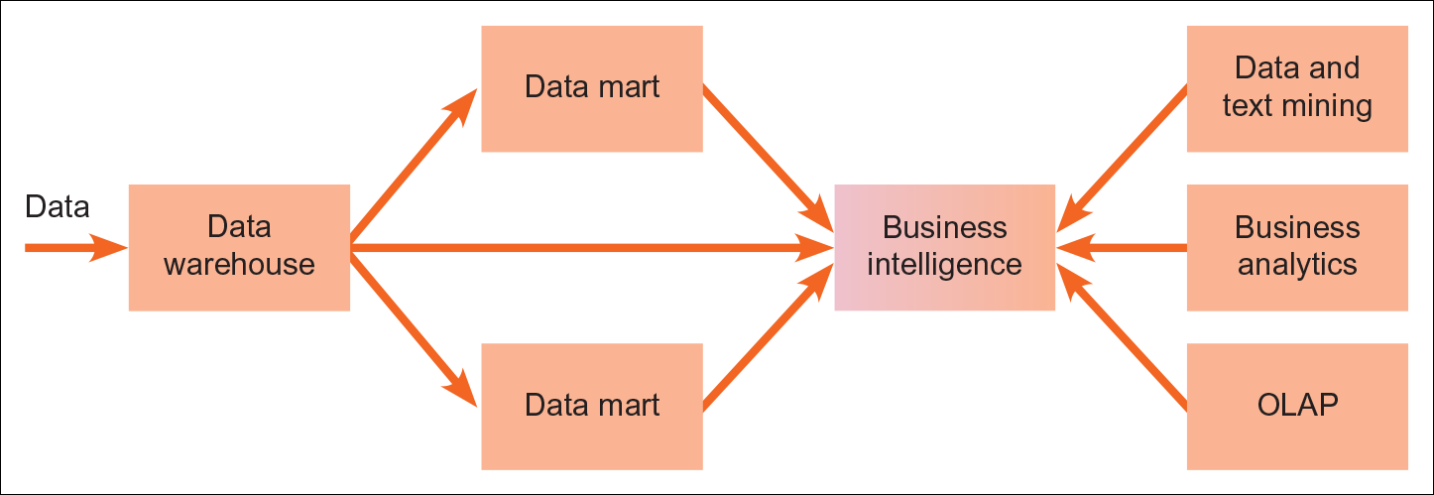

**Figure 05:** *Elements of a business intelligence system*

**Source**: Bocij et al (2015), pg. 153

* + 1. **Business analytics**

Business analytics (BA) is the practice of iterative, methodical exploration of an organization's data, with an emphasis on statistical analysis. Business analytics is used by companies committed to data-driven decision-making. It is a term that is used to describe various approaches to data driven analysis including reporting tools such as OLAP and visualisation tools such as dashboards.

* + 1. **Online analytical processing (OLAP)**

Online analytical processing (OLAP) refers to the ability to analyse in real time the type of large data sets stored in data warehouses. ‘Online’ indicates that users can formulate their own queries, compared to standard paper reports.

* + 1. **Data mining**

Data mining in its broadest sense is a process that uses statistical, mathematical, artificial intelligence and other techniques to extract useful information from large databases. Under this wide definition most types of data analysis can be classified as data mining.

Particular data mining techniques include:

* **Identifying associations:** This involves establishing relationships about items that occur at a particular point in time.
* **Identifying sequences:** This involves showing the sequence in which actions occur, e.g. path or click-stream analysis of a web site.
* **Classiﬁcation:** This involves analysing historical data into patterns to predict future behaviour.
* **Clustering:** This involves finding groups of facts that were previously unknown.
* **Modelling:** This involves using forecasting and regression analysis to   
  predict sales.
  + 1. **Cube Analysis**
* Data in a multidimensional database are broken down for analysis into a number of chosen dimensions. For example, for sales data the common dimensions are time period, product types and geographic location.
* Dimensions can be then broken down into categories. For example, for time these could be months, quarters or years.
* Usually a multidimensional database is formed from data held in a data warehouse specifically for multidimensional analysis.
* The form of the data used in the multidimensional database is termed a **data cube.**
  + 1. **Text mining and web mining**
* **Text mining** is the application of data mining to text files. Text held in documents will normally be unstructured in terms of its content and text mining aims to find previously hidden patterns in text within and between documents.
* **Web mining**: Because of the size and popularity of the web many data mining applications are being developed to analyse information from the web and these are classified under the term web mining. Extraction of information from web pages specifically is termed web content mining and involves reading and analysing data from web pages.
  1. **Telecommunications and Networks**

Telecommunications refers to the exchange of information by electronic and electrical means over a significant distance. A complete telecommunication arrangement is made up of two or more stations equipped with transmitter and receiver devices. A single co-arrangement of transmitters and receivers, called a transceiver, may also be used in many telecommunication stations. Telecommunications devices include computers, cell phones, telephones, telegraph, radio, micro-wave communication arrangements, fiber optics, satellites and the Internet.

* + 1. **Computer Networks**

A computer network can be defined as: ‘a communications system that links two or more computers and peripheral devices and enables transfer of data between the components’. A network can be use in different environments such as corporates and home and can be built using either wired or wireless technology as explained below:-

1. **Wired Networks**

Wired networks use Ethernet cables and network adapters. Even though two computers can be directly wired to each other using an Ethernet crossover cable, wired networks also require central devices like switches and routers to accommodate allow connection or more computers.

1. **Wireless Networks**

Wireless networks are computer networks that are not connected using any cables. Instead they use radio waves to and wireless network cards to communicate to each other. Wireless network enables enterprises to avoid the costly process of introducing cables into buildings or connection between different equipment located geographically.

* 1. **Characteristics of networks**
* **Sharing Resources** from one Computer to another Computer over a network.
* **Performance** by measuring the speed of data transmission with number of users, connectivity and the software used.
* **Reliability** makes easy to use an alternative source for data communication in case of hardware failure or connectivity issues.
* **Scalability** increases the system performance by adding more processors.
* **Security** is the main characteristics of Computer network where you can take necessary steps for protecting your data from unauthorized access.
  1. **Types of Networks**

Different types of private networks are distinguished based on their sizes (in terms of the number of machines), their data transfer speeds, and their reach. Private networks are networks that belong to a single organization. There are usually said to be three categories of such networks: local area network (LAN), wide area network (WAN), and metropolitan area network (MAN)

* + 1. **Local-area network (LAN)**

A local area network (LAN) is a setup of computers and associated devices that share a common communications line or wireless link. Typically, a LAN comprises of computers and peripherals connected to a server within a distinct geographic area such as an office or a commercial institution.

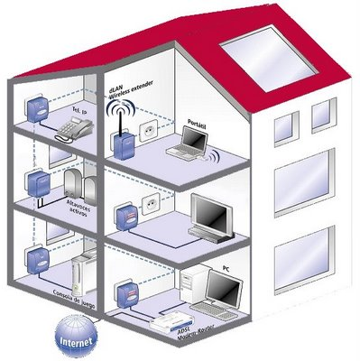

**Figure 06: A Local Area Network Set up**

* + 1. **Wide-area network (WAN)**

A wide area network (WAN) refer to a connection of multiple LANs over great geographic distances. The speeds on the WAN varies depending on the cost of the connections, which increases with distance, and may be low. WANs function using routers, which helps in choosing the most appropriate path for data to take to reach a network node. The most well-known WAN is the Internet.

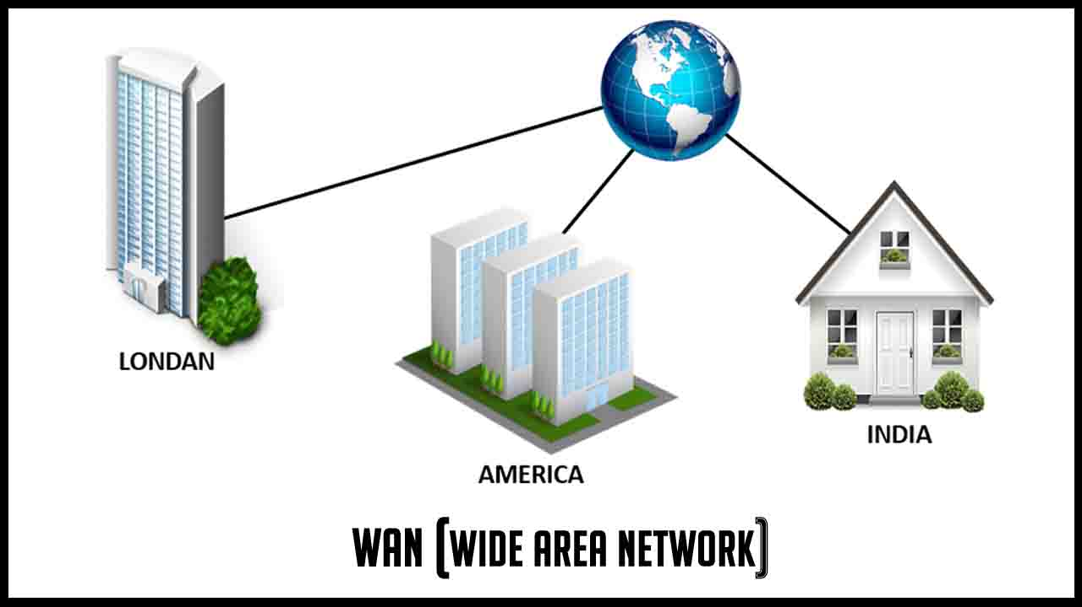

**Figure 07: A wide area network**

* + 1. **Metropolitan Area Network (WAN)**

A metropolitan area network (MAN) is a network that links users with computer resources in a geographic area or region larger than that covered by even a large local area network (LAN) but smaller than the area covered by a wide area network (WAN). The term is applied to the interconnection of networks in a city into a single larger network (which may then also offer efficient connection to a wide area network). It is also used to mean the interconnection of several local area networks by bridging them with backbone lines. The latter usage is also sometimes referred to as a campus network.

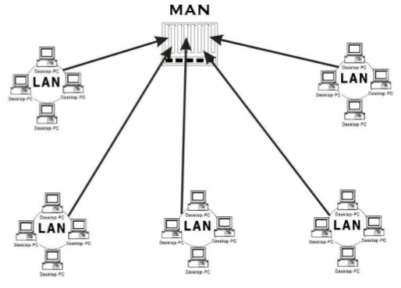

**Figure 08: A Metropolitan area network**

* + 1. **Telecommunications Network**

High speed, high capacity, long-distance communications system comprising of computers, electronic switches, cables, satellites, wireless transmitters and antennas, etc., which link multiple remote sites.

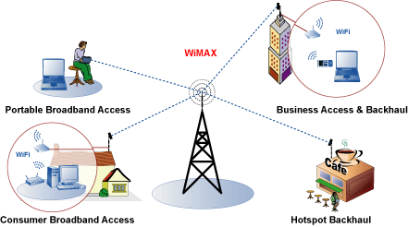

**Figure 09: A Telecommunication area network**

* + 1. **Intranet and Extranet**

**Intranet**: An intranet is a secure and private enterprise network that shares data o application resources via Internet Protocol (IP).

**Extranet**: An extranet is a controlled private network allowing customers, partners, vendors, suppliers and other businesses to gain information, typically about a specific company or educational institution, and do so without granting access to the organization's entire network.

* + 1. **The Internet**

The internet refers to the physical network that links computers across the globe, it is also called the network of networks or the World Wide Web (WWW). It consists of the infrastructure of network servers and communications links between them that are used to hold and transport information between the client PCs and web servers.

The internet has become very important to every business and individuals to an extent where it is very difficult to imagine how any business could operate during this time without the use of the internet. The advancement of the internet has significantly changed the day to day running of businesses, this include how people communicate with each other and their customers. Information can be easily transmitted to any place in a matter of few seconds.

In as far as marketing and advertising is concerned the internet has become an essential tool. Any business can make itself known to customers through the use of a website or online advertisements. A lot of businesses now use the internet as a means of making customers know their products and services and this as proven to be very valuable especially to businesses that are targeting a younger audience.

* + 1. **Internet Terminologies**
       - **World Wide Web (www),** a site or area on the World Wide Web that is accessed by its own Internet address is called a Web site.
       - **Internet Browser** is a software program that enables you to view Web pages on your computer. Browsers connect computers to the Internet, and allow people to “surf the Web.”
       - **Internet service provider (ISP)** a provider enabling home or business users a connection to access the Internet. They can also host web-based applications.
       - **Backbones** High-speed communication links used to enable Internet communications across a country and internationally.
       - A **Web Page** is like a page in a book. Websites often have several pages that you can access by clicking on links. A Web site can be a collection of related Web pages.
       - Each Web site contains a **home page** (this is the original starting page) and may also contain additional pages. Different computers will have different home pages. You can set your own webpage.
       - **The URL** stands for Uniform Resource Locator, and is used to specify addresses on the World Wide Web. A URL is the fundamental network identification for any resource connected to the web (e.g., hypertext pages, images, and sound files).

|  |  |
| --- | --- |
| Activity 000 |  |
|  | 1. *Explain what ICT infrastructure is and its components* |
|  | 1. *Explain at least three types of networks their characteristics* |
|  | 1. *Explain the relationship between Internet, Intranet and Extranet* |

**UNIT SEVEN**

1. **Key system applications for the digital age**
   1. **Introduction**

This chapter examines the core information system applications businesses are using today to improve operational excellence and decision making. These applications include enterprise systems; systems for supply chain management, customer relationship management, collaboration, and knowledge management; e-commerce applications; and decision-support systems. The chapter will answers questions such as: How can enterprise applications improve business performance? How do firms use e-commerce to extend the reach of their businesses? How can systems improve collaboration and decision making and help companies make better use of their knowledge assets?

* 1. **Objectives**
* Enterprise Systems and how the help running of the businesses
* Supply Chain Management Systems
* Customer Relationship Management Systems
* Electronic Commerce (E-commerce), its pros and cons
* Knowledge Management and the types involved
  1. **Achieving operational excellence and customer intimacy: Enterprise applications**
     1. **Enterprise Systems**

Around the globe, companies are increasingly becoming more connected, both internally and with other companies. If you run a business, you will want to be able to react instantaneously when a customer places a large order or when a shipment from a supplier is delayed. You may also want to know the impact of these events on every part of the business and how the business is performing at any point in time, especially if you are running a large company. Enterprise systems provide the integration to make this possible. Let’s look at how they work and what they can do for the firm.

Enterprise Systems are also called “Enterprise Resource Planning (ERP) systems”, they are a suite of integrated software modules and a common central database that collects data from many divisions of firm for use in nearly all of firm’s internal business activities and any Information entered in one process is immediately available for other processes

ERPs are built around thousands of predefined business processes that reflect best practices. Figure 10 describes some of the major business processes supported by enterprise software.

An organisation is able to use configuration provided by the software to tailor a particular aspect of the system to their business needs. E.g. they can use the available tables to choose whether they wants to track revenue by product line, geographical unit, or distribution channel. If the ERP does not support the way the organization conduct its business, companies can rewrite some of the software according to their business processes. However, ERPs is not complex, and extensive customization may reduce system performance, compromising the information and process integration that are the main advantages of the system. If an organisation want to acquire the maximum benefits from the use of the ERP, they need to change the way they operate in order for them to conform to the business processes in the software.

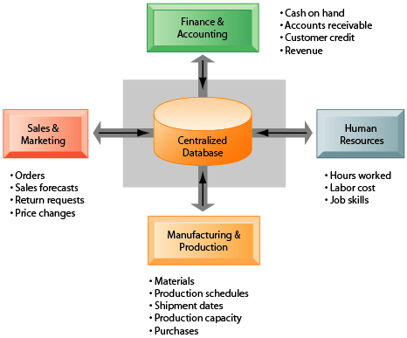

Figure 10: how enterprise systems work

Source:

* + 1. **Business value of enterprise systems**
* ERPs provide value both by increasing operational efficiency and by providing firm wide information to help managers make better decisions.
* Large companies with many operating units in different locations have used ERP systems to enforce standard practices and data so that everyone does business the same way worldwide. Coca-Cola, for instance, implemented a SAP enterprise system to standardize and coordinate important business processes in 200 countries. Lack of standard, companywide business processes prevented the company from leveraging its worldwide buying power to obtain lower prices for raw materials and from reacting rapidly to market changes.
* ERPs help organisations to respond rapidly to customer requests for information or products. Because the system integrates order, manufacturing, and delivery data, manufacturing is better informed about producing only what customers have ordered, procuring exactly the right amount of components or raw materials to fill actual orders, staging production, and minimizing the time that components or finished products are in inventory.
* ERP software includes analytical tools for using data captured by the system to evaluate overall organizational performance.
* ERP system data have common standardized definitions and formats that are accepted by the entire organization. Performance figures mean the same thing across the company.
* ERP systems allow senior management to easily find out at any moment how a particular organizational unit is performing or to determine which products are most or least profitable.
  1. **Supply Chain Management Systems (SCM)**

Supply chain management (SCM) is the broad range of activities required to plan, control and execute a product's flow, from acquiring raw materials and production through distribution to the final customer, in the most streamlined and cost-effective way possible.

SCM encompasses the integrated planning and execution of processes required to optimize the flow of materials, information and financial capital in the areas that broadly include demand planning, sourcing, production, inventory management and storage, transportation or logistics and return for excess or defective products. Both business strategy and specialized software are used in these endeavors to create a competitive advantage.

Supply chain management is an expansive, complex undertaking that relies on each partner from suppliers to manufacturers and beyond to run well. Because of this, effective supply chain management also requires change management, collaboration and risk management to create alignment and communication between all the entities.

In addition, supply chain sustainability which covers environmental, social and legal issues, in addition to sustainable procurement and the closely related concept of corporate social responsibility which evaluates a company's effect on the environment and social well-being are areas of major concern for today's companies.

**Logistics vs. supply chain management**

The terms supply chain management and logistics are often confused or used synonymously. However, logistics is a component of supply chain management. It focuses on moving a product or material in the most efficient way so it arrives at the right place at the right time. It manages activities such as packaging, transportation, distribution, warehousing and delivery.

In contrast, SCM involves a more expansive range of activities, such as strategic sourcing of raw materials, procuring the best prices on goods and materials, and coordinating supply chain visibility efforts across the supply chain network of partners, to name just a few.

**Benefits of supply chain management**

Supply chain management creates efficiencies, raises profits, lowers costs, and boosts collaboration and more. SCM enables companies to better manage demand, carry the right amount of inventory, deal with disruptions, keep costs to a minimum and meet customer demand in the most effective way possible. These SCM benefits are achieved through the appropriate strategies and software to help manage the growing complexity of today's supply chains.

**Supply chain complexity**

The most basic version of a supply chain includes a company, its suppliers and the customers of that company. The chain could look like this: raw material producer, manufacturer, distributor, retailer and retail customer.

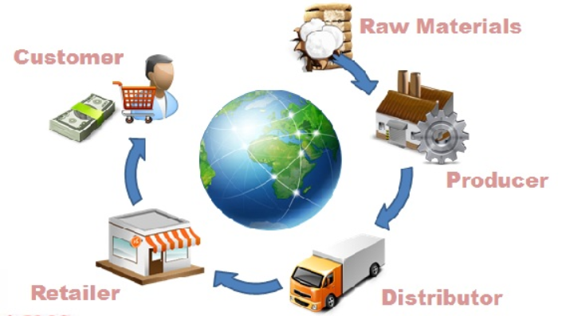

A more complex, or extended, supply chain will likely include a number of suppliers and suppliers' suppliers, a number of customers and customers' customers or final customers and all the organizations that offer the services required to effectively get products to customers, including third-party logistics providers, financial organizations, supply chain software vendors and marketing research providers. These entities also use services from other providers.

The totality of these organizations, which evokes the metaphor of an interrelated web rather than a linear chain, gives insight into why supply chain management is so complex. That complexity also hints at the types of issues that can arise, from demand management issues, such as a release of a new iPhone that chokes demand for old iPhone cases; to natural supply chain disruptions, such as the halt of transportation in the U.S. in 2015 due to extreme winter weather, or California's drought and its effect on crops; to political upheaval, such as the strikes in India that throttled movement at its largest container port.

**The role of supply chain management software**

Technology is critical in managing today's supply chains, and ERP vendors offer modules that focus on relevant areas. There are also business software vendors that focus specifically on SCM. A few important areas to note include:

* Supply chain planning software for activities such as demand management.
* Supply chain execution software for activities such as day-to-day manufacturing operations.
* Supply chain visibility software for tasks such as spotting and anticipating risks and proactively managing them.
* Inventory management software for tasks such as tracking and optimizing inventory levels.
* Logistics management software and transportation management systems for activities such as managing the transport of goods, especially across global supply chains.
* Warehouse management systems for activities related to warehouse operations.

The increasingly global nature of today's supply chains and the rise of e-commerce, with its focus on nearly instant small deliveries straight to consumers, are posing challenges, particularly in the area of logistics and demand planning. A number of strategies such as lean and newer approaches such as demand-driven material requirements planning may prove helpful.

Technology especially big data, predictive analytics, and the internet of things (IoT) technology, supply chain analytics, robotics and autonomous vehicles is also being used to help solve modern challenges, including in the areas of supply chain risk and disruption and supply chain sustainability.

As just two examples, IoT can help with transparency and traceability to help boost food quality and safety by using sensors to monitor the temperature of perishable food while it's in transit. And analytics can help determine where to put smart lockers in densely populated areas to cut the number of single-item deliveries and lower greenhouse gas emissions.

* 1. **Customer Relations Management Systems (CRM)**

Customer relationship management (CRM) is a term that refers to practices, strategies and technologies that companies use to manage and analyze customer interactions and data throughout the customer lifecycle, with the goal of improving customer service relationships and assisting in customer retention and driving sales growth.

CRM systems compile customer data across different channels -- or points of contact between the customer and the company -- which could include the company's website, telephone, live chat, direct mail, marketing materials and social media. CRM systems can also give customer-facing staff detailed information on customers' personal information, purchase history, buying preferences and concerns.

**Components of CRM**

At the most basic level, CRM software consolidates customer information and documents into a single CRM database so business users can more easily access and manage it.

Over time, many additional functions have been added to CRM systems to make them more useful. Some of these functions include recording various customer interactions over email, phone, social media or other channels; depending on system capabilities, automating various workflow automation processes, such as tasks, calendars and alerts; and giving managers the ability to track performance and productivity based on information logged within the system.

**Marketing automation.** CRM tools with marketing automation capabilities can automate repetitive tasks to enhance marketing efforts at different points in the lifecycle. For example, as sales prospects come into the system, it might automatically send the prospects marketing materials, typically via email or social media, with the goal of turning a sales lead into a full-fledged customer.

**Sales force automation.** Sales force automation tools track customer interactions and automate certain business functions of the sales cycle that are necessary to follow leads and attract and obtain new customers.

Contact center automation. Designed to reduce tedious aspects of a contact center agent's job, contact center automation might include prerecorded audio that assists in customer problem-solving and information dissemination. Various software tools that integrate with the agent's desktop tools can handle customer requests in order to cut down on the time of calls and to simplify customer service processes.

Geolocation technology, or location-based services. Some CRM systems include technology that can create geographic marketing campaigns based on customers' physical locations, sometimes integrating with popular location-based GPS apps. Geolocation technology can also be used as a networking or contact management tool in order to find sales prospects based on a location.

* **Workflow automation**. CRM systems help businesses optimize processes by streamlining mundane workloads, enabling employees to focus on creative and more high-level tasks.
* **Lead management**. Sales leads can be tracked through CRM, enabling sales teams to input, track and analyze data for leads in one place.
* **Human resource management**. CRM systems help track employee information, such as contact information, performance reviews and benefits within a company. This enables the human resource department to more effectively manage the internal workforce.
* **Analytics**. Analytics in CRM help create better customer satisfaction rates by analyzing user data and helping create targeted marketing campaigns.
* **AI in CRM**. Artificial intelligence technologies, such as Salesforce Einstein, have been built into CRM platforms to automate repetitive tasks, identify customer buying patterns to predict future customer behaviors and more.

**Types of CRM technology**

The four main vendors of CRM systems are **Salesforce**, **Microsoft**, **SAP** and **Oracle**. Other providers are popular among small- to midmarket businesses, but these four tend to be the choice for large corporations. The types of CRM technology offered are as follows:

**On-premises CRM**. This system puts the onus of administration, control, security and maintenance of the database and information on the company using the CRM software. With this approach, the company purchases licenses upfront instead of buying yearly subscriptions from a cloud CRM provider. The software resides on the company's own servers and the user assumes the cost of any upgrades. It also usually requires a prolonged installation process to fully integrate a company's data. Companies with complex CRM needs might benefit from an on-premises deployment.

**Cloud-based CRM**. With cloud-based CRM -- also known as SaaS (software as a service) or on-demand CRM -- data is stored on an external, remote network that employees can access anytime, anywhere there is an internet connection, sometimes with a third-party service provider overseeing installation and maintenance. The cloud's quick, relatively easy deployment capabilities appeal to companies with limited technological expertise or resources.

Companies might consider cloud CRM as a more cost-effective option. Vendors such as Salesforce charge by the user on a subscription basis and offer the option of monthly or yearly payments.

Data security is a primary concern for companies using cloud-based systems, as the company doesn't physically control the storage and maintenance of its data. If the cloud provider goes out of business or is acquired by another company, an enterprise's data can be compromised or lost. Compatibility issues can also arise when data is initially migrated from a company's internal system to the cloud.

Finally, cost may be a concern, since paying subscription fees for software can be more costly over time than on-premises models. However, one can still use open source CRM. Open source CRM. An Open source CRM system make source code available to the public, enabling companies to make alterations at no cost to the company employing the system. Open source CRM systems also enable the addition and customization of data links on social media channels, assisting companies looking to improve social CRM practices.

Open Source CRM platforms such as OroCRM, SuiteCRM and SugarCRM offer alternatives to the proprietary platforms from Salesforce, Microsoft and other vendors.

Adoption of any of these CRM deployment methods depends on a company's business needs, resources and goals, as each has different costs associated with it.

* 1. **E-commerce, digital markets, digital goods**

Have you ever bought or sold anything over the internet? Or ever used the internet to search for information about your products and services before buying them in a retail store? If so, you’ve participated in e-commerce. By the year 2010, about 133 million Americans at least bought something online, so as many other people did worldwide. Even though most people are still buying goods and services through traditional channels, e-commerce continues to grow rapidly and to change the way many companies do business. In 2010, e-commerce represented about 6 percent of all retail sales in the United States, and continued to grow at 12 percent annually (eMarketer, 2010). Nowadays, most organisations world over have adopted the same methods.

* 1. **E-commerce**

E-commerce refers to the use of the Internet and the Web to transact business. More formally, e-commerce is about digitally enabled commercial transactions between and among organizations and individuals it can also be defined as the buying and selling of goods over the internet. For the most part, this means transactions that occur over the Internet and the Web. Commercial transactions involve the exchange of value (e.g., money) across organizational or individual boundaries in return for products and services.

* + 1. **Types of E-commerce (E-commerce Models)**

Typically, e-commerce business models can be divided into six major types, such as:

* Business-to-Business (B2B)
* Business-to-Consumer (B2C)
* Consumer-to-Consumer (C2C)
* Consumer-to-Business (C2B)
* Business-to-Administration (B2A)
* Consumer-to-Administration (C2A)

**Business-to-Business (B2B):** This kind of eCommerce consists of all the electronic transactions and dealings related to the goods and services. These basically are conducted between companies and include conventional wholesalers and producers dealing with retailers.

**Business-to-Consumer (B2C):** The Business-to-Consumer eCommerce is related to the transactions and relationship between businesses and the end customers. This is mainly to do with the retail eCommerce trade that takes place online. With the inception of the internet, B2C eCommerce has evolved to a great extent. Today, we find scores of electronic shopping sites and virtual stores on the web, that sell myriad products, ranging from computers, fashion items to even necessities.

In this case, the customer has more info about the products in the form of informative content and there is also a chance to buy products at cheaper rates. Most times, quick delivery of the order is also maintained.

**Consumer-to-Consumer (C2C):** This consists of electronic transactions of products and services between two customers. These are mainly conducted through a third party that provides an online platform for these transactions. Sites, where old items are bought and sold, are examples of C2C eCommerce.

**Consumer-to-Business (C2B):** In this, a complete reversal of the selling and buying process takes place. This is very relevant for crowdsourcing projects. In this case, individuals make their items or services and sell them to companies. Some examples are proposals for company site or logo, royalty free photographs, design elements and so on.

**Business-to-Administration (B2A):** In this kind of eCommerce transaction, there are dealings between companies and public administration. It encompasses different services, such as social security, fiscal measures, legal documents, employment and so on.

**Consumer-to-Administration (C2A):** In this eCommerce model, electronic transactions are carried between individuals and public administration. Some examples are distance learning, information sharing, electronic tax filing, and so on.

The main objective of both the B2A and C2A types of eCommerce is to increase flexibility, efficiency, and transparency in public administration.

* + 1. **Advantages of E-commerce**
* Perhaps the greatest benefit of eCommerce is its huge reach and reception across the global market, with minimum investments. It enables sellers to sell to a global audience and also customers to make a global choice. Geographical boundaries and challenges are eradicated drastically reduced.
* Through direct interaction with final customers, this eCommerce process cuts the product distribution chain to a significant extent. A direct and transparent channel between the producer or service provider and the final customer is made. This way products and services that are created cater to the individual preferences of the target audience.
* The process of eCommerce enables sellers to come closer to customers that lead to increased productivity and perfect competition. The customer can also choose between different sellers and buy the most relevant products as per requirements, preferences, and budget. Moreover, customers now have access to virtual stores 24/7.

ECommerce also leads to significant cost reduction. It leads to a significant reduction of transaction costs and accordingly customers also get to buy at a lower rate.

* + 1. **Disadvantages of E-commerce**

ECommerce has its share of disadvantages too, such as:

* It depends strongly on network connectivity and information technology
* There aren’t definite legislations both domestically and internationally to regulate eCommerce transactions
* The whole market culture is not favourable to electronic commerce (for example customers cannot try the products)
* At times, there is a loss of the privacy, culture or economic identity of the customer
* There is a chance of fraudulent financial transactions and loss of sensitive financial information

Nevertheless, the pros overweigh the cons when it comes to eCommerce. With innovative eCommerce processes in vogue, it is expected that these cons will be done away with.

* 1. **Managing knowledge**

Bergeron (2003), defines **knowledge management** as Knowledge Management (KM) is a deliberate, systematic business optimisation strategy that selects, distils, stores, organises, packages, and communicates information essential to the business of a company in a manner that improves employee performance and corporate.

Many organisations have adapted to the knowledge economy by adopting new structures and by creating new roles for managers. The term **knowledge worker** describes a person whose role is based around creating, using, sharing and applying knowledge. The work of a **knowledge engineer** focuses on eliciting knowledge from experts so that it can be recorded and shared with others within the organisation. Knowledge can be thought of as the combined result of a person’s experiences and the information they possess. In general, knowledge can be described as **explicit** or **tacit**.

**Explicit Knowledge**

Explicit knowledge is easily captured and stored within documents and other media. This type of knowledge tends to be highly detailed, formal and systematic. It is often stored in the form of manuals, documents, procedures and database files. From a managerial perspective, the greatest challenge with explicit knowledge is similar to information. It involves ensuring that people have access to what they need; that important knowledge is stored; and that the knowledge is reviewed, updated, or discarded.

**Tacit Knowledge**

Tacit knowledge is characterized by factors such as perceptions, beliefs, values, intuition and experience. Since a great deal of tacit knowledge may be held unconsciously, it is difficult to elicit, describe or record. Knowledge management is involved with collecting (eliciting) knowledge and converting (codifying) it into a form that allows it to be shared across the organisation. A key part of this process involves gathering tacit knowledge and converting it into explicit knowledge. Tacit knowledge is found in: the minds of human stakeholders. It includes cultural beliefs, values, attitudes, mental models, etc. as well as skills, capabilities and expertise (Botha et al 2008). On this site, I will generally limit tacit knowledge to knowledge embodied in people, and refer separately to embedded knowledge (as defined below), whenever making this distinction is relevant.

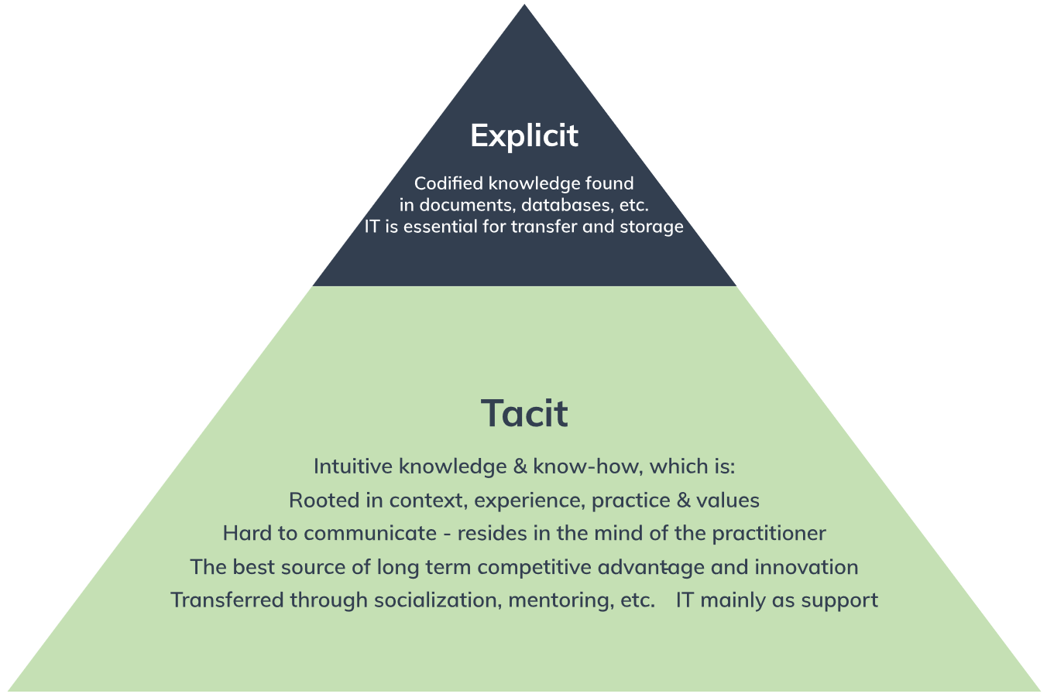

**Figure 11**: Explicit and Tacit Knowledge

**Embedded Knowledge**

Embedded knowledge refers to the knowledge that is locked in processes, products, culture, routines, artifacts, or structures (Horvath 2000, Gamble & Blackwell 2001). Knowledge is embedded either formally, such as through a management initiative to formalize a certain beneficial routine, or informally as the organization uses and applies the other two knowledge types.

The challenges in managing embedded knowledge vary considerably and will often differ from embodied tacit knowledge. Culture and routines can be both difficult to understand and hard to change. Formalized routines on the other hand may be easier to implement and management can actively try to embed the fruits of lessons learned directly into procedures, routines, and products.

Due to the difficulty in effectively managing embedded knowledge, firms that succeed may enjoy a significant competitive advantage. Embedded knowledge is found in: rules, processes, manuals, organizational culture, codes of conduct, ethics, products, etc. It is important to note, that while embedded knowledge can exist in explicit sources (i.e. a rule can be written in a manual), the knowledge itself is not explicit, i.e. it is not immediately apparent why doing something this way is beneficial to the organization.

* 1. **Enhancing decision making**

In today’s dynamic world business organisations have to make a number of decisions every now and then. Managers at all levels know how important decision-making is from the organisational point of view. For example, the R&D department management can decide whether to pursue one or multiple design strategies. That is, should the company introduce one new high-priced stereo system or four complementary systems for each market segment.

Similarly, the production or manufacturing department can also decide whether to manufacture the electrical components or subcontract to other firms. In the same way, the financial manager would decide either to invest in a new plant or to lease. The marketing managers too has to determine the suitable production mix with regard to value and promotion: if several products are manufactured, what should be the price range among different products? Finally, the HR department might also decide to introduce new and different pay scales. None of the above decisions are simple and it is practically impossible for decision makers to take into consideration fully for all of the factors that could influence the outcome of the decision. Hence, the future bordered around uncertainty and risks have to be assumed.

Decision making is an essential part of all marginal activities including organising, leading and controlling. However, it is usually most closely related with the planning function, in as much as it is an important tool for most planning activities. We always ought to make a decision or the other. Managers are faced with a wide range of decisions on a daily basis. For a manager the ability to make the best, reliable and professional decision is the key to success. In the actual fact, management is basically a study of the decision-making process within an organisation.

**Types of Decisions**

There are three types of decisions made by different sections of the organization. Information systems are used to help with these decisions. The tree are Structured made at operation management level, semi-structured made at tactical level and unstructured made and strategic level as summarised in figure 12 below:-

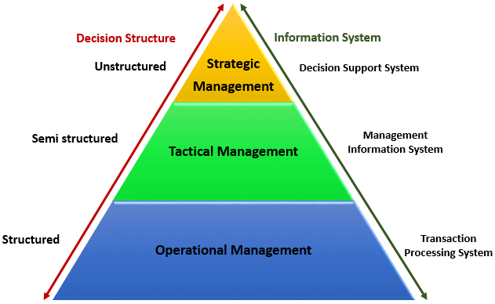

**Figure 12: The three level management decision making pyramid**

**Structured Decisions**

They are well-structured problems are constrained problems with convergent solutions that engage the application of a limited number of rules and principles within well-defined parameters. Structured decisions refer to those situations where a problem is recurring and repetitive, the common factors can be identified in order to identify a particular course of action. Due to which defined set of procedure can be devised for their solution. Hence; Procedures for obtaining the best solution are standardized, objectives are clearly defined and has some clearly specified inputs and outputs

**Un-structured Decisions**

These are problems possess multiple solutions, solution paths, fewer parameters which are less Manipulate able, and contain uncertainty about which concepts, rules, and principles are necessary for the solution or how they are organized and which solution is best. Un-structured decisions are those problems that are non-routine, critical and novel in nature, they require individual judgment, evaluation and insight varying on case-to-case basis. There is no well understood or agreed upon procedure for handling these problems. For such situations, predefined policy cannot be devised. However, once the problem has been figured out, a policy may be devised to handle the problem in future. This can make the problem look like as structured one giving regard to the role of individual judgment.

**Semi-Structured Decisions**

Semi-Structured decisions­ lies between the structured and unstructured range. Here part of the Decision can be specified allowing for certain factors out of control while the others are not. Semi-structured Decisions refer to the grey area of decisions which lie between the two extremes. Some (but not all) structured phases and often solved using standardized solution procedures and human judgment. In small organizations decisions are usually transferred from form top to bottom. In large organizations the decision are usually taken based on meeting of all departmental heads. The fact is that whether decisions are taken by single person or all in a formal meeting is not the sole determinant of a decision being structured or unstructured. Rather it simply shows the complexity of the problem

Three main categories of information systems serve different organizational levels: operational-level systems, management-level systems, and strategic-level systems. Operational-level systems support operational managers by keeping track of the elementary activities and transactions of the organization, such as sales, receipts, cash deposits, payroll, credit decisions, and the flow of materials in a factory. The principal purpose of systems at this level is to answer routine questions and to track the flow of transactions through the organization. How many parts are in inventory? What happened to Mr. Williams’s payment? To answer these kinds of questions, information generally must be easily available, current, and accurate. Examples of operational-level systems include a system to record bank deposits from automatic teller machines or one that tracks the number of hours worked each day by employees on a factory floor.

**Types of information systems**

Organizations can be divided into strategic, management, and operational levels and into four major functional areas: sales and marketing, manufacturing and production, finance and accounting, and human resources. Information systems serve each of these levels and functions.

**Management-level systems** serve the monitoring, controlling, decision-making, and administrative activities of middle managers. The principal question addressed by such systems is this: Are things working well? Management-level systems typically provide periodic reports rather than instant information on operations. An example is a relocation control system that reports on the total moving, house-hunting, and home financing costs for employees in all company divisions, noting wherever actual costs exceed budgets.

Some management-level systems support non-routine decision making. They tend to focus on less-structured decisions for which information requirements are not always clear. These systems often answer “what-if” questions: What would be the impact on production schedules if we were to double sales in the month of December? What would happen to our return on investment if a factory schedule were delayed for six months? Answers to these questions frequently require new data from outside the organization, as well as data from inside that cannot be easily drawn from existing operational-level systems.

**Strategic-level systems** help senior management tackle and address strategic issues and long-term trends, both in the firm and in the external environment. Their principal concern is matching changes in the external environment with existing organizational capability. What will employment levels be in five years? What are the long-term industry cost trends, and where does our firm fit in? What products should we be making in five years?

**Four Major Types of Systems**

Figure 13 shows the specific types of information systems that correspond to each organizational level. The organization has executive support systems (ESS) at the strategic level; management information systems (MIS) and decision-support systems (DSS) at the management level; and transaction processing systems (TPS) at the operational level. Systems at each level in turn are specialized to serve each of the major functional areas. Thus, the typical systems found in organizations are designed to assist workers or managers at each level and in the functions of sales and marketing, manufacturing and production, finance and accounting, and human resources.

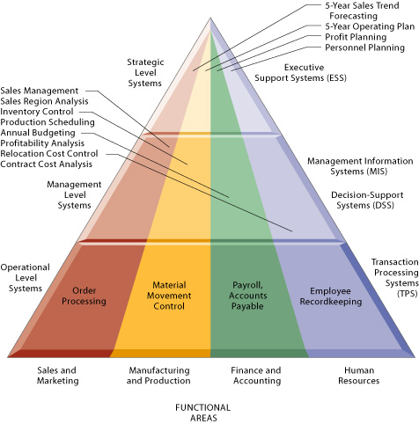

**Figure 13: Functional Areas**

**The four stages of the decision-making process**

* 1. **Intelligence**
* Discovering, identifying, and understanding the problems occurring in the organization
  1. **Design**
* Identifying and exploring solutions to the problem
  1. **Choice**
* Choosing among solution alternatives
  1. **Implementation**
* Making chosen alternative work and continuing to monitor how well solution is working

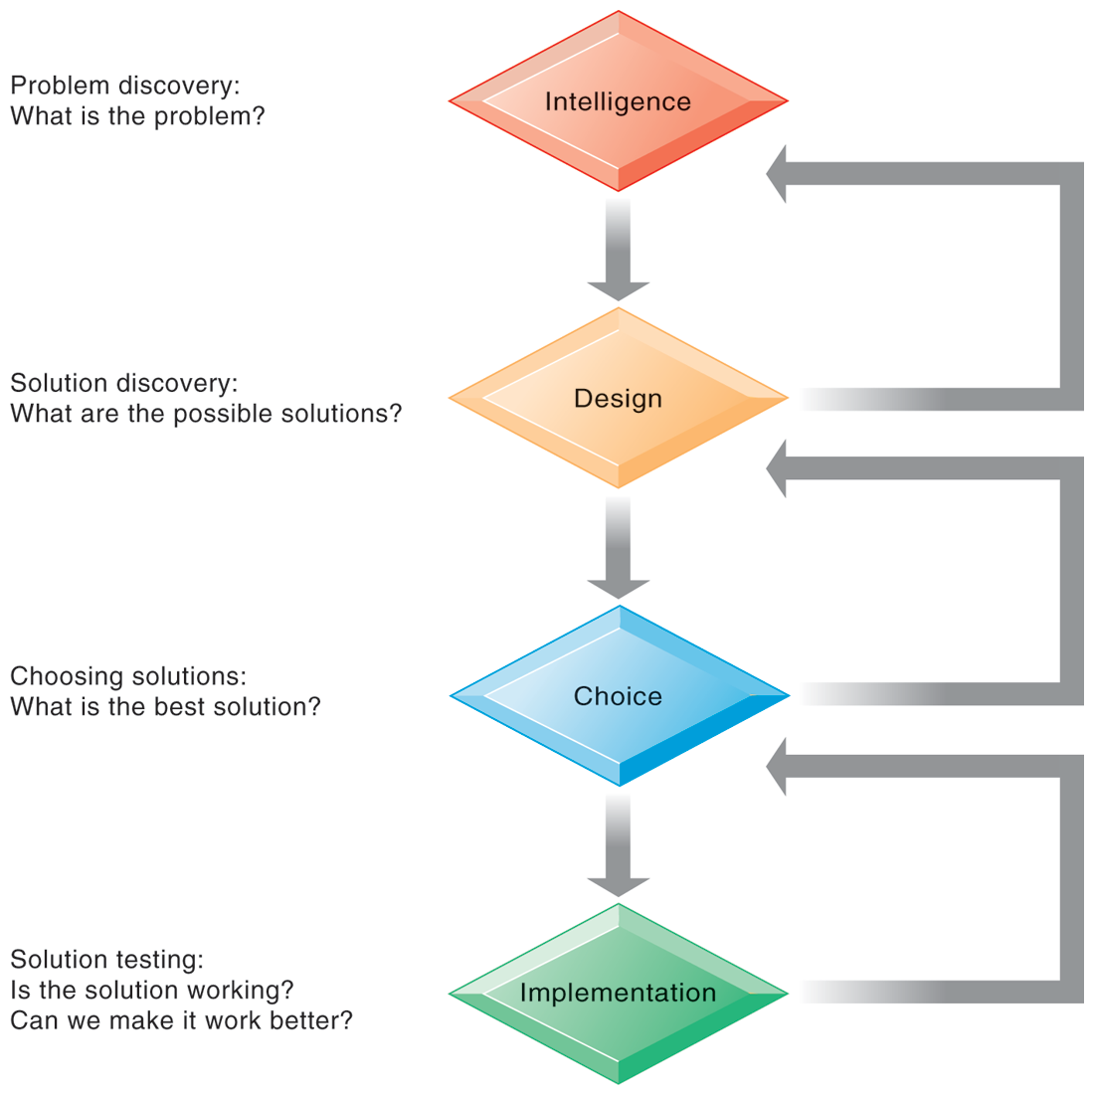

**Figure 14**: **The decision-making process**

|  |  |
| --- | --- |
| Activity 00 | *With the use of a three level management pyramid, explain how decisions are made at each level and the systems used on each.* |
|  | *State and explain the two types of knowledge and how you can manage them* |

**UNIT EIGHT**

**Building and Managing Systems**

* 1. **Introduction**

Systems development is a process used in systems engineering, information systems, and software engineering for planning, creating, testing, and deploying an information system. It involves the process (activity) where organizations introduce new information system, modify or expands an existing one.

* 1. **Learning objectives**

After this chapter, you will be able to understand the following:-

* What information system development is all about?
* The System development life cycle and all the stages involved
* Managing ICT Projects, network analysis and project estimations using different methods
  1. **Information Systems Development**

Information System Development includes sub-activities of analysis, design, development, implementation, and evaluation. Depending on the certain perspective, it can be seen as a software engineering process of a software producer, an application procurement process of a software user.

* 1. **Systems development lifecycle (SDLC)**

Any information systems project follows a logical series of development phases. These are known as the systems development lifecycle. SDLC is the oldest method for building systems, it assumes that system has a life cycle with a beginning, middle, and end structured type of problem solving with distinct stages, activities, and deliverables each stage consists of activities which must be completed before next stage begins.

The stages of SDLC include the following:-

* Initiation stage
* Feasibility study stage
* Analysis of business requirements stage
* Systems design stage
* System building stage
* Implementation stage
* Review and maintenance stage

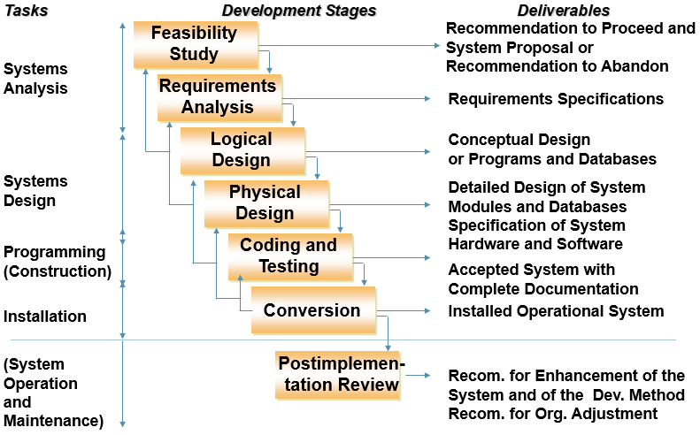

**Figure 15**: **The SDLC Model**

**Systems Analysis**

The Analysis Phase is also the part of the project where you identify the overall direction that the project will take through the creation of the project strategy documents. Gathering requirements is the main attraction of the Analysis Phase. It determine what the system will do (as opposed to how) and involves 2 stages;

1. Feasibility study (preliminary investigation)
2. Requirements Analysis

**Feasibility Study**

An analysis and evaluation of a proposed project to determine if it is technically feasible, feasible within the estimated cost, and its profitability. Feasibility studies usually takes place where huge amounts of funds are at stake. It can also be called feasibility analysis.

The objective of this stage is to establish whether the proposed system is feasible/desirable before resources are committed systems analyst perform a preliminary investigation of the business problem/opportunity takes about 5-10% of project’s resources (time & money). The feasibility study tasks

* Define problem/opportunity
* Establish overall objectives of system
* Identify users of system
* Establish scope of system

The outcome of this activity are the recommendation to proceed or to abandon the project

**Requirement Analysis**

The most important phase of the SDLC is the requirement gathering and analysis phase because this is when the project team begins to understand what the customer wants from the project. During the analysis phase, the project team needs to ensure they can deliver the requirements. Requirements analysis encompasses those tasks that go into determining the needs or conditions to meet for a new or altered product or project, taking account of the possibly conflicting requirements of the various stakeholders, analyzing, documenting, validating and managing software or system requirements. The objectives of this stage is to produce the requirements specifications for the system details about what the system will do. The requirements analysis establishes the following:-

* Outputs of system
* Inputs to system
* Processing steps needed to transform inputs into outputs
* Files and databases needed to store data
* The volumes of data to be handled
* numbers of users
* file and database capacities

**System Design**

The development of a new information system involves several different, but related activities. These activities, or phases, usually include planning, analysis, design, implementation, and maintenance/support. In other words, SDLC is a conceptual model that guides project management in information system development. This stage details how the system will meet the requirements as determined by the systems analysis. Like a blueprint for a house which details all the specifications that give the system its form and structure. The system design looks at the following:-

* Hardware & Software
* Program & Modules
* Specifications of the modules
* Design the Data base
* Design the USER interface
* Develop the system procedures

There are two types of designs:-

1. **Logical design**: A more macro level design, conceptual and its activities include;

* Devising alternative solutions to problem and choosing an alternative user interface design
* Logical/conceptual design of database

1. Physical design: the objective of this design is to produce a complete specification of all system modules and of interfaces between them

to perform the physical design of the database. When the physical design is complete, the following aspects will be specified:

* System outputs (e.g., report layouts, screen designs)
* System inputs
* User interface
* Program design
* Detailed test plan
* Database
* Conversion plan

**Programming**

Upon receiving system design documents, the work is divided in modules/units and actual coding is started. Since, in this phase the code is produced so it is the main focus for the developer. This is the longest phase of the software development life cycle.

**Testing**

After the code is developed it is tested against the requirements to make sure that the product is actually solving the needs addressed and gathered during the requirements phase. During this phase all types of functional testing like unit testing, integration testing, system testing, acceptance testing are done as well as non-functional testing are also done.

**Deployment**

After successful testing the product is delivered / deployed to the customer for their use. As soon as the product is given to the customers they will first do the beta testing. If any changes are required or if any bugs are caught, then they will report it to the engineering team. Once those changes are made or the bugs are fixed then the final deployment will happen.

**Maintenance and Review**

Once when the customers starts using the developed system then the actual problems comes up and needs to be solved from time to time. This process where the care is taken for the developed product is known as maintenance.

* + 1. **Cyclical nature of SDLC**

When an analyst finishes one phase and proceeds to the next, the discovery of a problem may force the analyst to go back to the previous phase.

* + 1. **Limitation of SDLC**

Appropriate for building large transaction processing and management information systems where requirements are highly structured and well-defined also used for complex technical systems (e.g. air traffic control) where formal and rigorous requirements are needed, along with tight controls.

* + 1. **Drawbacks**

1. Resource intensive - takes lots of time to gather detailed information and prepare volumes of specifications
2. Approach is inflexible and inhibits change -

* To make changes/ correct errors - repeat appropriate life cycle activities, but must generate more documents - substantially increase development time and costs
* Encouraged to freeze system specifications early in development process - so changes not encouraged

1. Approach not suited for decision making applications

* Decision making tends to be unstructured;
* Requirements change/uncertain so difficult to specify requirements
  1. **Prototyping**

The Prototyping Model is a systems development method (SDM) in which a prototype (an early approximation of a final system or product) is built, tested, and then reworked as necessary until an acceptable prototype is finally achieved from which the complete system or product can now be developed. It is a process of building an experimental system rapidly and inexpensively for users to evaluate working version of an IS or part of the system preliminary model.

Prototyping much more iterative than SDLC, it promotes design changes that are less formal approach than SDLC and quickly generate working model of system with no detailed specifications

**Steps in prototyping**

1. Identify users’ basic requirementsdesigner works with user only long enough to capture basic needs
2. Develop working prototypedesigner creates prototype quickly
3. Use prototype: user works with prototype to determine how well it meets his/her needs and suggests improvements
4. Revise and enhance prototypedesigner refines prototype based on users’ inputrepeat steps 3-4 until user satisfied

Approved prototype becomes basis for final specifications of the system more rapid, iterative and informal than SDLC

**Advantages of Prototyping**

* Useful when uncertainty about information requirements or design solutionse.g. requirements for decision-oriented systems can be vague -- difficult to specify.
* Good for design of user interface (part of system that end-users interact with)
* Encourages user involvement throughout systems development

**Disadvantages of Prototyping**

* should not substitute for careful requirements analysis better suited for smaller applications
  1. **Outsourcing**

Outsourcing is a business practice in which a company hires another company or an individual to perform tasks, handle operations or provide services that are either usually executed or had previously been done by the company's own employees.

**Advantages of Outsourcing**

* Economy - less costly
* Service quality - may get better service than from internal development
* Predictability - outsourcing contract with fixed price
* Flexibility - growth without making major changes in IT infrastructure
* making fixed costs variable - pay only for amount of services used rather than for maintaining internal system
* freeing human resources for other projects
* freeing financial capital - can sell technology to vendor

**Disadvantages of Outsourcing**

* Loss of control over IS function
* Vulnerability of strategic information - trade secrets, proprietary information
* Dependency on viability of vender - i.e. financial, quality of services provided
* Loss of knowledge and expertise
  1. **Managing projects**

Projects are unique, temporary or one-time operations designed to accomplish a specific set of objectives in a limited timeframe. A project is said to be unique in that it is not a routine operation, but a specific set of operations designed to accomplish a singular goal. So a project team often includes people who don’t usually work together sometimes from different organizations and across multiple geographies.

The development of software for an improved business process, the construction of a building or bridge, the relief effort after a natural disaster, the expansion of sales into a new geographic market all are projects. All projects are expected to be expertly managed and be delivered on time, according to the budget, learning and integration that organizations need.

**Project Management**

Project management, then, is the application of knowledge, skills, tools, and techniques to project activities to meet the project requirements. Project management processes fall into five groups: Initiating, Planning, Executing, Monitoring and Controlling and Closing stages.

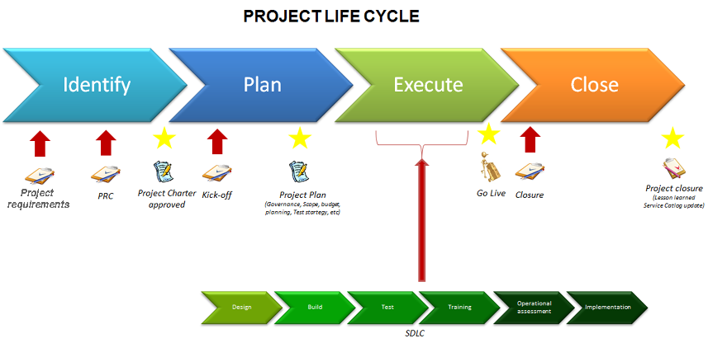

**Three key elements of project management**

The three key elements of project management is referred to as the triple constraints. The triple constraint is explained using a model of the constraints inherent in managing a project. Those constraints are:

1. **Cost:** The financial constraints of a project, also known as the project budget
2. **Scope:** The tasks required to fulfill the project’s goals
3. **Time:** The schedule for the project to reach completion

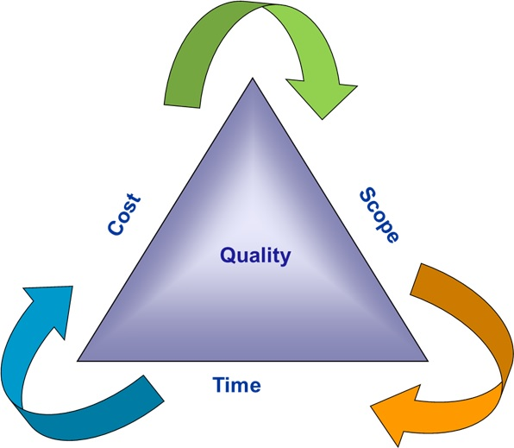

**Figure 00:**The triple constraint of project management

Basically, the Triple Constraint states that the success of the project is impacted by its budget, deadlines and features. As a manager of that project, you can trade between these three constraints; however, changing the constraints of one means that the other two will suffer to some extent (PMI, 2008).

While it’s true that the Triple Constraint is an important part of any successful project, it doesn’t determine success. Projects are made from many parts, more than the three, albeit major ones, that make up the Triple Constraint. Sometimes you can’t play around with the Triple Constraint, but those three factors are always at play in the project (ibid).

Think of the Triple Constraint as the boundaries in which you can work. Just as restrictions enhance creativity, the Triple Constraint provides a framework that everyone in the project can agree on. These metrics drive the project forward while allowing for adjustments as needed when issues arise (op.cit).

Managing a project is often a series of trade-offs and compromises to keep things moving towards a successful completion. The Triple Constraint is a model that helps managers know what trade-offs are going to work and what impact they’ll have on other aspects of the project.

The Triple Constraint appears simple, but that’s only on the surface. Each of the three points of this triangle can be unpacked to reveal deeper meaning.

**Cost**

The financial commitment of the project is dependent on several variables. There are the resources involved, from materials to people, which include labor costs. There are other outside forces that can impact a project, which must be considered in the cost of the work (PMI, 2008).

There are also the fixed and variable costs inherent in any project, such as the economic cost of teams with varying skills and productivity, which must be calculated. This can seriously come into play with the use of contract workers or outsourcing.

Cost processes include cost estimating to figure out the needed financial commitment for all resources necessary to complete the job. Cost budgeting creates a cost baseline. [Cost control](https://www.projectmanager.com/training/basics-project-cost-management) works to manage the fluctuation of costs throughout the project.

**Scope**

As mentioned, [project scope](https://www.projectmanager.com/blog/project-scope) deals with the specific requirements or tasks necessary to complete the project. Scope is important to manage on any project, whether agile software projects or well-planned waterfall projects, because if you can’t control the scope of the project, you’re not likely to deliver it on time or under budget (PMI, 2008).

When managing scope it is critical that you [prioritize your tasks](https://www.projectmanager.com/software/task-management), enabling you to plan and assign resources effectively. Without creating a sense of order, it’s easy to become overwhelmed, enabling scope creep. Make sure that you knock out prerequisite tasks so your project can develop smoothly without hangups.

Another key factor in managing and establishing scope is handling stakeholder expectations. Stakeholders can often have new demands that popup during a project, and you need to be able to assuage their expectations. This can especially be the case in long term projects where there might be new stakeholders introduced in the middle of the project.

**Time**

At its basic, the schedule is the estimated amount of time allotted to complete the project, or producing the deliverable. Usually, this is figured out by first noting all the tasks necessary to move from the start to the finish of the project.

A Work Breakdown Structure (WBS) is used to take the large project goal and break it down into a series of more manageable tasks. These tasks are then prioritized, dependencies are linked, and then placed on a timeline.

A [Gantt chart](https://www.projectmanager.com/software/gantt-chart) is one way to visualize the project schedule, with each task a point on that timeline, with task dependencies linked, and durations determined. Having historic data can help make more accurate estimates.

**Why do projects fail?**

Lyytinen and Hirscheim (1984) researched the reasons for information systems projects failing. They identified five broad areas which still hold true today:

* Technical failure stemming from poor technical quality, this is the responsibility of the organisation’s IS function.
* Data failure due to (a) poor data design, processing errors and poor data management and (b) poor user procedures and poor data quality control at the input stage.
* Responsibility for the former lies with the IS function, while that for the latter lies with the end-users themselves.
* **User failure** to use the system to its maximum capability – may be due to an unwillingness to train staff or user management failure to allow their staff full involvement in the systems development process.
* **Organisational failure**, where an individual system may work in its own right but fails to meet organisational needs as a whole (e.g. while a system might offer satisfactory operational information, it fails to provide usable management information). This results from the senior management’s failure to align IS to overall organisational needs.
* **Failure in the business environment** – this can stem from systems that are inappropriate to the market environment, failure in IS not being adaptable to a changing business environment (often rapid change occurs), or a system not coping with the volume and speed of the underlying business transactions.

**Project Organisation**

**Project sponsor**:The project sponsor’s role is to provide a justification of the project to senior management.

**Project manager**:Appointed by the project sponsor the project manager’s role is to provide day-to-day management and ensure that the *project* objectives are met.

**Project user**: The project user is the person or group of people who will be utilising the outcome of the information systems project.

**Quality manager**: This role involves defining a plan containing procedures that ensure quality targets are met.

**Risk manager**: All projects contain some risk that the investment made will not achieve the required business objectives.

**Project management process**

The project process includes the following main management elements:

* + Estimate
  + Schedule/plan
  + Monitoring and control
  + Documentation.

**Project estimation**

Estimation allows the project manager to plan for the resources required for project execution through establishing the number and size of tasks that need to be completed in the project.

**Project constraints:**

Projects can be resource-constrained (limited by the type of people, monetary or hardware resources available) or time-constrained (limited by the deadline).

**Work breakdown structure (WBS):**

This is a breakdown of the project or a piece of work into its component parts (tasks).

**Work breakdown structure (WBS) for an accounting system**

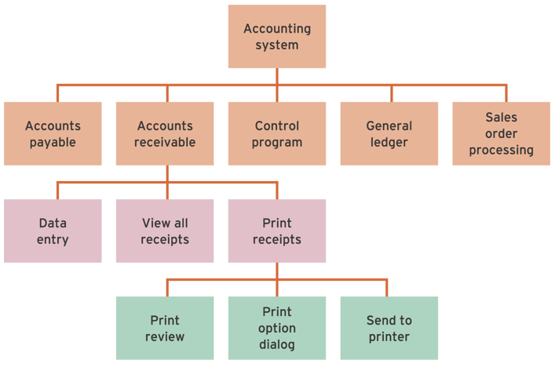

**Calculating Effort and elapsed time**

* Effort time is the total amount of work that needs to occur to complete a task.
* The elapsed time indicates how long in time (such   
  as calendar days) the task will take (duration).

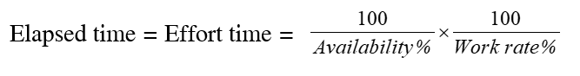

* Estimate effort time for an average person to undertake the task.
* Estimate different work rates and availability of staff.
* Allocate resources (staff) to task.
* Calculate elapsed time on the basis of the number of staff, availability and work rate.
* Schedule tasks in relation to other tasks.

**COCOMO**

* Constructive cost model (COCOMO):
* A model used to estimate the amount of effort required to complete a project on the basis of the estimated number of lines of program code



Where:

* + *WM* = number of person months
  + *C* = one of three constant values dependent on development mode
  + *KDSI* = delivered source lines of code × 1000
  + *K* = one of three constant values dependent on development mode
  + *EAF* = effort adjustment factor.

**Function point analysis**

* A method of estimating the time it will take to build a system by counting up the number of functions and data inputs and outputs and then comparing these two completed projects.
* The five user function categories are as follows:
  + number of external input types;
  + number of external output types;
  + number of logical internal file types;
  + number of external interface file types;
  + External enquiry types.

**Scheduling**:

* Scheduling involves determining when project activities should be executed.
* The finished schedule is termed the project plan.

**Resource allocation**:

* This activity involves assigning a resource to each task.

**Monitoring and control:**

* Monitoring involves ensuring the project is working to plan once it is started. Control is taking corrective action if the project deviates from the plan.

**PRINCE2**

* PRINCE2: A process-based project management methodology for effective IS project. the PRINCE2 methodology says that a project should have the following:
  + An organised and controlled start, i.e. organise and plan things properly before leaping in
  + An organised and controlled middle, i.e. when the project has started, make sure it continues to be organised and controlled
  + An organised and controlled end, i.e. when you’ve got what you want and the project has finished, tidy up the loose ends.

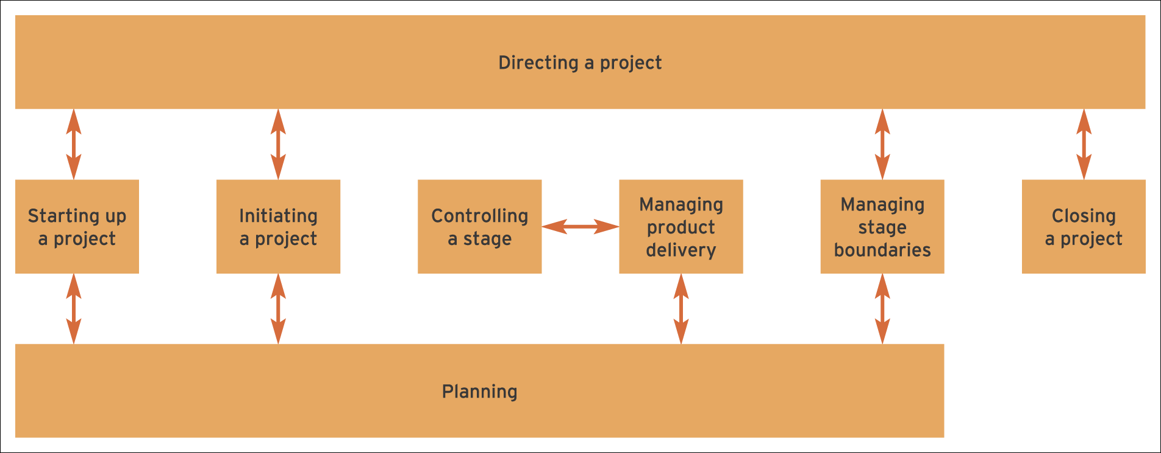

Figure XX PRINCE2 Process Model

**Network analysis**

Critical path diagrams are used extensively during scheduling and monitoring to show the planned activities of a project and the dependencies between these activities. **Critical path**: Activities on the critical path are termed critical activities. Any delay in these activities will cause a delay in the project completion time. **Critical path method (CPM):** Critical path diagrams show the relationship between activities in a project.

**Activity on node**

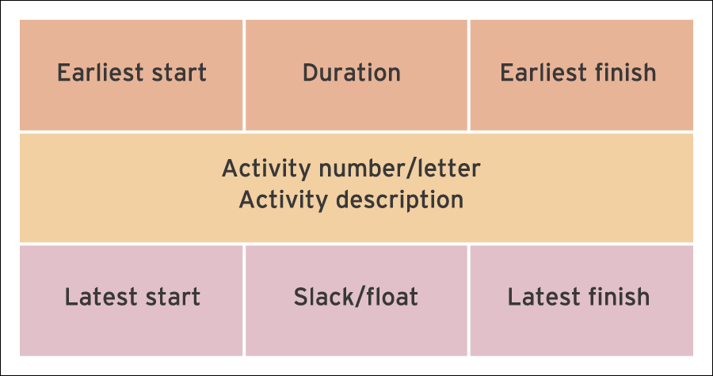

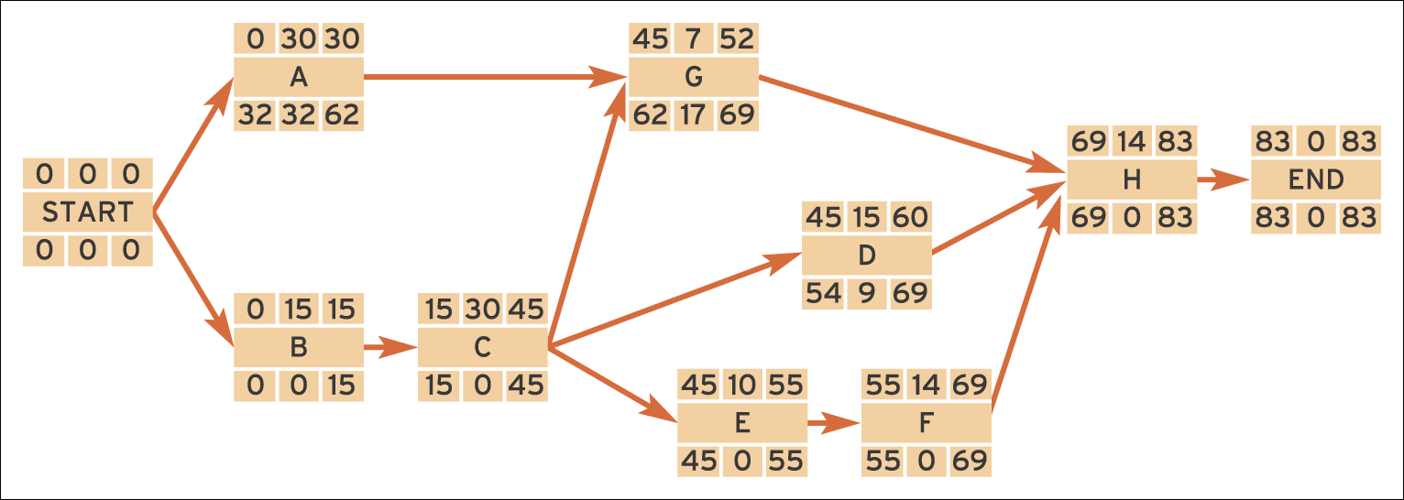

**Creating a Network Diagram Step-by-Step**

Predecessor Relationships for Your Picnic

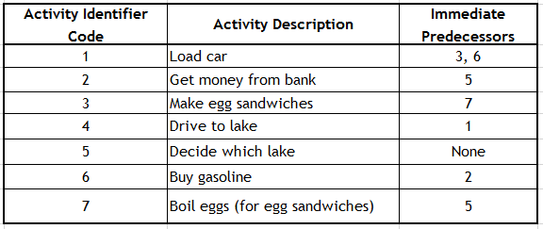

1. Begin your project with a single milestone and label it *Start.*
2. Find all activities in the table that have no immediate predecessors — they can all start as soon as you begin your project.

* **In this case, only Activity 5 has no immediate predecessors.**

1. Begin your diagram by drawing the relationship between the Start of your project and the beginning of Activity 5.

**Depict Activity 5 with a box and draw an arrow to it from the Start box.**

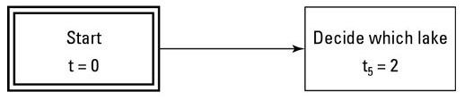



1. Find all activities that have your first activity as an immediate predecessor.

**Activities 2 and 7 have Activity 5 as an immediate predecessor.**

**Draw boxes to represent these two activities, and draw arrows from Activity 5 to Activities 2 and 7.**

5. Continue in the same way with the remaining activities.

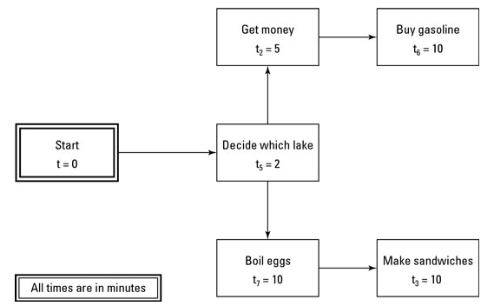

* Only Activity 6 has Activity 2 as an immediate predecessor.
* Draw a box to represent Activity 6 and draw an arrow from Activity 2 to that box.
* Only Activity 3 has Activity 7 as an immediate predecessor. So draw a box to represent Activity 3, and draw an arrow from Activity 7 to Activity 3.
* Now realize that Activity 1 has both Activities 3 and 6 as immediate predecessors.
* Therefore, draw a box representing Activity 1 and draw arrows from Activities 3 and 6 to this box.
* The rest is pretty straightforward. Because only Activity 4 has Activity 1 as its immediate predecessor, draw a box representing Activity 4 and draw an arrow from Activity 1 to Activity 4.

6. After adding all the activities to the diagram, draw a box to represent *End,* and draw an arrow from Activity 4 (the last activity you have to complete) to that box.

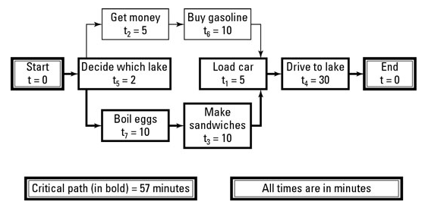

**Completed picnic-at-the-lake network diagram.**

Now for an important timing-related question.

**Q. How long will you and your friend take to get to the lake for your picnic?**

The upper path (*Start*, Activities 5,2, 6, 1, 4, and *End*) takes 52 minutes to complete.

The lower path (*Start,* Activities 5, 7, 3, 1, 4, and *End*) takes 57 minutes to complete.

* **Thus, it will take 57 minutes from the time you start until you arrive at the lake for your picnic, and the lower path is the critical path.**

**How to Draw a PERT Chart**

* Using the ***forward pass method***, you can determine the ***earliest possible dates***for each milestone. To use the forward pass method, you start by writing a 0 (as in, “day 0”) on the first node (in our example, node 1).
* Then proceed from left to right through each path, adding up the duration of each activity and writing the milestone dates on each node.
* Milestones can have multiple dates at this point, if they are part of multiple paths.
* Once you get to the right side, you go back through the chart and choose only the highest date for each milestone (node) and discard the others.
* Using the ***backward pass method***, you can determine the ***latest possible date*** for each milestone.
* Just like the forward pass, but opposite, you start on the right, using the highest date on the last milestone (the completion date).
* Proceed through each possible path and write each date on the nodes by subtracting the activity durations.
* Then choose only the lowest date for each milestone and discard the rest.  These are the latest possible dates of the milestones.
* For each milestone, you can subtract the earliest possible date from the latest possible date to get the float. This is the amount of play that each activity has before it affects the critical path.

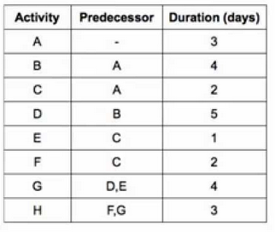

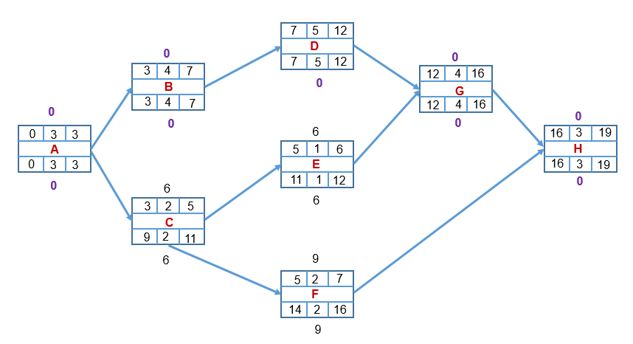

|  |  |
| --- | --- |
| **Activity 00** | *What is the triple constraint of project management and how do you balance them in a project?* |
|  | *Explain what SDLC is and all the stages involved* |
|  |  |

**UNIT NINE**

**Securing Information System**

* 1. **Introduction**

Information Systems security is one of the biggest challenges facing organisations and the society at large in this technological age. Technology have become an integral part of everyday life in the home, businesses, government, and organizations. Information Systems have changed the way that people live their lives, conduct business, even run the government. As a result, Information Systems have become a very important aspect of everyday life because there are many uses of Information Systems that make it much easier and faster to perform certain tasks, or even to perform certain tasks simultaneously.

* + **Learning outcomes**

By the end of this chapter, you will be able to understand the following:-

* What security is and the need for information security
* Why are information systems so vulnerable?
* What special measures must be taken to ensure the reliability, availability, and security of systems data and information?
* Understand the threats posed to information security and the more common attacks associated with those threats.
* Malware and computer viruses
  + **Information System Security**

In information System Security, is the defense of digital information and ICT assets against internal and external, malicious and accidental threats. This defense includes detection, prevention and response to threats through the use of security policies, software tools and ICT services.

The protection of information and information systems against unauthorized access or modification of information, whether in storage, processing, or transit, and against denial of service to authorized users.

Information security includes those measures necessary to detect, document, and counter such threats. Information security is composed of computer security and communications security.

It involves safe-guarding an organization's data from unauthorized access or modification to ensure its, **Confidentiality**, I**ntegrity** and **Availability** (CIA). The CIA is referred to as a triple trait in security

* + **Information System Security as a process**

Effective Information Security incorporates security products, technologies, policies and procedures. No collection of products alone can solve every Information Security issue faced by an organization.

More than just a set of technologies and reliance on proven industry practices is required, although both are important. Products, such as firewalls, intrusion detection systems, and vulnerability scanners alone are not sufficient to provide effective Information Security.

* + **IS Security Policy and Procedure documents**

An information system security policy is a well-defined and documented set of guidelines that describes how an organization manages, protects its information assets and makes future decisions about its information systems security infrastructure. On the other hand, a security procedures document accurately outlines how to accomplish a specific task.

**Example**

A policy may specify that antivirus software be updated on a daily basis, and a procedure will state exactly how this is to be done by providing a list of steps.

* + **Responsibility of IS Security**

Although some individuals may have “Security” in their title or may deal directly with security on a daily basis, security is everyone’s responsibility. Despite the robustness of a firewall, if a single user has hardware (e.g. a modem) or software (e.g. some File sharing software) that allows bypassing the firewall, a hacker may gain access with catastrophic results.

Security is an issue during an application’s entire lifecycle. Applications must be designed to be secure, they must be developed with security issues in mind, and they must be deployed securely. Security cannot be an afterthought and be effective. System analysts, architects, and programmers must all understand the Information Security issues and techniques that are relevant to their work.

* End user awareness is critical, as hackers often directly target them.
* Users should be familiar with Security Policies and should know where the most recent copies can be obtained.
* Users must know what is expected and required of them.
* Typically this information should be imparted to users initially as part of the new hire process and refreshed as needed.
  + 1. **Causes of Information Risks**

**Human error:**

* e.g. entering incorrect transactions; failing to spot and correct errors; processing the wrong information; accidentally deleting data

**Technical errors:**

* e.g. hardware that fails or software that crashes during transaction processing a*ccidents and disasters*: e.g. floods, fire

**Fraud**

* Deliberate attempts to corrupt or amend previously legitimate data and information

**Commercial espionage:**

* E.g. competitors deliberately gaining access to commercially-sensitive data such as customer details; pricing and profit margin data, designs.

**Malicious damage:**

* Where an employee or other person deliberately sets out to destroy or damage data and systems for example hackers and creators of viruses.
  + 1. **Common Threats in Information Systems**

1. **Accidents**

* ***Inaccurate data entry***. As an example, consider a typical relational database management system, where **update queries** are used to change records, tables and reports. If the contents of the query are incorrect, errors might be produced within all of the data manipulated by the query. Although extreme, significant problems might be caused by adding or removing even a single character to a query.
* ***Attempts to carry out tasks beyond the ability of the employee***. In smaller computer-based information systems, a common cause of accidental damage involves users attempting to install new hardware items or software applications. In the case of software applications, existing data may be lost when the program is installed or the program may fail to operate as expected.
* ***Failure to comply with procedures for the use of organisational information systems*.** Where organisational procedures are unclear or fail to anticipate potential problems, users may often ignore established methods, act on their own initiative or perform tasks incorrectly.
* ***Failure to carry out backup procedures or verify data backups*.** In addition to carrying out regular backups of important business data, it is also necessary to verify that any backup copies made are accurate and free from errors.
* ***Update query***: Used to change records, tables and reports held in a database management system.

1. **Natural disasters**

* All information systems are susceptible to damage caused by natural phenomena, such as storms, lightning strikes, floods and earthquakes.
* In Japan and the United States, for example, great care is taken to protect critical information systems from the effects of earthquakes.
* Although such hazards are of less concern in much   
  of Europe, properly designed systems will make allowances for unexpected natural disasters.

1. **Sabotage (industrial and individual)**

* Deliberate deletion of data or applications
  1. **Logic bomb**: Sometimes also known as a time bomb, a logic bomb is a destructive computer program that activates at a certain time or in reaction to a specific event.
  2. **Back door**: A section of program code that allows a user to circumvent security procedures in order to gain full access to an information system.
  3. **Data theft**: This can involve stealing sensitive information or making unauthorised changes to computer records.
* Accidental deletion

1. **Unauthorised use (hacking)**

* ***Hacker***: Hackers are often described as individuals who seek to break into systems as a test of their abilities. Few hackers attempt to cause damage to systems they access and few are interested in gaining any sort of financial profit.

1. **Malware and computer viruses.**

**Malware**, or malicious software, is any program or file that is harmful to a computer user. **Malware** includes computer viruses, worms, Trojan horses and spyware. Malware includes the following:

* Computer viruses
* Trojans and key loggers
* Spyware.

A **virus** is a type of malware or a small infectious agent that replicates only inside the living cells of other organisms. **Viruses** can infect all types of life forms, from animals and plants to microorganisms, including bacteria and archaea. It is a computer program that is capable of self-replication, allowing it to spread from one ‘infected’ machine to another.

The origin of the term **computer virus** is credited to Fred Cohen, author of the 1984 book *Computer Viruses: Theories and Experiments*. However, ‘natural’ computer viruses were reported as early as 1974 and papers describing mathematical models of the theory of epidemics were published in the early 1950s.

A **keylogger** is just as it sounds: a program that logs keystrokes. The danger of having a keylogger virus on your computer is that it can very easily keep track of *every single keystroke* you enter through your keyboard, and this includes every password and username.

What's more, is that a ***Trojan***keylogger is installed along with a regular program. Trojan horse viruses are malicious programs that don't actually look dangerous. They are attached to a regular, sometimes functioning program so that it doesn't seem like anything nefarious is installed to your computer.

**Trojan keyloggers** are sometimes called keystroke [malware](https://www.lifewire.com/what-is-malware-2625933), keylogger viruses, and Trojan horse keyloggers.

**Spyware** is unwanted software that infiltrates your computing device, stealing your internet usage data and sensitive information. Spyware is classified as a type of malware (malicious software) designed to gain access to or damage your computer, often without your knowledge.

**Worm**: A small program that moves through a computer system randomly changing or overwriting pieces of data as it moves.

**Virus security measures**

* Unauthorised access to machines and software should be restricted as far as possible.
* Machines and software should be checked regularly with a virus detection program.
* All new disks and any software originating from an outside source should be checked with a virus detection program before use.
* Regular backups of data and program files must be made in order to minimize the damage caused if a virus infects the system.

**Internet-related threats**

* **Denial of service (DoS):** This is a form of attack on company information systems that involves flooding the company's Internet servers with huge amounts of traffic. Such attacks effectively halt all of the company’s Internet activities until the problem is dealt with.
* **Brand abuse:** This describes a wide range of activities, ranging from the sale of counterfeit goods (e.g. software applications) to exploiting a well-known brand name for commercial gain.
* **Cybersquatting**: The act of registering an Internet domain with the intention   
  of selling it for profit to an interested party. As an example, the name of a celebrity might be registered and then offered for sale at an extremely high price.
* **Cyberstalking**: This refers to the use of the Internet as a means of harassing another individual. A related activity is known as corporate stalking, where an organisation uses its resources to harass individuals or business competitors.
* **Cyberterrorism**: This describes attacks made on information systems that   
  are motivated by political or religious beliefs.
* **Online stock fraud:** Most online stock fraud involves posting false information to the Internet in order to increase or decrease the values of stocks.
* **Social engineering:** This involves tricking people into providing information that can be used to gain access to a computer system.
* **Phishing:** A relatively new development, phishing involves attempting to gather confidential information through fake e-mail messages and web sites.

**Managing Internet threats**

A range of software applications are now available to assist other methods of managing threats:

* **Firewalls** – software to prevent unauthorised access to the company
* **Intrusion detection software** – monitors network to identify intruders

There is no such thing as fail-safe security for information systems. When designing security controls, a business needs to address the following factors.

**Prevention**

What can be done to prevent security accidents, errors and breaches? Physical security controls are a key part of prevention techniques, as are controls designing to ensure the integrity of data.

**Detection**

Spotting when things have gone wrong is crucial; detection needs to be done as soon as possible - particularly if the information is commercially sensitive. Detection controls are often combined with prevention controls (e.g. a log of all attempts to achieve unauthorised access to a network).

**Deterrence**

Deterrence controls are about discouraging potential security breaches.

**Data recovery**

If something goes wrong (e.g. data is corrupted or hardware breaks down) it is important to be able to recover lost data and information.

**Backup**

Refers to the copying and archiving of computer data so it may be used to restore the original after a data loss event.

**Data encryption**

Translation of data into another form, or code, so that only people with access to a secret key (formally called a decryption key) or password can read it.

**Frequency change of password**

Change passwords frequently in order to ensure the security of your computer account. Failure to this leads to it getting familiar and eventually lead to its compromise.

* + 1. **Benefits of Information Security**

Managing information security is often viewed as a headache by management. It is often perceived as adding costs to a business by focusing on negatives, that is, what might go wrong. However, there are many potential business benefits from getting information system security right:

* If systems are more up-to-date and secure - they are also more likely to be accurate and efficient
* Security can be used to "differentiate" a business – it helps build confidence with customers and suppliers
* Better information systems can increase the capacity of a business. For example, adding secure transaction controls.
* online ordering to a web site can boost sales enabling customers to buy 24 hours a day, 7 days a week
* By managing risk more effectively – a business can cut down on losses and potential legal liabilities

|  |  |
| --- | --- |
| **Activity** |  |
|  | *Mention some common threats in information systems* |
|  | *Explain the terms Malware and Computer Viruses and explain their difference* |
|  | *State and explain 5 online threats to information systems* |
|  | *Explain some prevention measures to put in place against internet attacks* |

**References**

Bocij. P., Greasley. A., &Hickie. S., (2015) Business Information Systems. *Technology, Development and Management of E-Business, 5th Edition*, Pearson Education Limited, New York. USA.

French C. S. (2003). Computer Science. 5th Edition. Continuum International Publishing Group: London

John Ward & Joe Peppard (2002), Strategic Planning for Information Systems, 3rd Edition. John Wiley & Sons Ltd, Chichester, South-west, England.

Kenneth C. Laudon .K. C & Laudon J.P., (2014), Management Information Systems Managing the Digital Firm, 13th Edition, Pearson Education Limited, Edinburgh Gate, Harlow, Essex CM20 2JE, England.

Laudon C. K. and Laudon P. J. (2014). Management Information Systems: Managing the Digital Firm, 13th Edition, Prentice Hall, Cloth.

Lyytinen, K., &Lehtinen, E., (1984). On information modeling through illocutionary logic*. In Report of the 3rd Scandinavian Research seminar on Information Modeling and Data Base Management*. Tampere, Finland.

**Oliver E. C. and Chapman R. J. (1990). Data Processing and Information Technology. 8th Edition. Letts Educational: London.**

Phiri, W. (2016). Research Based ICT Education. Lusaka; MP Publishers

PMI (2008), a guide to the project management body of knowledge (PMBOK GUIDE) 4th Edition, 14 Campus Blvd, Newtown, PA 19073-3299 USA.