  Chalimbana University | ecs 4100

ECS 4100: CURRICULUM STUDIES
SECOND EDITION 2021

AUTHORS: Chalimbana University
Chipanama Leah School of Early Childhood Studies
MaibaRosta Department of Early Childhood Education

Copyright

© 2018 Chalimbana University – First Edition
All rights reserved.

No part of this publication may be reproduced, stored in retrieval system or transmitted in any form by any means electronic, mechanical, photocopying or otherwise, without prior written permission of Chalimbana University.

Chalimbana University
School of Early Childhood Studies
Department of Early Childhood Education
Private Bag E 1
Chongwe
Lusaka
Zambia
Cell: +260977485465
E-mail: ece@chau.edu.zm
Website: www.chau.ac.zm/
Acknowledgements
Chalimbana University, Directorate of Distance Education wishes to thank the persons named below for producing this module:
Chipanama Leah
MaibaRostaMpande
VVOB Education for Development

Table of Content
About this Module 1
How this module is structured 1
Course overview 5
Welcome to ECCS 4101 Curriculum Studies 5
ECCS 4101 Curriculum Studies 5
Is this course for you? 5
Course outcomes 6
Timeframe 6
Study skills 7
Need help? 8
Assignments 9
Assessments 9
Getting around this Module 11
Margin icons 11
Unit 1 13
INTRODUCTION TO CURRICULUM STUDIES 13
Introduction 13
Definition of curriculum 14
Curriculum content in early childhood…………………………………………..15
Concepts of curriculum 15
Importance of curriculum studies in early childhood 16
Principles of early learning 18
Activity 18
Reflection 19
Unit summary 20
Unit 2 21
CURRICULUM DESIGN 21
Introduction 21
 21
Terminology 21
Curriculum design in early childhood 22
Elements/components of curriculum design in early childhood 23
Characteristics/ features of the curriculum 25
The syllabus in early childhood 26
Activity 28
Reflection 28
Unit summary 29
Unit 3 30
CURRICULUM DEVELOPMENT MODELS 30
Introduction 30
THE MEANING OF CURRICULUM DEVELOPMENT MODELS 31
Step 1 Stating Objectives 33
Step 3. Organizing Learning Experiences 33
33
Step 4. Evaluation 33
The weaknesses of the model 33
• Ralph Tyler’s model evaluation was at the end, this means that even if there were some mistakes that were made at some stages they would not be corrected. 33
Elements/components of the curriculum 37
The process of curriculum development 38
Principles of Curriculum Development in ECE. 39
Activity 40
Reflection 40
Unit summary 41
Unit 4 42
CURRICULUM IMPLEMENTATION AND EVALUATION 42
Introduction 42
CURRICULUM EVALUATION 44
Curriculum Implementation 45
Curriculum Change 46
Activity 48
Reflection 48
Unit summary 49
Unit 5 51
SUPERVISION AND MONITORING 51
Introduction 51
STANDARDS EVALUATION AND SUPERVISION 52
WHO IS A STANDARDS OFFICER? 54
WHO IS A SUPERVISOR? 55
PURPOSE OF STANDARDS OFFICER 57
Activity 58
Reflection 58
Unit summary 59
Unit 6 60
PLANNING AND DESIGNING A CURRICULUM FOR LEARNING THROUGH PLAY 60
Introduction 60
Planning for effective teaching and learning 61
Effective Early Learning 62
Creating effective Learning Contexts 65
Outdoor Learning and indoor learning 66
General Considerations for Outdoor Learning Areas 67
Creating Effective Schedules 68
Making visual Schedules 69
Effective Learning Involves Careful Planning 70
Indoor/Outdoor Play-Based Centers 70
Flexible Groupings 71
Effective Classroom Management 73
Addressing unacceptable behaviours 73
Activity 74
Reflection 75
Unit summary 75
Unit 7 76
Designing High Quality Centers for Learning 76
Introduction 76
Importance of curriculum design 77
Children enjoy learning and playing, do you think play methods should be included in the curriculum? 78
Activity 79
Flexible groupings 80
The Benefits of Flexible Grouping 80
Activity 82
Reflection 82
Unit summary 82
Unit 8 84
Play and Pretending 84
Introduction 84
Classroom designs 85
The Learning Environment 85
Play and pretending 86
Play circles 87
Importance of Play 88
Promoting play 89
Play and friendships 90
Importance of socio-dramatic play 92
Sequential development of symbolic play representations 92
Activity 93
Reflection 93
Unit summary 94
Unit 9 95
ASSESSMENT 95
Introduction 95
Types of tests 96
Identify children who may need additional support and determine if there is a need for intervention or support services. 97
Identify the strengths and weaknesses within a program and information on how well the program meets the goals and needs of the children. 98
Modes of testing early years 100
Progress Monitoring 100
Observation in Naturalistic Settings 101
Working with Young Children 102
Need for developmental practices 102
Activity 102
Reflection 103
Unit summary 103
Unit 10 104
School Experience and Peer Teaching 104
Introduction 104
What is the student experience? 105
Why Do Peer Teaching 105
Benefits of school experience 106
Importance of school experience 106
Activity 107
Reflection 107
Unit summary 107
References 108
Kaschman, T. (2011). Theories of learning and studies of instructional practice. New York, NY: Springer. Lieberman, A. (2011). High quality teaching and learning. New York, NY: Taylor & Francis. Ovens, P. (2011). Developing inquiry for learning. New York, NY: Routledge. Tyler, R. W. (1949). Basic principles of curriculum and instruction. Chicago, IL: University of Chicago Press. Williams, J. D. (2011). How science works: Teaching and learning in the science classroom. New York, NY: Continuum International Publishing Group 109

About thisModule
Curriculum Studies in Early Childhood Education has been produced by Chalimbana University. All modules for Early Childhood produced by Chalimbana University are structured in the same way, as outlined

How this module is structured
The module overview
The module overview gives you a general introduction to the module Information contained in the module overview will help you determine:
- If the course is suitable for you.
- What you will already need to know.
- What you can expect from the course.
- How much time you will need to invest to complete the course.
The overview also provides guidance on:
- Study skills.
- Where to get help.
- Course assignments and assessments.
- Activity icons.
- Units.
We strongly recommend that you read the overview carefully before starting your study.
The course content
The module is broken down into units. Each unit comprises:
- An introduction to the unit content.
- Unit outcomes.
- New terminology.
- Core content of the unit with a variety of learning activities.
- A unit activity.
- A reflection
- A unit summary
Resources
For those interested in learning more on this subject, we provide you with a list of additional resources at the end of this Course; these may be books, articles or websites.
Your comments
After completing curriculum studies in Early Childhood Education, we would appreciate it if you would take a few moments to give us your feedback on any aspect of this course. Your feedback might include comments on:
- Course content and structure.
- Course reading materials and resources.
- Course activities.
- Course/unit summary.
- Course duration.
- Course support (assigned tutors, technical help.
Your constructive feedback to the school will help us to improve and enhance this course.

Course overview

Welcome toECCS 4101 Curriculum Studies
This course introduces you as a student to curriculum, curriculum planning and development, curriculum development models, implementation and evaluation to the leaners in early childhood. It further provides information on standard officers in education, their roles and purposes. It also shades light on planning and designing a classroom curriculum for learning through play in early childhood. The course emphasizes on equipping student teachers with adequate knowledge, skills and values in planning play activities across the curriculum so that learning can occur for all children. This will assist in the development of learner’s mental, Social, emotional, physical, spiritual and moral ability.

ECCS 4101 Curriculum Studies

Is this course for you?
This course is intended to equip students with knowledge and skills in curriculum studies through teaching learners in early childhood through play.

Course outcomes
Upon completion of Curriculum Studies– ECSE 4101- you will be able to:
  Outcomes | - Define curriculum and its concepts  - Explain principles related to curriculum
- Discuss the process of curriculum planning, development and evaluation.
- Discuss curriculum development models
- Examine curriculum change
 | - Discuss standards officers and their duties
 | - Demonstrate play activities for young children.
 | - Discuss school experience in early childhood.

Timeframe

  How long? | Half a year comprising of three (3)residentials  Three (3) weeks of contact sessions  You need three (3) weeks for contact sessions and three (3) hours for formal study per week and you are expected not to spend less than ten (10) hours per week for self – study.

Study skills
 | As an adult learner your approach to learning will be different to that from your school days: you will choose what you want to study, you will have professional and/or personal motivation for doing so and you will most likely be fitting your study activities around other professional or domestic responsibilities.  Essentially you will be taking control of your learning environment. As a consequence, you will need to consider performance issues related to time management, goal setting, stress management, etc. Perhaps you will also need to reacquaint yourself in areas such as essay planning, coping with exams and using the web as a learning resource.  Your most significant considerations will be time and space i.e. the time you dedicate to your learning and the environment in which you engage in that learning.  We recommend that you take time now—before starting your self-study—to familiarize yourself with these issues. There are a number of excellent resources on the web. A few suggested links are:  http://www.how-to-study.com/  The “How to study” web site is dedicated to study skills resources. You will find links to study preparation (a list of nine essentials for a good study place), taking notes, strategies for reading text books, using reference sources, test anxiety.  http://www.ucc.vt.edu/stdysk/stdyhlp.html  This is the web site of the Virginia Tech, Division of Student Affairs. You will find links to time scheduling (including a “where does time go?” link), a study skill checklist, basic concentration techniques, control of the study environment, note taking, how to read essays for analysis, memory skills (“remembering”).  http://www.howtostudy.org/resources.php  Another “How to study” web site with useful links to time management, efficient reading, questioning/listening/observing skills, getting the most out of doing (“hands-on” learning), memory building, tips for staying motivated, developing a learning plan.  The above links are our suggestions to start you on your way. At the time of writing these web links were active. If you want to look for more go to www.google.com and type “self-study basics”, “self-study tips”, “self-study skills” or similar.

Need help?

  Help | MrsMaiba R. Mpande  Mobile: +260 977475999  Email: 1988rosmaiba@gmail.com  Office: Room number 20  Ms Leah Chipanama  Mobile: +260 976562652  Email: leahchipanama44@gmail.com  Office: Home Economics Room 7

Assignments

  Assignments | You are expected to write one (1) assignment given to you by the course lecturers/tutors.  All assignments shall be submitted to course lecturers/tutors.  The due dates will be advised accordingly by the course lectures/tutors.

Assessments

  Assessments | You are expected to write One (1) assignment, one (1) Test, and final Examinations which are Tutor/Lecturer marked assessments.

Getting around this Module

Margin icons
While working through this Module, you will notice the frequent use of margin icons. These icons serve to “signpost” a particular piece of text, a new task or change in activity; they have been included to help you to find your way around this Module.
A complete icon set is shown below. We suggest that you familiarize yourself with the icons and their meaning before starting your study.
 |  |  | 
Activity | Assessment | Assignment | Casestudy
 |  |  | 
Discussion | Groupactivity | Help | Noteit!
 |  | 
Outcomes | Reading | Reflection | Studyskills
 |  |  | 
Summary | Terminology | Time | Tip
 |  |  | 
Computer-BasedLearning | Audio | Video | Feedback
 |  | 
Objectives | Basic Competence | Answers to Assessments

Unit 1

INTRODUCTION TO CURRICULUM STUDIES IN EARLY CHILDHOOD

Introduction
Have you ever heard of curriculum studies or your colleagues talking about it? Well, let us look at this unit. Curriculum consists of knowledge and skills to be acquired in the educational program as well as the plans for experiences through which children’s learning will take place. It is important for you to learn that the first six years of life are critical years of human life since the rate of development in these years is more rapid than at any other stage of development. An effective curriculum makes a positive contribution to children’s long term development and learning by facilitating an enabling and stimulating environment in these foundation stages of lifelong learning. Therefore, our focus is on the definition of the term curriculum and its related concepts, the importance of curriculum and the principles of learning in early childhood.
By the end of this unit, you are expected to:
Outcomes | - Define curriculum  - Explain aspects of curriculum content in early childhood  - Discuss related concepts of curriculum  - Explain the importance of curriculum.  - Discuss the principles of early learning.

 | Terminologies
 | Curriculum……………….. | Course of study
 | Implementation……….... | Putting into practice

Definitions of curriculum
Let us look at this word curriculum. I’m sure you might have heard some scholars talk about this word so much that you could have wondered what it meant or means. The term curriculum is derived from the Latin word, currere, meaning to run or to run a course. Basing on this origin, some authority have defined curriculum as a course of study or subject matter (lewy 1991). The Ministry of Education (2000) defines it as, “a specification of the desired knowledge, competencies, skills, values and attitudes which school children in Zambia need to achieve.
Ogula (1998) says that, it is all that is planned to enable the learners acquire and develop the desired knowledge, skills, and attitudes.”
Having looked at the definition of curriculum we can simply say that, curriculum is a course of study offered by a school or institution. Subjects/activities that are being offered in a school or institution formal teaching and Informal activities which we call extra-curricular.

Curriculum content in early child hood

Curriculum Content must address the following interrelated domains of holistic development through an integrated and play based approach which focuses on development of life skills.
Physical and Motor Development: Gross motor skills, coordination of fine muscles with dexterity, eye hand coordination, sense of balance, physical co-ordination, and awareness of space and direction, nutrition, health status and practices.
Language Development: Listening and comprehension, oral skills/speaking and communicating, vocabulary development etc.
Cognitive Development: Development of various concepts including pre number and number concepts and operations etc.
Socio-Personal and Emotional Development: Development of self-concept, self-control, life skills/ self-help skills, habit formation, initiative and curiosity etc.
Sensorial Development: Development of the five senses through visual, auditory and kinesthetic experiences.
Development of Creative and Aesthetic Appreciation: Exploring different art forms, develop dispositions, expression and appreciation for artistic, dance/ drama and musical activities Physical & Motor Development Language Development Cognitive Development Emotional Development Socio-Personal Development Creative and Aesthetic Appreciation. (Early Childhood Education Curriculum (Framework 2012)

Concepts of curriculum
Let us now look at related concepts of curriculum, since you can now define the term curriculum without any difficulties. Did you know that there are some related concepts to curriculum? The following are related concepts of curriculum.

The intended curriculum
The term intended curriculum is used to refer to the knowledge, skills,attitudes and behaviours that curriculum developers would like learners to learn in school.

The implemented curriculum
This refers to what is actually taught by teachers in the classroom situation. What teachers teach is extraced from the syllabus to the schemes of work, then to the lesson plan which the class teacher will use as a guide in his or her teaching.

The achieved curriculum
This refers to all the experiences of the learner which are outcomes of the planned curriculum. These consits of the knowledge, skills, and attitudesacquired by learners during their interaction with the planned curriculum. This includes the intended and unintended experiences of the learner (Ogula, 1998)

Curriculum planning
Curriculum planning is the process of gathering, sorting, balancing and sythesizing relevant information from sources in order to design those experiences would assist learners in attaining the goals of the curriculum (Ogula, 1998).

Curriculum design
Curriculum design refers to the arrangement of the elements of the curriculum. The elements include objectives, content, learning activities and evaluation. An essential feature of any curriculum is the conceptualisation and organisation of its various parts.

Importance of curriculum studies in early childhood
Having discussed on the related concept of curriculum, it is imperative that we now look the importance of curriculum studies in early childhood. Every concept and project in life requires a proper framework and planning. This relates to all processes, including education. In Latin,the word curriculum simply means race or course.
Curriculum studies is important as a course of deeds and experiences through which children grow up into adults and get going for success in the society. A curriculum is more than putting together a set of academically required subjects. It considers all aspects of a leaners’ life.
Curriculum studies is a concentration within curriculum and instruction that is concerned with understanding curricular as an active force of human educational experience.
Curriculum is important because it has a broad scope which is not only for the school but also about the development of the society in general in which the child also belongs.
Curriculum studies are also considered as the heart of any learning institution which means that schools or universities cannot exist without a curriculum.
With its importance in formal education, curriculum studies have become a dynamic process due to the changes that occur in the society.
Curriculum studies provide answers or solutions to the world’s pressing conditions and problems such as, environmental, socio-economic and other issues to improve the way of life. Through curriculum studies, there are a host of obligations that the child is required to shoulder. Together they constitute the discipline of the school.
Finally it is through the practice of school discipline that we can inculcate the spirit of discipline in the child starting at early childhood.

Principles of early learning
Let us look at the principles of early childhood learning. Close your eyes and think of any? Well here they are:
- Principles of Early Learning begins from birth: From infancy children are mentally and physically active. They learn through all their senses and stimulations
- Children construct knowledge: They construct their own knowledge or working models while they actively engage in their environment and through touch, taste, shake things etc.
- Children’s curiosity and desire to learn: Children are curious and eager to learn.
- Children learn through play: Play is central to the child’s well-being and development Children’s spontaneous play provides opportunities for exploration, experimentation, manipulation and problem solving that are essential for constructing knowledge. Play contributes to the development of representational thought.

Activity
Activity | - In your own words define the word curriculum and give an example related to early childhood. Curriculum.  - Briefly explain any principles of learning in early childhood and how you can put it into practice.

Reflection
Reflection | Having discussed on the curriculum content in early childhood. Design some aspects that you would consider in an early childhood curriculum and indicate their importance.

Unit summary
Summary | In this unit we defined the term curriculum and its related concepts which you will come across in the course of study. Further, we have discussed how the content in early childhood should be, the importance of curriculum in early childhood and the principles of early learning. We hope that you have grasped what has been discussed in this unit as we move on to the next unit.  Key References  Allen and Unwin, (1993). Curriculum Development and Design. Malaysia: Murray Print  Early Childhood Education Curriculum (Framework 2012)  George, Bishop, (1989). Curriculum Development. A Textbook for Students. London Mac Millan  Murray Print, (1993). Curriculum Development and Design. Malaysia: Allen and Unwin

Unit 2

CURRICULUM DESIGN

Introduction
Welcome to unit 2, I hope you enjoyed and interacted well in the previous unit. In this unit we will discuss the meaning of the term curriculum design, elements of curriculum design and the syllabus. We will further discuss the components of the syllabus in early childhood.

By the end of this unit, you are expected to:
- Define the meaning of curriculum design in early childhood
- Explain the elements/components of curriculum design
- Discuss the syllabus in early childhood
- Discuss the main components of a syllabus in early childhood
Outcomes

Terminology
Curriculum design: the arrangement of the elements of curriculum

Curriculum design in early childhood

Definition of curriculum design in early childhood
You may wonder what a curriculum design is. Let us see what scholars have defined curriculum design.
Ornstein and Hunkins (1993), the term curriculum design refers to the arrangement of the elements of a curriculum into a substantive entity. In this regard we would say that curriculum design is the horizontal pattern or structure of a curriculum.
Print, (1993) defines it as, an arrangement of the elements of a curriculum. He further simplified these elements of a curriculum as the essential building blocks of any curriculum. By organizing curriculum elements in a particular ways, different designs emerge.
Curriculum designs usually takes place as part of curriculum planning process.
Preparation of a curriculum design enables curriculum developers to form ideas on the overall curriculum that is being applied in schools before it is implemented.
Be reminded that designing a curriculum is the most important work of a curriculum specialist. In Zambia the curriculum for schools is designed and developed at curriculum development centre whereas that of colleges is developed together with curriculum development subject specialist and the college of education staff in their respective subject/course disciplines or study areas.
Designing a curriculum involves developing a new one which never existed or modify an existing one. Let us talk about the elements or components of curriculum design

Elements/components of curriculum design in early childhood
The curriculum design of each course consist of six parts that we call components or elements. These are namely, objectives, content, learning activities, resources, assessment methods and time allocation.
The curriculum design is normally structured horizontally in the columns as shown below.
Outcomes | Content | Learning  Activities | Resources | Assessment Methods | Time  Allocation
Let us discuss these elements of curriculum design in details as follows:

Outcomes
Outcomes state the value for the learner/s. They state the mental and psychomotor skills, what knowledge and attitudes the learner in early childhood is required to achieve. Outcomes may state what learners will acquire, this is very important to the young ones at early childhood. When we talk about outcomes it includes general outcomes and specific outcomes or instructional outcomes.

Resources
These are materials that are used to make teaching and learning more effective. Resources can be real objects, charts, pictures just to mention a few.

Content
Content is the subject matter of the teaching and learning process and it includes the knowledge, skills and values as associated with that subject. It is important for you to learn that content selection tends to emphasize on either a subject approach which is on knowledge or a process approach which is on skills.
Let us look at the criteria for selecting an effective content for a curriculum in early childhood: The following below will be considered.
- Significance: how essential is it to the subject?
- Validity: how accurate or true is it?
- Relevance: whether it is worthwhile to society, in this case it is to the young ones at early childhood.
- Utility: How useful the content is to the functioning of young children.
- Learnability: this is whether the child at early childhood can acquire the content.
- Interest: this implies whether the content has intrinsic interest to learners at early childhood.

Learning activities
Learning activities are a range of activities promoted to achieve learning such as dissemination or discussion activities. Learning activities are building blocks in a larger pedagogical scenario.
Learning activities are those activities that the teacher of early childhood would prepare and engage the learners in the learning. These activities can be in many forms such as through play which is very much encouraged in early childhood among the young ones. Young children in early childhood learn more through play.
Learning activities should be relevant, stimulating, exciting and motivating to the young ones by actively participating in the activity. Learning activities should be planned towards meeting the planned objectives that you as a teacher prepared to be achieved by learners.

Time allocation
As a student teacher in early child hood, what is time allocation for in every activity in a school?
Time allocation is the duration that is allocated to every subject that is taught to learners. Every subject that is taught in a school at early childhood has time allocated to it on the class time table and in the syllabuses. Curriculum developers also consider time allocation as an important aspect in the development of the curriculum.

Assessment methods
Assessment methods in early childhood are ways of finding out how much learners have learnt and understood from what the teacher has been teaching. You must learn that there are so many ways of assessing young children in early childhood.
Can you think of any assessment method that you can remember? Well, here are some of the examples of assessment methods. Direct observation of young ones performing an activity or activities, children writing a class exercise and so on. Assessment exercises should be related the stated objectives that you want learners to achieve.

Characteristics/ features of the curriculum
A curriculum has characteristics or features which qualifies it to be a curriculum. Think of any two or three features/characteristics. Every curriculum has these characteristics /features namely:
- Content
- Outcomes
- Learning Activities
- Time Allocation
- Methodology
- Resources

The syllabus in early childhood
The syllabus is an important document that you should be aware of a teacher of early child hood education. A syllabus is a document that contains all the topics for a course of teaching of a particular subject. A syllabus is planned to include the work to be taught for the whole year. Be informed that, if the curriculum changes even the syllabus must change also.
Syllabuses can be found in the following areas:
- In the headmaster’s office
- In the teacher training library
- In the university library
- In the head of department /section office
- Standard officer’s office
- Resource centres for teachers

Main components/elements of a syllabus
If I may ask you these questions. What is a syllabus? Did you know that a syllabus is derived from the curriculum design? Let us answer these questions now.
A syllabus is an outline of subject topics or content and their objectives, planned to be covered by each class in each subject. A syllabus is a formal dimension of a school curriculum. A school syllabus contains the following components.
- Aims and objectives of the subject/ course.
- The syllabus contains the objectives of the subject/ course level. As a teacher you need to study these objectives and understand them before you plan for the lesson to teach early childhood learners. Understand the skills, knowledge and the attitudes learners are meant to gain from them.
- General and specific objectives for every subject.
- Subject to be covered.
- General introduction consists of a brief statement on the purpose of teaching the subject methodology to be used.
- Number of periods per week for each subject.
- Time allocation per subject per week.
- Modes of assessment to be adopt.
- The recommended books for each topic for learners.
- The recommended teacher’s guide and reference books.

Activity
Activity | Elements of curriculum development are said to be building blocks to curriculum development in your own understanding justify this comment in relation to early childhood.

Reflection
Reflection | - .Examine these components/elements and discuss how you can arrange them to suit learners in early childhood between the ages four and five.  - Discuss the main components of a syllabus in any learning area in early childhood

Unit summary
Summary | In this unit you learnt about curriculum design. We defined the meaning of curriculum design, the elements and components of a curriculum. Furthermore, we discussed the syllabus and where it can be found and its main components.  Key References  Paul Ogula, (1998).Handbook).On Curriculum Development. Nairobi: New Kemit Published  Urevbu, A. (1994). Curriculum Studies. Lagos Longman.

Unit 3

CURRICULUMDEVELOPMENT MODELS

Introduction
In this unit we shall look about curriculum models, the Tyler and Taba models further, curriculum elements or components will be discussed. The curriculum development process will be discussed in details as well.

By the end of this unit, you will be expected to:
Outcomes | - Explain the meaning of curriculum model  - Discuss Tyler, wheeler and Taba models of curriculum development  - Discuss curriculum development process  - Explain the principles of curriculum development.

Terminology | Model: | A simplified complex representation of a complex reality

THE MEANING OF CURRICULUM DEVELOPMENT MODELS

Curriculum model
Models are frame works that have been developed by scholars. Most educationists do not understand curriculum development models. Some of the reasons are as follows:
- Lack of understanding the process and models.
- The other reason being that of insufficient experience both theoretical and practical in understanding.
- Inadequate amount of time in which to apply and inquire curriculum models.
- Lack of support from the education system, many people do not understand them hence it cannot be supported.
- There are numerous conflicting conceptions of the nature and curriculum development.
What is a model? It is important to understand what a model is before we discuss it in details. A model is a simplified representation of a complex reality which can enables understanding such behavior. It is a means of representing the components and structure of a curriculum.
You need to understand that curriculum development model can also be described as a theoretical framework for designing what students are to learn in a particular subject based on desired objectives, learning experiences, types of curriculum development modes, teaching techniques and evaluation procedures.
A Theoretical framework is a framework based on theory where a Conceptual framework is your conception on how you are going to apply this concept in your own understanding.
A Model is usually depicted in a diagrammatical form. It will help the curriculum specialists to see the relationship among elements. Now let us look at these models below.

The Objectives Model (Ralph Tyler)
The objectives model was first proposed by Ralph Tayler of 1949 who came up with four questions which stated that curriculum developers should consider when developing a curriculum. The following are the questions.
1. What educational purposes should the school seek to attain
2. What educational experiences can be provided that are likely to attain these purposes?
3. How can these educational experiences be effectively organized?
4. How can we determine whether these purposes are being attained?
5. Purposes here refers to the objectives that the school should come up with to help learners learn and achieve these objectives.
2. Educational experiences refer to the content and the methods of teaching that the school should apply to enable learners learn.
3. Effectively organized refers to how the content should be organized in terms of teaching from known to the unknown, from simple to complex concepts.
4. How to determine whether these purposes are being attained refers to class exercises, tests, puzzles and examinations.
Using these questions Tyler proposed a simple linear model as follows:

Tyler’s conceptual model of curriculum development

Step 1 Stating Objectives

Step 2. Selecting Learning Experience

Step 3. Organizing Learning Experiences

Step 4. Evaluation

The weaknesses of the model

Ralph Tyler’s model evaluation was at the end, this means that even if there were some mistakes that were made at some stages they would not be corrected.

- Tyler did not specify adequately the sources of his
objectives.
- The model has been so much over used.
- The model was said to be teacher centered. It does not give room to the learners to explore. Educational psychology has proved it that learning takes place on what the learner does.
- It doesn’t talk about management to facilitate the learning process.
- The model was said to be too simple.
The strengths of the model
- He used objectives in his model.
- It was easy to follow as a result it was not complicated.
- It was logical and simplified.
- The model was systematic and elaborate.
- It has an inherent logical organization, because curriculum development is very difficult and complex. However, this model makes it simple.
- It also forces curriculum developers to think seriously about the task. The objectives are constantly consulted they are every key.

Wheeler’s Cyclical Model
Having discussed Tayler’s model, Wheeler also came up with a cyclical model. Wheel argued that curriculum developers should employ a cyclical process when developing a curriculum whose elements were related and interdependent. His model had five steps as shown below:
- Step 1. Selection of goals, aims and objectives.
- Step 2. Selection of learning experiences to help achieve these aims, goals and objectives.
- Step 3. Selection of content through which certain types of experiences may be offered.
- Step 4. Organization and integration of learning experiences and content with respect to the teaching and learning process.
- Step 5. Evaluation of each phase of the attainment of goals.
Wheeler’s model lies along the continuum between the extremes of rational and dynamic models incorporating elements of both to provide a different approach devising curricula. Wheeler’s model is an extension of the rational models which are logical and sequential in approach.

Wheeler’s Cyclical Model
Aims, goals and objectives
Selection of learning experiences

Selection of content

Evaluation
Organisation of learning experiences

Hilda Taba’s Model
Hilda Taba criticized Tyler’s model having been his pupil she came up with her approach where she modified his model. She said his model did not have enough flesh but, she still maintained the linear model. She argued that Tyler’s model needed more information. In this regard she came up with a model which had seven steps as shown below.
Taba’s Model
Step 1: Diagnosis of needs
Curriculum development should be based on scientific and systematic approach, this is what she says. Curriculum developers should go out in the society and find out the needs of the learners. The society will give them what learners need in the development of the curriculum.
Step2: Formulation of objectives
Having come out with the needs of the learners, curriculum developers will formulate objectives. These objectives will lead to the formulation of the content.
Step3: Selection of content
She further says that, now that the curriculum developers have known the needs and objectives of the learners, they can then select the content. The content should respond to the objectives.
Step4: Organisation of content
Under this step the curriculum developers will organize the content according to scope and sequence. This refers to how deep the content is with regards to the level, age and ability of the learners
Step5: Selection of learning experiences
Here curriculum developers will look at the suitable teaching and learning aids, the resources, teaching methods, type of desks learners will use, pictures, charts, quality of chalk boards and pieces of chalk. Etc.
Step6: Organisation of learning experiences
Here there will be organization of content, putting it in order. In schools the heads of section, the senior teachers and heads of department will be involved in this activity.
Step7: Determination of what to evaluate
In this step the developers should look at ways of assessments through tests, class exercises etc. According to Taba curriculum development should be based on scientific approach.
These are the seven steps that Taba came up with. According to her she states that in our society at least three factors should be considered. These three factors are the Learner, the Learning process and the Cultural demand on each discipline. She emphasized much on the learners that they should be taken care of during curriculum development.

Elements/components of the curriculum
There are four generally agreed upon elements/components of curriculum.

Curriculum Intent
You must realize that curriculum intent is made up of aims, goals and objectives. You must know that curriculum intent gives the direction that any curriculum can take. They point to outcomes. The curriculum intent is the criteria of the selection of content, selection of learning experiences and evaluation procedures. Curriculum intent gives birth to the curriculum elements.

Content
Content is the subject matter of the teaching and learning process it includes facts, concepts, values, generalizations etc.

Learning activities and experiences
According to Tyler1949, a learning experience is the in reaction between the learner and the conditions within the external environment to which this learner can react and respond. Learning activities are produced to learners so that they can do something. Whereas, teaching strategies are approaches that a teacher uses to teach learners.

Evaluation
The evaluation of the curriculum involves the judgment or the worthy of or the quality of the materials, the implementation and the assessment procedures.
Evaluation of the effectiveness of aims, goals and objectives of the program. Evaluation goes further in looking at a program you collect, interpret, analyse. In evaluation you are commissioned. You also conduct research out of curiosity. Take note that evaluation and assessment are not the same. Assessment is a systematic process of finding out whether learners have acquired the intended vales, skills and knowledge.

The process of curriculum development
Curriculum development is a process not an event. This you must understand as a student teacher and an early child hood teacher to be. In developing an effective curriculum, the curriculum developer addresses himself or herself the following:
- To whom shall the curriculum be directed?
In this case the curriculum developer will look at the type of learners, their characteristics in terms of age, educational, physiological and emotional backgrounds.
- Why should the learner be taught?
Here the developer will consider goals and objectives and learning outcomes.
- What should they be taught?
This refers to the content, its scope and sequence.
- What teaching and learning strategies should be used?
Here a variety of teaching methods should be used to help learners learn
- What teaching learning resources should be used?
In this situation the curriculum developer will look at different textbooks, teacher’s guides, audio and visual aids, laboratories, workshops and teachers.
- How shall the effectiveness of the curriculum be determined? This will be determined through different assessment methods, both formative and summative methods,
- Approximately how much time will be spent on each topic?
The time factor is the major constraint when determining the scope and sequence.
It is not only the above questions that are considered when developing the curriculum. In addition to the above questions, the following psychological principles of learning are considered.

Principles of Curriculum Development in ECE.

The principle of simple to complex.
Researchers have shown that it is useless to present materials to students before they are ready to assimilate it. Curriculum developers organize the curriculum in such a way that the simplest notions are presented first followed by progressive introduction of the complex aspects of the same.

The principle of association.
Research has also shown that experiences that occur together tend to reoccur together. What it means is that one tends to do it in a situation what she has done before.

The principle of practice.
The principle states that we learn from what we do or practice. Thus continued practice is usually necessary for retention of learning.

The principle of effect
Practice which annoys the learner may hinder learning in so far as it discourages further practice.

Balance in the curriculum.
The curriculum should offer students a balance of activities and subject matter in the three domains of learning namely, cognitive, psychomotor and affective domain (Ogula, 1998).

Activity
- Compare and contrast Tyler and Taba models of curriculum development.
- Briefly explain why you think Taba came up with a seven step model.
- Examine three weaknesses and three strengths of Tyler’s model.
- Write a lesson plan which includes all the stated elements.

Reflection
In your own understanding, draw a sample of a model reflecting ideas on how you would like the early childhood curriculum model to look like.

Unit summary
In this unit you learned about what a curriculum development model is. Further, two curriculum development models were discussed namely, The Tyler and Taba models and their steps. Finally, curriculum elements or components and curriculum development process were discussed
Key References
Allen and Unwin, (1993). Curriculum Development and Design. Malaysia: Murray Print
Murray Print, (1993). Curriculum Development and Design
Malaysia: Allen and Unwin
Paul Ogula, (1998).Handbook).On Curriculum Development. Nairobi: New Kemit Published
Urevbu, A. (1994). Curriculum Studies. Lagos Longman.

Unit 4

CURRICULUM IMPLEMENTATION AND EVALUATION

Introduction
In this unit. We shall look at curriculum implementation, factors that affect curriculum implementation, curriculum change and reasons why curriculum changes. We shall discuss curriculum evaluation and its functions.

By the end of this unit you are expected to:
Outcomes  Terminologies | - .Define curriculum evaluation curriculum implementation and curriculum change.  - Explain functions of curriculum evaluation.  - Examine factors affecting curriculum implementation.  - Discuss the reasons leading to curriculum change.  Curriculum evaluation: Is a process of measuring and judging learning activities.  Curriculum change: Transform or improvement for better.  Curriculum implementation: Putting into practice.  Formative evaluation: It is a method for judging the worthy of a program.  Summative evaluation: determines the worth of a course at the end of the course implementation.

CURRICULUM EVALUATION

Meaning of curriculum evaluation
You need to learn the meaning of curriculum evaluation. What do you think is curriculum evaluation? Let us define it. Curriculum evaluation is the collection and use of information for decision making about the curriculum. The main focus of curriculum evaluation is on judging the quality of the curriculum.

Functions of curriculum evaluation
The first function of curriculum evaluation is to identify educational needs. Before a new curriculum is developed, it is normally necessary for curriculum specialists to carry out a needs assessment to identify appropriate educational objectives. This is because the curriculum of schools and colleges in any country must be a reflection of the felt needs of the learners and community if education is to be relevant to the needs of society.
The second function of evaluation is to revise the curriculum. The curriculum normally goes through a variety of stages before the final product. One of the stages focuses on an evaluation of the objectives and content of the curriculum. Before learning activities are created, there is some appraisal of objectives, content that have been formulated.
Once the curriculum has been implemented, the curriculum developer and evaluator visit the classroom to watch the learners use the materials and to observe the teachers and talk with them about the materials. Formative evaluation is normally carried out by a professional evaluator who is familiar with the curriculum and was part of its development.
Summative evaluation provides decision makers with information about the worthy of the curriculum. It involves the evaluation of a complete programme.
The third function of curriculum evaluation is determining whether the curriculum brings about desirable changes in learner’s knowledge, skills, values, beliefs and attitudes as well as finding out the effects of the curriculum on learners.
The fourth function of evaluation is to compare programmes, teaching methods and other aspects of schooling such as school organisation (Ogola, 1998)

Curriculum Implementation

Meaning of curriculum implementation
We have discussed curriculum evaluation and I hope you have clearly learnt what it is, let us now look at curriculum implementation. What is curriculum implementation? Curriculum implementation is the process of putting the curriculum into practice and ensuring that the curriculum is effective.

Factors affecting curriculum implementation
What are the factors affecting curriculum implementation? Well the following are some of the factors that affect curriculum implementation.
- Characteristics of the new curriculum, namely, clarity, complexity and practability of the instructional materials and suggested teaching strategies.
- Local conditions, such as, DEBS, the role of head teachers, community support and the school climate.
- Quality of teachers, staffing and learning capacity of students.
- Financial problems due mismanagement of funds and the economic conditions.
- Low teacher morale due to low salaries.
- Shortage of personnel to monitor the implementation of the curriculum effectively.
- Shortage of school facilities, equipment, instructional materials and other resources adversely affect the implementation of the curriculum.
- Lack of professional support from the educational system has been highlighted by researchers as a major factor hindering effective implementation of the curriculum.
- The pattern and methods of examinations and assessment also affect the implementation of the curriculum.

Curriculum Change
We have discussed curriculum evaluation and curriculum implementation. I’m sure that now as a teacher you are fully empowered with these two aspects of curriculum. They are very important for your understanding as a teacher to be, because you will interact with these concepts in your profession. Now let us look at curriculum change why does curriculum change?

Meaning of curriculum change
Curriculum change is the improvement or change of the curriculum for better. It involves the development or the utilization of of the curriculum in new and unique ways which will enhance the attainment of higher levels of students.

Reasons for carrying out curriculum change
The following are some of the reasons for carrying out curriculum change.
- Search for relevance
Curriculum change is carried out when the existing curriculum becomes inadequate in addressing the needs and interests of the learners and society.
- Nature of knowledge
Changes in educational thinking may call for changes in the curriculum. This sometimes results in curriculum change.
- Scarcity of resources
Curriculum changes have also been carried out when it became apparent that the government could not provide adequate teaching and learning resources in schools.
- Technological advancement
Technological advancements usually lead to curriculum change in order to equip learners with the necessary knowledge and skills that will enable them to cope with the world outside the school.
- Influence of evaluation studies
An evaluation study, particularly summative evaluation, normally leads to reform in many countries.
- Developments in other countries
Educational developments in developed countries have led to curriculum changes in African countries. For instance, the introduction of new curriculum such as computers.

Activity
- What effect does curriculum change have towards a country’s development?
- How often would you like the curriculum in early childhood change?
- Indicate the areas that you think can be change in the ECE learner’s curriculum and make suggestions.

Reflection
Having studied on curriculum change, implementation and evaluation. Analyze how you would evaluate the learner’s curriculum.

Unit summary
Summary | This unit discussed what curriculum evaluation is, the functions of curriculum evaluation. It also looked at what curriculum implementation is and factors that affect curriculum implementation. Curriculum change was discussed and why curriculum is not static it keeps on changing and the reasons why curriculum changes.  Key References  Allen and Unwin, (1993). Curriculum Development and Design. Malaysia: Murray Print  George, Bishop, (1989). Curriculum Development. A Textbook for Students. London Mac Millan  Murray Print, (1993). Curriculum Development and Design  Malaysia: Allen and Unwin

Unit 5

SUPERVISION AND MONITORING

Introduction
In this unit we shall discuss what supervision and monitoring is. Who are standards officers and their duties in early childhood? Personal qualities of standards officer’s and their relationships with teachers. It also talks about types and purposes of standards evaluation.

By the end of this unit you are expected to:
Outcomes | - . Explain who standards officers are.  - Discuss duties of standards officers.  - Discuss qualities of standards officers.  - Explain the relationships of standards officers with teachers.  - Discuss types and purposes of standards officers.
Terminology
Standards officer: Responsible for monitoring, promoting and maintaining safe and fair teaching standards
Supervision: The action of supervising someone or something

STANDARDS EVALUATION AND SUPERVISION
Can you think of what is involved in standards evaluation? Well, this refers to a specific occasion when a given school is examined thoroughly and evaluated as a place of learning in such a way that advice may be given for its improvement and that advice is embodied in a report.
On the other hand supervision can be put into two distinct namely: professional supervision and administrative supervision.
Professional supervision deals with ways of supporting teachers in their daily work and improving their professional skills and abilities. It focuses on materials and the methods they use in teaching including early childhood.
Administrative supervision deals with the organisation of the school, with supplies, equipment, record keeping, use of school funds, reporting health and safety within the school, and all other aspects of routine which help the school to run smoothly and productively. .
Some aims and objectives of school supervision are:
- To raise the effectiveness of teachers through constant advice and in-service training.
- To ensure productive learning process through monitoring teaching methods and materials used.
- Ensuring that all children including those in early childhood benefit something from the time spent at school.
- Ensuring that there is proper flow of information between the Ministry of Education, other Government ministries, departments and Ngo on educational matters.
Can you think of what is involved in standards evaluation? Well, this refers to a specific occasion when a given school is examined thoroughly and evaluated as a place of learning in such a way that advice may be given for its improvement and that advice is embodied in a report.
On the other hand supervision can be put into two distinct namely: professional supervision and administrative supervision.
Professional supervision deals with ways of supporting teachers in their daily work and improving their professional skills and abilities. It focuses on materials and the methods they use in teaching including early childhood.
Administrative supervision deals with the organisation of the school, with supplies, equipment, record keeping, use of school funds, reporting health and safety within the school, and all other aspects of routine which help the school to run smoothly and productively. .
Some aims and objectives of school supervision are:
- To raise the effectiveness of teachers through constant advice and in-service training.
- To ensure productive learning process through monitoring teaching methods and materials used.
- Ensuring that all children including those in early childhood benefit something from the time spent at school.
- Ensuring that there is proper flow of information between the Ministry of Education, other Government ministries, departments and Ngo on educational matters.

WHO IS A STANDARDS OFFICER?
Who do you think is a standards officer? To help you answer this question I would say that a standards officer is an advisor to teachers. The standards officer is there to provide by every possible means concrete and constructive advice to teachers so that the quality of education can be improved
This can be done through school visits and organization of in-service courses, refresher courses, seminars, exhibitions and any other means. The standards officer helps teachers to assist pupils in their learning. The standards officer is one person who by his or her attitude and approach can win the respect and confidence of teachers so that they are encouraged to and stimulated to improve in their work.
A standards officer must be equipped with modern approaches to teaching early childhood children inclusive. The standards officers should provide honest, accurate and definite reports on the schools that he or she visits and evaluates on the teachers she observes, and on the educational value obtained from the expenditure of public funds.
The reports made are of great value to many people. If the reports made are for the office of the headmaster and members of staff these will help them for their guidance.
Records in the form of reports they provide an element of continuity. Reports enable the teacher or administrator taking over a new post to know something about what transpired in the past.

WHO IS A SUPERVISOR?
Briefly explain who a professional supervisor is? Well a professional supervisor is anyone who helps teachers to improve pupil’s learning and deliver quality teaching. Supervisors, evaluation officers and advisors are all appointed for the purpose of helping teachers providing them professional support in order to facilitate quality learning process of children including early childhood.

Duties of a standards officer
What are duties of standards officers? The following are some of the duties of standards officers:
- Advising on the methods of teaching and what subjects to take such as early childhood.
- Participating in curriculum development and evaluation.
- Taking lead in syllabus review and revision.
- Organization of in-service training for teachers.
- Involvement in examinations.
- Production of supportive materials for teacher and pupils.
- Interpreting and monitoring the implementation of government policy on education.
- Establishing national standards and trends in educational performance.

Personal qualities of standards officers
There are many qualities of a standards officer, just to mention two qualities these are willingness to go on learning and good relationship with other people.
If the standards officer is to be free to plan his or her own campaign in the battle of improvement, he or she must recognize that such freedom carries with it a responsibility to work in harmonious co-operation with others.
The ability to go on learning is very important as it will enable the standards officer not only to keep abreast with the latest developments in education but also make him or her have an edge over the majority of teachers that he or she is going to advice. He or she must have something to offer them. Something that can effectively contribute to their day to day teaching assignments.

Standards officer’s relationships with teachers
Do you know that the quality performance of a standards officer will largely depend on the kind of relationship that he or she is able to develop with the teachers in the schools? An unhealthy relationship with teachers is likely to militate against earnest endeavors by the standards officer
Healthy and productive relationship should be based on:
- A thorough knowledge of the standards officer’s craft and material.
- A helpful attitude. The standard officer’s attitude and approach towards work should be constructive and helpful.
- Understanding. The standards officer should always try to understand the character and background of every school and every teacher he or she evaluates.
- Frankness and honesty. The standards officer should be able to offer definite, relevant, frank and honest advice to the teachers, with confidence that the standards officer has in himself and herself, knowledge of the syllabus and text books, and with the basic understanding of teacher and the school.
- Patience. The standards officer should have patience in the advice that they give to teachers because however useful and substantial, will not transform things overnight, neither can the benefits arising from such given advice be realized.
- Reliability. This will invariably earn the standards officer confidence and respect from the teachers and the school community.

PURPOSE OF STANDARDS OFFICER
Standards evaluation of a school is only one method of improving the quality of education. The following are the purposes of evaluation.
- To provide a basis for concrete and constructive advice designed to improve the quality of education
- To furnish material foe accurate and honest reports upon schools and teachers.
- To provide a basis for action. Reports given are of little value if there is no action. Immediate action made towards improvements is recommended without undue delay.

Activity
- supervision and administrative supervision are.
- Write down any two aims and objectives of a school supervision.
- Who is a standards officer?
- Write down any three duties of standards officers.

Reflection
Having discussed on supervision and monitoring, what is your observation on the supervision and evaluation of early childhood? Have there been any hiccups or not? How would you like this to be effectively done? Comment.

Unit summary
In this unit we have discussed standards evaluation and supervision. We discussed who is a standards officer? The duties of standards officer, the personal qualities and their relationship with teachers. Finally the purposes of standards evaluation.

Key references
Mwamba, D. Kalabula, (2000). Mornitoring and Supervision

Unit 6

PLANNING AND DESIGNING A CURRICULUM FOR LEARNING THROUGH PLAY

Introduction
Welcome to unit six, before we can share what we have for you in this unit, we will ask you to close your eyes. Can you guess what we have for you? Well here comes our car to offload what we have for you. In this unit we will discuss planning for an effective learning and teaching. We will talk about strategies and organisation of an effective class room management.

By the end of this unit you will be expected to:
Outcomes  Terminologies | - Plan effective teaching and learning  - Create effective learning schedules  - Plan effective classroom management  - Design a classroom for learning through play  Play: Active participation. As a student teacher training in early child hood it is important to plan all the activities that undergo in pre-school. You need to use the following documents namely, the syllabus, schemes of work, weekly forecast, record of work done and the lesson plan  Indoor: Conducted within a building or under cover  Outdoor: Done, situated or used out of doors

Planning for effective teaching and learning
As a student teacher training in early child hood it is important to plan all the activities that undergo in pre-school. You need to use the following documents namely, the syllabus, schemes of work, weekly forecast, record of work done and the lesson plan.

Learning through play
Curriculum development and implementation
Learning through play with stimulating materials is an essential feature of pre-primary curricula, although specifics will differ across contexts and cultures. Playful learning experiences is likely to promote progress across all areas of development and learning.
Examples of strategies to promote play in curriculum development and implementation Ensure that play and/or active, child-centered learning and teaching are a core value of national and local curricula.
Provide clear, user-friendly curriculum implementation guides as a teacher. To implement learning through play, you require user-friendly curriculum guides that describe what to do and why. You also need training to use these materials. Implementation guides should be supplemented with such resources as simple.

Effective Early Learning
Effective learning can occur for young children through careful planning. As we discuss we will look at these three areas below:
- Creating effective settings where children are self-motivated to learn?
- What strategies can be used for organizing daily activities that enhance children’s independence?
- What are some techniques that help to develop effective interaction and create classrooms that are responsive to children’s needs?
Organizing classrooms so that an effective learning can take place is very important. It requires you as a teacher to work very effective, think carefully of the objectives or the purpose of each learning activity. You must learn that an effective earning occurs during well planned settings where guided interactions assist children in tailored learning activities that suits their level of operation.
As a teacher of early childhood you must know that all skills can equally be enhanced through the use of carefully planned developmental practices ( Copple and Bredekamp, 2006) The following are four proven ways in which play impacts multiple developmental areas of young children and provides a foundation for successful learning (Elkonon, 1977)
- Play impacts children’s motivation. Play is the first context where children demonstrate the capability of delaying their gratifications through negotiating and sustaining a pretend enactment. Example, when children are pretending to shop at a market, on child will quietly wait while the checker is adding up the merchandise. Most children are eager to participate in playful activities and will typically seek out ways to prolong such activities on their own.
- Play facilitates cognitive decentering. Through play activities children learn to take on another person’s perspective and think and talk about that person’s thought processes. As children’s language develops, their abilities increase to negotiate, coordinate, and sustain play activities with their peers.
- Play advances the development of representations. When involved in play activities, children use their verbal abilities to develop abstract thinking and imagination.
- Play enhances deliberate behaviours. Play requires children to follow rules and consistently monitor their play activities those of their play partners. Children develop favorite play partners and tend to exclude children they believe will disrupt the smooth and cohesive development of their activities. They work hard to exclude children they know will not contribute to enhancing their play story.
Therefore as an early childhood teacher you must understand the importance of play. Motivation, perspective taking, mental representations, monitoring, and following rules are key traits for academic success in later school years. Children who lack such skills have difficulty in adapting in school. They typically have challenges when socially interacting with peers and teachers and in motivating themselves to learn about different content areas.
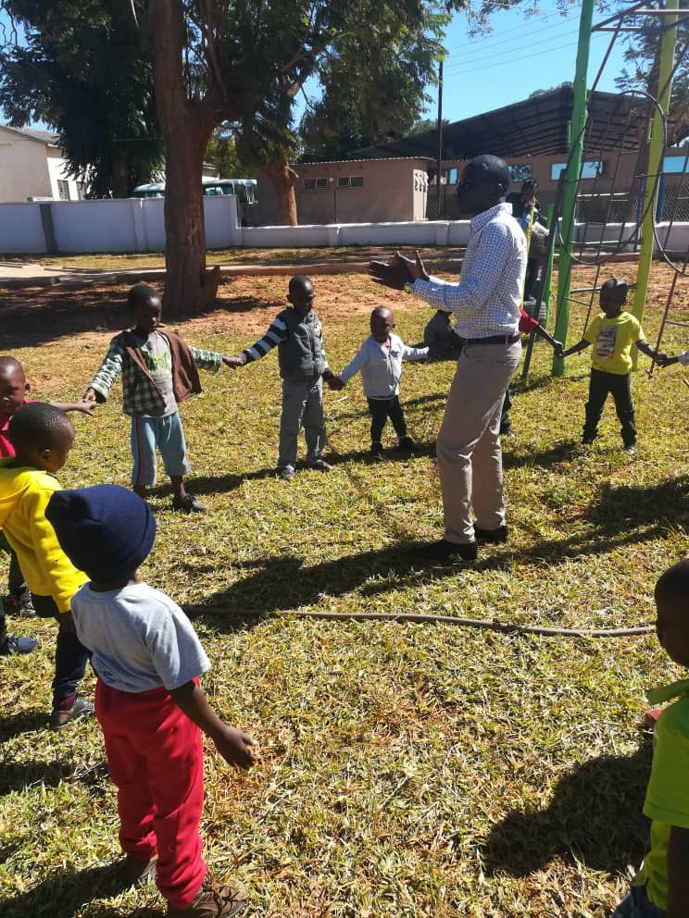
SOURCE: Chalimbana University Demonstration School
Activity
- Two 3 years children are standing at a water table splashing their hands in the green water. There is one water wheel, a number of funnels, and some plastic pipes.
Think of four ways of that play impacts development. How do they apply the situation described above? How does this situation impact self- motivation? How does it impact cognitive decentering? How does it enhance mental representations? How does it foster deliberate behaviour?

Creating effective Learning Contexts
From the above discussion you must take it into consideration that classrooms should not discriminate between play activities and learning activities. Learning activities for young children should center on well- planned and playful child-centered activities that occur in both indoor and outdoor settings.
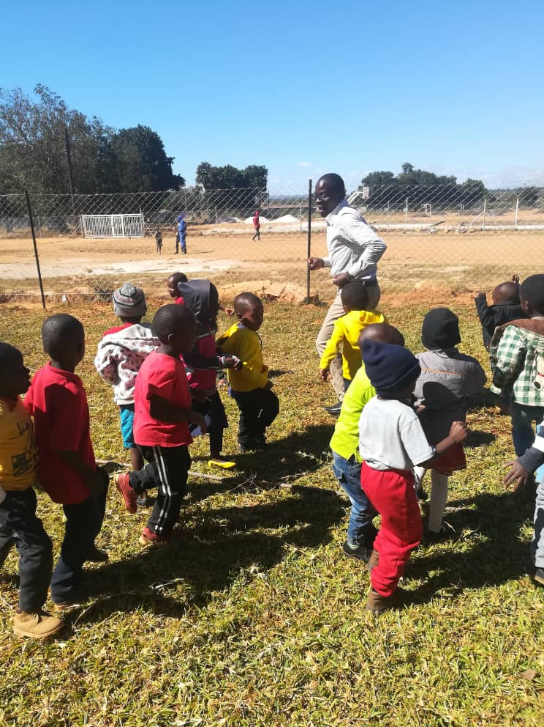
SOURCE: Chalimbana University Demonstration School

Outdoor Learning and indoor learning
Indoor activities should incorporate multiple home-like items that allow children to feel comfortable when transitioning from home to a day care or school environment.
The classroom furniture must be comfortable for small children and must be child-sized.
The cultural background of the children must be considered by furnishing the classroom with household items that they are familiar with. Having items from home in the classroom provides children with a great sense of pride for their family. It makes children feel safe being with who they are celebrating their diversity. Children gain a sense of belonging.
Outdoor activitiesallow children use natural materials. Children usually have a larger place where they can move their entire bodies, they have fewer noise restrictions.As a result, children can focus more on their physical and social skills when participating in outdoor activites.

General Considerations for Outdoor Learning Areas

Outdoor play areas should include:
- Water, vegetation, animals, insects, sand, dirty.
- Structures and objects that can be changed.
- Private areas to hide, different levels.
- Places to sit on, under and against.
- Natural outdoor, colors, diversity change.

Benefits of Outdoor Learning Centers
- Increase learning space
- Calls for a variety of activities
- Accommodates different types of behaviors
- Encourages diverse Learning Styles
- Improves Healthy of a child
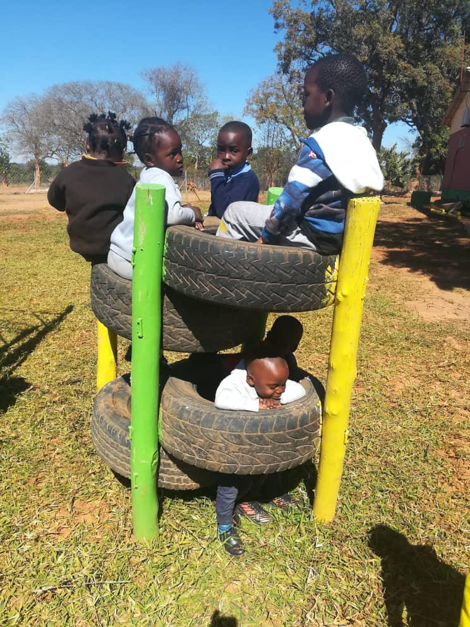
SOURCE: Chalimbana University Demonstration School

Creating Effective Schedules
Early education daily schedules for children in early childhood can be designed around half a day programs where children can have an option of attending either a 3- 4 hour morning or afternoon session, or full day programs, where children attend for an entire day and that with today’s demands for high quality activities, many half day programs are being asked to change to full day programs. It is therefore, very important for you to plan your work before you go for teach every day.
Effective programs seek to foster children who are anxious to learn and require explanations, information, further instructions and practice time.
In response to these pressures, programs are being asked to change from half day education programs to full day education program.
6.7 Sample Schedules for 3 to 6 years olds
Full day
10 minutes Arrival/ Indoor activities
60 minutes Small groups play motor skills or main activity
30 minutes Snack time

10- 15 minutes clean up and transition
45 minutes Outdoor play
35 minutes large group circle activities:
20 minutes Carpet time- Stories/ songs
15 minutes clean up and transition
Home -Time

Making visual Schedules
1. Choose picture, drawings, or word cards, or a mixture and mount them on durable card board and laminate
2. Make either vertical or horizontal board and laminate
3. Place Velcro on the cards and on the board
4. Model use the schedule for the children who need it
5. Use the schedule.

Effective Learning Involves Careful Planning
Be mindful that effective learning of the learners involves careful planning. Take note of these below:

Indoor/Outdoor Play-Based Centers
- Up to one hour in a. m. and p. m.
- Based on children’s interest
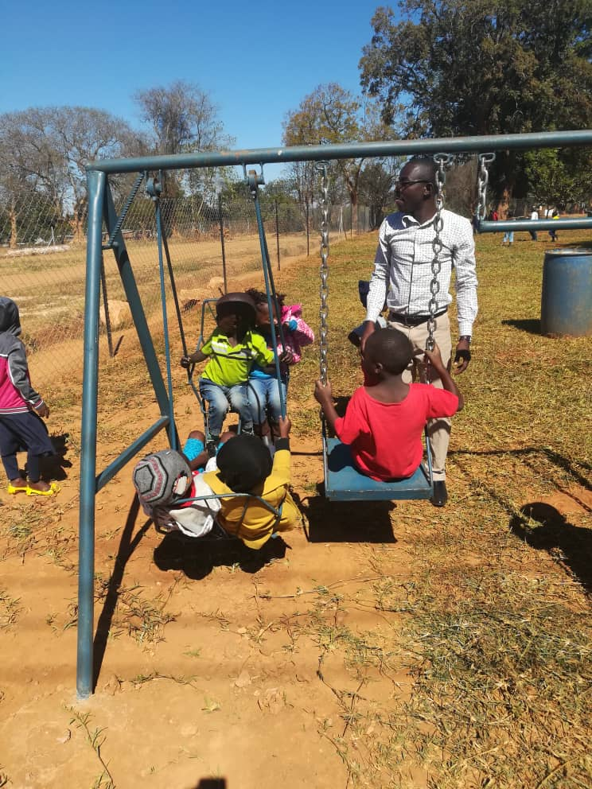
SOURCE: Chalimbana University Demonstration School

Flexible Groupings
- Large groupings, small groupings and center groupings

Examples of large groups activities:
- Introduce learning concepts
- Discuss special events
- Discuss classroom routines
- Get suggestions from children
- Problem solve
- Sing, chant, read and recite poems, do finger play, dance
- Create a class story
- Offer choices of activities
- Read aloud
- Model correct behaviours
Examples of small group activities
- Share similar interests
- Provide mini lessons
- Write play plans
- Design a group project
- Work on specific tasks
- Provide more guidance
- Share work
- Scaffold support
- Work on similar strengths
- Introduce a task

Examples of learning center activities:
- Manipulate materials
- Interact with others
- Explore hands on learning
- Develop a deeper understanding
- Demonstrate self -expression
- Generalize concepts
- Children responsible for cleaning up and transitioning

Effective Classroom Management
Try your best to create a responsive classroom approach that can increase academic achievement. This will decrease problem behaviours though social skills by moving towards creating high quality of instructions to your learners.
Develop classroom rules and effect them such as the following:
- How to play together peacefully
- How to communicate what they think and need
- How to take care of themselves, friends, and their environment
- How to listen to others with openness and compassion
- How to choose an effective course of action and make it happen

Addressing unacceptable behaviours
Sometimes you may experience children who may display unacceptable behavior in your school the following are some of the steps that you can take.
- Approach the situation calmly
- Acknowledge the child’s feelings
- Gather information
- Restate the problem
- Ask for ideas for solutions and choose one together
- Be prepared to give follow up support

Activity
- There are two 3 years old children standing at a water table splashing their hands in the water. There is one water wheel, a number of funnels and some plastic pipes.
- Think and write four ways that play impacts holistic development from the given scenario. Explain how you would apply the described situation above?
- How does this situation impact self- motivation, cognitive decentering.
- Demonstrate how it enhances mental representations and foster deliberate behavior?

Reflection
- As teachers in early childhood, design some activities that you can use for play activities for each learning area. After effecting it for a month share your observations and benefits of teaching through play.

Unit summary
Planning and designing a curriculum for leaners in early childhood is an important aspect. As a student teacher in early childhood you must consider creating an effective learning, effective schedules and practicing an effective class management. To crown it all practice flexible groupings.
Key references
Children’s Play Council, The New Charter for Children’s Play, London: NCB/Children’s Society, 1998
The EYLF (2009) is based on sound, proven early childhood pedagogy and practice principles. However, for the EYLF to be implemented properly, all early childhood educators need to know what play is, why it is important, how to implement and assess a play-based program and their role in it.
Siraj-Blatchford, I. (2008). Understanding the relationship between curriculum, pedagogy and progression in learning in early childhood.

Unit 7

Designing High Quality Centers for Learning

Introduction
Welcome to unit 7 of this course, we are going to look at various principles of designing learners’ curriculum which is play based. Designing a curriculum is ideally something that is first, of all effective and matches assessment with what is taught on a course. However, it also aims to give students a broader perspective. This approach to design is not only shaped by knowledge of your subject but by the many internal and external influences that impact on the academic content. It is an opportunity to change life by imparting knowledge into students. As a teacher, you ought to use best methods in curriculum design for you to understand play based activities for young children.

By the end of this unit you will be expected to:
Outcomes | Distinguish high quality centres for learning.  Explorethe influence of flexible learning in groups in different play based set ups.  Identify various ways of designing and techniques used in designing a curriculum in early childhood education.

Terminology | curriculum: | lessons or academic content taught in a school or in a specific course or programm.
 | designing: | Coming up with something or creation of a plan or convention for the construction of something.

Importance of curriculum design
You need to be part of curriculum design, since it is an important part in education. Look at several aspects when designing a curriculum. As a student, you will receive the same knowledge which should be used with your learners. Make sure you establish different age groups in order to have the capacity to teach.

Children enjoy learning and playing, do you think play methods should be included in the curriculum?
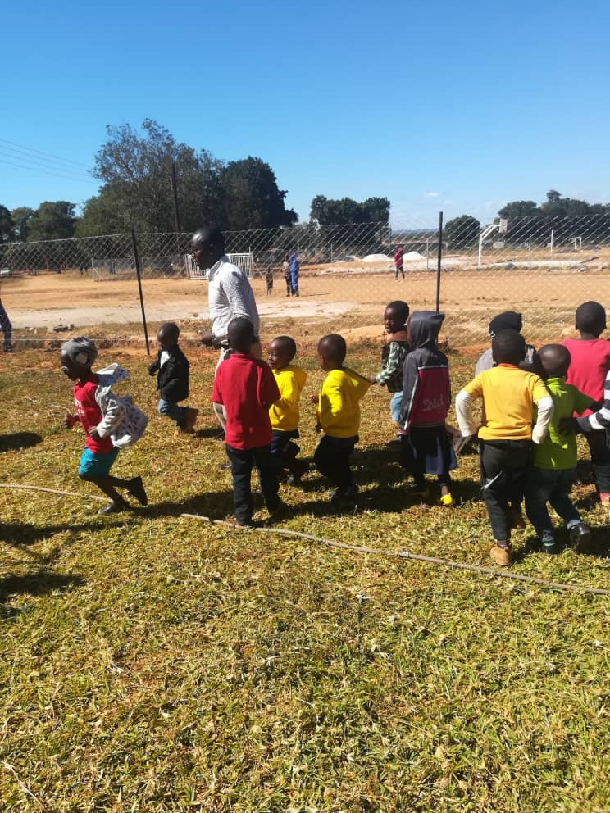
SOURCE: Chalimbana University Demonstration School

Creating effective learning
Remember to attend to children’s physical and psychological needs for security and order, love and belonging, personal power and competence, freedom, novelty, and fun. Enter the classroom and become immediately engaged in a learning activity. Greet all the learners at the Door Every Day with eye contact. Give you a verbal greeting, depending on the age of the learners—a high five, fist bump, or handshake.
SOURCE: Chalimbana University Demonstration School

Activity
Do you think a greeting can help a child start a day on a good note, explain why?

Flexible groupings
Take advantage of groups for efficiency teaching;provide different learning experiences over a relatively short timeframe through groupings that are well-matched to task purpose.

The Benefits of Flexible Grouping
Any time learners work in a small group they are separated from the rest of their classmates. With flexible grouping, separation is temporary. Over the course of days, weeks, and months, they come together to work with a wide range of peers in new ways prevented by continuous whole-group work, independent work, or interaction in a static small group.
Your learners will conduct a kind of status check, gathering clues about what the teacher believes about their abilities. Base your groups on learners’ readiness or skills but consider interest, learning preference and experience.
SOURCE: Chalimbana University Demonstration School

Activity
1. Explain how curriculum design is an important part of learning?
2. Do you think teachers should be part of a curriculum design and why?

Reflection
Having discussed the importance of designing a curriculum, do you think teachers should be involved in this process?

Unit summary
In this unit you learned on designing the curriculum and how a teacher can benefit in the process. Furthermore, we explained how to handle flexible groups in the learning process and effective class management.

Key references
Children’s Play Council, The New Charter for Children’s Play, London: NCB/Children’s Society, 1998
The EYLF (2009) is based on sound, proven early childhood pedagogy and practice principles. However, for the EYLF to be implemented properly, all early childhood educators need to know what play is, why it is important, how to implement and assess a play-based program and their role in it.
Siraj-Blatchford, I. (2008). Understanding the relationship between curriculum, pedagogy and progression in learning in early childhood.

Unit 8

Play and Pretending

Introduction

- By the end of this unit, you will be expected to:
- Outcomes | - Distinguish different play based environments  - Explore all types of play and pretending activities for young learners.  - Identify various play equipment to be used in play and pretending.
Terminology
 | Play:  Pretend : | Simultaneous activity  behaving so as to make it appear real

Classroom designs
The World Forum Foundation has extensively explored the issue of design in early childhood settings. Through their Global Collaborative On Design for Children, they have worked with architects, landscape architects, educators and the public to determine which factors are important in designing an early childhood classroom. This collaboration has emphasized several points.
Based on their research, every early childhood classroom should be inspired by the fact that each child is unique and classrooms should be designed to adapt to the rhythm of each child’s life and his or her daily routine.

The Learning Environment
The learning environment should reﬂect the learning that is taking place within the classroom. Teachers should consider the physical environment which must be bright, stimulating and airy. Displays are a mixture of children’s and teacher’s work, reﬂecting the learning taking place. Children are working in a print rich environment. If space is an issue use smaller equipment, water tray can become a basin which can sit on a table top. The cognitive environment All children are actively involved and enjoying learning. Children are aware of learning intentions and agreed success criteria. Children are thinkers, problem solvers and active learners. The social/emotional environment Children feel happy, safe and secure. Relationships and attitudes towards learning are positive. Successes in learning are celebrated and shared. Everyone’s efforts are valued. The learning/teaching environment A variety of strategies are used by teachers and children. Learning is stimulating and challenging and activities are linked to children’s interests and experiences.
Suggestive Developmentally Age appropriate Activities for ECE
For Children under 3 years focus on health, nutrition and early psycho social stimulation through free play and a lot of adult child interaction. E.g., (infant games, traditional songs and syllables, access to variety of play materials.
For Children between 3 to 4 years Planned play based programme for all round development with more of free play. More free but some guided.
Opportunities to listen to stories, learn rhymes, create, indulge in imaginative play, ask questions, do simple problem solving, experiment to promote active and interactive learning and generally have a ‘feel good’ experience for a positive self-image . For Children between 4 to 6 years Moving towards an increasing ratio of adult guided vs. free play activities, and more of large group activities

For 4-5 year old and focused more on specific school readiness
For 5-6 year old with increasing complexity in all of above.
Reading Readiness: e.g. picture –sound matching, shapes, phonetics, increasing vocabulary, verbal expression, developing bond with and interest in reading through picture books, storytelling, charts etc.
(Early Childhood Education Curriculum Framework 2012)

Play and pretending

Play provides opportunities for children to experience learning in a meaningful and purposeful way. It is a means by which children can develop the skills and capabilities to be effective learners. Play provides a context for children to
Opportunities should be given to children to build on previous experiences and make connections in their learning in an enjoyable way. The environment should encourage children to develop positive dispositions and share ownership of their learning. The teacher should provide opportunities for the children to engage in effective learning within a safe and secure environment. This reﬂects how children learn. Learning through Play Teachers should build on existing good practice in Nursery and the Foundation Stage.
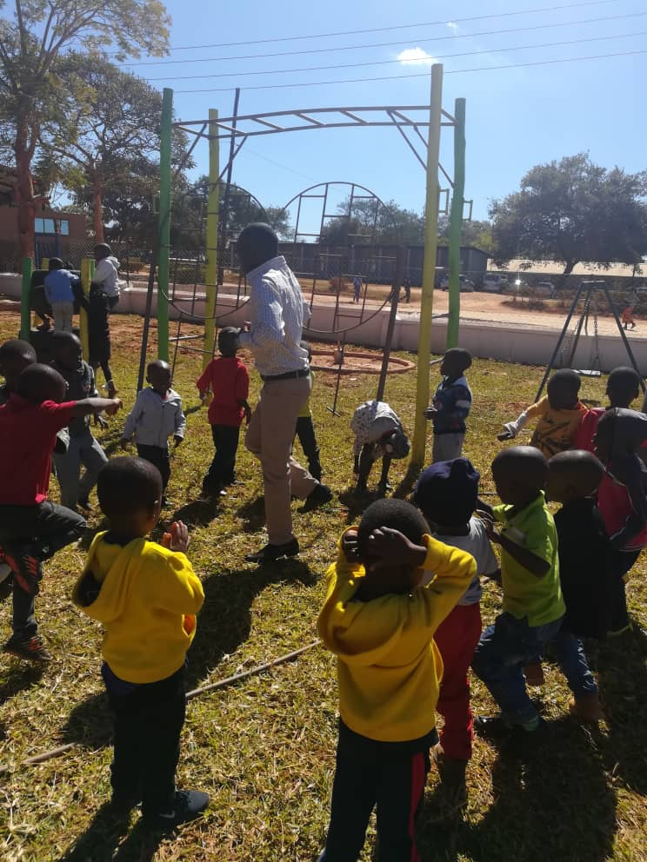
SOURCE: Chalimbana University Demonstration School

Play circles
Develops the fundamental skills of literacy, numeracy and oral communication Provides rich and varied contexts for developing skills such as observing, organising, recording, interpreting and predicting Promotes positive attitudes to school and to learning• Provides opportunities to learn in a practical way Provides opportunities for developing movement and manipulative skills Develops natural curiosity and stimulates imagination Provides opportunities for exploration, investigation, problem solving and decision-making Provides opportunities to develop knowledge, understanding and skills through a range of contexts spanning all subjects in the curriculum

Importance of Play
Encourage play that promotes children’s development, learning, creativity and independence Play keeps children healthy and active. Children become active adults Play fosters social inclusion. It helps children understand the people and places in their lives, learn about their environment and develop a sense of community Play allows children to ﬁnd out about themselves, their abilities and their interests Play is therapeutic. It helps children to deal with difﬁcult or painful circumstances, such as emotional stress or medical treatments Play gives children the chance to let off steam and •have fun.
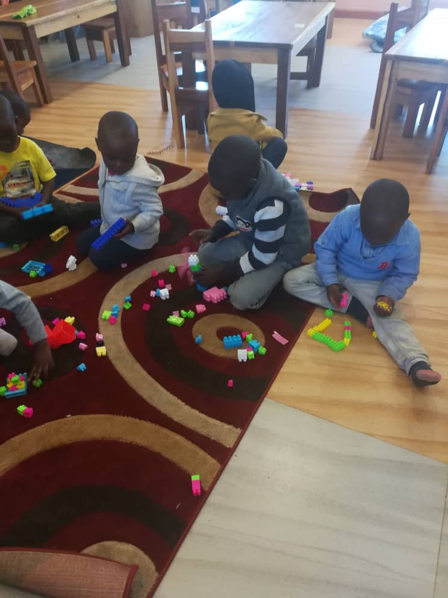
SOURCE: Chalimbana University Demonstration School

Promoting play
Play is one of the most important parts of early childhood, but unfortunately, the importance of play is often overlooked in many early childhood settings. Studies show that children learn while playing, and several longitudinal studies have even shown that children who play until age 6 perform better in school at age 12 than their counterparts who were in more academic settings before age 6.

How to promote Holistic development
You need to promote play; classrooms should be equipped with a variety of toys that encourage imaginative playing using toys that have multiple functions. For example, wooden blocks can be used in a variety of ways while most electronic toys have one prescribed use. Ideally, classrooms should have a wide range of toys, costumes, play kitchens and other objects that promote play. Through play, children will learn how to interpret external settings and personal experiences.

Play and friendships

Social play and friendship skills evolve throughout life. The process begins with infant-caregiver interaction and develops through various stages into mutually supportive friendships and relationships.
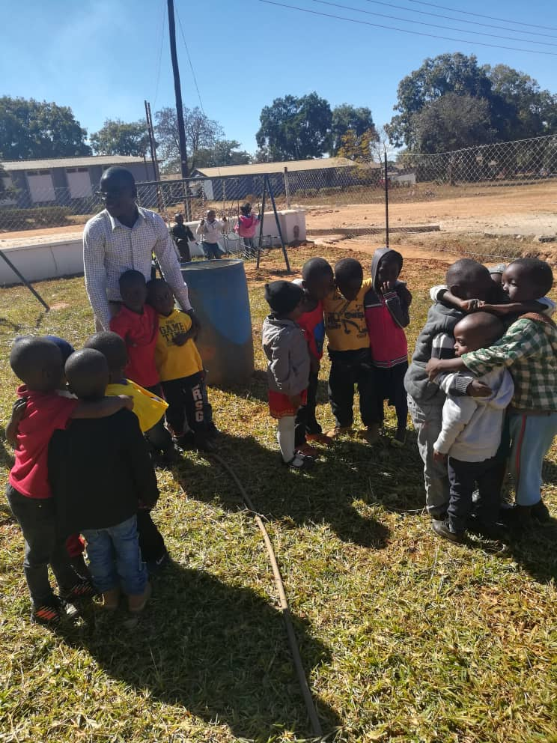
SOURCE: Chalimbana University Demonstration School

The starting point for any intervention is to identify the pupil’s understanding of and desire for peer-interaction/friendships. Specific resources for assessing and developing social play and friendship skills are given in the resources list, for example, The Social Play Record (White, C. 2006, Jessica Kingsley www.jkp.com). This gives small-steps. Playing teaches problem-solving

Importance of socio-dramatic play
Socio-dramatic play can help your son develop his fine motor skills. Whether he’s dressing toys or fixing an engine, he’ll be improving his ability to manipulate small objects.
You’re likely to see the biggest benefit in his cognitive skills. Because he is using his imagination and creativity to construct his scenarios, his memory improves as he recalls the finer details of the events he’s recreating, as well as the sequence of actions he must go through. Pretending to take a shopping trip will help his counting and sorting skills, and preparing dinner will make him more familiar with the names of food and cooking items.

Sequential development of symbolic play representations
Symbolic play and language are known to be highly interrelated, but the developmental process involved in this relationship is not clear. Three hypothetical paths were postulated to explore how play and language drive each other: (1) direct paths, whereby initiation of basic forms in symbolic action or babbling, will be directly related to all later emerging language and motor outputs; (2) an indirect interactive path, whereby basic forms in symbolic action will be associated with more complex forms in symbolic play. Early childhood education is not about teaching, it’s about exploration and learning, and observations play an important role in meeting the developmental needs of your young learners.

Activity
1. Do you use play in teaching?
2. in small groups, demonstrate how teachers can promote romote socio-dramatic activities and why?
3. How can you help learners in friendship creation?

Reflection
Play is very beneficial in learning. Think about how you organize play activities to enhance learning?

Unit summary
In this unit you learned on play and friendships and how a teacher can take advantage in the process. Furthermore, we explained how to plan play based activities to enhance holistic development.

Key references
Children’s Play Council, The New Charter for Children’s Play, London: NCB/Children’s Society, 1998
The EYLF (2009) is based on sound, proven early childhood pedagogy and practice principles. However, for the EYLF to be implemented properly, all early childhood educators need to know what play is, why it is important, how to implement and assess a play-based program and their role in it.

Unit 9

ASSESSMENT

Introduction

Welcome to unit 9 of this course. In this unit, we shall discuss assessment as a process of gathering information in order to understand what the learners know on the important aspects in teaching. You need to understand the need to assess learners in order to help them improve.

By the end of this unit, you will be expected to:
Outcomes | - Distinguish effective early childhood education teaching approaches, strategies and techniques for effective teaching and learning.  - Explore the influence of flexible learning in groups in different play based set ups.  - Identify various ways of designing and techniques used in designing a curriculum in early childhood education.  - Employ various principles in creating schedules.

Terminology | Assessment : | Process of finding out learners progress
 | Test : | Method of assessment

Types of tests

Early Childhood testing
Early childhood testing is a tool used to gather and provide educators, parents, and families with critical information about a child’s development and growth. In most African countries, licensed early childhood programs are now required to include a child assessment component in their programs. Here we have included information and resources to inform you on early childhood assessment programs.

What is childhood testing?
Childhood testing is a process of gathering information about a child, reviewing the information, and then using the information to plan educational activities that are at a level the child can understand and is able to learn from.
Testing is a critical part of a high-quality early childhood program. When educators do these tests, they observe a child to get information about what he knows and what he can do.
Observing and documenting a child’s work and performance over the course of a year allows an educator to accumulate a record of the child’s growth and development. With this information, educators can begin to plan appropriate curriculum and effective individualized instruction for each child.
This testing record is also a great tool to share with parents so they can follow their child’s progress at school, understand their child’s strengths and challenges, and plan how they can help extend the learning into their homes.

Why is testing important?
Testing provides educators, parents, and families with critical information about a child’s development and growth. Assessment can
Provide a record of growth in all developmental areas namely; cognitive, physical/motor, language, social-emotional, and approaches to learning.
The areas of assessment
Areas of assessment includes areas such as:
• The child’s interest and participation
• Skills and abilities
• Social interactions
The assessment of the children should be formative, continuous flow from the experiences planned in the curriculum.
( Early Childhood Education Curriculum Framework 2012)

Identify children who may need additional support and determine if there is a need for intervention or support services.
- Help educators plan individualized instruction for a child or for a group of children that are at the same stage of development.

Identify the strengths and weaknesses within a program and information on how well the program meets the goals and needs of the children.
- Provide a common ground between educators and parents or families to use in collaborating on a strategy to support their child.

What are different child testing methods?
Methods of child testing can be informal (conducting natural observations, collecting data and children’s work for portfolios, using educator and teacher ratings) and formal (using testing tools such that are standardized). Both methods are effective and can help inform educators and parents about a child’s progress.
- Observations can be made with minimal or no intrusion into children’s activities. Educators can observe all facets of development, including intellectual, linguistic, social-emotional, and physical development, on a regular basis.
- Portfolios are a record of data that is collected through the work children have produced over a period of time. The collection clearly shows the progress of a child’s development. Portfolios can be an important tool in helping facilitate a partnership between teachers and parents.
- Educator Ratings are useful in assessing children’s cognitive and language abilities as well as their social-emotional development. These ratings can be linked to other methods of assessment, such as standardized testing or other assessment tools. (See the next question below.)
- Parent Ratings integrate parents into the assessment process. Parents who are encouraged to observe and listen to their child can help detect and target important milestones and behaviors in their child’s development.
- Standardized Tests are tests created to fit a set of testing standards. These tests are administered and scored in a standard manner and are often used to assess the performance of children in a program.

What are different types of child assessment systems?
There are two different types of assessment systems. Both are used to guide decisions about a child’s development and program resources.
- Developed child assessment tools Program- are developed to align with a specific program’s philosophy and curriculum.
- Published child assessment tools -have been researched and tested and are accepted as a credible source in assessing children’s development.

Modes of testing early years

Universal screening
Universal screening is an emerging practice in early childhood settings (NAEYC 2005). Universal screening involves using low-cost tools that can be administered quickly and used repeatedly to gather data on each child in the classroom. While universal screening with all children is not yet a reality in most early education programs, early childhood teachers are moving in this direction. A good place for teachers to begin is to consider all of the assessment information that is already being gathered in their classrooms. Ideally, formal and informal measurement activities are linked to the curriculum and to early learning standards, and samples of student performance are collected repeatedly throughout the year to assess children’s progress in learning and to inform adjustments in classroom instruction.

Progress Monitoring
Progress monitoring is a term used to describe any of a number of activities or approaches to data collection that focus on a child’s learning over time and help to document and provide meaningful feedback on learning outcomes. Progress monitoring measures (e.g. Individual Growth and Development Indicators [IGDIs]) provide information about the rate and level of children’s growth in key skills, which helps to determine the intensity of support and services every Child requiresbeing successful. Currently, the majority of progress monitoring tools target language and early literacy skills rather than all domains of development and learning.

Observation in Naturalistic Settings
Teachers and parents are uniquely positioned to obtain information about how children function within different natural (e.g., classroom, community) environments or settings. One way teachers can understand children’s development, interests, and needs within the context of the pre-kindergarten or child care classroom is through observation and documentation (Bordignon& Lam, 2004). Through systematic observation over time, teachers are able to routinely observe children engaging in regular classroom routines and activities and reflect on the meaning of what they see (Hills, 1993). For example, a teacher might observe that a child does not initiate book interactions or attempt writing and might reflect on what this means for that child. The key to systematic observation is that conclusions or interpretations are based on observations of the child over time rather than a one-time assessment of a child’s skills and abilities.
Successful observations allow teachers, parents, and other adults to capture and record meaningful details while children are engaged in a variety of activities and take into account children’s development, interests, and needs across domains of development and learning, allowing for a more complete view of the “whole child” (Bagnato, 2007). For example, when observing three children stringing beads and talking together about the shapes and colors of the beads, a teacher observes the children’s fine motor skills while also observing their cognitive, language, and social skills.
When conducting observations, teachers must take particular care to avoid allowing any preconceptions or biases color their impressions. When conducting systematic observations, teachers should be using their understanding of child development as a filter to identify expected behavior as well as pick up on red flags that indicate a child might be struggling with learning.

Working with Young Children
You will release that working with children introduces you to the fast-growing field of early childhood education. You will develop skills for guiding children effectively while keeping them healthy and safe. this implies child development principles to child care settings.

Need for developmental practices
If you are a preschool or kindergarten teacher you probably hear, read, or say the words Developmentally Appropriate Practice (DAP) a lot. Or maybe you just hear it and haven’t really ever fully understood what it means. That is why it is important to share a very basic overview of what Developmentally Appropriate Practice is and more importantly how you can follow it in your early childhood classroom.

Activity

- How can you assess learners during a lesson through play?
- Explain how you would engage learners who have withdrawn from an activity?

Reflection
According to your experience, which method would you use in assessing learning considering individual differences.

Unit summary
In this unit you learned, we discussed common ways of testing learners, we further gave examples on how ECE teachers can utilize tests and get good results without leaving a child behind.

Unit 10

School Experience and Peer Teaching

Introduction
Welcome to unit 10 of this course. In this unit, we will learn how School experience can help you process is what you have experienced as a student going through school. What would change might be something along the lines of how much you studied, how you communicated with teachers, or how much you participated in extracurricular. Getting school experience is a vital step on the way to becoming a teacher. That first time in school will give you a deeper insight into teaching and learning, which will support you towards a successful application and interview

By the end of this unit, you will be expected to:
Outcomes | - Examine teaching experience and peer teaching.  - Describe advantages of school experience.  - Describe the role of school experience in the teaching/learning process.  - Categorize needs for school experience.

Terminology | School:  experience: | any interaction during: the course of the program

What is the student experience?
The belief that genuine education comes about through experience does not mean that all experiences are genuinely or equally educative. Experience and education cannot be directly equated to each other. For some experiences are not educative. Any experience that has an effect of arresting or distorting the growth of further learning is not educative.

Why Do Peer Teaching

An experience will be provided as peer teaching before you actually go out for school experience. It may produce sensitivity and of responsiveness with understanding of what you expect in the field. The possibilities of having richer experience in future are high when given a chance to participate in peer teaching.

Benefits of school experience
As a student, you will benefit from excellent teaching, both on-campus and in the field, and a strong academic and pastoral support framework which responds effectively to the range of individual circumstances, experience, expectations and interests.
You will be exposed to extensive curricular and co-curricular opportunities which includes opportunities learn different things and develop skills to improve employability such as gaining skills for teaching or taking on a role as a student ambassador.
You will have access to excellent recreational and sports activities which will help you transfer the knowledge to young children.

Importance of school experience
Your school experience will be part of your becoming ready’, you need to build useful skills that cannot be taught in the classroom as well as contacts that learners would not be exposed to. The need to build soft skills, team working, communication skills and commercial awareness is very necessary. School experience also helps you to differentiate yourself, an important factor when you teach children. The student experience encompasses many aspects of academic and intellectual development, social and emotional life, and the growth and refinement of cultural, political, sporting and artistic interests. The experience of being a student in the University, should prepare you for life beyond your studies and begin a positive lifelong relationship in teaching and handling learners in early childhood education.

Activity

How do you differentiate school experience from peer teaching?

Why should students undergo peer teaching?

Do you know any challenges found in peer teaching?

Is school experience beneficial to students, explain why?

Reflection
Now that we have identified advantages of school experience and peer teaching, which one would be the major advantage of school experience?

Unit summary
In this unit you learned about the importance of school experience and peer teaching, we explained the advantages of being exposed to school experience. We further gave examples on how ECE student teachers can take advantage of peer teaching before you are exposed to a classroom.

References
Information Services Department (2006). Hong Kong YearBook. Hong Kong, Hong Kong SAR: Information Services Department
Kelly, A.V. (1999). The curriculum: theory and practice (4th Ed.). London, UK: Paul Chapman Publishing Ltd.
Marsh, C. J. (2009). Key Concepts for understanding curriculum. Retrieved from http://qzabansara.com/News/NF23256.pdf
Morris, P. and Adamson, P. (2010). Curriculum, Schooling and Society in Hong Kong. Hong Kong, HKSAR: Hong Kong University Press.
Bilbao, P. P., Lucido, P. I., Iringan, T. C., and R. B. Javier (2008). Curriculum development. Philippines: Lorimar Publishing, Inc.

Cite this article as: Alvior, M. G. (December 13, 2014). The Meaning and Importance of Curriculum Development. In SimplyEducate.Me. Retrieved from https://simplyeducate.me/2014/12/13/the-meaning-and-importance-of-curriculum-development
Bilbao, P. P., Lucido, P. I., Iringan, T. C., and R. B. Javier (2008). Curriculum development. Philippines: Lorimar Publishing, Inc.
Bilbao, P. P., Lucido, P. I., Iringan, T. C., and R. B. Javier (2008). Curriculum development. Philippines: Lorimar Publishing, Inc.
Cite this article as: Alvior, M. G. (December 13, 2014). The Meaning and Importance of Curriculum Development. In SimplyEducate.Me. Retrieved from https://simplyeducate.me/2014/12/13/the-meaning-and-importance-of-curriculum-development/

Kaschman, T. (2011). Theories of learning and studies of instructional practice. New York, NY: Springer. Lieberman, A. (2011). High quality teaching and learning. New York, NY: Taylor & Francis. Ovens, P. (2011). Developing inquiry for learning. New York, NY: Routledge. Tyler, R. W. (1949). Basic principles of curriculum and instruction. Chicago, IL: University of Chicago Press. Williams, J. D. (2011). How science works: Teaching and learning in the science classroom. New York, NY: Continuum International Publishing Group

Children’s Play Council, The New Charter for Children’s Play, London: NCB/Children’s Society, 1998
The EYLF (2009) is based on sound, proven early childhood pedagogy and practice principles. However, for the EYLF to be implemented properly, all early childhood educators need to know what play is, why it is important, how to implement and assess a play-based program and their role in it.
Siraj-Blatchford, I. (2008). Understanding the relationship between curriculum, pedagogy and progression in learning in early childhood. Hong Kong Journal of Early Childhood, 7 (2), 6-13.
Steglin, D. A. (2005). Making the case for play policy: Research-based reasons to support play-based environments. Young Children, 60(2), 76-86

Clarke, S., Enriching Feedback in the Classroom, Hodder Murray, 2003
Hurst, V., Planning for Early Learning: Educating Young Children. 2nd ed., Chapman Publishing Ltd., London, 1997
Northern Ireland Curriculum, Key Stages 1 and 2 Programmes of Study and Attainment Targets. Characteristics of the Curriculum at Key Stage 1, 1996
Northern Ireland Curriculum, www.nicurriculum.org.uk/ docs/assessment_for_learning
Sylva, K. and Lunt, I., ‘Child development: A First Course’, Blackwell, 1992
Whitebread, D., Teaching and Learning in the Early Years, 2nd Ed, Routledge, 1996
Black, P., Harrison, C., Lee, C., Marshall, B. &Wiliam, D., Working inside the Black Box, Department of Education and Professional Studies, King’s College, London, 2002

Bodrova, E. & Leong, D. J. (2005). Uniquely preschool: What research tells us about the ways young children learn. Educational Leadership, 63(1), 44-47.
Department of Education, Employment and Workplace Relations (DEEWR). (2009). Belonging, being & becoming: The Early Years Learning Framework for Australia. Canberra: DEEWR.
Lester, S. & Russell, S. (2008). Play for a change. Play policy and practice: A review of contemporary perspectives. Play England. Retrieved 21.6.2010 from http://www.worldleisure. org/pdfs/Copy%20of%20book_rev_play_for_change.pdf
South Australian Curriculum Standards and Accountability Framework (2009) Learners and Learning in the Early Years. Retrieved 15.6.2010 from http://www.sacsa. sa.edu.au/content/doc_fsrc.asp?ID=%7BDCB8452E-3D30-40E7-9C3C- 570AE5168C17%7D&sec=%7B25AAFB50-4954-457F-9426-FDB72E5202EF%7D
Shipley, D. (2008). Empowering children. Play based curriculum for lifelong learning. (Fourth ed). USA: Nelson Education.

