
CHALIMBANA UNIVERSITY | END 2101

END 2101: Numeracy Development 2
AUTHORS
Chimfwembe G.Gondwe Chalimbana University
Chingi Samuel
Mulenga George School of Early Childhood Studies
Zulu N Hildah Department of Early Childhood Education

Revised by
Chimfwembe G Gondwe
Chingi Samuel
Nthani H Zulu

Copyright

© 2019 Chalimbana University
All rights reserved.
No part of this publication may be reproduced, stored in retrieval system or transmitted in any form by any means electronic, mechanical, photocopying, recording or otherwise, without prior written permission of Chalimbana University.

Chalimbana University
School of Early Childhood Studies
Department of Early childhood Education
Chalimbana University
Private Bag E 1
Lusaka
Zambia
Cell: +260977485465
E-mail: ece@chau.edu.zm
Website: www.chau.edu.zm/ece

Acknowledgements
Chalimbana University, School of Early Childhood Studies wishes to thank those below for their contribution to this course:
Mrs Getrude C Gondwe | Lecturer – Chalimbana University
Mr. Chingi Samuel | Lecturer – Chalimbana University
Mr George Mulenga  Mrs. Hildah N. Zulu | Lecturer – Chalimbana University  Lecturer – Chalimbana University
VVOB | CDC, Lusaka.

Contents
About this Course 1
How this Course is structured 1
Course overview 3
Welcome to END 2101: Numeracy Development 2 3
Course outcomes 4
Timeframe 4
Study skills 5
Assignments 6
Assessments 7
Getting around this Course 9
Margin icons 9
Unit 1: 13
Integers 13
Introduction 13
CONTENT 13
Activity 18
Reflection 18
Unit summary 18
In this unit you learned that 18
Unit 2: Fractions 20
Fraction 20
Introduction 20
Fractions 20
Reflection 24
Unit summary 24
Unit 3 25
STATISTICS AND PROBABILITY 25
Introduction 25
Collecting Data in the Classroom: A Teacher's Guide 25
Formative Data 25
Observational Data 26
Standardized Tests, Key Milestone Exams and Project Work 26
Student Files 26
• Student Reported Data 27
Line Graph 29
Making a line graph. 30
Drawing a pie chart 32
Frequency Distribution Table 33
What is a Frequency Distribution Table? 34
Experimental Probability 35
Activity 37
Reflection 38
Unit summary 38
Unit 4 39
Matrice 39
Introduction 39
Matrices 39
Activity 46
Reflection 46
Unit summary 47
Unit 5 49
Building assessment into instruction 49
Introduction 49
5.1 Building Assessment into Instruction 55
Activity 68
Reflection 70
Unit summary 70
Unit 6 71
Planning to Teach 71
Introduction 71
Content 72
Behaviourist Theory of Learning 81
Activity 85
Reflection 85
Unit summary 86
Unit 7 87
Mathematical games, songs, and stories 87
Introduction 87
Reasons to use games in class and outside 91
Activity 99
Reflection 100
Unit summary 100
Unit 8 101
Learning through play 101
Introduction 101
Curriculum Connections 102
Activity 108
Reflection 108
Unit summary 108
Unit 9 110
STANDARDS AND DEVELOPMENTALLY APPROPRIATE PRACTICES 110
Introduction 110
Quality in early childhood education 110
Language of instructions 115
APPROACHES, TEACHING METHODS AND STRATEGIES IN NUMERACY 117
Key Methods and Strategies of Teaching Numeracy 118
100-Cell Calculation 118
Photo story telling in Numeracy 119
Activity 120
Reflection 121
Unit summary 121

About this Course
Teaching Numeracy Development has been produced by Chalimbana University. All Courses produced by Chalimbana University are structured in the same way, as outlined below.

How this Course is structured
The course overview
The course overview gives you a general introduction to the course. Information contained in the course overview will help you determine:
If the course is suitable for you.
What you will already need to know.
What you can expect from the course.
How much time you will need to invest to complete the course.
The overview also provides guidance on:
Study skills.
Where to get help.
Course assignments and assessments.
Activity icons.
Units.
We strongly recommend that you read the overview carefully before starting your study.
The course content
The course is broken down into units. Each unit comprises:
An introduction to the unit content.
Specific Outcomes
Unit outcomes.
New terminology.
Core content of the unit with a variety of learning activities.
A unit activity.
A reflection
A unit summary
Resources
For those interested in learning more on this subject, we provide you with a list of additional resources at the end of this Course; these may be books, articles or web sites.
Your comments
After completing Teaching Numeracy Development, we would appreciate it if you would take a few moments to give us your feedback on any aspect of this course. Your feedback might include comments on:
Course content and structure.
Course reading materials and resources.
Course activities.
Course/unit summary.
Course duration.
Course support (assigned tutors, technical help, etc.)
Your constructive feedback will help us to improve and enhance this course.

Course overview

Welcome to END 2101:Numeracy Development 2
Introduction:
This module is intended for In-service pre-school teachers who will be responsible to teach children between the ages of 3 to 8 years. It consists of content (integers, fractions, statistics and probability, matrices) and methods (building assessment in to instruction, planning to teach, mathematics games, songs and stories, learning through play and standards & developmentally appropriate practices and their applications in real life situations). This module has taken an integrated approach of linking both pedagogy and content which is applicable in early childhood curriculum. The module brings out emerging research base on how young children approach the study of mathematical relationships with the reality of daily life in an early childhood classroom and how teachers should teach. It further illustrates a thematic approach that could be developed from curricular webs on topics of interest to young children that a teacher can use. These activities are not an end to themselves but might be sources of ideas that trigger creativity in all of us.

AIM:
This course is envisioned to capacitate In-service pre-school students to be able to inculcate mathematical knowledge and skills in children between the ages of 3 to 8 years.

Pre requisite: END 1101
The entry requirement to this course is that student must have undertaken and cleared END 1101course prior to being enrolled to undertake this course.
.

Course outcomes
Upon completion of this unit you should be able to
  Outcomes | - Explain mathematical concepts at early learning level  - Relate mathematical concepts to real life  - Apply mathematical concepts to real life  - Apply play approach in the teaching and learning of mathematics at an early learning level.

Timeframe

  How long? | Half a year comprising two residential  Four (4) weeks of contact sessions  You need three (3) hours for formal study per week and you are expected not to spend less than ten (10) hours per week for self – study.

Study skills
 | As an adult learner your approach to learning will be different to that from your school days: you will choose what you want to study, you will have professional and/or personal motivation for doing so and you will most likely be fitting your study activities around other professional or domestic responsibilities.  Essentially you will be taking control of your learning environment. As a consequence, you will need to consider performance issues related to time management, goal setting, stress management, etc. Perhaps you will also need to reacquaint yourself in areas such as essay planning, coping with exams and using the web as a learning resource.  Your most significant considerations will be time and space i.e. the time you dedicate to your learning and the environment in which you engage in that learning.  We recommend that you take time now—before starting your self-study—to familiarize yourself with these issues. There are a number of excellent resources on the web. A few suggested links are:  - http://www.how-to-study.com/  The “How to study” web site is dedicated to study skills resources. You will find links to study preparation (a list of nine essentials for a good study place), taking notes, strategies for reading text books, using reference sources, test anxiety.  - http://www.ucc.vt.edu/stdysk/stdyhlp.html  This is the web site of the Virginia Tech, Division of Student Affairs. You will find links to time scheduling (including a “where does time go?” link), a study skill checklist, basic concentration techniques, control of the study environment, note taking, how to read essays for analysis, memory skills (“remembering”).  - http://www.howtostudy.org/resources.php  Another “How to study” web site with useful links to time management, efficient reading, questioning/listening/observing skills, getting the most out of doing (“hands-on” learning), memory building, tips for staying motivated, developing a learning plan.  The above links are our suggestions to start you on your way. At the time of writing these web links were active. If you want to look for more go to www.google.com and type “self-study basics”, “self-study tips”, “self-study skills” or similar.

Need help?

Mrs. Gondwe: 0977423642
Email: getrudegondwe68@yahoo.com

  Help | Mr Mulenga George  Mobile: 097722320711  Email:gcmulengachanda@yahoo.com  Mr. Chingi Samuel  Mobile: +260 977335882  Email: nechingi@yahoo.com  Mrs. H.N. Zulu: 0979093006  Email: hildanthanizulu@gmail.com

Assignments

 | One (1) assignment should be completed as given to you by the Lecturer(s).  You will be required to submit a research proposal on a topic of your choice.  All assignments shall be submitted electronically through the learning management system. The due dates will be advised accordingly by the Lecturers and they will be posted on the learning management system.

Assessments

  Assessments | One (1) assignment, one (1) Test, a research proposal and a Final Examination which are Teacher/Lecturer marked assessments.

Getting around this Course

Margin icons
While working through this Course, you will notice the frequent use of margin icons. These icons serve to “signpost” a particular piece of text, a new task or change in activity; they have been included to help you to find your way around this Course.
A complete icon set is shown below. We suggest that you familiarize yourself with the icons and their meaning before starting your study.
 |  |  | 
Activity | Assessment | Assignment | Casestudy
 |  |  | 
Discussion | Group activity | Help | Note it!
 |  | 
Outcomes | Reading | Reflection | Study skills
 |  |  | 
Summary | Terminology | Time | Tip
 |  |  | 
Computer-Based Learning | Audio | Video | Feedback
 |  | 
Objectives | Basic Competence | Answers to Assessments

Assessment
- Continuous Assessment 50%
2 Assignments 30%
1 Test 20%
- Examination 50%
Total 100%

Unit 1:

Integers

Introduction

You might be aware that +1, +2,+3,… are positive whole numbers and -1,-2,-3,… are negative whole numbers. These numbers and zero together are called integers. The set of integers is often named Z.
Upon completion of this unit you will be able to:
Outcomes | - Define the set of integers.  - Order a set of integers in ascending or descending order.  - Add integers on number line.  - Subtract integers on number line.  - Add and subtract integers without using a numberline.  - Multiply and divide integers correctly.

CONTENT

Look at the thermometer below. What can you see?
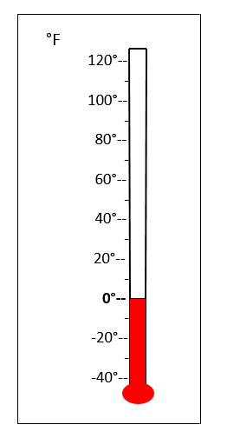
You see that -12° C is below 0° C. This shows that -12° C is a colder temperature than 0°. It follows that -12 is a smaller number than 0. Locate -12°C on this thermometer, and mark it with an arrow. Now complete the following two sentences
A positive number is a number that is ________ ________ ________.
A negative number is a number that is ________ ________ ________.

Example 1
Which is colder, 15° C or 34° C? ________ locate both temperatures on this thermometer, and mark them with arrows.
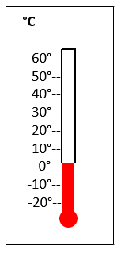
15° C is colder than 34° C, and 15 is ________ ________ 34.
34° C is warmer than 15° C, and 34 is ________ ________ 15.
Example 2
Which is colder, -6° C or -14° C? ________ Locate both temperatures on this thermometer, and mark them with arrows.

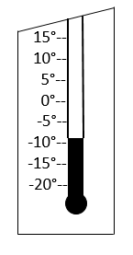
-14° C is __________ than -6° C, and -14 is _______ _______ -6.
-6° C is __________ than -14° C, and -6 is _______ _______ -14.

3
Example 3
Put these temperatures in order from smallest to largest (or coldest to warmest):
38°, 70°, -10°, 15°, -6°, 45°, 0°
Which of those temperatures are positive?__________________________
Which of those temperatures are negative? _________________________

Adding 2 numbers using a number line
Now let us do addition and subtraction using a number line.
Example
Add 6 + 1 using a number line.

Solution
To add using a number line a number line you move 6 steps to the right from zero till you reach 6, then you move again one step to the right till you reach 7, as shown in the figure below.

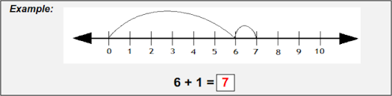

Example 2
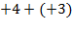
Similarly, to add 4+ 3 you move 4 Steps to the right followed by 3 steps till you reach 7 as shown below.
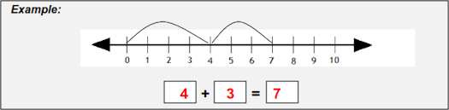

Example 3:

Add 4 +10 +3 using a number line
To add 4 +10 +3
you move 4 Steps to the right followed by 10steps till you reach 14, the you move 3 more steps as shown below.

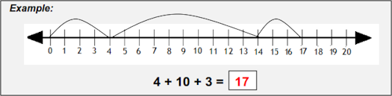

Addition and subtraction of integers without using a numberline
Now that you have learnt on how to add and subtract using a numberline, let us do addition and subtraction of integers without using a numberline.
Example 4
Workout the following without using a number
- 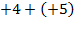
- 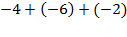
- 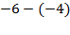
Solution
- 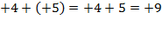
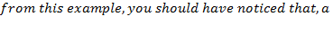
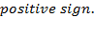
- 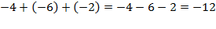

- 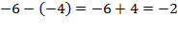
Multiplication of integers
Let’s look at the addition 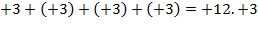 is added to itself four times. In short, this can be written as
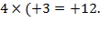
We can consider multiplication as repeated addition.
Example 5
Work out 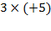
Solution
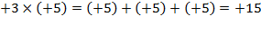
A positive number multiplied by a positive number gives a positive number.
Example 6
Work out 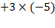
Solution
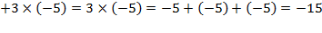
A positive number multiplied by a negative number gives a negative number.
Division of integers
We know that 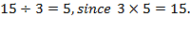 But what is
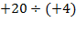? To get the answer, we ask the question; by what number is +4 multiplied to give us +20? The number is +5 since 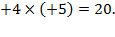 Therefore 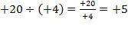.
Example 7
Divide -20 by +4.
Solution
To get the answer, we have to find a number such that
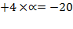. The number is -5 since 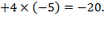 Therefore, 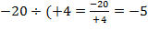
From the examples given you can observe that; when two integers are divided the quotient is:
- Positive when the signs are the same.
- Negative when the signs are not the same.

Activity

Activity | Work out the following problem first by using a number line, then without using a number line:  - +(4) – (+6)  - – 11 – (- 9) – (+3)  - 0 – (-5)  - -3 + 3  - +8 + (-1) + (+7)  - -8 – (-6) – (-2) + (+11)  - 4 x (+6)  - 7 x (-7)  - -3 x (-3) x (-3)  - (+2) x (+2) x (+2) x (+2) x (+2) x (+2)  - 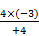  - 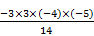

Reflection

Now that you have learnt about integers, how would you apply integers to real life situations

Unit summary

Summary | In this unit you learned that  Addition of integers is presented as a movement of so many units either to the right or to the left. The first number in the expression is your "starting point". If you add a positive integer, you move that many units right. If you add a negative integer, you move that many units left.

Unit 2: Fractions

Fraction

Introduction
A fraction is a number which can tell us about the relationship between two quantities. These two quantities provide information about the parts, the units we are considering and the whole. Determining the whole is important when working with fractions
Upon completion of this unit you will be able to:
Outcomes | Define a fractions  Use real life object to explain the concept of fraction  Identify a denominator  Identify a numerator  Addition of fractions  Subtraction of fractions  Multiplication and division of fractions

Fractions

Introducing fractions
- Explain to your class that today, they will be learning about fractions. Define a fraction as a part of a whole.
- Display the orange or apple to your class, and tell them that you want to give half of the fruit to a person in the class.
- Use your knife to cut the fruit in half. Give one of the halves to a pupil.
- Then say there were two parts of an orange, but one has been given away.
- We can also say one out of two parts has been given away.
- Then draw an orange and shade one part.
- Write the fraction 1/2 on the whiteboard.
- Explain to students that the denominator, or number on the bottom, tells how many equal parts the item is divided into. Tell your class that the numerator, or number on the top, tells how many of those parts are being referred to.
- Then draw a picture of a common fraction on the board, to better illustrate the concept to your students.
- Ask children to state the fraction represented below
($\frac{1}{2},\frac{3}{4},\frac{1}{4},\frac{1}{3}$)

Adding and Subtracting Fractions
Adding and subtracting fractions may seem problematic at first, but if you follow the simple steps and practice all the problems, in this unit you will find the operations to be easy.
Here are some steps to follow:
- Check to see if the fractions have the same denominator.
- If they don't have the same denominator, then convert them to equivalent fractions with the same denominator.
- Once they have the same denominator, add or subtract the numbers in the numerator.
- Write your answer with the new numerator over the denominator.
Note: The denominator may have changed when you converted the fractions to the same common denominator.
Example1
A simple example is when the denominators are already the same as shown below:

$\frac{1}{5}\text{+ }\frac{3}{5}\text{ = }\frac{4}{5}$

Since the denominators are the same in each question, you just add or subtract the numerators to get the answers.
Different denominator
Here we will try a problem where the denominators are not the same.
$\frac{3}{7}\text{+ }\frac{2}{5}$
As you can see, these fractions do not have the same denominator. Before we can add the fractions together, we must first create equivalent fractions that have common denominators.
Find the Common Denominator
To find a common denominator, we check the lowest common multiple of 5 and 7. In this case it 35.

$\frac{3}{7}\text{+ }\frac{2}{5}\text{ = }\frac{\text{15+ 14}}{\text{35}}=\frac{\text{29}}{\text{35}}$
After finding 35 the denominator, Add the Numerators
Now that the denominators are the same, you can add the numerators and put the answer over the same denominator.

Subtracting Fractions
Subtraction of Fractions is done in a similar manner as addition. Here is an example of subtracting fractions where denominators are different:
$\frac{3}{7}\text{- }\frac{2}{5}\text{ = }\frac{\text{15- 14}}{\text{35}}=\frac{1}{\text{35}}$
Tips for Adding and Subtracting Fractions
- Always make sure that the denominators are the same before you add or subtract.
- If you multiply the top and the bottom of a fraction by the same number, the value stays the same.
- Be sure to practice converting fractions to common denominators. This is the hardest part of adding and subtracting fractions.
- You may need to simplify your answer after you are done adding and subtracting. Sometimes the answer can be reduced even though the original fractions could not be reduced.
- The same process is used for both adding and subtracting, if you can add fractions, you can subtract them.
- If there are mixed numbers that you are adding or subtracting be sure to convert them to improper fractions before you start the process.
Multiplication of fractions

Example 2
Work out
- 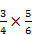
- 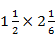
- 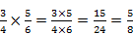

- 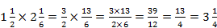

Division of fractions
Look at the following working very carefully:
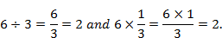
You will notice that 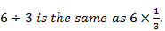
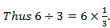 is called the reciprocal of 3, and on the other hand, 3 is the reciprocal of
When a number and its reciprocal are multiplied together, they give the answer 1.
When dividing fractions, we multiply the dividend by the reciprocal of the divisor.
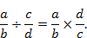
Example 3
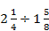
Solution
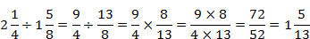
Activity
- Colour the folloing according to the indicated fraction
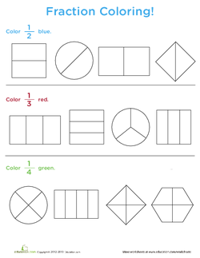
- Work out the following
- $$\frac{4}{5}+\frac{3}{5}\text{ =}$$
- $$\frac{4}{\text{15}}+\frac{\text{13}}{\text{15}}\text{ =}$$
- $$\frac{2}{\text{10}}+\frac{3}{5}\text{ =}$$
- $$\frac{7}{\text{25}}−\frac{\text{13}}{\text{15}}\text{ =}$$
- $$\frac{\text{14}}{\text{18}}−\frac{5}{9}\text{ =}$$
- Work out the following:
- 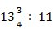
- 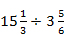
- 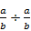
- 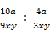
- Find the value of 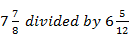.
- What is the length of a field if the area is 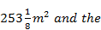 is 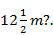

Reflection

what are some of real life situation where you find fraction or you apply the concept of fraction

Unit summary

Summary | In this unit you learned about addition and subtraction of fractions. You have also learned how to multiply and divide fractions which are essential competencies required in the teaching and learning of pre mathematics.

Unit 3

STATISTICS AND PROBABILITY

Introduction
In almost every early childhood classroom, you find examples of children displaying, collecting and analyzing data such as displaying graphs on the wall. This is me “bulletin board that lists everyone’s favorite colors, foods and books; pictures of families, marked with numerals indicating the number of siblings and pets; and number of tallies showing how many children want milk, ride the bus, are in the block center.
Upon completion of this unit you will be able to:
Outcomes | - State methods of data collection in a classroom.  - State methods of data presentation  - Plot bar graph, pie chart, frequency distribution table.  - Calculate the mean, mode and median respectively.  .

Collecting Data in the Classroom: A Teacher's Guide

Teachers are in the role of continually making assessments. They evaluate how the students are performing. They look at how well the material being used is accepted by the students. They are interested in how they’re teaching style works in the classroom. Throughout their day, they are collecting data in the classroom to make assessments.
There are several different ways to collect the information they use. Some techniques will work better for some teachers than others. Some techniques work better in certain classrooms. If one technique does not work quite right, another can be employed fairly quickly

Formative Data
Short quizzes, question and answer drills and a simple show of hands generates a certain kind of data. It may show where

the class’ understanding is in that moment so the teacher can decide in which direction to take the class.

Observational Data
Teachers learn to watch their students. Observe behaviors while interacting with the student, when they are working on assignments by themselves or on a group assignment. Each situation results in unique information about each student.
How do students react when the teacher is walking around the classroom versus standing in front in one of the “teaching spots”? What is the behavior when students talk with the teacher? Present to the class? How does behavior change when a guest addresses the class?
How are questions answered? When asked a direct question, how does the student respond? How much time do they take to think about the answer and formulate their response?
While a student is answering the teacher or addressing the class, the rest of the room should be scanned to observe the responses of the other students.
Depending on what is going on in the classroom, observational data can be difficult to collect with any consistency. It may be beneficial to have another person spend time observing the students as a class progresses. A teaching assistant who has been trained in observational techniques can watch the class and record what they see. This can be especially useful for a teacher who is very busy during an instruction or in a class that loves to participate.

Standardized Tests, Key Milestone Exams and Project Work
Summative data is collected from the examinations given at the end of unit or the end of year. Large projects that take several weeks also become a source of information. This data is often looked at as a reflection of the group’s learning.
This data is sometimes considered more an indicator of the effectiveness of the teaching of the material or the class’ ability to comprehend that level of information.

Student Files
While not exactly data collected in the classroom, student records provide useful information. Taking the time to

review student files and counseling records, the teacher will have some reference points from which to compare the data from within the class.
- Student Reported Data
- Students can be engaged in various ways to produce a lot of helpful information. By creating fun projects for students to report their own progress, teachers can gain more insight into how the student perceives their own accomplishments and ability.
- If teaching the Common Core curriculum, create bar charts that students can color in to indicate their own level of understanding of the material.

presentation of data in a classroom
After the collection and verification of data, it needs to be compiled and displayed in such a way that highlights the essential features clearly to the users. The statistical analysis can only be performed if it is properly presented. There are three modes of presentation of data, textual presentation, tabular presentation and diagrammatic presentation.
There are various ways of presenting data in a classroom: Bar charts, graphs, pie, frequency distribution tables and Functional Assessment Scatter Plot. In this section we will look at all these ways presenting data. Using visual representations to present data from makes them it easier for pupils to understand. Bar graphs, pie charts, line graphs, and histograms are an excellent way to illustrate your program results. This brief includes concepts and definitions, types of graphs and charts, and guidelines for formatting.
Graphs and charts condense large amounts of information into easy-to-understand formats that clearly and effectively communicate important points. In selecting how best to present your data, think about the purpose of your graph or chart and what you want to present, then decide which variables you want to include and whether they should be expressed as frequencies, percentages, or categories.

When you decide what kind of graph or chart best illustrates your data, you should consider what type of data you are working with. Categorical data are grouped into non-overlapping categories (such as grade, race, and yes or no responses). Bar graphs, line graphs, and pie charts are useful for displaying categorical data. Continuous data are measured on a scale or continuum (such as weight or test scores). Histograms are useful for displaying continuous data. Bar graphs, line graphs, and histograms have an x- and y-axis. The x-axis is the horizontal part of the graph and the y-axis is the vertical part.

Bar graph
A bar graph is a chart that that graphically represents the comparison between categories of data. It displays grouped data by way of parallel rectangular bar of equal length. Each rectangular block indicate specific category and length of the bar depends on the value they hold. The bars in a bar graph are presented in such a way that they do not touch each other. Bar graphs can be horizontal or vertical here a horizontal bar graph is used to represent data varying over space whereas the vertical bar graph represents time series data. It contains to axis, here one axis represents the categories and the other axis shows the discrete value of the data.
Example of a bar chart

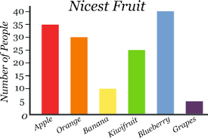

Line Graph
A line graph displays the relationship between two types of information, such as number of school personnel trained by year. They are useful in illustrating trends over time.

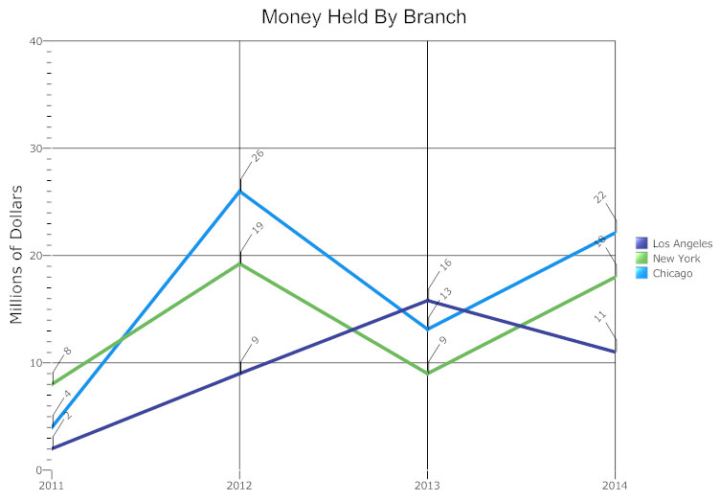

What is a Line Graph?

A line graph, also known as a line chart, is a type of chart used to visualize the value of something over time. For example, a finance department may plot the change in the amount of cash the company has on hand over time.
The line graph consists of a horizontal x-axis and a vertical y-axis. Most line graphs only deal with positive number values, so these axes typically intersect near the bottom of the y-axis and the left end of the x-axis. The point at which the axes intersect is always (0, 0). Each axis is labeled with a data type. For example, the x-axis could be days, weeks, quarters, or years, while the y-axis shows revenue in dollars.
Data points are plotted and connected by a line in a "dot-to-dot" fashion.
The x-axis is also called the independent axis because its values do not depend on anything. For example, time is always placed on the x-axis since it continues to move forward regardless of anything else. The y-axis is also called the dependent axis because its values depend on those of the x-axis: at this time, the company had this much money. The result is that the line of the graph always progresses in a horizontal fashion and each x value only has one y value (the company cannot have two amounts of money at the same time).
More than one line may be plotted in the same axis as a form of comparison. For example, you could create a line graph comparing the amount of money held by each branch office with a separate line for each office. In this case each line would have a different color, identified in a legend.
The line graph is a powerful visual tool for marketing, finance, and other areas. It is also useful in laboratory research, weather monitoring, or any other function involving a correlation between two numerical values. If two or more lines are on the chart, it can be used as a comparison between them.

Making a line graph.
- Create a table. Draw the x- and y-axes on the page. On the top of the page, place a title that briefly describes the purpose of the chart.
- Label each axis. If time is one of the factors, it should go along the horizontal (x) axis. The other numeric values measured should be placed along the vertical (y) axis. Each axis should be labeled with the name of the numeric system as well as the measurements being used. For example, you may label the x axis with "Time (Days)", indicating that each number written on the axis is a number of days. Divide each axis evenly into applicable increments.
- Add data. Data for a line graph is usually contained in a two-column table corresponding to the x- and y-axes. With Smart Draw you can also import data from Excel. Once you've added your data, your line graph will automatically reflect its values. If you want to call attention to any particular value, you can add a label with an arrow pointing to it.
- Create a key. If you are comparing multiple items, you'll want to create a key that identifies what each line is by its color.
Example of a line graph
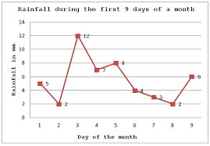

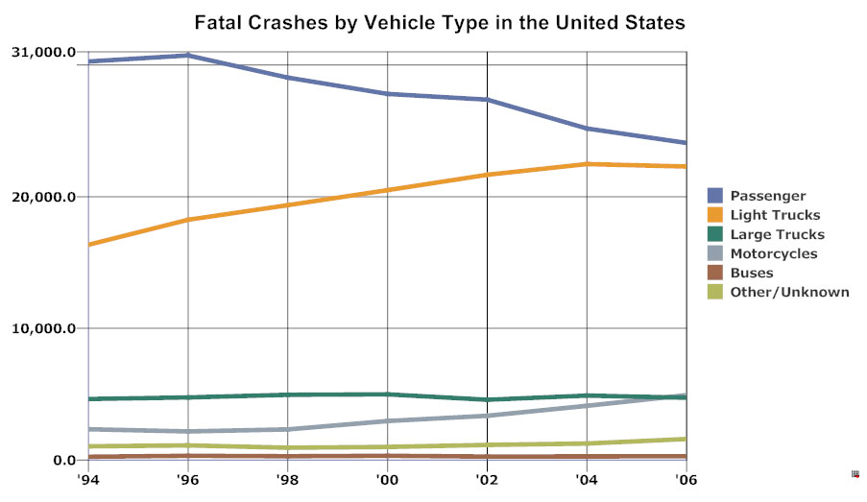
The best way to understand line graphs is to look at some examples of line graphs.

Pie charts and frequency diagrams

Drawing a pie chart
Look at this record of traffic travelling down a particular road.

Type of vehicle | Number of vehicles
Cars | 140
Motorbikes | 70
Vans | 55
Buses | 5
Total vehicles | 270
To draw a pie chart, we need to represent each part of the data as a proportion of 360, because there are 360 degrees in a circle.
For example, if 55 out of 270 vehicles are vans, we will represent this on the circle as a segment with an angle of: (⁵⁵/₂₇₀) x 360 = 73 degrees.
This will give the following results:

Type of vehicle | Number of vehicles | Calculation | Degrees of a circle
Cars | 140 | (¹⁴⁰/₂₇₀) x 360 | = 187
Motorbikes | 70 | (⁷⁰/₂₇₀) x 360 | = 93
Vans | 55 | (⁵⁵/₂₇₀) x 360 | = 73
Buses | 5 | (⁵/₂₇₀) x 360 | = 7
This data is represented on the pie chart below.
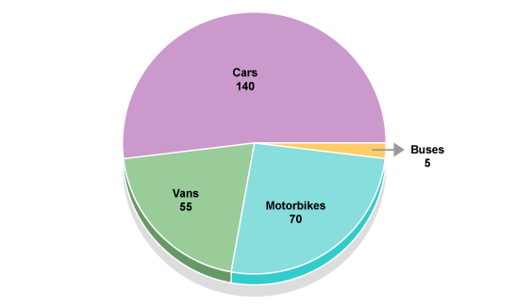

Frequency Distribution Table
Contents
- Frequency Distribution Table?
- making Frequency Distribution:
- Using Tally Marks

What is a Frequency Distribution Table?
Frequency tells you how often something happened. The frequency of an observation tells you the number of times the observation occurs in the data. For example, in the following list of numbers, the frequency of the number 9 is 5 (because it occurs 5 times):
1, 2, 3, 4, 6, 9, 9, 8, 5, 1, 1, 9, 9, 0, 6, 9
Tables can show either categorical variables (sometimes called qualitative variables) or quantitative variables (sometimes called numeric variables). You can think of categorical variables as categories (like eye color or brand of dog food) and quantitative variables as numbers.

The following table shows the mode of transport used by 30 pupils in an early childhood grade at Kabelenge primary school, used to get to school. The left column shows the categorical variable (Method) and the right column is the frequency

A frequency distribution table showing categorical variables
Mode of transport | Number of pupils
Car  Train  Bus  Walking  Bicycle | 3  5  1  11  10
Total | 875
Frequency distribution tables give you a snapshot of the data to allow you to find patterns. A quick look at the above frequency distribution table tells you the majority of pupils Walk to school
The frequency table below shows a how many of the early childhood teacher had a certain number of pets

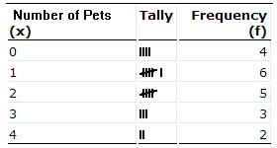

From the frequency table we see that four teachers had no pet, six had only one pet each, five had two pets each, three had three pets each and two had four pets each.
Measures of central tendency
There are three main measures of central tendency: the mode, the median and mean. Each of these measures describe a different indication of the typical or central value in the distribution.
The mean
The mean, often called the average of a numerical set of data, is simply the sum of the data values divided by the number of values. This is also referred to as the arithmetic mean. The mean is the balance point of the distribution.
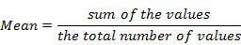
Example
The following numbers represent the number of hours Stephen has worked on the web site for each of the past 7 months: 24, 25, 31, 50, 53, 66, 78.
What is the mean (average) number of hours that Stephen worked on this web site each month?
Solution
Step1: add the numbers to determine the total number of hours he worked.
Step2: divide the total by the number of months.
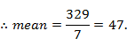
The median
The median is the number that falls in the middle position once the data has been organized. Organized data means the numbers are arranged from smallest to largest or from largest to smallest. The median for an odd number of data values is the value that divides the data into two halves. If n represents the number of data values and n is an odd number, the median will be found in the 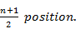
Example
Find the median of the following data:
12, 2, 16, 8, 14, 10, 6.
Solution
Step 1: organize the data or arrange the numbers from smallest to largest.
2, 6, 8, 10, 12, 14, 16
Step2: since the number of data values is odd, the median will be found in the
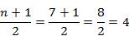
Step 3: in this case, the median is the value that is found in the fourth position of the organized data.
Hence the median is 10.
The mode
The mode of a set of data is simply the value that appears most frequently in the set.
If two or more values appear with the same frequency, each is a mode. The downside to using the mode as a measure of central tendency is that a set of data may have no mode, or it may have more than one mode. However, the same set of data will have only one mean and only one median.
- The word modal is often used when referring to the mode of a data set.
- If a data set has only one value that occurs most often, the set is called unimodal.
- A data set that has two values that occur with the same greatest frequency is referred to as bimodal.
- When a set of data has more than two values that occur with the same greatest frequency, that set is called multimodal.

Example
Find the mode of the following data:
76, 81, 79, 80, 78, 83, 77, 79, 82, 75
Solution
There is no need to organize the data, unless you think that it would be easier to locate the mode if the numbers were arranged from least to greatest. In the above data set, the number 79 appears twice, but all the other numbers appear only once. Since 79 appears with the greatest frequency, it is the mode of the data values.

Experimental Probability

What Does Probability Mean?
Probability is the chance that something will happen, or how likely it is that an event will occur.
When we toss a coin in the air, we use the word probability to refer to how likely it is that the coin will land with head's side up.
Experimental probability refers to the probability of an event occurring when an experiment was conducted.
Experimental probability = $\frac{\text{Number of event occurrences}}{\text{Total number of trials}}$
For example, if a dice is rolled 1000 times and the number '3' occurs 50 times, then the experimental probability that '3' shows up on the dice is 50/1000 = 0.05
On the other hand, theoretical probability is determined by noting all the possible outcomes theoretically, and determining how likely the given outcome is. Mathematically, For example, the theoretical probability that the number '3' shows up on a dice when rolled is 1/6 = 0.167. This is because of the 6 possible outcomes (dice showing '1', '2', '3', '4', '5', '6'), only 1 outcome (dice showing '3') is favorable. As the number of trials keeps increasing, the experimental probability tends towards the theoretical probability. To see this, the number trials should be sufficiently large in number. Experimental probability is frequently used in research and experiments of social sciences, behavioral sciences, economics and medicine.
In cases where the theoretical probability cannot be calculated, we need to rely on experimental probability.
For example, to find out how effective a given method is a teacher apply a given method to a class. We then find out how many pupils passed this would give us the experimental probability that a method is effective to be the ratio of number of pupils who passed to the total number of pupils tested. It should be noted that in order for experimental probability to be meaningful in research, the sample size must be sufficiently large.
Why Teach Probability in the Elementary Classroom?
The study of probability in the early grades provides a stronger foundation for pupil. In addition, the study of probability allows learners to make sense of experiences involving chance. Probability also connects many areas of mathematics, particularly counting and geometry (NCTM, 1989). An understanding of probability theory is essential to understand such things as politics, weather reports, genetics, sports, and insurance policies. As shown Table 1, the list of questions present

Activity

  - Eighty pupils were asked which subject they like most. 16 said Mathematic, 20 said English, 12 said science, eighteen said Geography, and 14 said Religious education.
(i)Represent the information in a table
(ii)Calculate the number of degrees required to represent each answer in a pie chart, hence draw a pie chart
  - Explain how children develop statistical thinking?
  - What are some of the materials a teacher can use in order to involve children in working with data and probability?
  - Discuss with illustrations some of the sources of data and graphs for young children?
  - Discuss some of the ways that adults can use to stimulate children to interpret data they have collected, organized and displayed.
  - Mark operates technology Titans, a web site service that employs 8 people. Find the mean age of his workers if the ages of the employees are as follows:
55, 63, 34, 59, 29, 46, 51, 41
  - Find the median of the following data: 1, 1, 3, 4, 4, 6, 7, 8, 9, 11.
  - The ages of 12 randomly selected customers at a best buy are listed below: 23, 21, 29, 24, 31, 21, 27, 23, 24, 32, 33, 19. What is the mode of the above ages?

Reflection

You have just completed working through statistic and probability. Apply and extend what you have learned in this unit by completing the following and sharing it with others-children or adults:
Like other mathematics topics for young children, working with data and probability have the potential for enhancing children’s problem –solving, communicating, and reasoning abilities and for connecting to everyday life. Devise an activity and list 10 ways that children’s skills and understandings in these four areas can be strengthened. Share your list with a colleague, improve and revise it, then represent it to a larger group for their comments.

Unit summary

In this unit you learned about how statistical thinking develops, materials for involving children in working with data and probability, how to gather, organize and display data, sources of data, and graphs for young children, how to interpret data and how to introduce probability to young children.

Unit 4

Matrices

Introduction
A matrix is a collection of numbers arranged into a fixed number of rows and columns. Usually the numbers are real numbers. In general, matrices can contain complex numbers but we won't see those here.

Upon completion of this unit you will be able to:
Outcomes | - Identify types of matrices.  - Add Matrices.  - Subtract matrices .  - Multiply matrices by a scalar  - Multiply matrices.  - Determine the determinant and inverse of a matrix.

Matrix

Basic operations
There are a number of basic operations that can be applied to matrices such as addition, subtraction and multiplication.

Types of matrices
In this section various types of matrices will be discussed.
Upper triangular matrices
A upper triangular matrix is a square matrix in which all the elements below the diagonal are zero, as shown below.

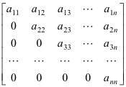

Lower triangular matrices
A lower triangular matrix is a square matrix in which all the elements above the diagonal are zero as shown below.

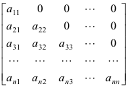

Diagonal matrices
A diagonal matrix is a square matrix in which all of the elements are zero except for the diagonal elements, as shown below.

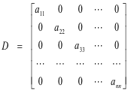
A Scalar matrix is a diagonal matrix in which all of the diagonal elements are equal to some constant “k”.

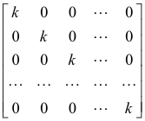

An Identity matrix is a diagonal matrix in which all of the diagonal elements are equal to “1" as shown below.

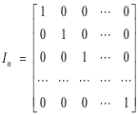

An identity matrix of order n x n is denoted by I_{n} .

Adding and Subtracting Matrices
Two matrices may be added or subtracted only if they have the same dimension; that is, they must have the same number of rows and columns.
Example1
Evaluate
here, add corresponding elements.
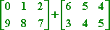
To add the two matrices, the zero in the first matrix is added to six in the second matrix, and one to five and two to four. Thus each element in the first matrix is added to the element in the second matrix in a corresponding position.
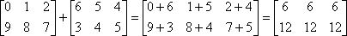
So the answer is:

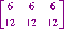
In the above example, both matrices have the same number of rows and columns (2 rows and 3 columns), so they can be added and subtracted.
Example 2
Evaluate
$\left[\begin{matrix}4 & 3 \\ 5 & 6\end{matrix}\right]$- $\left[\begin{matrix}2 & 1 \\ 3 & 2\end{matrix}\right]$= $\left[\begin{matrix}2 & 1 \\ 2 & 4\end{matrix}\right]$
Example 3
Evaluate
$\left[\begin{matrix}3 & 3 & 4 \\ 4 & 5 & 6 \\ 3 & 4 & 5\end{matrix}\right]$ -$\left[\begin{matrix}2 & 1 & 3 \\ 1 & 6 & 4 \\ 5 & 2 & 3\end{matrix}\right]$=$\left[\begin{matrix}1 & 1 & 1 \\ 3 & −1 & 2 \\ −2 & 2 & 2\end{matrix}\right]$

Multiplication of a matrix by a constant
We can multiply a matrix by some value by multiplying each element with that value. The value can be positive or negative. This value is called a scalar.
Example 4
Given that A = $\left[\begin{matrix}4 & 3 \\ 5 & 6\end{matrix}\right]$, find 2A
Solution
Here, multiply each element with the scalar 2.
2A = $\left[\begin{matrix}8 & 6 \\ \text{10} & \text{12}\end{matrix}\right]$
Multiplying Matrices
We can multiply a matrix (A) by another matrix (B) if the number of columns in A is equal to the number of rows in B. Multiplication of A by B is typically written as A (B) or (A) B.
Given that A =$\left[\begin{matrix}2 & 3 \\ 3 & 1\end{matrix}\right]$ and B =$\left[\begin{matrix}2 & 3\end{matrix}\right]$ A is a 2 x 2 matrix and B is 1 by 2 matrix
Notice that we find BA because the number of columns in B is equal to the number of rows in A. But we cannot find AB because the number of columns in A are not equal to the number of rows in B (in bold).

Example 5
Evaluate
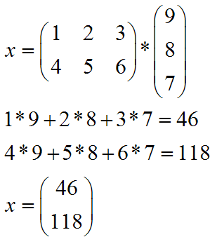
Determinant and Inverse of a matrix
Determinant
The determinant of the matrix A = $\left[\begin{matrix}a & b \\ c & d\end{matrix}\right]$is given by ad –bc.
Example 6
Given that A = $\left[\begin{matrix}6 & 8 \\ 3 & 9\end{matrix}\right]$, find the determinant of matrix A.
Determinant
Inverse of a matrix
The Inverse of a matrix A = $\left[\begin{matrix}a & b \\ c & d\end{matrix}\right]$ is given by $\frac{1}{\text{datA}}$ $\left[\begin{matrix}d & −b \\ −c & a\end{matrix}\right]$and is denoted by A⁻¹

Example 7
Given that A = $\left[\begin{matrix}6 & 8 \\ 3 & 9\end{matrix}\right]$find the inverse of A.
Solution.
The determinant = (6x9)-(3x8) = 54-24 = 30, hence the inverse of A is
A⁻¹= $\frac{1}{\text{30}}$$\left[\begin{matrix}9 & −8 \\ −3 & 6\end{matrix}\right]$= $\left[\begin{matrix}\frac{3}{\text{10}} & −\frac{4}{\text{15}} \\ −\frac{1}{\text{10}} & \frac{6}{\text{30}}\end{matrix}\right]$

Transpose of a matrix.
The matrix resulting from interchanging the rows and columns in the given matrix A is called the transpose matrix and is denoted by A^{T}
Example 8
Find the transpose of matrix A given that
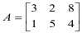
Solution:
The transpose is given by

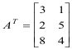

The first row of A becomes the first column of A^{T}, the second row of A becomes the second column of A^{T},

Activity

Activity | Given that A = $\left[\begin{matrix}6 & 7 \\ 2 & 6\end{matrix}\right]$, B = $\left[\begin{matrix}6 & 8 \\ 3 & 9\end{matrix}\right]$ , C= $\left[\begin{matrix}6 & 5 \\ 8 & 9\end{matrix}\right]$ and D= $\left[\begin{matrix}2 & 1 & 7 \\ 3 & 6 & 8 \\ 5 & 7 & 9\end{matrix}\right]$  - Evaluate the following where possible:  - A + B  - (ii) A – C  - (iii) B+ D  - D + D  - (vi) 3B  - (vii) AB  - (viii) CD  - (vi) A^{T}  - (v) D^{T}  - For each of the matrix A, B, C, and D find the Determinant and Inverse

Reflection

You have just completed working through unit four. Think of what you have learned in this unit and how it would help you broaden your understanding of the matrices.

Unit summary

In this unit you have learned the operation on matrices: addition, subtraction, multiplication, determinant and inverse

Unit 5

Building assessment into instruction
Introduction
The word Assessment is frequently used by different professionals and meaning different things according to context and purpose. The use may overlap and does not render it useless to assess to specific needs despite having been done elsewhere. You may also have your own understanding. What comes into your mind when you think of assessment in early learning of mathematics?

Assessment is the process of collecting, synthesizing and interpreting information to help classroom decision –making of the teacher. Assessment in early learning primarily involves observation what children are doing and hearing what they are saying which come with its own challenges in having meaningful assessment. However, it is from this data that you the teacher may know what type of instructions should be given to the learners.
Upon completion of this unit you will be able to:
Outcomes | - Identify children who may be in need of specialized services  - Plan instruction for individuals and groups of children.  - Assess how well a program is meeting goals for children  - Identify program improvement and staff development needs.  .

Forms of Assessment
As earlier discussed, assessment has a broad meaning and what is involved. The purpose includes assessment for teaching and learning, assessment for management and accountability and assessment for research (Fawcett, 2009). Assessment in early learning include observing children, gathering evidence about each child’s knowledge, behaviours, and dispositions, documenting the work that children do and how they do it and making inferences from that evidence for a variety of purposes. Assessment can be formative, summative, diagnostic, evaluative and informative. We shall take to explore these types of assessment.

Formative assessment
An assessment designed to measure progress on an objective rather than to give a qualitative result. Normally it is used during instructional periods to monitor how learners are progressing and serves as a planning tool based on individual children’s need.

Diagnostic assessment
Assessment is done to identify possible barriers to progress in learning such as deafness, dyslexia, hyperactivity, where a child may need special help or targeted activities. This assessment also help to identify current challenges in a child’s life such as neglect or abuse that can take different forms like physical, emotional or sexual.

Summative assessment
A final assessment to assign a grade or determine mastery of an objective. This comes at a conclusion of a term or a year or any defined period. This type of assessment in children must be taken with caution as may not be ideal for younger children. This may involve a test type situation where children are easily distracted, are sensitive to social context if a non-familiar person is involved, tensed with the test environment as well as interpersonal relationships. It assumes the teacher that the children understand the concept being taught and can move on to the next stage of instruction.

Evaluative assessment
You may have heard of review of performance; this is another way of referring to evaluative assessment. It does not so much focus on individual children but though it contributes as well. It primarily focuses on quality of activities, equipment, contribution of staff and the general environment.

Informative assessment
You may need to differentiate between formative and informative assessment. Informative assessment focuses on reciprocal sharing of information between parents and early learning staff. It recognises the fact that both parents and staff are educators with varying responsibilities. In this assessment, record keeping forms a very important element, hence maintenance of a learner’s profile is cardinal.
There are five common assessment strategies namely:
1. Observation
2. Interview
3. Performance tasks
4. Portfolio
5. Children writing including self-assessment
These are procedures used to collect information and should be matched to the purpose for which information is being collected. A teacher may conduct a formal or informal interview. Formal methods and procedures are used for higher stakes decisions as the use of formal tests with young children is generally considered inappropriate except for purposes of identifying disabilities, establishing eligibility, and documenting program accountability (Naeyc & naecs/sde, 2003).
In a formal interview the child spends time alone with the teacher and the teacher on an assessment form records the child’s actions as she ask the child questions like ‘ how did you figure it out’ meaning the answer.
Informal interview involves good questioning techniques to assess whether the child really understands the concept especially when planning or getting started on an activity. Good teachers use informal interviews as a part of the daily class routine.
Interviewing techniques are key to the success of many problem- solving curriculums. For instance, the first –grade child has just finished writing a story and number sentence about three groupings of buttons. Each child received a bag of buttons and three plates. After sorting the buttons, the teacher interviewed each child.
Teacher: What groups do you have?
Children share their findings with other children in class so that other children can see the variety of options possible.
Teacher: How many different ways did we sort our buttons
Children responded accordingly
Teacher: Is there another way of making the groups?
Children put back the buttons in one pile, and the children tries to form other groups. The class noticed that there are many ways to classify buttons hence the idea of classification, sorting and making patterns.
Portfolios
This is a format for conducting an evaluation of a child. Portfolios are a collection of a child’s work. Teachers’ assessments and other information that contributes to a picture of the child’s progress. Most teachers develop a workable format that includes a cover, table of content a small number of items and written narrative on why each piece was selected.
It has several unique advantages:
- Helps children take ownership over their own learning.
- It gives teachers a vehicle to communicate more effectively to parents about children’s progress
- It focuses on the child’s strengths and accomplishments.
- It contains a wide variety of work samples and performance indicators
- In some schools it is a means to evaluate instructional programs
- It’s organization and presentation fosters critical thinking and higher level mental processes
Observation
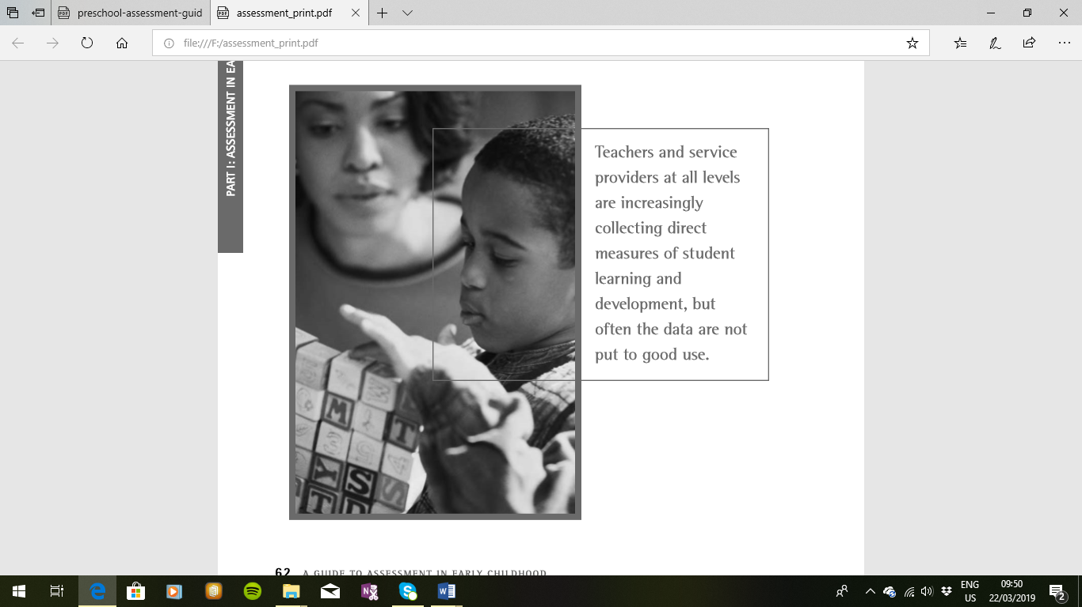
This is a natural part of the teaching / learning process. At school the teacher is the one who notices and decide on what to do with the children whether to change the lesson or redirect the focus of the activity. The teacher is usually alert to when children displays signs of discovering a solution or exhibit behavior that signals that the children are confused. Because so many things happen in a day .So the teacher must devise a plan which is workable to keep record of all what transpires and later all these observations are summarized in to a more formal report. When a child seems to struggle with a certain activity which might be simple like sorting things then it is important for the teacher to investigate because all children have strength as well as weaknesses.
Performance Tasks
Performance tasks help teachers assess the aspect of progress on attainment of key outcomes. Children’s achievement is judged by awarding points based on a scoring system that has been established as a criteria for success .Performance tasks includes assignments, homework, quizzes, examination, class presentations etc.
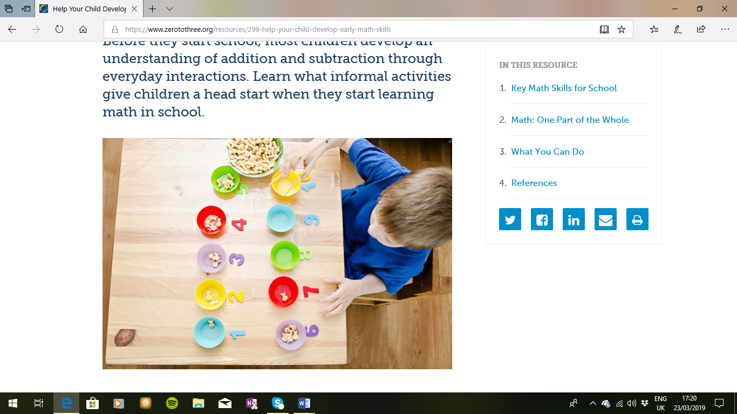

Building Assessment into Instruction
This section of the guide presents summary and specific information for a large compendium of assessment instruments, and is presented as a companion to the narrative about assessment purposes and recommended practices included in Part I. Like all tools, assessment instruments are designed for specific purposes, and to be useful the tool needs to match the task. In order to make informed decisions about assessment instruments, professionals need to understand each assessment task by recognizing the exact purposes for which they are collecting information, and knowing how the resulting data will be used.

Early Childhood Assessment
We purposefully have not designated any tools specifically for school readiness assessment, despite the fact that many schools and districts engage in some type of assessment as children enter school as kindergarten students. As with all assessments, it is important that these tools be selected with care. First and foremost, the school needs to consider the reasons they are assessing entering kindergarteners. If the purpose of the assessment is to identify children who need additional supports or services, it makes most sense to choose a tool (or tools) designed for screening appropriate for kindergarten-aged children and covering a wide variety of domains. At a minimum, the tool or tools selected should include cognitive, language, motor, and socio-emotional skills. If the school is assessing in-coming kindergartners in order to make instructional plans, then tools should be selected that are appropriate for informing instructional and are in line with the school’s kindergarten curriculum. As noted in the first section of this guide, kindergarten assessments should never be used to screen children out and delay kindergarten entry. Children who have the most to learn should have the opportunity to begin school as soon as possible, with the maximum instructional supports in place. Instead, if assessments are used as a regular part of kindergarten entrance, they should be selected to ensure that every child benefits maximally from the kindergarten experience.
The instruments are intended as tools for gathering information, not as meaningful stand-alone products. Think of the actual assessment resources as analogous to the internet browsers used to find information on the computer. An assessment instrument, like a browser, is only as good as the information it yields. Assessment tools provide a structure for accessing and organizing information about early learning and development, but knowing which instrument to select can be confusing and complex.
This section is designed to provide a foundation for understanding the purposes, types, and methods of assessment as a framework for developing a system that meets the needs of the children you serve.
Consideration in Early Childhood Assessment
Early childhood professionals are feeling ever-increasing pressure to document learning outcomes in an era of standards, accountability, and achievement testing. In addition to parents, we are the people responsible for the well-being of young children. Many professionals have legitimate concerns about misuse of assessment practices and instruments, and the potential for inequitable consequences for the children in our programs. Before discussing the various purposes, types, and methods of assessment, it is important to consider some implications of the unique nature of early development and learning:
- Complete and meaningful assessment in early childhood necessitates an understanding of family context, including getting to know family language and culture, gathering developmental information from parents, and conducting home visits with parent approval. This principle applies to all youngsters and families, but is especially critical for children whose families may not share the language or some of the economic advantages of the dominant culture. Understanding family expectations and experience places a child’s behaviour in context and can prevent harmful decisions that result from misinterpretation of assessment data (NAEYC, 2005).
- Younger children present some complex challenges and require flexible procedures for gathering meaningful and useful assessment information. Constitutional variables such as fatigue, hunger, illness, and temperament can easily overshadow the abilities of a young child. Time of day, setting, testing materials and other situational factors also affect performance. The younger a child, the more likely he or she is to fall asleep, become distressed, and refuse to comply with directions, or be distracted from assessment activities. Professionals should be prepared to modify activities, explore alternative procedures, and/or reschedule rather than risk gathering faulty information that compromises assessment results.
- Young children learn by doing, and demonstrate knowledge and skills through action-oriented activities. Authentic assessment of youngsters as they participate in daily activities, routines, and interactions generally produces the most valuable information for assessment. To the extent possible, assessment methods should allow for observation of young children engaged in spontaneous behaviours in familiar settings and with familiar people.
PART I: ASSESSMENT IN EARLY CHILDHOOD
- More assessments and increased data do not necessarily result in better assessment information. Early childhood professionals should only gather information they need, and know ahead of time how they will use all the information collected. It is generally most desirable to identify a set of appropriate methods and instruments that provide necessary information, and refine the use of those procedures over time.
- Some assessment instruments and procedures are better than others. Factors such as purpose, content, reliability and validity, efficiency, cost, and availability of professional development are all more important than appealing packaging and effective advertising. Of primary importance is the quality of information gathered and the decisions made as a result of assessment. Ultimately, whatever assessments we conduct should benefit the children, families, and programs we serve.
By now it is obvious that assessment in early childhood is a complicated and multifaceted enterprise. Recommendations from the field and the professional literature indicate that early care and education programs should incorporate into their services, coherent systems of assessment organized to address the following purposes:
- Screening: To identify potential problems in development; ensure development is on target.
- Instructional: To inform, support, and monitor learning.
- Diagnostic: To diagnose strengths and areas of need to support development, instruction and behaviour. To diagnose the severity and nature of special needs, and establish program eligibility.
- Program Evaluation and Accountability: To evaluate programs and provide accountability data on program outcomes for the purpose of program improvement.
Each purpose of assessment provides different levels of information to answer specific questions about early learning and development. We will describe each of the four purposes listed above more completely in subsequent sections of the guide, providing just a brief overview of each purpose here. At the end of this section is a graphic representation of an assessment system that includes screening, instructional, and diagnostic assessments.
PART I: ASSESSMENT IN EARLY CHILDHOOD
Screening Assessment
Screening is a process designed for the purpose of identifying potential problems in learning or development. Screening instruments are quickly and easily administered to identify children who need more extensive assessment. Screening is a vital assessment activity in almost all early childhood programs because positive developmental and academic outcomes are associated with early identification of and attention to problems.
Instructional Assessment
The most important reason for assessment in early childhood is to support early learning and development. This level of assessment yields information about what children know and are able to do at a given point in time, guides “next steps” in learning, and provides feedback on progress toward goals. Assessment to support instruction is a continuous process that is directly linked to curriculum. Instructional assessments are aligned directly with curriculum goals which, in turn, are aligned with early childhood standards such as the Washington Early Learning and Development Benchmarks.
Diagnostic Assessment
Diagnostic assessment is a thorough and comprehensive assessment of early development and/or learning for the purpose of identifying specific learning difficulties and delays, disabilities, and specific skill deficits, as well as evaluating eligibility for additional support services, Infant Toddler early intervention, and special education. Diagnostic assessments usually are conducted by trained professionals using specific tests. When used to determine eligibility for specific support services, early intervention and special education, diagnostic assessment is a formal procedure governed by federal and state law.
Assessment for Program Evaluation and Accountability
Assessment for program evaluation and accountability addresses program-level outcomes. While instructional, screening, and diagnostic assessments address the development and learning of individual children, program evaluation and accountability assessments focus on the performance of groups of children. In addition, program evaluations routinely address variables, such as the quality of personnel and the physical environment, effectiveness of parent involvement, and community collaboration activities. Accountability assessment is often required by external agencies and used by policy makers to make decisions about funding, needed program supports, and program requirements.
Methods of Assessment
Methods of assessment refer to the procedures used to collect information and should be matched to the purpose for which information is being collected. As a general rule, more formal methods and procedures are used for higher stakes decisions. It is easy to think of assessment only as testing, but the use of formal tests with young children is generally considered inappropriate except for purposes of identifying disabilities, establishing eligibility, and documenting program accountability (NAEYC & NAECS/SDE,
2003). Neisworth & Bagnato (2004) make a persuasive argument that “conventional testing must be abandoned within early childhood for every purpose including screening, eligibility determination, program planning, progress monitoring, and notably, program evaluation outcomes research” (pg. 199). Their indictment covers every purpose for assessment described above, and they recommend authentic alternatives for all forms of early childhood assessment instead.
Because early development is complex and dynamic, the most effective assessment procedures are characterized by a combination of methods and sources of information. Developmental checklists, rating scales, caregiver interviews, and portfolios of children’s work are useful methods for gathering information about progress toward developmental goals. Increasingly, new assessment instruments incorporate caregiver reports and observation of specific developmental and content standards, and some states now allow use of authentic, observational instruments for eligibility determination.
Specific methods of collecting assessment information relevant to curriculum planning and monitoring child progress are described in the section on Assessment to Inform and Monitor Instruction.
Types and Properties of Assessments
The interpretation of assessment data is dependent on the purpose and method of the assessment, and the type of data collected. Assessment tools are generally designed for a single purpose and it does a great disservice to children to use them otherwise. Screening instruments, for example, cannot be used to inform or monitor instruction, or to qualify a child for Infant Toddler early intervention or special education services. Program accountability data provide little, if any, information useful for planning individual instruction. The brief review of the various types of assessments that follows is designed to provide background information, introduce terminology, and illustrate some potential areas of misuse.
Standardized assessment involves a predetermined set of assessment items that represent “standards” of knowledge and/or skills. Standardized tests may be norm or criterion referenced, and items are presented to all children in the same sequence, using the same administration procedures and materials.
Scoring and interpretation of performance is also standardized. Scores on standardized tests can unfairly penalize specific groups of children, such as English language learners and youngsters with receptive language delays who do not understand verbal directions. Children with sensory and physical impairments may not be able to demonstrate skills if the standard set of materials cannot be modified to accommodate their responses.
Norm-referenced assessments compare a child’s score to the scores of a group of same-age peers (norm group). Such a comparison is only meaningful if the norm group includes children who share the language, culture, and/or (dis)abilities of those being assessed. Norm-referenced assessments yield numerical scores that can underestimate the performance of young children with disabilities, those learning English, and those whose early experience differs significantly from the “norm”. Norm-referenced tests are almost always standardized to preserve a consistent basis for comparison of scores.
Criterion-referenced assessments measure a child’s performance against a predetermined set of criteria, generally developmentally sequenced or task analysed skills. Criterion-referenced measures yield performance profiles and numerical scores that reflect the number of skills mastered. These instruments may be standardized, as in the case of oral reading fluency timings in primary grades, but for developmental content usually allow flexibility in administration procedures and assessment materials.
Curriculum-referenced assessments are criterion-referenced instruments that are packaged with an aligned set of curriculum goals. Curriculum-based assessment serves to place children in a curriculum sequence and the same items are used to monitor progress toward learning objectives. These assessments often provide a logical teaching sequence, and may also include instructional activities.
Readiness assessments are tests that gather information to determine how well a child is prepared for
a specific program. In early childhood, readiness assessments are most frequently used (some would say misused) at kindergarten entry. Readiness assessments become problematic when the results are used to exclude children from programs rather than to identify areas where extra support is needed. The following three terms are also important to understand and consider when selecting and using any assessment instrument:
- Reliability refers to the accuracy and stability of assessment scores. Every assessment contains some degree of error (in administration, scoring, interpretation) and error decreases accuracy of scores. Assessment developers ensure reliability by testing the same children twice, by having multiple people score the same child, and by statistical analysis of items.
- Validity is an indication of how closely the assessment measures what it is intended to measure. An assessment has to be reliable in order to be valid. Assessment developers make logical hypotheses and analyse groups of test scores to see if the hypotheses hold. Logical hypotheses for a developmental test are that older children score higher than younger children, and children with identified physical and language disabilities score lower in those domains. A screening instrument demonstrates validity if children who are identified by screening to have a problem also receive low scores on a comprehensive test of development.
- Technical adequacy describes the degree of demonstrated reliability and validity of a test. Technical information is often included in the assessment guide. Technical adequacy is an important consideration when selecting assessment instruments for any purpose, although norm-referenced assessments generally have more information on reliability and validity than do criterion-referenced instruments.

Recommendation Practices in Assessment to Inform and Monitor Instruction
The challenge for teachers and others who plan early childhood curriculum is to determine how much assessment data to gather and how to use the resulting information. The key is to organize sustainable infrastructure that facilitates gathering meaningful information on every child regularly and systematically.
1. The best instructional assessment information is collected frequently and used continuously to inform curriculum and instruction decisions. Young children learn quickly, and regular monitoring of progress is necessary to document incremental improvements in skills and behaviours.
Teachers and other adults are more likely to collect, interpret, and apply assessment data if the process is built into the daily classroom schedule and responsibilities.
2. Assessment to inform and monitor instruction is most accurate if multiple sources are considered and multiple methods used. Because much of young children’s learning and development occurs outside classrooms, it is important that competencies and progress are considered in all contexts and environments. The richest results are obtained when the perspectives of parents, care givers, teachers, specialists, and children themselves are combined. Assessment instruments that gather information by observation and report, and include components for parents to report on children’s developmental and academic progress, provide a helpful structure.
3. Methods used to collect instructional assessment information should resemble on-going instruction and the interactions of home, child care centres, and classrooms. There are valid concerns about the negative effects of testing on young children. One of the biggest advantages of assessment to inform and monitor instruction is that the process seldom necessitates individualized testing. Adults should be able to collect instructional assessment data using the same experiences designed to facilitate preschool learning in group activities, support parent/infant interactions at home, or provide instruction in primary classrooms.
4. Assessment instruments should be criterion-referenced with items that reflect functional skills.
Actual assessment items and administration procedures will vary depending on whether the focus is in development or early academics. Nonetheless, a repeated measure of performance across a sequence of skills that reflects curriculum goals provides the best documentation of children’s progress. Assessment to inform and monitor instruction is only as good as the curriculum and instruction young children receive. Assessing what we teach and teaching what we assess is essential for meaningful instructional assessment.
5. Instructional and classroom assessment instruments should ideally reflect a logical teaching sequence. Assessments to inform and monitor instruction are most useful if items are organized in a sequence that reflects major skills in the curriculum, along with prior knowledge and prerequisite skills. This organization maps the curriculum for teachers and provides guidance for selection of subsequent learning goals.
6. If results are being used to develop plans and monitor progress toward IEP goals or IFSP outcomes, instructional assessments must have data available to document reliability and validity.
A guide to Assessment in Early Childhood
Data about the technical properties of tests are necessary for professionals to have confidence that individualized plans of instruction will be accurate and effective. Children receiving additional help cannot afford to spend instructional time or everyday learning activities working on goals, objectives, or outcomes that are too easy or too difficult. In addition, it is critical that changes in assessment results reflect real progress rather than inconsistencies in administration, scoring, or interpretation of assessment results.
7. Instructional assessment instruments and procedures must be culturally and linguistically relevant.
If the basic skills represented in early developmental and academic curricula are functional and appropriate for young children, instructional assessments have the advantage of being able to incorporate familiar materials, people, routines, and important events of a child’s life. On developmental CBAs, items that are culturally inappropriate can be revised, and parents can suggest more familiar and appropriate materials and behaviours. It is especially important that English Language Learners not be penalized by test materials or directions that confuse cultural and language differences with cognitive or academic delays. Selecting methods and organizing a system for gathering instructional assessment data for even a small group of young children might initially seem to be an intimidating undertaking. The good news is that there are many existing models and instruments to use in designing an approach that will work best for any given program, many of which are listed at the end of this section under Potential Instruments and Additional Resources. Including CBAs in assessment systems for birth to five-year-olds offers a structured and consistent framework for periodic collection of instructional assessment information. Most early childhood CBAs can be scored primarily or totally via observation of children engaged in activities and interactions at home, in child care settings, or in the classroom. Detailed results identify precisely the skills and behaviours that have been acquired, those that need more practice, next steps in learning, and problematic skill and knowledge areas. Similarly, the use of CBM is an efficient, reliable, and valid approach to identification of early academic goals, diagnosis of academic problems, and progress monitoring. A summary of characteristics of instruments to inform and monitor instruction is included at the end of this section.
Methods for collecting on-going Assessment Information
Effective instructional assessment does not require any one particular method to collect, interpret, or share the information. Any of the assessment methods described below can be employed, preferably in combination, to gather instructional assessment data. Selections of specific methods and instruments will depend on the size of the group, ages and characteristics of children, areas being assessed, and program resources. The most popular and useful methods include:
Interviews – Interviews involve collecting child assessment data that is reported by people familiar with children’s skills and behaviours. Interviews are useful for including the multiple perspectives of parents, other adults, and children themselves. Interviews are the preferred method for gathering contextual information to clarify a child’s history, describe variability across settings, and identify family priorities. Some CBAs include structured components for parents to report directly on child development and learning.
Permanent Products of Children’s Work – A popular method for documenting certain types of skills is to collect and display children’s work over time. Viewing progress of skills in drawing and writing is especially efficient and informative. Audiotapes of language samples and oral reading are also very illustrative. Permanent products are often included in portfolios that are organized to include observation records, photos, interview excerpts, and other sources of assessment information.
Direct Assessment – Direct assessment has traditionally meant removing children from familiar environments and testing them individually. Currently, direct testing for purposes of informing and monitoring instruction of infants, toddlers, and pre-schoolers is more likely to involve observation of individual children as they play and interact at home and school. In primary grades, direct assessment of early academic skills is usually conducted at the classroom level and interpreted individually.
Using Instructional Assessment Effectively
Every method of assessment has advantages and drawbacks. Repeated observations of youngsters over time and across settings provides rich and detailed information on authentic performance, but requires design of a system for organizing and summarizing information, as well as a significant time investment for both collecting and interpreting data. Interviews with parents and observations of children at home are especially informative for English Language Learners, but often entail the services of an interpreter. Permanent products of children’s work provide concrete samples of progress over time, but are only representative of specific types of skills.
Mixing and matching methods can create flexibility in collecting information to accommodate the characteristics of individual children within a systematic plan that is realistic for an entire group of youngsters. In collecting samples of early writing, for example, a teacher could decide to sample twice as many products from a child growing up in a bilingual home. Likewise, an interview in the home might supplement a brief written survey that all parents fill out. Record Keeping
Recording Record the child’s answers and strategies in the student record booklets. Keep any recording discreet. Some children become anxious if they see check marks being recorded. If the child self-corrects, record the revised answer. Record any additional information in the “Comments” column. For example, when counting on from 57, the child may look around the room to locate numbers on the 100 chart. Do not try to interpret the child’s responses on the spot. Complete the assessment, and look over the results later.

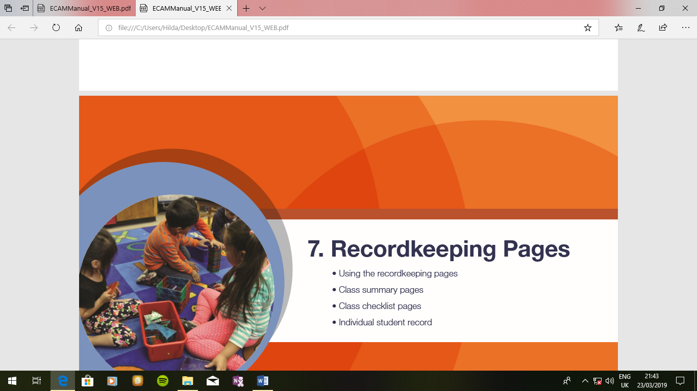
CHECKLIST FOR THE CHILDREN
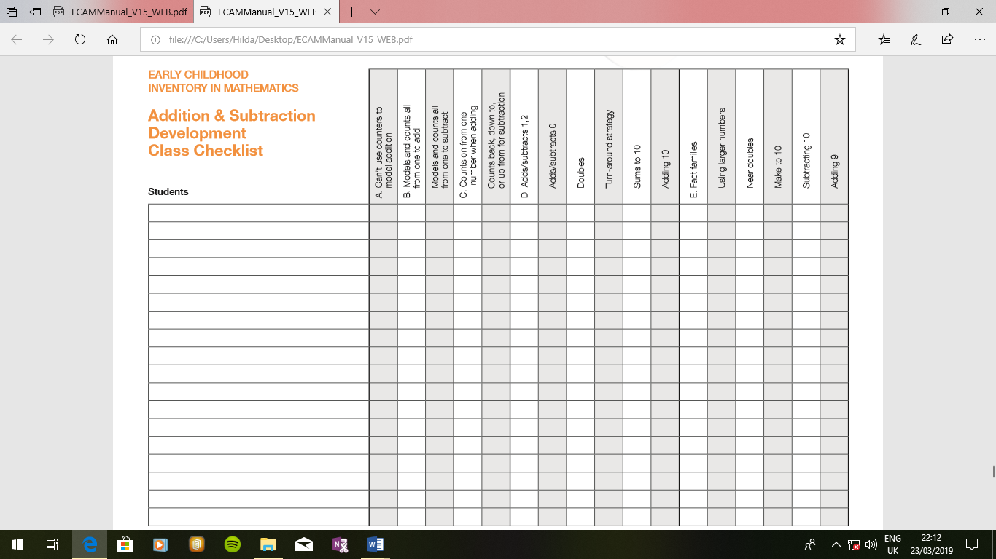

Reflection

In this unit you have discussed issues of children assessment in pre-maths and its importance. Now choose one of the assessment principles and describe its intent and impact on the early childhood classroom, Prepare a 5 minute presentation and be ready to share your ides with the class.

Unit summary

- In this unit you have learned that observation is the basic tool of assessment.
- Informal activities give the children a head start when they do mathematics in school.

Unit 6

Planning to Teach

Introduction
Planning to teach is a very important component of teacher training for Early Childhood Education teachers for either pre-service or in-service students. Student teachers need to acquaint themselves with various teaching strategies that focus on learner centeredness in order to ensure effective inculcation of knowledge, skills and positive attitudes. This topic brings out the fundamental core of developmental appropriate teaching practices of mathematics. It combines an understanding of how children learn, how to promote that learning by teaching through play and using the processes of problem solving, communication, representation, reasoning and proof and connections.
Upon completion of this unit you will be able to:
Outcomes | - Use the process of problem solving, communication, representation, reasoning and proof and connections in the teaching of mathematics.  - Investigate conceptual understanding of the major domains in mathematics  - Link content to psychological research and developmental benchmarks  - Explain constructivism theory, developmental theory and Piaget’s cognitive theory.  - Explain how to plan for teaching  - Explain various ECE teaching methods and approaches  - Design a schemes of work, weekly forecast and lesson plan.  - Show deep understanding of the pre-mathematics school syllabus.

ECE pre-mathematics school syllabus
What is the early childhood education pre-mathematics school syllabus?
It is a document that attempts to transmit to the young learners the knowledge, skills, positive attitudes and values that will allow them to live and grow into resourceful and useful members of their communities. The syllabus will provide the children with opportunities and experiences which are mathematical in nature necessary for the development of mental, physical, emotional, social, spiritual and moral abilities and potentialities.
How are early childhood education learners going to acquire mathematical knowledge stipulated in the syllabus or have you ever thought of how ECE children learn mathematics?
A child in early childhood institutions learns better when manipulating objects other than getting involved in hypothetical reasoning. This means therefore, that the concepts of classification, number, measurement and geometry should be done very practically. Children learn better using concrete objects and their day to day life experiences. When children are exposed to rich, informal mathematical activities, they acquire a solid foundation of mathematics concepts and skills. They also learn that mathematics is enjoyable and useful.
What does the ECE pre-mathematics school syllabus cover?
This syllabus covers the following domains:
- Algebra: classification (matching, sorting, ordering and grouping).
- Numbers: counting, number recognition, number sequencing; addition and subtraction; number writing.
- Geometry: plane shapes.
- Measurements: length, weight and time.
- Commercial Arithmetic: money.
General Outcomes
- Develop mathematical, knowledge, skills and values.
- Develop interest and curiosity towards the environment and nature through mathematics.
Key Competencies
- Demonstrate ability to classify objects, counting and measure and apply geometrical skills.
- Demonstrate ability to identify Zambian currency.

Constructivism
Constructivism is a learning theory found in psychology which explains how people might acquire knowledge and learn. It therefore has direct application to education. The theory suggests that humans construct knowledge and meaning from their experiences. Constructivism is not a specific pedagogy. Piaget's theory of Constructivist learning has had wide ranging impact on learning theories and teaching methods in education and is an underlying theme of many education reform movements. Research support for constructivist teaching techniques has been mixed, with some research supporting these techniques and other research contradicting those results.

What is constructivism?

Concept to classroom: Construction as a paradigm for teaching and learning.

Provides a workshop on the concept of constructivism beginning with an explanation of the term and ending with a demonstration of how the concept can be applied in the classroom.

Learning Theories
Provides an overview of the concept of Constructivism, that learning is an active, contextualized process of constructing knowledge rather than acquiring it.
Constructivism as a Paradigm for Teaching and Learning: How does this theory differ from traditional ideas about teaching and learning?
Provides a comparison of a “traditional classroom” with a “constructivist classroom”. In a constructivist classroom the students are the focus and the teacher is a facilitator who asks good questions.
- Concept to Classroom. Constructivism as a Paradigm for Teaching and Learning. What does constructivism have to do with my classroom? Explains through a series of examples how Constructivist principles can be applied in the classroom demonstrating how Constructivist teachers pose questions and problems, then guide students to help them find their own answers, using many techniques in the teaching process.
- The Practice Implications of Constructivism
Discusses the notion of Constructivism and its implications for teaching. Concludes that the most important contribution of constructivism may well be a focus on student-cantered learning.

Constructivist teaching methods
Constructivist teaching is based on constructivist learning theory. This theoretical framework holds that learning always builds upon knowledge that a student already knows; this prior knowledge is called a schema. Because all learning is filtered through pre-existing schemata, constructivists suggest that learning is more effective when a student is actively engaged in the learning process rather than attempting to receive knowledge passively. A wide variety of methods claim to be based on constructivist learning theory. Most of these methods rely on some form of guided discovery where the teacher avoids most direct instruction and attempts to lead the student through questions and activities to discover, discuss, appreciate and verbalize the new knowledge.
History
Constructivist teaching methods are based on constructivist learning theory. Along with John Dewey, Jean Piaget researched childhood development and education. Their theories are now encompassed in the broader movement of progressive education.
Constructivist learning theory says that all knowledge is constructed from a base of prior knowledge. Children are not a blank slate and knowledge cannot be imparted without the child making sense of it according to his or her current conceptions. Therefore children learn best when they are allowed to construct a personal understanding based on experiencing things and reflecting on those experiences.

Characteristics of Constructivist Teaching
One of the primary goals of using constructivist teaching is that students learn how to learn by giving them the training to take initiative for their own learning experiences.
According to Audrey Gray, the characteristics of a constructivist classroom are as follows:
- the learners are actively involved
- the environment is democratic
- The activities are interactive and student-centred The teacher facilitates a process of learning in which students are encouraged to be responsible and autonomous.
Furthermore, in the constructivist classroom, students work primarily in groups and learning and knowledge are interactive and dynamic. There is a great focus and emphasis on social and communication skills, as well as collaboration and exchange of ideas. This is contrary to the traditional classroom in which students work primarily alone, learning is achieved through repetition, and the subjects are strictly adhered to and are guided by a textbook. Some activities encouraged in constructivist classrooms are:
- Experimentation: students individually perform an experiment and then come together as a class to discuss the results.
- Research projects: students research a topic and can present their findings to the class.
- Field trips. This allows students to put the concepts and ideas discussed in class in a real-world context. Field trips would often be followed by class discussions.
- Films. These provide visual context and thus bring another sense into the learning experience.
- Class discussions. This technique is used in all of the methods described above. It is one of the most important distinctions of constructivist teaching methods.
Constructivist approaches can also be used in online learning. For example, tools such as discussion forums, wikis and blogs can enable learners to actively construct knowledge.
Because existing knowledge schemata are explicitly acknowledged as a starting point for new learning, constructivist approaches tend to validate individual and cultural differences and diversity
Role of teachers
In the constructivist classroom, the teacher’s role is to prompt and facilitate discussion. Thus, the teacher’s main focus should be on guiding students by asking questions that will lead them to develop their own conclusions on the subject.
David Jonassen identified three major roles for facilitators to support students in constructivist learning environments:
- Modelling
- Coaching
- Scaffolding
Constructivist Learning Environments (CLEs)
Jonassen has proposed a model for developing constructivist learning environments (CLEs) around a specific learning goal. This goal may take one of several forms, from least to most complex:
- Question or issue
- Case study
- Long-term Project
- Problem (multiple cases and projects integrated at the curriculum level)
Jonassen recommends making the learning goals engaging and relevant but not overly structured.
In CLEs, learning is driven by the problem to be solved; students learn content and theory in order to solve the problem. This is different from traditional objectivist teaching where the theory would be presented first and problems would be used afterwards to practice theory.
Depending on students' prior experiences, related cases and scaffolding may be necessary for support. Instructors also need to provide an authentic context for tasks, plus information resources, cognitive tools, and collaborative tools.

Constructivist assessment
Traditionally, assessment in the classrooms is based on testing. In this style, it is important for the student to produce the correct answers. However, in constructivist teaching, the process of gaining knowledge is viewed as being just as important as the product. Thus, assessment is based not only on tests, but also on observation of the student, the student’s work, and the student’s points of view. Some assessment strategies include:
- Oral discussions. The teacher presents students with a “focus” question and allows an open discussion on the topic.
- KWL(H) Chart (What we know, What we want to know, What we have learned, How we know it). This technique can be used throughout the course of study for a particular topic, but is also a good assessment technique as it shows the teacher the progress of the student throughout the course of study.
- Mind Mapping. In this activity, students list and categorize the concepts and ideas relating to a topic.
- Hands-on activities. These encourage students to manipulate their environments or a particular learning tool. Teachers can use a checklist and observation to assess student success with the particular material.
- Pre-testing. This allows a teacher to determine what knowledge students bring to a new topic and thus will be helpful in directing the course of study
Arguments against Constructivism Teaching Techniques
Critics have voiced the following arguments against constructivist based teaching instruction:
- A group of cognitive scientists has also questioned the central claims of constructivism, saying that they are either misleading or contradict known findings.
- One possible deterrent for this teaching method is that, due to the emphasis on group work, the ideas of the more active students may dominate the group’s conclusions.

- While proponents of constructivism argue that constructivist students perform better than their peers when tested on higher-order reasoning, the critics of constructivism argue that this teaching technique forces students to "reinvent the wheel."
Proponents of Constructivism
- Supporters counter that "Students do not reinvent the wheel but, rather, attempt to understand how it turns, how it functions."
- Proponents argue that students — especially elementary school-aged children — are naturally curious about the world, and giving them the tools to explore it in a guided manner will serve to give them a stronger understanding of it.
- Kirchner et al. (2006) agree with the basic premise of constructivism, that learners construct knowledge, but are concerned with the instructional design recommendations of this theoretical framework.
- A mixed approach that incorporates components of constructivist learning along with other approaches, including more guided teaching strategies, would better meet the learning needs of the majority of students in a classroom by accounting for differences between learning styles and capacities

Piaget's Theory of intellectual Development
Jean Piaget was a French-Swiss Psychologist who was originally a trained biologist. His research along with those of other psychologists spanned more than fifty years. They were based in Geneva. Piaget researched into intellectual and cognitive development of children. He was not the only contributor to this field. Others include Bruner and Gagne and many more. Piaget and others studied and analyzed the growth and development of children thinking.
According to Piaget, there are four stages of intellectual thinking and development. The stages are sequential.
His school was noted for the study of psychological or intellectual problems underlying the learning of mathematics. His work has the greatest value for teachers of mathematics especially at the primary school level. Piaget saw cognitive or intellectual development in terms of well-defined sequential stages in which a child’s ability to succeed in terms of his biological readiness (heredity) for the stage and partly his experiences with activities and problems in earlier stages.
According to Piaget, the four stages of Intellectual development are:
The Sensory-motor stage: Age (0-2) years
At this stage, the child relates to his environment through its senses only. By the end of the second year of life, children have a rudimentary understanding of space and are aware that objects exist apart from their experience of it.
Pre-Operational stage: Age (2-7 years.)
This generally covers the cognitive development of children during pre-school years, normally referred to as a pre-nursery and nursery (kindergarten) years. At this stage, children are able to deal with reality in symbolic ways.
Their thinking at this stage are, however, limited by cantering inability to consider just one characteristic of an object at a time. At this, stage most of them are not able to understand Reversibility: - the ability to think back to the causes of events. Because of these inabilities cannot conserve – retain important features of objects and events. They cannot therefore engage in logical thinking in any coherent sense. The child is said not to possess the concept of conservation of number, volume, quantity or space.
Piaget Demonstrated the Lack of Conservation in Two

Experiment: The implication of children not understanding conservation at the pre- operational stage is for the mathematics teacher not to waste his time and not to harm the children by telling the pupils what they cannot experience through their senses. That is through seeing, feeling as well as hearing. Abstract mathematical ideas should therefore not be introduced at this stage. Children at this stage should be permitted to manipulate objects and symbols so as to be able to appreciate reality. Mathematically-oriented recreational activities such as mathematics games, plays, use of counters, blocks, stones and marbles etc are important materials for learning mathematics at this stage.
The Concrete Operational Stage (7-12 years)
This stage is very important to every primary school teacher since most of their pupils are in this stage of development. This stage is the beginning of what is called the logical-mathematical aspect of experience. At this stage, a pupil understand the conservation of objects, counting a set of objects from front to back, back to front or from the middle gives the same answer. This is also part of logical-mathematical. This logical-mathematical also underlines the physical act of grouping and classifying in the algebra of sets. Conservation of invariant is usually illustrated by the pouring of equal amount of liquid to two equal jars of cups. One of the two cups is then emptied into a thinner cup. When asked which cup contains more liquid, he says the new cup, because the height of the liquid in the thinner cup is higher even though he saw that the liquid poured is the same as in the first case.

At this stage, there is one limitation children have, difficulty from hypothetical assumptions.

Formal Operational Stage (12+ years)
This is Piaget’s last stage of intellectual development. At this stage, children can think abstractly if they are not affected by the limitations of the concrete operational stage. As shown by research, less than half of adults ever function at the formal operational level. At this stage, the child now reasons or hypothesizes with ideas or symbols rather than needing objects in the physical world as a basis of his thought. He can think scientifically and as a logician. He can reason hypothetically. He is no more tied by his thoughts to existing reality. He can construct operations. The ages separating the stages are approximate and they differ slightly according to cultures.
Activity
1. Define the following terms:
  - Reversibility

  - Cognitive
  - Operation

2. Discuss the meaning of learning.
(i) What is it?
(ii) How does it come about?
(iii)How do we know it has taken place?

Behavioural and Developmental Theories of Learning

Behaviourist Theory of Learning
This depends upon the principle of operant conditioning most clearly expounded by psychologists B.F. Skinner and Gagne. They hold that learning takes place through a stimulus-response (S-R) mechanism. Teaching is something done to the child, it is a process through which the child is put to obtain certain desired behaviours. The child’s mind is thought of as an empty pot to be filled by the teachers. The result can be favourable (R+) or unfavourable (R-) to the learner. When the desired behaviour of the child’s mind is achieved, that is (R+), and then positive reinforcement in the form of a reward, for instance, praise is given by the teacher. Negative reinforcement (to some extent, some sort of punishment) may be also be given if (R-) occurs. Learning is often organised as a series of guided exercises, called programmed learning.

The Developmental Theory of Learning
This has been developed through the work of psychologists such as Jean Piaget, Jerome Brunner, Zoltan Dienes and Richard Skemp. These people believe that, in learning, the mental processes of the child must be taken into account. Children cannot learn the same content as adults and individual will differ in the way they learn. In other words learning is a personal experience and the job of the teacher is to facilitate this process. They also believe that there are developmental stages in the ability of the child to think logically (mathematically) and that children have to reach a certain point of development before they are ready or able to understand a particular mathematical concept.

The formation of concepts
Richard Skemp describes a concept as: the mental object which results when we abstract from a number of examples something which they all have in common.
For instance, young children learn the concept of dog from repeated contact with many types of dogs. Words and symbols are used to describe or label concepts. The learning of language and the symbols that name concepts often is behind the formation of the concept itself. Children learn their early mathematics by abstracting concepts from concrete experiences. Primary concepts are built from sensory experiences, for instance, seeing, feeling, smelling, and tasting and so on.
For example, the concept of redness is formed from seeing many red objects and recognising their common property. Similarly, the concept of Threeness is formed from experiencing many different sets, each containing three objects. In the same vein, secondary concepts are built up by combining primary concepts. So red, blue, green, and so on are all colours and one, two, three; and so on are all numbers. This process of building concepts from simpler ones occurs with increasing complexity within mathematics.

Various ECE Teaching Methods and Approaches
Teaching Styles
The mathematics teacher should not only know his or her teaching methods well but should also understand and be able to apply them effectively. Teaching styles have three components namely: strategies, methods and approaches.

Strategies
A strategy here is defined as a way of organising pupils in a class for delivery of a lesson. The main two strategies identified are group instruction and individualised instruction.

Group instruction: this is where the lesson is delivered to either the whole class as one group or to smaller groups into which the class has been divided.

Individualised Instruction: this is where the lesson is delivered to the class by assigning work to pupils in their individual capacities.

Methods
There are several methods of teaching mathematics. These are: lecture (teacher exposition), demonstration, discussion, investigation, programmed instruction, project and problem solving.

Lecture (teacher exposition) Method
Being the oldest method of teaching, the lecture method is sometimes referred to as the traditional method. In this method the teacher talks for most of the lesson, transmitting information only in in one direction, to pupils. The role of the pupils in the course of the lecture is to absorb the information, think about it and sometimes to write notes. This method has advantages:
- It is a means of disseminating background information and a quick way of presenting information to a large group of people.
- It allows the teacher to take full control of both content and sequence, enabling the teacher to place emphasis where he or she wishes,
- It allows the teacher to complete the syllabus within the time limit.
- The method also combines easily with other methods and can be interrupted by pupils with requests for details.
However, the method has limitations:
- It does not adjust to individual speed of comprehension.
- Learners do not participate in the learning process.
- It is difficult to maintain interest and attention of the learners.
- Retention of learned material is poor.

Demonstration Method
In this method the teacher shows pupils how a particular activity or skill is carried out, followed by performance of the same skills by pupils. It is a method commonly used in science and industrial arts where the skills of handling apparatus and tools have to be demonstrated to pupils. In mathematics, we use the demonstration method when teaching topics such as measurements and constructions.
The method has the following advantages:
- It saves time and talk because it is easier to watch a procedure than to listen to verbal descriptions.
- It gives the learners confidence when they perform extremely well.
The method has the following disadvantages:
- It needs a lot of time to prepare the materials in advance.
- Learners can be frustrated if they fail to carry out the given task.

Discussion Method
Discussion is a method in which pupils are required to participate in a lesson by contributing ideas through a dialogue. The teacher initiates the discussion by asking questions which stimulates critical thinking in the learners, hence provides them with an opportunity to actively engage in the learning process.
The following are the advantages of discussion method:
- It stimulates active learning in the pupils.
- It enhances critical thinking in the learners.
The following are the disadvantages of discussion method:
- It is time consuming if not well managed.
- It requires expertise from the teacher to guide the learning process.

Project Method
In the project method the teacher assigns a topic to the learners to research on or a task to carry out and compile a report. A project can be assigned to a group or individual learners. It may be short term or long term. A project may be given as a means of applying and consolidating the material learned or as a discovery method of teaching.
The following are advantages of project method:
- It consolidates the material taught and enhances committing skills and competencies to the long term memory.
- Learners can discover more details of concepts learned.
The following are some of the disadvantages of project method:
- It requires close supervision from the teacher.
- It requires a lot of time to complete the task.
- Learners may be frustrated if they fail to complete the project.

Approaches
When the method has been chosen, the teacher decides on a particular approach he or she wishes to use to teach a specific topic. There are four different types of approaches to the teaching of mathematics. These are explanation, deductive, inductive and experimentation. The choice of these approaches will depend on the nature of the topic.

Explanation
This is an approach where the teacher is required to introduce background information to the topic. Definitions, notations and facts which form the basis of the topic need to be explained. There are many topics in mathematics which require the teacher to provide background information, for instance, sets.

Deductive
In the deductive approach, new mathematical knowledge is acquired by making deductions from the existing knowledge. For example, the formula for the area of a triangle is derived from the knowledge of the meaning of area and the area of a rectangle.

Inductive
In the inductive approach, particular examples are used to arrive at a generalisation. For example, to arrive at the general law of multiplication of indices, the teacher uses a number of specific examples before making a conclusion.

Experimentation
In experimentation, pupils carry out an activity to investigate either properties of a mathematical relation or the truth of a mathematical formula or proof. For example, using mirrors, tracing paper or paper cuttings to investigate properties of line symmetry, using paper cuttings to investigate Pythagoras’ theorem, etc, would come under this category.

Curriculum overview of early childhood mathematics
At early childhood education (ECE), the child should demonstrate elementary pre-numeracy skills. The curriculum is dominated by play and pre-learning activities. The curriculum at this level has been standardised and linked to grade one.
Previously, centres used different curricula make it difficult for some learning activities to provide a smooth transition to grade one. The standardised curriculum now provides much time allocated to social interaction for learners. The social interaction consists of guided and unguided activities of different types which are meant to develop various skills, positive attitudes and values. The language of instruction at this level will be a familiar Zambian language; language of play or local language. However, some mathematical concepts should be ‘corrupted’ to avoid distorting the mathematical meaning.
[source: Zambian teacher’s guide].

Schemes of work for early childhood mathematics
A schemes of work defines the structure and content of an academic course. It splits an often multi-year curriculum into deliverable units of work, each of a far shorter weeks’ duration. Each unit of work is then analysed out into teachable individual topics of even shorter duration.
Here is the scheme of work for your reference.

Lesson plan for early childhood mathematics
A lesson plan is a teacher’s guide for facilitating a lesson. It typically includes the goal (what learners need to learn), how the goal will be achieved (the method of delivery and procedure) and a way to measure how well the goal was reached (usually via homework, assignments or tests).

Here is a sample of the lesson plan for your consideration.
SAMPLE LESSON PLAN
MINISTRY OF HIGHER EDUCATION
CHALIMBANA UNIVERSITY

SUBJECT : _________________ TIME:_______________________
TOPIC:____________________DURATION:_________________
TOPIC: _________________ DURATION_______________
SUB-TOPIC: ___________ GRADE: ________________
REFERENCES: ___________ NUMBER OF PUPILS
FEMALES:________
MALES:__________

TEACHING /LEARNING MATERIALS:_____________
RATIONALE: ___________________________________________________________________________________________________________________________________________________________________________________________________________________________________________
SPECIFIC OUTCOMES:_______________________________________________________________________________________________________________________________________________________________________________________________________________________________
Learners are expected to (L.A.E.T):__________________________________________________
_________________________________________________________________________________________________________________________________________________________________________________
INTRODUCTION: Sing a song (time should be stated)
DEVELOPMENT
STEP | CONTENT | TEACHERS ACTIVITY | L/ACTIVITY
1.---------(time should be stated)
2----------(time should be stated)
APPLICATION
CONCLUSION

TEACHER EVALUATION--------------------------------------------------------------------------------------------------------------------------------------------------------------------------------------------------------------------------------------------------------------------------------------------------------------------------------------------------------------------------------------------------------------------------------------------------------------------------------------------------------------------------------------------------------------------------------------------------------------------------------------------------------------
LEARNER EVALUATI0N------------------------------------------------------------------------------------------------------------------------------------------------------------------------------------------------------------------------------------------------------------------------------------------------------------------------------------------------------------------------------------------------------------------------------------------------------------------------------------------------------------------------

Activity

1. Define the following terms:
  - Reversibility

  - Cognitive
  - Operation

2. Discuss the meaning of learning.
(i) What is it?
(ii) How does it come about?
(iii)How do we know it has taken place?
3. Explain the implications of the constructivism learning theory to the teacher of early childhood and education in relation to the teaching and learning of mathematics.
4. State the relevance of developmental learning theory to early childhood education in the teaching and learning of mathematics.
5. What are the advantages and disadvantages of lecture method in the teaching and learning of mathematics in early childhood education?
6. prepare a scheme of work for pre-mathematics for a full term.
7. prepare a lesson plan for pre-mathematics based on any topic of your choice from your schemes of work.

Reflection

In this unit you have studied learning theories and various early childhood education teaching methods and approaches pertaining to the way children learn. Now choose one of the learning theories, teaching methods and approaches; then describe its intent and implications on early childhood classroom. Prepare a ten minutes presentation and share your ideas with the class

Unit summary

- Constructivism is a learning theory found in psychology which explains how people might acquire knowledge and learn. It therefore has direct application to education.
- The theory suggests that humans construct knowledge and meaning from their experiences.
- Piaget's theory of Constructivist learning has had wide ranging impact on learning theories and teaching methods in education and is an underlying theme of many education reform movements.
- Discusses the notion of Constructivism and its implications for teaching. Concludes that the most important contribution of constructivism may well be a focus on student-cantered learning.
- A scheme of work, in short is an overview or a long term plan for what you aim to teach in a particular subject across a term or academic year. It’s a road map for where you want to go and the steps you will need to take in order to get there.
- It is important to balance your schemes of work between delivering content and facts to your child and teaching them transferable and valuable skills.
- A lesson plan is the teacher’s guide for running a particular lesson and it includes the goal (what the learners are supposed to learn) and how the goal will be achieved.

Unit 7

Mathematical games, songs, Rhymes and stories

Introduction
A game is a structured form of play, usually undertaken for enjoyment and sometimes used as an educational tool. Some people feel that games are an activity that is merely serve as a ‘time- filler ‘for the children. A game is children’s work and it is linked to learning. It can influence the development of a child socially, emotionally and enhance creativity. It usually accelerates the process of children’s learning.
Upon completion of this unit you will be able to:
- Explain mathematical concepts behind each aspect whether game, song, rhyme and stories.
- Relate mathematical concepts to real life
- Apply mathematical concepts to real life
- Demonstrate an understanding of mathematical concepts, skills and values to real life situations
Let us now consider the following; game, song, rhyme and stories.
Looking at the four aspect they all fall under play and we know that play is a natural, universal activity of childhood. Through play, the child expresses feelings and participates fully which s/he is unable to explain verbally or in other situations. Children will learn quickly, and much of that learning is achieved through play. You can facilitate your child's learning by playing games with him so that he will want to practice his learning again and again. Through simple childhood games, you and your child can have fun while building his cognitive development. Games can be very productive learning activities.
What is the difference between a game and an activity?
A 'game' needs to have two or more players, who take turns, each competing to achieve a 'winning' situation of some kind, each able to exercise some choice about how to move at any time through the playing". For example, if we consider snake and ladders, here the players have no choice, winning relies totally on chance. There is nothing that one player does which affects the other. No interaction between the players. Therefore, this one is not a game as players make no decision. According to Oldfield (1991) states that mathematical games are activities which:
- involve a challenge, usually against one or more opponents;
- are governed by a set of rules and have a clear underlying structure;
- normally have a distinct finishing point;
- have specific mathematical cognitive objectives.
- normally have a distinct finishing point;
- have specific mathematical cognitive objectives.
Advantages
- Meaningful situations - for the application of mathematical skills are created by games
- Motivation - children freely choose to participate and enjoy playing
- Positive attitude - Games provide opportunities for building self-concept and developing positive attitudes towards mathematics, through reducing the fear of failure and error;
- Increased learning - in comparison to more formal activities, greater learning can occur through games due to the increased interaction between children, opportunities to test intuitive ideas and problem solving strategies
- Different levels - Games can allow children to operate at different levels of thinking and to learn from each other. In a group of children playing a game, one child might be encountering a concept for the first time, another may be developing his/her understanding of the concept, a third consolidating previously learned concepts
- Assessment - children's thinking often becomes apparent through the actions and decisions they make during a game, so the teacher has the opportunity to carry out diagnosis and assessment of learning in a non-threatening situation
- Home and school - Games provide 'hands-on' interactive tasks for both school and home
- Independence - Children can work independently of the teacher. The rules of the game and the children's motivation usually keep them on task.
- Few language barrier.
What to consider when deciding on the structure of a game.
- Use games for specific purposes, not just time-fillers
- Make sure the game matches the mathematical objective
- Keep the number of players from two to four, so that turns come around quickly
- The game should have enough of an element of chance so that it allows weaker students to feel that they a chance of winning
- Keep the game completion time short
- Use five or six 'basic' game structures so the children become familiar with the rules - vary the mathematics rather than the rules
- Send an established game home with a child for homework
- Invite children to create their own board games or variations of known games.

Reasons to use games in class and outside
I have always enjoyed playing games. My family regularly plays board games when we get together, I play games with my own children almost every day, and (not surprisingly) I have used a wide variety of games* as instructional tools in my classroom. I have never had a student ask “Why are we playing games?” Instead, students usually ask, “Can we play this againsoon?”
Some people may wonder, “Why play games in a class?” I think it is important to articulate the value of game playing for myself, my students, colleagues, parents and others. Over the years, I think the researchers have come up with some reasons as to why game playing is a powerful instructional tool.
- Children learn through the process of playing the game. Playing games make children to understand new concept or idea from a different perspective...
- Games provide a context for engaging practice.!). Through lively games children do willingly use the vocabulary and structures, repeatedly gaining much-needed practice. However, for the practice to be meaningful, children must be engaged.
- Through games, children can learn a variety of important skills. There are countless skills that children can develop through game playing such as creativity, critical thinking skills.
- While playing games, children develop a variety of connections with the content and can form positive memories of learning. A positive emotional connection can facilitate learning. Furthermore, many games feature a variety of different stimuli; some students might remember the vocabulary words from acting them out, others remember reading the clues, and other students remember hearing classmates call out answers.
- Games grab children’s attention and actively engage them. A game allows children to quickly engage and transition back to the content they were working on because they really enjoy playing games,
Type of Games
Below are some of the games that the teacher or parent can employ in order to enhance the particular skills of the children.
- Hiding and Memory Game
To help your baby understand object permanence -- the concept that objects continue to exist even when they are unseen -- hide a favourite toy under a blanket and encourage him to look for it. When your child is a toddler, introduce the game of Hide-and-Seek by hiding toys. Teach him to count to 10 while you hide the toy, and then let him look for it. Use phrases such as, "Have you looked under the chair?" or "Maybe it is behind the curtain" to reinforce positional words.
Once your child is a pre-scholar, you can begin playing a memory matching game using cards that have pairs of identical pictures. Begin with just four or five pairs of cards turned face down and have him turn them over two at a time, looking for a match. As his memory increases, you can include more cards in your game. When he reaches school age, make the cards using letters, numbers or simple sight words.
- Sorting Game
Young children are learning to recognize similarities and differences among objects. According to the Kansas Department of Education, older infants can begin using toys that have parts that fit together, such as a shape sorter or simple puzzles to begin matching like-shapes. Toddlers and preschoolers will enjoy sorting their toys into categories by color or size as they play, so encourage your child by saying things such as, "Let's see if we can find all the blue cars and put them together."
You can teach your child lessons in practical situations. For example, you can let him help out with the laundry by asking him to help you sort the clothes into piles by colour or by which family member they belong to. Once your child has sorted objects into categories, encourage him to count the objects and compare which group has more items. When he is an older pre-schooler, he will be able to sort objects by function, such as "things that fly" or "things we eat." Give your child several household objects and encourage him to sort them into the categories he chooses.
(c) Card Game
A deck of cards can be used for several different learning games with children of all ages. Toddlers can use them to match the suits or they can sort them by colour. Pre-schoolers who are learning to count and recognize numbers can use them to sequence the numbers found on the cards. Older pre-schoolers have more number sense and can compare which number is greater.
To play a simple comparing game, divide a deck of cards in half and give one-half to each player. Have both players turn over the top card from their pile and lay it on the table. Looking at the two numbers, have the players decide which one is 'more.' The player with the higher card will then place both cards in his pile. Continue playing until one player has collected all of the cards. When your child reaches elementary school, he may be ready to use some rules of addition while playing a variation of this game. Have players turn over two cards and add the numbers together. The player with the higher sum will win all the cards.
(d) Movement Game
Learning doesn't have to take place while sitting down or being quiet. Let your child fulfill his need to move by playing some fun games outside. You can practice counting and number recognition with a game of hopscotch. Younger children can simply count as they hop on each square, while your older preschooler can find a number you call out.
- You can use sidewalk chalk for a shape-recognition game that will help your child follow multi-step directions. Draw several large shapes on the ground using a variety of colors. Then call out instructions for how your child should move to each shape. For instance, "Hop to the blue triangle," or "Skip to the purple circle." He will be practicing his listening skills while burning off energy.It is important for learners to know about different shapes because they will acquire some psychomotor skills through drawing shapes. For instance:
Lesson 1:
Colour a circle
Teacher give instruction
- Sing a song about shapes
- Display real objects of a circle shape e.g, bangles, bicycle rims,
- Display a chart for basic shapes
- Ask children to identify a circle on the chart showing basic shape
- Ask children to stand in a circle
- Ask children to colour circle in their books
Activities
- Children to sing a shape song
- Children to identify a circle from the chart
- Children to colour circles in their books
- Observe children as they colour circle in their books
Other ways of developing mathematical learning outside include:
- Chant games such as what time is it Mr Wolf?
- Following the ‘bear trail’ children step on numbered paw prints to reach the bear’s cave
- Observing insects in ‘bug boxes’ and counting legs and wings
- Posting activities – matching, for example,shapes on envelopes to shapes on post-boxes around the area.
Songs
Music is a language which can express thoughts, feelings and emotions. Music can make people realize, appreciate and indeed understand the needs and aspirations of others, especially those dearest and nearest to us. Children should be encouraged and given an opportunity of enjoying music on their own. A music corner in the classroom is important to attract their attention. It is important to make some small wall hanging or pictures depicting musical instruments with rhymes to match the pictures. These should only be those you have already taught the children. Some simple musical instrument can also be made and not just drawn.
DOH RAY ME FAH SOH LAH TE DOH
To make the lesson live, the teacher should produce some charts which s/he needs to explain to the children systematically for them to learn and produce something sound.
As far as possible, music from different cultures should be embraced and not treated in isolation. This will help the children see that their songs are no way inferior to those of other cultures. If this is achieved, then it will make it easier for the children to accept and appreciate music from other lands. So this will make development in the music industry or people possible. If the teacher take a lead in participation and performance of music, the interest and enthusiasm of the children will be enhanced hence deepening the beauty of music. For instance, the rhyme below which teaches how to count in pre-mathematics.
RYHMES
FIVE LITTLE SPARROWS
5 Little sparrows
Sitting on the wall
1 said chip chip
1 must go
1,little 2,little 3,little
4,little 5little sparrows all.
4little sparrows…
3 little sparrows…
2 little sparrow
1 little sparrow sitting on the wall,
She said dear me what shall I do
1 little 2, little 3, little 4 little 5,
Little sparrows gone
once i caught a fish alive
1 2 3 4 5 Once I caught a fish alive
6 7 8 9 10 Then I let it go away
Why did you let it go
Because he bit my finger so
Which finger did it bite?
This little finger on my right!!

Story-telling
This is another technique that the teacher can use to build the skill of counting in children. As such a teacher should make all the children participate in story- telling activities. For instance,
Teacher ask learners what they do when they knock off from school. Depending on the feedback the teacher will build up together with the learnerson the story given.Usually the responses will be that they go and play.What sort of play? Some children will say that they go and play.

Activity

- What should teachers say when asked to educationally justify the use of games in mathematics lessons? Give examples of some traditional songs and games that you can use in the teaching of mathematics in early years.
- Show how you can teach the following games
  - Make 16
  - Dice numbers
  - Pairs of Ten
  - In the right place
  - Nsolo
Explain how to teach the following mental activities:
    - Ping pong
    - Counting
    - Number card subtraction and addition
    - Pass it on calculations
    - Guess my number
- What educational benefits are there to be gained from games

Reflection

You have just completed working through this unit in which you have studied games, rhyme, and storytelling. Now choose one of the aspects from the list and explain how it can assist development of early number sense.

Unit summary

In this unit you have learned the children future understanding of mathematics requires play through games, rhyme, and story telling

Unit 8

Learning through play

Introduction
In this unit you are going to learn about how to develop a democratic community, measure a good society and you will discuss ways of creating a democratic classroom.

Upon completion of this unit you will be able to:
Outcomes | - Explain concept of learning through play  - Evaluate a learning through play classroom  - Discuss learning through play approaches to classroom management  - Apply strategies of how to deal with equity issues in the classroom

Content
Learning through play
Have ever wondered about some of the steps in developing a learning through play system? Of course you must have been thinking about the following steps: One of the first steps in establishing a relationship of equality and mutual respect is to create, together, a classroom constitution. First, you should ask your children to identify the characteristics of good teachers and good children. Then, you should brainstorm behavioral expectations and group them. The following list may be of help and may guide you on what may be the agreed upon as a set of principles that may guide learner’s actions in class:
- To behave in an appropriate way, wherever they are
- To respect others and their property
- To work on being inclusive
- To resolve conflicts peacefully
The above constitution may provide the foundation for classroom management. Because every child must have agreed to follow the above norms and because everyone participated in creating them in the first place, it may be easy to hold individuals accountable for their behavior.
The children and you must also structure their time to create a democratic setting. You are advised that every day you begin with an open-agenda class meeting. Children should depend on this meeting as an opportunity to communicate openly with one another. Children should help in identifying discussion topics, including nonacademic topics such as basketball scores, is important because it helps to foster the classroom community and draw students into the group. Children must also use class meetings to stay informed about what their classmates are doing in their activities and to learn from one another.
Reflections
How else can you promote democracy in a mathematics lesson?
You might have been thinking of the following way:

Curriculum Connections
You may also give children opportunities to make important, meaningful decisions about the curriculum. In doing so, children feel more ownership of their accomplishments, more in control of their education, and more responsible for their academic successes. Children and you should form a partnership as you work together to determine what and how you will learn. Children are quick to recognize this as a unique opportunity, and they will know that it relies on their active and mature participation.
During the first week of school, the children and you may establish the base for your themes on questions and concerns they had about themselves and their world. This will make your work inherently interesting, relevant, and most important, not imposed by the teacher. At the same time, you can also discuss the fundamentals in your curriculum—the topics you have to study no matter what. For instance, the fundamental topics may include the geographic regions of Zambia, the sub-region, and Africa. In addition, you can have specific mathematics and language curriculums.
Because research, lessons, and activities all revolve around one theme, the curriculum is cohesive. You can also use separate subject areas as tools to help children further their understanding of the main theme. At the start of each unit, the children and you can generate a web with the theme in the center. You can then brainstorm specific concepts to explore and activities to complete. You can also negotiate deadlines and expectations for children’s work.
As a teacher your expectations for children’s productivity should be high. When working on projects, children should decide how to manage their time, and they should know they must manage this time effectively. They should spend much of their project time each day researching concepts associated with the current theme, often using the time to visit the school library, explore the Internet, go on field trips, conduct phone interviews, write surveys, and work with data. Sometimes project time involves everyone working on assigned activities, such as science laboratories
So far we have looked at ways of developing democratic mathematics communities or classrooms. Now let us focus on how you as a teacher can help the children learn mathematics without disadvantaging other children.
Reflection
How can you promote equity in mathematics class? The next paragraph discusses equity issues in a mathematics class. You might have been thinking about the following ways:
Equity issues in mathematics
Every child regardless of race, gender or language should participate in mathematics to the fullest extent possible. Tracking special education learners into remedial classes may contribute to lack of success in later life.
Second language learners need special help to comprehend the meaning of mathematical terminology. For example, there is a table to eat on and a table to create a set of mathematical relationships. Conversation is key, but many new arrivals are given only wordless worksheets. Speaking clearly and at a reasonable pace help children to comprehend the language.
Furthermore, some mathematical concepts should not be translated in the local language but a language of play might be sufficient. For example, geometrical concepts may not have the equivalent translations in our local languages. Therefore, for example, a triangle remains a triangle and not otherwise. Can you think of any strategies that may help you to handle equity issues in a mathematics classroom? In the next paragraph i have tried to explain two strategies that maybe helpful.
The two helpful teaching strategies are think-pair- shares and use familiar language experts. In think pair shares, partners share an idea with each other and then discuss their thoughts with the class.
In the use of familiar language experts a child explains a strategy in her/his native language to a more capable English speaker. The English speaker maybe a teacher, a fellow child or any other person who is capable of translating. The capable person with the better knowledge of English or familiar language then translates the strategy for the teacher. The non-native speaker is able to hear the English version of her answer. The expert is able to practice the English language while learning mathematics. Then the non-native speaker is encouraged to retell the answer using as much English as possible.
In conclusion, you might have head so many times children say “School is boring” or “I don’t learn anything at school”? Not every child is going to fall in love with every topic presented. But there is a way to make the learning process enjoyable and meet the needs of your children. The good news is: you don’t even have to come up with the ideas yourself! Even with great intentions, it is likely that some children are going to become disengaged with a curriculum that they did not help design. Involve children in their own learning process and give them a say in the classroom encourages critical thinking. It allows the children to become empowered. It teaches them that they are worthy of being listened to and holds them accountable to good behavior because they designed the rules! Think of it as a community where all are equal, but you as the teacher simply are a resource to facilitate and share information. Let the children tell you how they like to learn, what they want to learn, and how you can improve. When the children generate ideas, it is crucial that you address them. If the idea seems unrealistic, make sure you consider it first, but then at least let the student know why you are unable to incorporate their idea. Praise and encourage each child to share so that they know their ideas are valid and continue to participate. It is also crucial to hold them accountable to the classroom that they create. For example, if they want to do an icebreaker activity before every class, have a new childH lead it each day. If they determine a list of agreements that says they will not interrupt one another, and they do, remind them of the list they created. Or, better yet, ask them to evaluate themselves to see if they are sticking to the agreements they created (why or why not?).

Children/students coming up with their own list of agreements for the classroom.
Start your first class by asking students to describe aspects of a safe, fun and respectful learning environment. Have one student writing it down on a large poster that can be hung in the classroom. Remind them that these are agreements that they have created and refer back to it when students are breaking their own “rules.” While students are creating the list, feel free to push them. For example, if a student says “active listening,” ask them to describe aspects. You can say things like “If somebody is on their phone while you are talking, are they actively listening?” and encourage them to create their own no cell-phone policy.

Have a daily or weekly evaluation of your class.
Have children evaluate classroom cultural competency, your teaching methods, and their own engagement. Always remember to include what is going well and what could be improved for next time. Have children explain how they can help change the classroom or themselves, as well as what you can do as a teacher. But don’t make it boring! You can have them write down ideas, share aloud, give a thumbs up, down or in the middle, and even look up ideas online. Have a different child lead evaluation each class. Change up your ideas, and seriously listen to the feedback. Tell the children how you are choosing to incorporate their feedback.

Ask students how they best like to learn.
Discussion, lecture, interaction, videos, groups, individual reading, etc. Children will tell you their favorite ways to learn– be sure to incorporate it into your teaching, and even ask them for ideas of how they’d like it to be. It may be helpful to take a quiz to see which type of learner they are. Hold them accountable to the methods they request!

Ask them what makes them feel close to each other and comfortable in the classroom.
Create regular icebreaker activities to keep their energy up and feeling close to one another. Have a different child lead each one. It may help to have them co-facilitate in pairs. Children will be much more likely to share ideas, enjoy class, and feel accountable for showing up if they have built a community.

Be transparent.
Tell your children about your intentions for the class. Let them know you want it to be interesting, engaging and that you think they are smart. Tell them you want to co-create a classroom where their voices feel heard and they feel excited to come to class. But that you need their help in doing that, because you cannot know if they don’t tell you!

Have them teach your lesson plan
Create small groups of children (3 or so) and sit down with them a week before the lesson is to be taught. Tell them what information you wanted to share, and allow them to present it to the rest of the class however they find most engaging. Offer them help if they are struggling, but encourage them that they are smart and can do anything they put their minds to.
Have each student perform a different role in the classroom
Have them brainstorm a list of roles. Help them to come up with roles like timekeeper, voice distributor, evaluator, note taker, whiteboard recorder, facilitator, etc. This gives children a unique way to participate and feel they have a crucial role in the functioning of class. Have children switch roles each time.
Give them options for projects.
Let them decide if they’d rather do an on-the-ground fieldwork project, write a paper, or make an art project. Require that they make a case for whichever option they desire most. Again, do not be afraid to hold them accountable to their own ideas if they begin to slack off.
Develop a relationship with each child
Children are more likely to try hard and show up to class if they feel like you will notice and care if they are gone. Show that you are concerned with everybody’s well-being. Check in with them when you know they are experiencing hardship or life changes. It is important to remain professional, but to show the children you care. After all, you may be the only adult in their lives who makes that effort.
Move the desks into a circle
Simple, but effective! Children are more likely to feel heard and valuable if everybody can see them speak. It also makes them feel closer at school and remember each other’s’ faces better!

Make sure your content is culturally competent
When you are giving examples or telling stories, don’t always default to status quo examples. Diverse influential figures and various lifestyles. Make sure that the history you teach and refer to includes heroes of all identities. Explain to them that diversity is crucial to a just society, and that things are not yet equal. In your evaluations, ask if you feel the children’s identity (race, gender, sexuality, ability, traditions, weight, etc.) is represented in material and accommodated for. For more help on this subject, check out our multiple resources on epochteacher.com.

Always provide different methods of learning/teaching.
Some children may not feel comfortable speaking out loud. The first step is to see if you can figure out what would make them feel comfortable enough to speak up. But then it is important to give them activities that they can thrive in. Have children write their ideas down and pass them to you. Have children share in small groups. Have them act out the information, draw it, teach it, make a collage, write a poem, or whatever other ideas they suggest. Again, encourage these suggestions in your evaluations. Overall, make sure that you are trying to hear all voices and keep an open mind in your classroom. Never doubt the power of the children’s voice. By giving them the opportunity to speak and be heard at a younger age, they are exercising power and critical thinking that will allow them to discover the type of leader they are. It will encourage them to become more active members of the community and increase their self-esteem for being acknowledged for their specific strengths.

Activity

Activity | - Critically analyze a democratic pre- mathematics classroom according to the expectations set by John Dewey  - What are the implications of using the principles that John Dewey proposed in our Education System?  - What are some of the measures that a teacher can use in transforming a class that was taught using a pure teacher- centered approach to child- centered approach?  - Explain how you can change instruction using criteria established by some early childhood mathematicians (e.g Angela Gight Andrews and Paul R Tafton etc)?

Reflection

Have you ever thought of other ways of creating a learning through play system in a mathematics classroom?
There are 12 ways you can create this environment in your classroom. These ideas can be used from kindergarten through college/university aged students!

- Unit summary Equity based mathematics teaching requires more than implementing new curriculum or using specific practices because it involves taking a stand for what is right.

- It requires mathematics pre-mathematics teachers to reflect on their on identity, positions and beliefs in regards to racist and sorting based mechanisms.
In this unit you have learnt on how to develop a learning through play environment.

Unit 9

STANDARDS AND DEVELOPMENTALLY APPROPRIATE PRACTICES

Introduction
In this unit you are going to learn about some internationally and locally accepted age appropriate standards for teaching mathematics to the 21st century children.

Upon completion of this unit you will be able to:
Outcomes | - Discuss characteristics of a high-quality early childhood mathematics education  - Explain on how to build on young children’s prior to school knowledge  - Discuss on how to engage children in general mathematical processes

Content

Quality in early childhood education
What does a high-quality early childhood program look like? A high quality early childhood program provides a safe and nurturing environment while promoting the physical, social, emotional, and intellectual development of young children.
Developmentally appropriate practices is an approach to teaching grounded in the research on how young children develop and learn and in what is known about effective early education. Its framework is designed to promote young children’s optimal learning and development. DAP involves teachers meeting young children where they are, both as individuals and as part of a group; and helping each child meet challenging and achievable learning goals. Developmentally appropriate practice is the foundation for all of NAEYC's work including—publications, training programs, conferences, accreditation of child care programs, and more (NAEYC, 2003). Have you ever wondered what this approach considers to be the most important where mathematics teaching is concerned? I am sure you must have been thinking about the following important considerations:
As a teacher you are expected to know what is individually appropriate for each child. Mind you what you learn about specific children helps you refine decisions about how to teach and care for each child as an individual. By continually observing children’s play and interaction with the physical environment and others, we learn about each child’s interests, abilities, and developmental progress.
You are further expected to know what is culturally important. We must make an effort to get to know the children’s families and learn about the values, expectations, and factors that shape their lives at home and in their communities. This background information helps us provide meaningful, relevant, and respectful learning experiences for each child and family.
Lastly, you are expected to know what is individually appropriate. What we learn about specific children helps us refine decisions about how to teach and care for each child as an individual. By continually observing children’s play and interaction with the physical environment and others, we learn about each child’s interests, abilities, and developmental progress.
This expectations are expected to be in conformity with some expected standards on the teaching/learning of mathematics for the young children.
ACTIVITIES
- What are the characteristics of developmentally appropriate practice?
- Discuss some teaching strategies that can help you to attain developmentally appropriate practices.
- Why are developmentally appropriate practices better for children?
REFLECTIONS
What do you think are some of this standards that you should adhere to as a teacher to ensure that children learn effectively?
You might have been thinking of the following standards:
Mathematics teaching is guided by six overarching philosophies—regarding equity, curriculum, teaching, learning, assessment, and technology—PSSM describes for each mathematics content and process area what children should be able to do from prekindergarten through second grade. Have you ever thought of some of the principles that can help you to be a good early childhood education mathematics teacher? The next paragraph may be of help:
You must have high expectations and strong support for all children. Your curriculum is more than a collection of activities; it must be coherent, focused on important mathematics, and well-articulated across the grades.
Teaching: On teaching we are saying effective mathematics teaching requires understanding of what students know and need to learn and then challenging and supporting them to learn it well.
Learning: On learning you should ensure that children learn mathematics with understanding, actively build new knowledge from experience and prior knowledge.
Assessment: Your assessment strategies should support the learning of important mathematics and furnish useful information to both teachers and children.
Furthermore, you should bear in mind that technology is essential to teaching and learning mathematics; it influences the mathematics that is taught and enhances students’ learning.
Therefore, you are advised to include all the aspects that have been discussed in the paragraph above to guide your teaching and ensure that you help the children to realize their potential.
Note that, the two standards below should be the focus of a high quality mathematics education for children between 3-to-6 years.
In high-quality mathematics education for 3- to 6-year -old children, teachers and other key professionals should enhance children’s natural interest in mathematics and their disposition to use it to make sense of their physical and social worlds; build on children’s experience and knowledge, including their family, linguistic, cultural, and community backgrounds; their individual approaches to learning; and their informal-knowledge; base mathematics curriculum and teaching practices on knowledge of young children’s cognitive, linguistic, physical, and social-emotional development; use curriculum and teaching practices that strengthen children’s problem-solving and reasoning processes as well as representing, communicating, and connecting mathematical ideas; ensure that the curriculum is coherent and compatible with known relationships and sequences of important mathematical ideas ; provide for children’s deep and sustained interaction with key mathematical ideas and integrate mathematics with other activities and other activities with mathematics
You should further provide ample time, materials, and teacher support for children to engage in play, a context in which they explore and manipulate mathematical ideas with keen interest; actively introduce mathematical concepts, methods, and language through a range of appropriate experiences and teaching strategies; support children’s learning by thoughtfully and continually assessing all children’s mathematical knowledge, skills, and strategies.
And in order to support high quality mathematics education, institutions, program developers, and policy makers should: create more effective early childhood teacher preparation and continuing professional development; use collaborative processes to develop well aligned systems of appropriate high-quality standards, curriculum, and assessment; design institutional structures and policies that support teachers’ ongoing learning, team-work, and planning; provide resources necessary to overcome the barriers to young children’s mathematical proficiency at the classroom, community, institutional, and system-wide levels.
Furthermore, outside the classroom you should support excellent early mathematics education, institutions, program developers, and policy makers should in order to create more effective early childhood teacher preparation and continuing professional development
Use collaborative processes to develop well aligned systems of appropriate high-quality standards, curriculum, and assessment
Design institutional structures and policies that support teachers’ ongoing learning, teamwork, and planning.
Provide the resources necessary to overcome the barriers to young children’s mathematical proficiency at the classroom, community, institutional, and system-wide levels.
To realize this vision, educators, administrators, policy makers, and families must work together—raising awareness of the importance of mathematics in early education, informing others about sound approaches to mathematical teaching and learning, and developing essential resources to support high-quality, equitable mathematical experiences for all young children.
You might be aware that, mathematics is an international subject and international standards have to be adhered to. One way of implementing this is by carrying out national and sub-regional assessments.
The Southern and Eastern Africa Consortium for Monitoring Educational Quality (SACMEQ) carries out large-scale cross-national research studies in member countries in the Southern and Eastern Africa region. It aims to assess the conditions of schooling and performance levels of learners and teachers in the areas of literacy and numeracy. SACMEQ has completed three cross-national educational research projects so far at five- to six-year intervals (SACMEQ I, 1995-1999, SACMEQ II, 1998-2004 and SACMEQ III, 2005-2010). It is currently implementing the fourth project. The picture from the previous SACMEQ reports shows a grey picture as shown in the table below:
This state of affairs is not any difference from the National assessment Surveys (NAS) that have been conducted by the Examination Council of Zambia at grade 5 level as shown below:
Therefore, in a quest to reduce the deficiencies that have been noticed level in performance levels by our children you are being advised to adhere to certain standards
Reflections
Have you ever thought of some of the ways on how performance in early childhood mathematics education can be improved in our country?
You might have been thinking about the following as some of the ways: upgrading the approaches, methods and strategies and improvement in the language of instruction
Now, let us briefly discuss your observations

Language of instructions
- You should be aware that, the Ministry of General Education has introduced a policy of using local languages as medium of instruction when teaching all subjects from ECE to Grade 4.
- All teaching and learning in all learning areas at the lower primary level will be in familiar Zambian languages. This is because there is evidence that children learn more easily and successfully through languages that they know and understand well.
- In Numeracy, the familiar language, which in most cases is the local language, and language of play, should be used from ECE to Grade 4.
- However, some mathematical concepts are better understood in English. For example, months and days of the week are easily understood if named in English and counted in the Gregorian calendar for uniformity. Day 1 should be Sunday while day 7 should be Saturday.
However, you should note that, you as a teacher you are being advised to consider your learners’ circumstances and cater for their needs.
Further, you should be aware that the use of local language as a medium of instruction will support and aid effective comprehension of numerical and mathematical concepts among learners in the early grades of early childhood to Grade 4. This approach is expected to reduce on the phobia that learners have of numeracy so that they learn the subject with ease and improve the performance levels which have been very low.
Of course as a teacher you should be worried about how possible this is. But do not forget that all numeracy books at this level have been translated into all the seven regional languages of Icibemba, Chitonga, Luvale, Lunda, Kikaonde, Chinyanja and Silozi. This has been done so because it is believed that improved performance at the lower primary may provide a good foundation for higher mathematical knowledge and skills comprehension at upper primary school and beyond.

However, please not that the medium of instruction from grade 5 upwards shall be in English language.

Further, you are advised that play based pedagogy shall be used throughout in the teaching of mathematics. This play based pedagogy is at times referred to as subjective learning. The next paragraphs highlights the main principles under subjective learning

Subjective Learning
Subjective Learning, sometimes called ‘Active Learning’, is a type of learning situation in which learners’ ideas and understanding drive the lesson. It is a type of learning where a learner is fully involved in the learning process by being given chance to process his/her own thinking and ideas as a way to find solutions to a problem. It fosters the following in learners:
- Thinking skills – theoretical, critical, systematical
- Processing skills – organising, strategising
- Expressing skills – summarising, writing
- Communication skills – listening, presenting
- Social manners – harmonising, respecting
- Self-reliance – reflecting, responsibility
- Meta-cognition – “How I decide”

Activities
- With examples, explain the fundamental aspects of subjective learning?
- Compare and contrast teacher centred teaching and child centred? Which model is suited for the 21st century? Give reasons for your choice?
- Write a lesson plan on any the following content areas: number and numeration, Geometry and spatial sense, measurement, probability and statistics, functions, relations and early algebra

APPROACHES, TEACHING METHODS AND STRATEGIES IN NUMERACY
The approach to teaching numeracy follows internationally recognized methods that include teaching the skills that are required for counting, reading and writing. These approaches are those that enhance learners’ ‘subjective learning’. Nonetheless, in addition to an effective approach, methodology or technique, the following factors matter significantly in a learning experience:
- The environment in the teaching and learning process;
- Teacher-learner relationship;
- Management of the school and support given to teaching and learning;
- Perceptions and attitudes of parents and communities to the teaching and learning environment and process;
- Readiness of teachers in unlearning old practices, relearning those that have changed and learning new ones in the teaching of Numeracy and Mathematics.
The above notion, supported by MOE (2004: 4) where it is indicated that ‘this initiative in Numeracy and mathematics teaching in Basic schools is a revolution that requires a lot of change…’ will require change in the following:
- Attitude of teachers and the way they relate to children;
- Managers of education at school, district and other levels in the manner in which they support the teaching and learning of Mathematics in Basic Schools;
- Attitude of parents and other members of the community in the way they perceive mathematics. Their support will be essential for the success of the mathematics initiative; and
- Methods and materials used to teach mathematics. .
MOE (2004: 4) further concludes that if positive change in the teaching and learning of Numeracy is done, the biggest change of all will be seen in the learners as they would become confident, enthusiastic and competent users of mathematical skills. They will not only make the learners to be at ease with numbers and enjoy learning but they will apply their mathematical skills more effectively in real life situations. Therefore, the teaching of numeracy content should be modified to embrace more learner centered approaches that would make the teaching/learning process more effective at early levels and grades.

Key Methods and Strategies of Teaching Numeracy
A number of methods and strategies have been employed to improve the teaching and learning processes so that the performance of learners could be raised. Among the key strategies that are being proposed and highly recommended for use by teachers of Mathematics and Numeracy are:
- Use of Weekly Schedules
- Rhymes, songs and games
- Use of approaches that promote subjective learning
The following are some of the teaching methods and strategies that you can use when teaching numeracy:

Cell Calculation
To improve calculation in all the four basic operations in Numeracy, an innovation of 100-cell calculation should be used to help learners with skills of decomposing and composing numbers. This is in order to help learners be weaned off from using counters and gain calculation competence, speed and confidence when doing numeracy activities and tasks. The Cell calculation enhances mental calculations as opposed to finger and stick counting. Teachers should conduct this as a warm-up activity before the commencement of a numeracy lesson. It is expected that by the end of two terms, the children subjected to the 100-cell calculation activities will have improved in the speed and process of calculating in many operations.
Reflection
Have you ever thought of some activities that you can design where you can use the hundred cell calculation? Please design some of this activities and explain how you could use the 100-cell calculation to teach such concepts in ECE?

Photo story telling in Numeracy
Photo story telling is a method of teaching using photographs or pictures in story form. The photos or pictures can be cut-out from newspapers, magazines or actual photos. When using photo story telling children are required to describe and interpret the photo/picture. What are the benefits of photo-story telling?
Benefits of storytelling in numeracy include;
- It develops learners’ multiple numeracy skills such as in the basic four operations (+, -, X, *) and thereby making it easier for children to effectively apply such skills in everyday life.
- It allows imagination, creating and critical thinking in children.
- Photo story telling in numeracy makes numeracy lessons interesting and enjoyable.

Rhymes, songs, games, and mental activities
Strategies such as rhymes, songs and role-play are also used to teach Numeracy. In almost all mathematical concepts and principles presented, the aim is to encourage learners to think logically and make connections between topics, and with other subjects. To achieve this, teachers should put emphasis on teaching the subject in a manner that will enable learners communicate their mathematical ideas as well as misconceptions.
From ECE up to Grade 1, songs, rhymes, games or activities in the local languages that enhance the teaching and learning of Numeracy are highly recommended so that they tally with the language of instruction at this level. The songs in English are highly recommended for Grade 2 upwards when oral English will have been introduced. You as a teacher needs to take advantage of such songs and games as long as they contain approved language and procedure used in that given environment.
Refer to the unit on games, songs, rhymes and stories to use in the teaching of mathematics to young children.
You are further being advised to move away from frequent use of lecture method to using more of learner -centered and other collaborative learning approaches so that shy, reserved learners who fail to ask the teacher can utilize peer interaction and association to solve problems encountered in Numeracy. This approach of using rhymes, songs, games, and numerical activities, coupled with the use of collaborative learning, will enhance learners’ understanding and appreciation of mathematical concepts and ideas as they construct their own knowledge.
Further scheduled lessons are expected to be adhered to. A scheduled lesson is a plan of small teachable units of content (lessons) as guided by each outcome in given topics in a sequence that is orderly enough for appropriate content flow from one topic to another. They are a guide to the teachers on what to teach everyday as they prepare lesson plans. They have been designed to standardize the teaching of Numeracy so that when the competence tests in week 5, 10 and 13 assessment tests are done, every child will have covered the same content.

The scheduled lessons are to be followed strictly and, where lapses emerge due to unplanned-for events, the school should endeavor to find extra time to cover up for the lost time.

Activity

Activity | - Discuss the characters developmentally appropriate practices and standards  - With examples, explain the fundamental aspects of subjective learning?  - Compare and contrast teacher centred teaching and child centred? Which model is suited for the 21st century? Give reasons for your choice?  - Write a lesson plan on any the following content areas: number and numeration, Geometry and spatial sense, measurement, probability and statistics, functions, relations and early algebra

Reflection

Having read through this unit, how else can you use the mathematical process in the teaching of early grade mathematics?

Unit summary

In this unit you have learnt about some internationally and locally accepted age appropriate ways for teaching mathematics to the 21st century children

