  Chalimbana University | ESC1101/2101

EARLY CHILDHOOD SCIENCE LABORATORY MANUAL

AUTHORS
Makwelele Geofrey
Miyambo Alfred Chalimbana University
Ndhlovu. D. William School of Early Childhood Studies
Mulenga George Department of Early Childhood Education
Copyright
© 2021 Chalimbana University
All rights reserved
No part of this publication may be reproduced, stored in retrieval system or transmitted in any form by any means electronic, mechanical, photocopying, recording or otherwise, without prior written permission of the publisher.

Chalimbana University
School of Mathematics and Science Education
Department of Early Childhood Education
Private Bag E 1
Lusaka
Zambia
Website:www.chau.edu.zm

Acknowledgement:
Chalimbana University wishes to thank the persons named below for his contribution in the production of this laboratory manual.
Geofrey Makwelele
Alfred Miyambo
William Ndhlovu
George Mulenga

TABLE OF CONTENTS
Copyright ii
Acknowledgement: iii
Table of contents iv
Introduction 1
Objectives 1
Safety in the laboratory 1
Maintenance of record book 2
ACTIVITY 1 3
ACTIVITY 2 6
ACTIVITY 3 11
ACTIVITY 4 13
ACTIVITY 5 15
ACTIVITY 6 17
ACTIVITY 7 17
ACTIVITY 8 18
ACTIVITY 9 19
ACTIVITY 10 21
ACTIVITY 11 22
ACTIVITY 12 23
ACTIVITY 13 24
ACTIVITY 14 25
ACTIVITY 15 25
ACTIVITY 16 27
ACTIVITY 17 29
ACTIVITY 18 30
ACTIVITY 19 32
ACTIVITY 20 34

Introduction
Practicals are an integral part of understanding and learning a particular subject. For the course in Environmental Science, practicals include field studies, laboratory exercises (analysis), and creative activities. These exercises are not only relevant to get a better understanding of environment but also provide hands-on experience at devising methods for preventing environmental degradation.

Objectives
- Appreciate the interrelationship between living and non-living components of our environment;
- Understand the impact of human activities on the local environment;
- Understand biodiversity and interdependence of plants and animals and their relationship with the environment;
- Understand pollution and its harmful effect on the environment and devise strategies for reducing pollution;
- Realize the importance of energy and relevance of energy audit for the conservation of energy;
- Learn about assessing the quality of air, water and soil.
- Develop an understanding of the main scientific concepts in Environmental Science related to chemistry and physics.

Safety in the laboratory
(DO’S AND DON’TS)
- Be well aware of the exercise you are going to perform in the laboratory.
- Use clean, instruments, glassware, and equipment. Replace them after completion of the exercise.
- Handle microscope and other delicate instruments gently and properly. Be at least 5 inches away from the edge of the table to avoid knocking it off accidently.Do not throw any broken glassware in the sink. It should be thrown in the dustbin.
- Never eat in the laboratory to avoid infection.

Maintenance of record book
We hope you will follow the instructions listed in each exercise while performing it and record your observations in your notebook. You may use the following style for writing the exercise in your record book.
- Title of the practical
- Aim of the practical
- Materials required.
- Method or procedure followed.
- Observations made
- Record/tabulate your observations draw diagram wherever necessary.
- Conclusions / Discussion / Interpretation.
- Precautions taken during experimentation.

ACTIVITY 1
LABORATORY SAFETY
Aim: To familiarise with laboratory safety protocols
Introduction
In this activity, we are going to dwell on safety. Health and safety are paramount values in science classrooms, laboratories and field activities. You are expected to learn, understand and comply with the laboratory, environmental, health and safety procedures and agree to follow the science safety policy. You are expected to conduct yourself professionally with respect and courtesy to all. You can read the science safety policy at: http://www.austincc.edu/sci_safe/

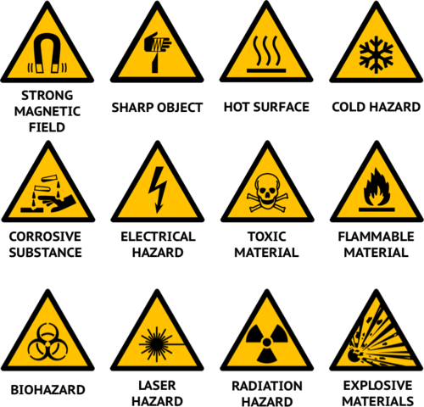
Figure 1: Symbols of some laboratory safety hazards (Source: Bing images)

Materials: Laboratory coat, safety rules, first aid kit, disposable Gloves, safe
goggles, fume cupboard, closed shoes, no caps and fire blanket.

Precautions
- At the beginning of any class held in a laboratory room, do not enter the room until your instructor tell you to do s. Wait even if the door is open
- Do not bring food or drinks into the laboratory room.
- Learn the locations of the vent switch, safety shower, extinguisher, glass disposal boxes, discarded tissue buckets, first aid kit and spill kits and be able to use each
- Wash laboratory benches with soap BEFORE and AFTER each laboratory period
- Keep your countertop clear of all but your laboratory manual and materials you are actually working with.
- Check your laboratory stool to be sure its intact. If the floor is wet notify the instructor
- If you drop and break a beaker or other glassware do not pick it up, notify the instructor.
- Follow the procedures as directed for proper handling and care of microscopes and slides
- Make sure the venting switch is on when dissections are being done.
- Wash and dry any dissecting utensils that you used and return them to the case in your laboratory drawer. Wash your hands after dissecting.

Method
There is usually reasonable care and caution required for any laboratory procedure, exposure to preservatives will require special attention as you work in the laboratory. The laboratory technician will take you through laboratory safety protocols. Notify your instructor if you know you are allergic to solutions or any other materials found in the laboratory.

All safety policies and procedures apply to scheduled laboratory classes as well as open labs. Consequences for not complying with safety procedures:
1. You will not be able to participate in a laboratory activity if:
- you are late for class and have missed safety training specific for that day’s lab or field activity;
- you have forgotten your personal protective equipment;
- you refuse to wear personal protective equipment;
- you have not followed safety policies and procedures for that laboratory or field activity.
2. You may be withdrawn from the class and not reinstated if:
- you missed required safety training at the beginning of the term;
- you repeatedly fail to follow laboratory safety policies and procedures.
3. You may be expelled from laboratory if you thoughtlessly or intentionally jeopardize
the health or safety of another individual.

Emergencies
If there is a life-threatening emergency (fire, major chemical spill, explosion, injury):
- Report the situation
- Evacuate if necessary
- Go to the designated rally point of your campus or building.

Laboratory Conduct
- Do these things: follow all procedures in manuals, in handouts, and as given by the instructor; store backpacks, coats, and other personal items as directed; report broken glass and chemical spills to your instructor immediately.
- Do NOT do these things: come to class while intoxicated or while under the influence of drugs that impair your ability to safely perform the lab or field activity; horse around or perform unauthorized experiments; eat, drink, or chew (tobacco or gum); bring drinks or food (even in closed containers) into the lab; pipet by mouth; taste chemicals or directly smell chemical fumes.
Laboratory Hygiene
- Clean up your individual work area/equipment and community work areas/equipment (e.g., sinks, balances).
- Put lids back on bottles and containers immediately after use.
- Dispose of chemicals and waste only as directed by the instructor.
- Turn off equipment as instructed. Wash your hands prior to leaving lab.
- Assume that chemicals used in laboratory are corrosive or irritating. If at any time chemicals come into contact with your skin wash the affected area immediately.

Results
-----------------------------------------------------------------------------------------------------------------------------
Discussion
---------------------------------------------------------------------------------------------------------

Conclusion
---------------------------------------------------------------------------------------------------------

THE FORMAT OF THE LABORATORY REPORT
The practical exercises presented in this manual have the same format as outlined below:
Title: Title of the practical
Introduction: It describes the purpose and relevance of the practical
Aim: It defines the scope of the practical.
Materials: Is a list of various materials, apparatus etc. required to carry out the practical
Precautions: The relevant precautions to be taken in carrying out the exercises are listed. Specific precautions if any, are listed along with the relevant step of the exercise
Method: It includes the steps to perform the practical in a sequential manner
Observation/Results: It involves use of senses and data recording from the activity
Discussion: Involves analysis of results
Conclusion: Justify the relationship between the aim of the exercise, the principle underlying it and the results obtained.
References: Any authority that the learner might have referred to.

ACTIVITY 2

THE MICROSCOPE
Aim: To study the structure and how to use a compound microscope
Introduction
Hello there. In this activity we will be studying the microscope. This is one of the most important instruments that have helped scientists to observe clearly and understand the function of microorganisms or specimen such as cells. The present day microscopes in use have a long developmental history behind them which cannot fit in this module. The compound light microscope was inverted by Jansen in 1590. In the 1930s the electron microscope was developed and was widely used by 1946. Below is a diagrammatic sketch of a compound microscope:

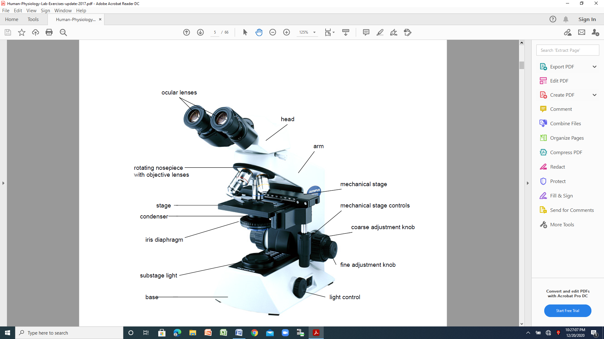
Figure 2: Parts of the microscope (Source: Bing images)

Materials: Compound light microscopes, hand lenses, glass slides, cover slips,
water, stains colour, source of electricity
Precautions: Take care NOT to break any of the materials provided

Method
Examining a microscope:
Study carefully the sketch diagram of a compound microscope above noting all the labelled parts. Examine the microscope provided to you and identify each of the labelled parts in the above sketch.
Using a microscope
- You are provided with a light compound microscope, plain slide and cover slip, a piece of paper with letters on it or an already prepared slide.
- Switch on the light on the microscope and mount the slide
- Rotate the nosepiece until the low-power objective lens (the shortest one) clicks into position. Check that the objective is in line with the body tube and that it is directly over the stage aperture.
- Adjust the mirror if necessary to gain maximum light .If the light is too bright; adjust the diaphragm to cut down the entry of light into the microscope.
- Place a paper containing a few letters on a clean slide and place a cover slip over it. Place the slide on the stage of the microscope in such a way that the letters lies directly over the stage aperture. Secure the slide in position with the stage clips.
- Lower the body tube by turning the coarse focusing knob (adjustment) in a clockwise direction until the letters on the paper become visible.
- If necessary, use the fine focusing knob to make the letters clearer. Carefully move the slide from right to left and left to right as you look into the eyepiece. Then move the slide carefully away from you and towards you as you continue looking into the microscope.
- Now use the high – power objective lens of the microscope and follow the procedure outlined above

Modern Advanced Microscopes:
1. Electron Microscope (EM)
It has an extremely short wavelength. It uses electrons, which are negatively charged. A beam of electrons can easily be focused through a specimen using electromagnets. It has a resolution of about 0.5nm. Resolution is the ability to distinguish between two separate objects. The light microscope has a resolution of 200nm.
2. Transmission Electron Microscope (TEM)
TEM is used to study the details of the internal structure of cells. The electron beam is transmitted through the specimen before viewing. The radiation enters at the top and the specimen viewed at the bottom. The beam of radiation is focused by condenser lens through the specimen, and then further lenses magnify the image. A voltage is passed through a tungsten filament at the top of the column. The white-hot filament releases a stream of electrons, kicked out by their orbits by high voltage. Electromagnets focus the beam. Inside the column is a high vacuum. Only very thin sections have to be observed. Electrons are not visible to the eye, so the image is made visible by showing the electrons onto a fluorescent screen.
The advantage of the TEM is that it gives high resolution. The disadvantages are that
The specimen must be dead since it is viewed in a vacuum. It is difficult to be sure that the specimen resembles a living cell in all details because preservation and staining damage the structure.
Expensive to buy and run.
Preparation of material is time consuming and requires expert training.
Specimen gradually deteriorates in the electron beam. Photographs have to be taken and require further study.
3. Scanning Electron Microscope (SEM)
It is used to produce three -dimensional images of the surface of the specimens. Electron beam is scanned to and fro across the specimen and electrons that are reflected from the surface are collected. They are used to form a TV – like image on a cathode ray tube.
Advantages of SEM
Surfaces of structures are shown
Great depth of field, large part of the specimen is in focus at same time.
Much larger samples can be examined
The disadvantage is that the resolution is lower than that of TEM (5-20nm).

Hand Lenses
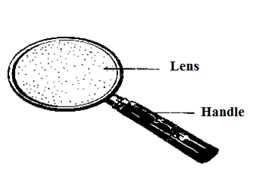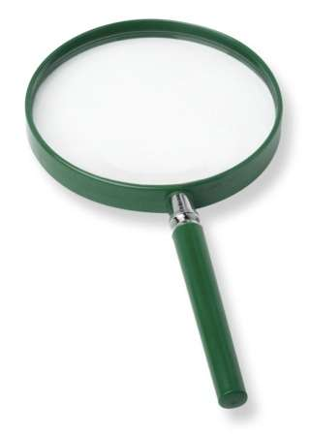

Figure 3: Hand lenses (Source: Bing images)

Hand lenses are also forms of microscopes because they enlarge things. A magnifying glass (also called a hand lens in laboratory contexts) is a convex lens which is used to produce a magnified image of an object. The lens is usually mounted in a frame with a handle as shown above. The distance between the Magnifying glasses and the object must be shorter than the focal length of the lens for this to occur. Otherwise, the image appears smaller and inverted, and can be used to project images onto surfaces. A small object is made to look bigger so that various parts of the object are seen clearly. By using the hand lens we can draw the image of the object and show how many times it has become bigger (magnified) than the object. To show this, we do the measurements and then apply the magnification formula.
Magnification
The magnification is the relationship of the size of a specimen and the size of its drawing. For example, if we measure the actual length of the specimen and we find that it is10mm, while the length of the drawing of the specimen we have drawn by using the hand lens is 20mm. Then magnification will be calculated as follows:

Magnification = Size of drawing
Size of specimen

Example:
Magnification = 20mm/10mm = 2/1, implying that our image is two times larger than the specimen or object. i.e. x2 or 2 times or 2x.
NOTE: If measurements are done in centimeters (cm), remember to always round
off to one decimal place e.g. 10.1cm.

Results
------------------------------------------------------------------------------------------------------
Discussion
------------------------------------------------------------------------------------------------------
Conclusion
------------------------------------------------------------------------------------------------------

ACTIVITY 3
THE HUMAN BODY
Aim: To study the external parts and functions of the human body
Introduction
In this unit, we will explore the main external parts of the human body and functions. The human life begins at conception. Growth /gestation of human life take about nine months, after which a baby is born. Thereafter, the human life passes through various stages which include toddler, infancy, teenager, adult and old aged stage. Each stage is associated with activities such as breast feeding, sitting, crawling, standing, running etc. The human body, like many other living organisms can be divided into three (3) main parts/regions. These include the head, chest/thorax and abdomen. Additionally, each region is made up of a number of associated structures. For example, the head has eyes, nose etc.
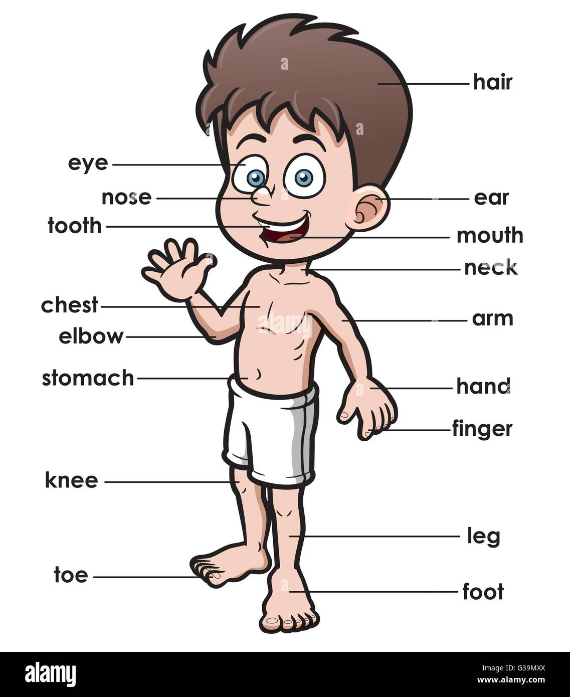
Figure 3: External parts of the human body (Source: Bing images)

Materials: Pairs of students [same sex is advised] to be models for this activity
Method
Students shall do this activity in pairs. In pairs students to identify the external parts of the human body and discuss the functions of each part
Results
Draw a table as shown below and complete it
Name of the body part | Function of the body part

Discussion
----------------------------------------------------------------------------------------------------
Conclusion
----------------------------------------------------------------------------------------------------

Activity
Draw a sketch diagram of the human being below in your book and label the parts using the words below
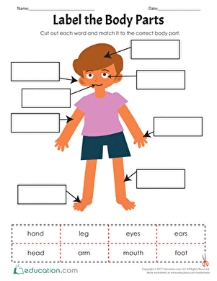

ACTIVITY 4
CARE FOR THE BODY
Aim: To learn how to look after our bodies
Introduction
The human body is amazing. It is always working and growing, changing food to fuel and fighting illness and germs. Parents take care of children's bodies by making sure that children have everything they need to grow and maintain good health. As kids get older and become more mature, they take over some of the responsibility for taking care of their bodies, and they learn that bodies need several different kinds of care to function well e.g.
- Eat a healthy diet with food from all of the food groups: dairy, fruits and vegetables, grains and protein. Food provides vitamins and minerals the body needs.
- Clean the body by taking a bath or shower. Wash your entire body from head to toe, including your face, and wash your hair regularly. A clean body is healthier, smells fresh and makes you feel good about yourself.
- Brush and floss the teeth after meals and snacks. Good care of teeth can make them last your whole life. Keep your breath fresh by keeping your teeth and gums clean.
- Control germs by washing your hands often with soap. Wash your hands before meals, after using the bathroom, after taking out the garbage and after blowing your nose.
- Exercise your body every day by finding ways to stay active
- Get enough sleep. The body needs sleep to get ready for the next day

Materials: Hand wash, water, toothpaste, toothbrush, comb, nail cutter
Methods
The instructor shall demonstrate hand washing after using the toilet or after handling dirty or meal. Depending on the situation, the instructor may demonstrate teeth brushing, combing hair, nail cutting, different exercises which involves how to take care of the body etc. Thereafter learners should be involved in the exercise.

Results
--------------------------------------------------------------------------------------------
Discussion
--------------------------------------------------------------------------------------------
Conclusion
------------------------------------------------------------------------------------------------

ACTIVITY 5
PLANTS
Aim: To classify and study external parts of plants
Introduction
Plants can be grouped into several categories. Among them are angiosperms and gymnosperms. An angiosperm is any plant that produces flowers, fruit, and seeds. They are the most advanced, diverse and abundant group of plants. Gymnosperms are the closest relatives of angiosperms. They are a group of woody plants that produce seeds but no flowers or fruit. Plants have different external parts and each part has a specific function. The activity will dwell on these two areas i.e. classification of plants, structure and functions.
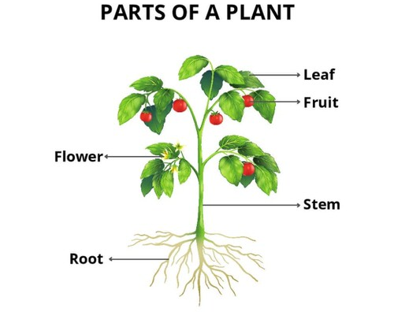
Figure 4: External parts of the plant (Source: Bing images)

Materials: Plants around the school environment

Methods
Taking a natural walk around the school premises classifying plants into flowering, non-flowering, crops and wild plants. Dig out a plants say from the garden and study the external parts such roots, stem, flowers and leaves.

Results
----------------------------------------------------------------------------------------------------
Discussion
----------------------------------------------------------------------------------------------------
Conclusion
----------------------------------------------------------------------------------------------------

Activity
Draw a sketch diagram of the plant below in your book and label the parts using the words below

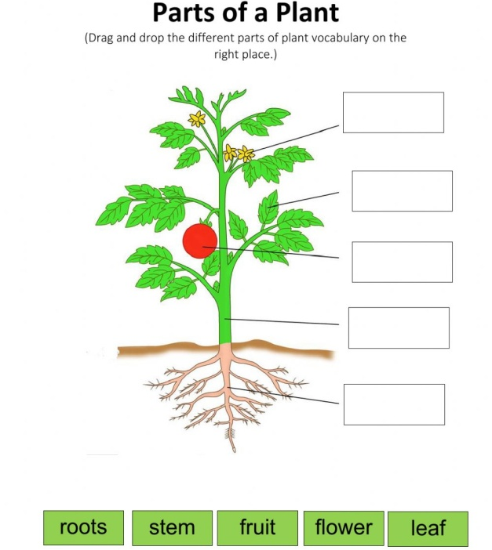

ACTIVITY
CONCEPT OF ENVIRONMENTAL SCIENCE
Aim: To explore living and non-living things in the school environment
Introduction:
The term 'environmental science' refers to a grouping of scientific disciplines that are all concerned with the physical, chemical and biological characteristics of the surroundings in which organisms live. We can find many things around us, from lakes and rivers to plants and animals. The environment in which we live is made up of several things. These “things” can be categorized into two different types – Living and Non-living Things.
All living things breathe, eat, grow, move, reproduce and have senses.
Non-living things do not eat, grow, breathe, move and reproduce. They do not have senses.
Living things have “life,” though some might not show its evident signs. For instance, a tree would probably not react the same way a human would. It would not react when we hit it, and it might not be able to walk around. Though the signs of life displayed by them are not very observable, it does not make them non-living.
Materials: pencil and paper
Precautions: Avoid touching dangerous animals. e.g snakes, bees
Method:
Through a walk observe different things that you can see in the school environment. Thereafter, using the basic characteristics of life and observation skills, identify living things and non-living things from the school environment.
Results:
------------------------------------------------------------------------------------------------------
Discussion:
------------------------------------------------------------------------------------------------------
Conclusion:
--------------------------------------------------------------------------------------------------

ACTIVITY
MATTER 1
Aim: To determine change of states of matter using ice cubes
Introduction:
Matter is defined as any substance that occupies space and has mass. Almost all substances can be classified into three states of matter namely; solids, liquids and gases. Each state has different properties. Heating and cooling a substance can cause it to change state.
Materials: Beaker, spatula, source of heat, table salt and distilled water
Method:
First procedure
Using a spatula place the ice cubes into the beaker. Leave it for 30 minutes and heat it until it boils. Record the observation.
Second procedure
Pour distilled water into a clean dry beaker. Add ice cubes into the beaker until the level of ice is above the level of water. Finally sprinkle two tablespoons of salt over the ice cube and observe for 30 minutes.
Results:
------------------------------------------------------------------------------------------------------
Discussion:
------------------------------------------------------------------------------------------------------
Conclusion:
------------------------------------------------------------------------------------------------------

ACTIVITY
MATTER 2
Aim: To determine the movement of particles in solids, liquids and gases
Introduction:
In a solid, particles are packed tightly together in a regular pattern. Solids have fixed shaped that are hard to break apart because individual particles do not have enough energy to escape individually. In liquids, particles are slightly further apart than in solids. Particles are held together by weak electrostatic forces of attraction. In gases, particles are much further apart from each other. The forces which hold the particles together are negligible.
Materials: Marbles/small balls, box
Method:
- Put a few marbles or small balls in a box and shake it. Observe the movement of the marbles.
- Put some more marbles in the box and shake it. Observe the movement of the marbles.
- Fill the box all the way and shake it. Observe the movement of the marbles.
Results:
A:

B:

C:

Discussion: (Include the state of matter represented by A, B and C)
------------------------------------------------------------------------------------------------------
Conclusion:
------------------------------------------------------------------------------------------------------

ACTIVITY
MAGNETIC AND NON-MAGNETIC MATERIALS
Aim: To determine magnetic and non-magnetic materials
Introduction:
A magnet is an object or material that attracts certain metals, such as iron, nickel and cobalt. It can also attract or repel another magnet. All magnets have North-seeking (N) and South-seeking (S) poles. When you place magnets near each other, opposite poles attract and like poles repel each other. Magnetic materials are those that are attracted by a magnet. Non-magnetic materials are those that are not attracted by magnets.
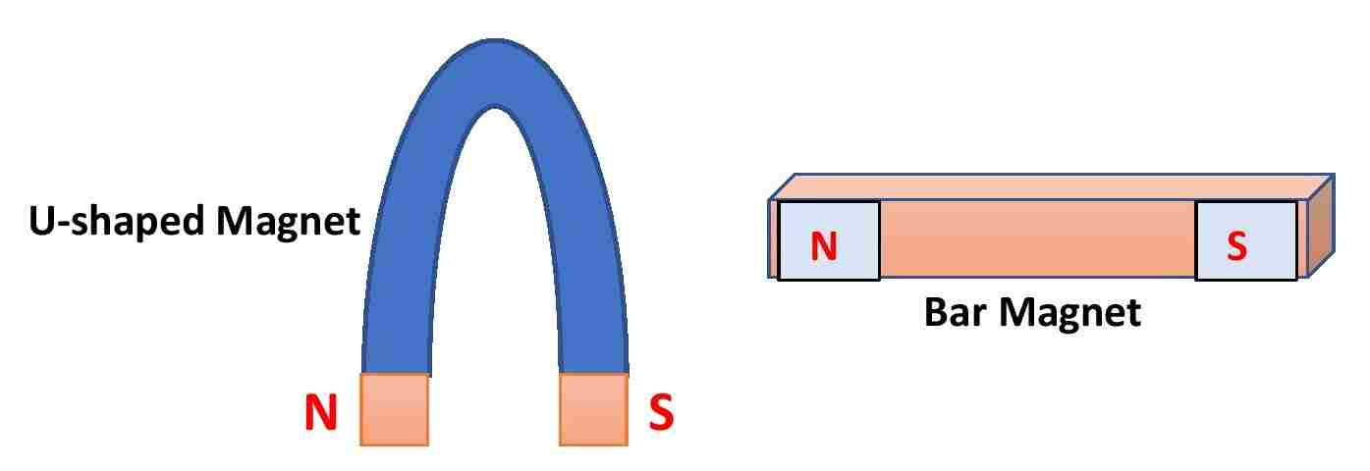
Figure …. A U-shaped and bar magnets with North and South poles (Source:
Bing images

Materials: pen, pencil, eraser, clips, iron nails, chalk, plastic toys, small magnets,
Horseshoe magnet, bowl and small stones
Method:
Put a pen, pencil, eraser, clips, iron nails, chalk, plastics toys, nails, small stones and small magnets in the bowl. Run the horseshoe magnet in the bowl and record the observation.
Results:
------------------------------------------------------------------------------------------------------
Discussion:
------------------------------------------------------------------------------------------------------
Conclusion:
------------------------------------------------------------------------------------------------------

ACTIVITY
POND ECOSYSTEM
Aim: To study a pond ecosystem
Introduction:
An ecosystem is a natural system that comprises a community of plants and animals that interact with each other and their physical environment. There are often complex relationships that exist in ecosystems, between the non-living elements (soils, rocks, water, sunlight etc.) and the living elements (plants, animals, bacteria etc.). The different types of ecosystem includes; terrestrial ecosystem, forest ecosystem, grassland ecosystem, desert ecosystem and freshwater ecosystem.
Materials: pencil and paper, a nearby pond
Method:
Study the pond ecosystem and observe the following;
- The biotic (living thing e.g. fish) factor of the pond ecosystem
- The abiotic (living thing e.g. water) factor of the pond ecosystem
- At least three feeding relationships which take place in the pond ecosystem

Results:
------------------------------------------------------------------------------------------------------
Discussion:
---------------------------------------------------------------------------------------------------
Conclusion:
-----------------------------------------------------------------------------------------------------

ACTIVITY
SURVEY FAMILIAR BIRDS, INSECTS AND OTHER ANIMALS IN AN AREA
Aim: To study local plants, birds and other animals in an area
Introduction:
Domestic animals are one of the most important inventions of man. Domestic animals changed our world and formed our culture. In many generations a great diversity of animal breeds evolved. This is a unique cultural and historical treasure, which we want to preserve for future generations. We, the human beings share our living space with wide variety animals. All of them contribute towards making our environment healthy and enjoyable. It is important to learn about them as they are our valuable companions.
Materials: pen / pencil, notebook, Nets for collecting insects
Precautions:
- Be calm, move slowly, and avoid loud noises
- Wear shoes
- Avoid the hind (back) legs of animals
- Avoid animals with babies

Method:
- Identify familiar birds in your area
- Identify familiar insects in your area
- Identify domestic animals by the food they eat
- Identify domestic animals by the sounds they make

Results:
---------------------------------------------------------------------------------------------------
Discussion:
-----------------------------------------------------------------------------------------------------
Conclusion:
----------------------------------------------------------------------------------------------------

ACTIVITY
HEAT
Aim: To determine heat transfer by conduction
Introduction:
Heat is the form of energy that is transferred between systems or objects with different temperatures (flowing from the high-temperature system to the low-temperature system). Conduction is the flow of heat through matter from places of higher temperature to places of lower temperature without movement of the matter as a whole e.g. the handle of a metal spoon held in fire soon gets warm. This is so because heat passes along the spoon by conduction.
Materials: Two bowls, balloon, plastic bottle, cold water, hot water
Method:
- Cover the mouth of the plastic bottle with a balloon
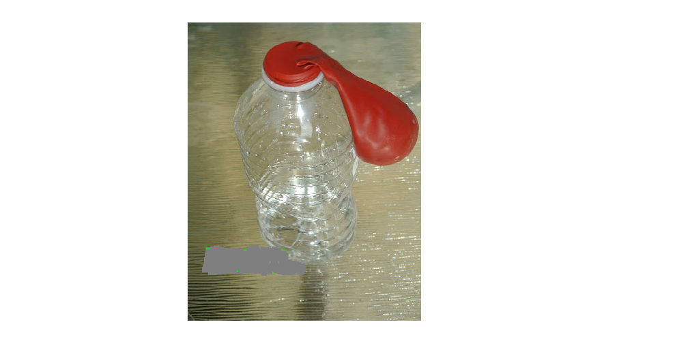
- Fill the bowl with cold water and then deep the plastic bottle with a balloon. Observe for 5minutes.
- Fill the bowl with hot water and then deep the plastic bottle with a balloon. Observe for 5minutes.
- Remove the plastic bottle with the balloon from hot water and deep it in cold water. Observe for 5 minutes.

Results:
------------------------------------------------------------------------------------------------
Discussion:
------------------------------------------------------------------------------------------------
Conclusion:
------------------------------------------------------------------------------------------------

ACTIVITY
COMPOSITION OF SOIL
Aim: To investigate the composition of a given soil
Introduction:
Soils comprise a mixture of inorganic and organic components: Minerals, air, water, and plant and animal material. Mineral and organic particles generally compose roughly 50 percent of a soil’s volume. The other 50 percent consists of pores – open areas of various shapes and sizes. Networks of pores hold water within the soil and also provide a means of water transport. Oxygen and other gases move through pore spaces in soil. Pores also serve as passage ways for small animals and provide room for the growth of plant roots.
Materials: Soil sample, water and beaker
Precautions: Collect samples of soil from the surface of the soil. Avoid using subsoil.
Method: Take samples of soil near the surface of the earth. Put the sample of soil in the beaker. Add water and shake it and then allow the particles to settle. After some time, observe the settlement of particles and draw the outcome.

Results:
------------------------------------------------------------------------------------------------------
Discussion:
------------------------------------------------------------------------------------------------------
Conclusion:
-----------------------------------------------------------------------------------------------------

ACTIVITY
SOIL TEXTURE
Aim: To study the texture of given samples of soil
Introduction:
Soil differs in its texture and characteristics, soil texture determines water availability and permeability, land use and management are influenced by soil texture. Texture refers to the proportion and size of soil particles. Texture can be determined very accurately in the lab. However, it can also be judged or estimated by the feel of the soil.
The designation of various kinds of soil particles mainly depends upon the diameter of the particles which can be categorized as mentioned in the following Table 1

Table 1: Soil size and their designations
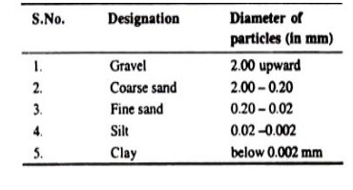

Materials: Different soil samples
Precautions: Collect samples of soil from the surface of the soil. Avoid soil of the
same size of particles.

Method:
For knowing the soil texture a rough but easy method is to examine the soil under the thumb and the finger in moist as well as dry conditions. Feel the particles by rubbing them between fingers. A hand lens may also be used for it. Different particles can be judged as follows:

1. Sand
Particles can be easily seen. These are loose and coarse. In moist conditions, the sand can be squeezed and cast but on touching by hand the particles will separate. Size of the particles varies from 0.02 to 2.0 mm.
2. Silt
It gives clotty appearance in dry conditions. The size of the particles ranges from 0.002 to 0.02 mm. in diameter.
3. Clay
It is sticky when wet. It forms a long flexible ribbon when pinched between thumb and finger. The size of the clay particles is smallest (below 0.002 mm. in diameter).

Results:
----------------------------------------------------------------------------------------------------
Discussion:
----------------------------------------------------------------------------------------------------
Conclusion:
----------------------------------------------------------------------------------------------------

ACTIVITY
POROSITY OF SOIL
Aim: Experiment to estimate the porosity of different soil samples:
Introduction:
Pores between the soil particles are of great importance for the plant growth because they contain air and water. Porosity of the soil depends upon the texture and structure of the soil, compactness of the soil and also on the organic content of the soil. It increases with the increase in the percentage of organic matter in the soil. It decreases with the decrease in the size of the soil particles. Porosity also decreases with the depth of the soil in the earth.
Materials: Balance, oven, soil samples, measuring cylinders, water.
Method:
- Take some amount of different soil samples (e.g. sand, clay), put them in the oven for some time and allow them to dry.
- Weigh 250 gm. of each oven-dry soil samples and place each of them in separate measuring cylinders.
- Add 250 ml of water in each measuring cylinder gradually through the wall and note the level of water in each cylinder.
- Wait for about 15 minutes and again note the water level in each cylinder. There is a fall of water level in each cylinder. Now deduct the second water level from the first one. This will give us the porosity of soil sample.

Table 2: ……………………………………….
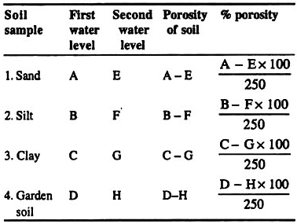
Result:
----------------------------------------------------------------------------------------------------
Discussion:
----------------------------------------------------------------------------------------------------
Conclusion:
----------------------------------------------------------------------------------------------------

Activity 17

Title:The moisture content in a given soil

Aim:to find out the moisture content in a given soil.
Introduction:
Moisture content in the soil is an important concept because it reflects on how much moisture shall be found in the soil.The moisture content in the soil will differ from soil to soil hence the need to understand this concept in order to predict its effects.
Objectives:
After performing this experiment, you should be able to:
- Calculate the moisture contained in the given soil
- Explain the importance of moisture in the soil.
Materials:
Polythene bags, oven, khurpa (a weeding instrument), beaker, balance.
Method:
- Take about 100 gm. of soil from the desired depth, keep it in polythene bag and bring to the laboratory.
- Keep a definite quantity (e.g., 100 gm.) in a pre-weighed beaker and place it in the oven for 24 hours at 70°C for drying.
- Weigh the beaker containing dry soil and calculate the moisture percentage as under :
Calculations:
Suppose:
- Weight of the empty beaker = 30 gm.
- Weight of the fresh soil = 100 gm.
- Weight of the dry soil and beaker = 110 gm.
- Weight of the dry soil = 110 – 30 = 80 gm.
- Moisture contents of the soil = 100 – 80 = 20 gm.
- 80 gm. of the soil contains = 20 gm. of moisture
- 100 gm. of soil will contain = 20 × 100/80 gm.
= 25 gm. moisture
Result:
100 gm. of dry soil contains 25 gm. moisture contents.
Conclusion:
Moisture percentage = 25%

Activity 18
Title:water-holding capacity of a given soil sample

Aim: to determine water-holding capacity of a given soil sample
Materials:
Soil sample, oven, tin or brass box with perforated bottom, weighing box, weighing balance, filter paper, petri-dish.
Method:
1. Take the soil sample, crush it thoroughly and allow it to dry.
2. Take a tin or brass box with perforated bottom and weigh it.
3. Also take a filter paper and weigh it with weighing balance.
4. Put the weighed filter paper at the bottom of the tin or brass boxand fill the box with soil.
5. Now place the soil-filled tin or brass box in a petri-dish containing water and wait for about 6 hours.
6. Again weigh the box containing wet soil.
7. Now put the box containing wet soil in an oven adjusted at 105°C and wait for about 24 hours.
8. Now remove this box and weigh it.
9. Now take four filter papers from the same filter paper packet used earlier, dip one of them in water and weigh it. In a similar fashion weigh other three wet filter papers and find out the average weight of water absorbed by one filter paper.
Observations:
(1) Weight of tin or brass box =
(2) Weight of dry filter paper =
(3) Weight of box + wet filter paper + wet soil = .
(4) Weight of box + dry filter paper + dry soil = .
(5) Weight of wet filter paper = .
Results:
Water-holding capacity is calculated as under:
(6) Weight of wet soil = (weight of box + wet filter paper + wet soil) – (weight of box + weight of wet filter paper)
= No. (3)-No. (1+5)
= 142 gm. – (50 gm. + 0.62 gm.)
= 142 gm.-50.62 gm.
=91.38 gm.
(7) Weight of soil dried in oven = (weight of box + dry filter paper + dry soil) – (weight of box + weight of dry filter paper)
= No. 4-No. (1 + 2)
= 122 gm – (50 gm + 0.12 gm)
= 122gm-50.12gm =71.88 gm
(8) Water present in the soil = weight of wet soil – weight of soil dried in oven
= No. 6 – No. 7 =91.38 gm – 71.88gm = 19.50 gm
(9) Water-holding capacity of the soil sample
= Amount of water present in the soil (8)/Weight of soil dried in oven (7) × 100
= 19.50/71.88 × 100%
= 27.12%

Activity 19

Title:horizons of local soil profile

Aim: to demonstrate different horizons of local soil profile
Introduction:
Soil horizons are layers parallel to the soil surface whose physical, chemical and biological characteristics differ from the layers above and beneath.

“Soil profile is defined as the vertical section of the soil from the ground surface downwards to where the soil meets the underlying rock.”

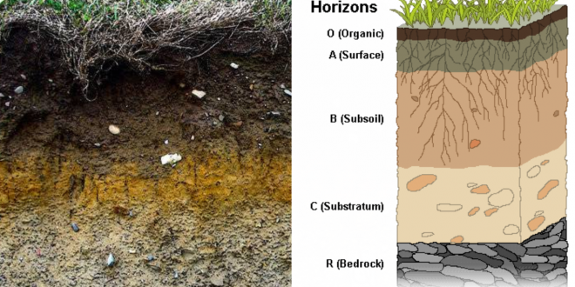
Soil Horizons Development & Soil Profile
Objectives:
At the end of this experiment,you should be able to:
- Differentiate a soil horison and a soil profile.
Materials:
Trowel (a small tool with a curved scoop for lifting plants or earth), pick and a wooden handle, used for breaking up hard ground or rock).
Method:
Select an undisturbed area anywhere or in your college campus and dig a long trench of about 75 cm wide and 1.5 metre deep. (Instead of trench, a narrow pit dug in the study area will also serve the same purpose).
Observations and Results:
Three horizons (A, B and C) may be traced or observed in the trench or pit starting from top or upper surface downwards. All these three horizons followed by their sub-horizons show characteristics mentioned in Table 3
Table 3 Different horisons, their sub- horisons and characters of soil profile
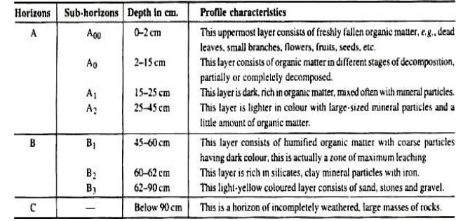
Conclusion:
Horisons exist in the earth’s crust and the soil profile has its characteristics.

Activity 20
Title:Soil pH.

Aim:to determine the soil pH:
Introduction:
The soil pH reflects whether a soil is acidic, neutral, basic or alkaline. The acidity, neutrality or alkalinity of a soil is measured in terms of hydrogen ion activity of the soil water system. The negative logarithm of the H ion activity is called pH and thus pH of a soil is a measure of only the intensity of activity and not the amount of the acid present. The pH range normally found in soils varies from 3 to 9.
pH of the soil can be estimated by pH meter or pH paper. One more satisfactory way for determining pH is the use of Universal Indicator.
Objectives:
At the end of this experiment, you should be able to:
- Use pH meter or pH paper and Universal Indicator to estimate the pH of a given soil
- estimate an acidic, neutral, basic or alkalinesoil .
Materials:
Soil, BDH Universal Indicator, test tube, water.
Method:
- Mix the soil in some water, shake and add BDH Universal Indicator. Compare the colour of the solution with the chart on the bottle of indicator and note the pH.
- Mix thoroughly the soil in a test tube with equal amount of barium sulphate and about 20 ml of water. Take a few drops of supernatant liquid on a porcelain tile and add equal amount of Universal Indicator, and compare the colour of the soil with the chart for pH given on the bottle of Universal Indicator.

Observation/Result:
The result you get can be any of the following:
<5.0 | 5.5 | 6.0 | 6.5-7.5 | 7.5-8.5 | >8.5
Strongly  Acid | Moderately Acid | Slightly  Acid | Neutral | Moderately  Alkaline | Strongly Alkaline
 |  |  | Best range for Most Crops
Conclusion
It is possible to determine the pH of the soil when you usepH meter or pH paper and Universal Indicator.

ACTIVITY
DENSITY 1
Aim: To determine the density of regular objects
Introduction:
Density is the mass of an object divided by its volume. Density is defined as mass per unit volume of a material substance. The formula for density is d = M/V, where d is density, M is mass, and V is volume. Density is commonly expressed in units of grams per cubic centimeter.
Materials: pencil and paper, beam balance, rule and a regular object
Precautions: The indicator of the beam balance should be at zero before measuring
the mass of the solid.
Method:
- Use a ruler to measure the length (l), width (w) and height (h) of the regular object.
- Place the object on the top pan balance and measure its mass.
- Calculate the volume of the cube using ( l × w × h ).
- Use the measurements to calculate the density of the object.

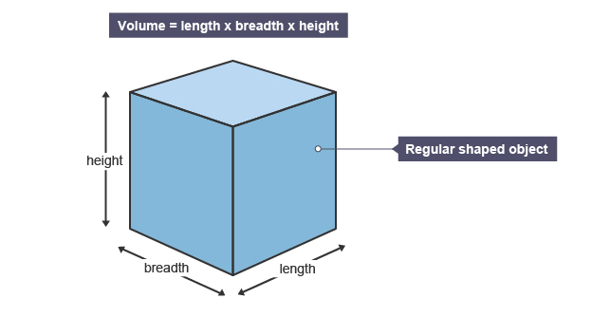

Results:
------------------------------------------------------------------------------------------------------
Discussion:
------------------------------------------------------------------------------------------------------
Conclusion:
------------------------------------------------------------------------------------------------------

ACTIVITY
DENSITY 2
Aim: To determine the density of irregular objects
Introduction:
Density is the mass of an object divided by its volume. Density is defined as mass per unit volume of a material substance. The formula for density is d = M/V, where d is density, M is mass, and V is volume. Density is commonly expressed in units of grams per cubic centimeter.
Materials: pencil and paper, beam balance, rule and a regular object
Precautions: The indicator of the beam balance should be at zero before measuring
the mass of the solid.
Method:
- Place the object on the top pan balance and measure its mass.
- Fill a measuring cylinder so that there is enough water to cover the object when it is placed inside the cylinder. Take the reading of the volume.
- Carefully lower the object into the cylinder.
- Take the new reading of the volume. Subtract the original reading to obtain the volume of the object.
- Use the measurements to calculate the density of the stone.

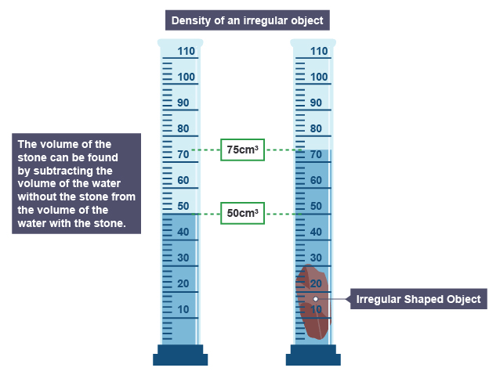
Figure ………………………………………………….

Results:
------------------------------------------------------------------------------------------------------
Discussion:
------------------------------------------------------------------------------------------------------
Conclusion:
------------------------------------------------------------------------------------------------------

ACTIVITY
GOOD AND BAD CONDUCTORS OF HEAT
Aim: To identify good and bad conductors of heat
Introduction:
Some materials allow the heat to flow through them and they are known as good conductors of heat or heat conductors. Other materials don’t allow the heat to flow through them and they are known as bad conductors of heat or insulators.
Materials: Spoon, pencil and paper, beaker, boiled water
Precautions: Be careful not to be burnt by the boiled water
Method:
Pour boiled water in a beaker. Immerse half of the pencil, rule and spoon in the boiled water. After five minutes touch the other end of the pencil, rule and spoon. Take into consideration how you feel when you touch the other end of the pencil, rule and spoon.

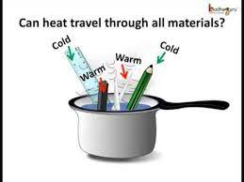
Figure ……………………………………………………….

Results:
-----------------------------------------------------------------------------------------------
Discussion:
------------------------------------------------------------------------------------------------
Conclusion:
----------------------------------------------------------------------------------------------

ACTIVITY
STATIC ELECTRICITY
Aim: To demonstrate the effects of static electricity
Introduction:
Static electricity is a familiar electric phenomenon in which charged particles are transferred from one body to another. For example, if two objects are rubbed together, especially if the objects are insulators and the surrounding air is dry, the objects acquire equal and opposite charges
Materials: Spoon, pencil and paper, beaker,
Precautions: Make sure there is no ignitable mixture (e.g., solvent vapour or dust in
the air)
Method:
Rub your hair on a balloon or wool sweater. What happens to your hair? Try to stick the balloon to the wall. Does it stick?Rub a plastic pen on the wool sweater and hold it near a stream of water. What do you observe?Rub the pen on the sweater again and try to pick up small pieces of paper. Try to bring the pencil near small pieces of paper after using it to rub the hair.
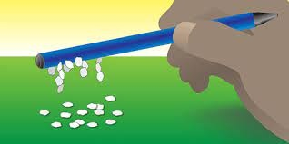
Figure ……………………………………………………….

ACTIVITY
ELECTRICITY
Aim: To identify good and bad conductors of electricity
Introduction:
Electric current can only occur if a complete path is created to allow the current to flow continuously. There are many materials that can be used to “close” a circuit, or allow current to flow. Materials that allow electric current to flow through easily are called conductors. Materials that do not allow electric current to flow well are insulators. It is also important to know the difference between conductors and insulators to prevent injury when dealing with electricity.
Materials: Wooden spoon, pencil, paper, Paperclip, plastic bag, water bottle

Precautions: Make sure you don’t connect the wire directly from the negative terminal to the positive of the battery

Method/procedure:
- Create a simple closed circuit by connecting two copper wires to the battery and light bulb. See diagram for example.

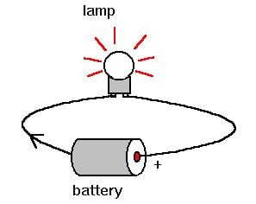

- Next you will test the following items: Wooden spoon, pencil, paper, Paperclip, plastic bag, water bottle to see if they are good conductors or insulator
- Disconnecting the copper wire from the positive terminal. Incorporate one item at a time into your circuit between the copper wire and the positive terminal in order to complete the circuit.
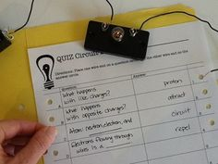
Figure ……………………………………………………….

Results:
--------------------------------------------------------------------------------------------------
Discussion:
-------------------------------------------------------------------------------------------------
Conclusion:
---------------------------------------------------------------------------------------------------

