

**Chalimbana University**

**Integrity. Service. Excellence**

**DIRECTORATE OF DISTANCE EDUCATION**

**BSP 3102: STRATEGIC PURCHASING**

**First Edition 2020**

**Authors:** Chalimbana University

Muzumara Taonga

Private Bag E1

Lusaka

Zambia

Website: [www.chau.ac.zm](http://www.chau.ac.zm)

**Copyright**

©2020 Chalimbana University

First Edition 2020

All Rights Reserved

No part of this publication may be reproduced, stored in a retrieval system or transmitted in any form or by any means, electronic, mechanical, photocopying or otherwise without prior written permission of the copyright owner, Chalimbana University.

Chalimbana University

School of Leadership and Business Management

Department of

Private Bag E 1

Chongwe

Zambia

Web: www. chau.ac.zm

# **Acknowledgements**

The Directorate of Distance Education wishes to thank Muzumara Taonga for writing Strategic Purchasing.

Table of Contents

Unit One: Strategic Purchasing 7

Unit Two : Purchasing strategy the internal and external aspect 11

Unit Three: Sourcing Strategies 22

Unit Four : Supplier relations and contract management 48

Unit Five : Strategic Service Purchasing 69

**Pre-requisite: None**

## Introduction

Strategic procurement management course is key for many organisation purchases and projects. Procurement of goods and services form the highest percentages of expenditure and it is also important to achieve value for money through careful appraisal and management. The procurement strategy promotes a controlled and auditable response to external influences as well as to ensure that the project objectives are met.

Welcome to the course Strategic procurement.

**Rationale of the study**

The course provides an overview ofplanning, implementing, evaluating and controlling strategic and operating purchasing decisions for directing all activities of the purchasing function toward opportunities consistent with the firm’s capabilities to achieve long term goal.

**Aim**

This course aims to equip students with the capacity to develop management and strategic skills in procurement in order to increase value for money.

**Learning Outcome**

At the end of this course, learners should be able to:

1. develop skills in a strategic procurement process
2. develop procurement strategy to deliver vision and objectives
3. illustrate the reduction of overall procurement cost
4. demonstrate collaborative form of working in strategic procurement

## Summary

The module looks at Strategic procurement

## Study Skills

As an adult learner, your approach to learning will be different to that of your school days: you will choose when you want to study, you will have professional and/or personal motivation for doing so and you will most likely be fitting your study activities around other professional or domestic responsibilities.

Essentially you will be taking control of your learning environment. As a consequence, you will need to consider performance issues related to time management, goal setting, stress management, etc. Perhaps you will also need to acquaint yourself with areas such as essay planning, searching for information, writing, coping with examinations and using the internet as a learning resource.

Your most significant considerations will be *time* and *space* i.e. the time you dedicate to your learning and the environment in which you engage in that learning.

It is recommended that you take time now before starting your self-study to familiarise yourself with these issues. There are a number of excellent resources on the web. A few suggested links are:

<http://www.how-to-study.com/>

The “How to study” website is dedicated to study skills resources. You will find links to study preparation (a list of nine essentials for a good study place), taking notes, strategies for reading text modules, using reference sources, test anxiety.

<http://www.ucc.vt.edu/stdysk/stdyhlp.html>

This is the website of the Virginia Tech, Division of Student Affairs. You will find links to time scheduling (including a “where does time go?” link), a study skill checklist, basic concentration techniques, control of the study environment, note taking, how to read essays for analysis, memory skills (“remembering”).

## Timeframe

You are expected to spend at least 18 hours of study time on this module. In addition, there shall be arranged contact sessions with lecturers from the University during residential possibly in April, August and December. You are requested to spend your time judiciously so that you reap maximum benefit from the course.

**Need Help?**

In case you have difficulties during the duration of the course, please get in touch with your lecturer for routine enquiries during working days **(Monday-Friday)** from 08:00 to 17:00 hours on Cell: +260963804004**; E-mail:** [**adsikalumbi@gmail.com**](mailto:adsikalumbi@gmail.com)**; website:** [**www.chau.ac.zm**](http://www.chau.ac.zm)**.**You can also see your lecturer at the office during working hours as stated above.

You are free to utilise the services of the University Library which opens from 07:00 hours to 20:00 hours every working day.

It will be important for you to carry your student identity card for you to access the library and let alone borrow modules.

**List of Equipment**

In this module you will need the following tools;

Note modules

## Assessment

In this course you will be assessed on the basis of your performance as follows:

**Continuous Assessment 50%**

Assignment 10%

Project 15%

2 Tests of equal weight 25%

**Final Examination 50%**

**Total 100%**

**Unit One: Strategic Purchasing**

**1.1 Introduction**

Welcome to the first unit of this module. This introductory unit offers general definitions and issues regarding strategic purchasing. You will be provided with an overview of the current purchasing state as well as a general understanding of the topic. First, the changing role of purchasing through the course of time is presented. Subsequently, the purchasing process will be discussed. With that said sit back, relax and enjoy the course, because the future in is bright.

**Outcomes**

**1.2 Learning Outcome**

By the end of this unit you should be able to;

* evaluate the general definition and issues regarding strategic purchasing.
* define strategic purchasing
* explain the current purchasing state.
* explain the changing role of purchasing
* discuss the characteristics of strategic procurement management
* describe strategic purchasing strategies for different products.

Time

**1.3 Time Frame:**

You will cover the following time;

* 2 hour 30 minutes’ study time
* 2 hours in class ‘’’’’

**1.4 The changing role of purchasing**

The role and character of purchasing has been changing constantly in the course of time. Traditionally, purchasing was seen as a merely supportive and supplementary operational activity, with little significance on a firm’s performance. During the 1970’s purchasing departments had a more administrative than strategic character. It used to be a department only handling buying orders for other divisions with its main aim to achieve maximum price reductions. Even top management did not realize the importance of purchasing and its contribution to a firm’s performance and regarded it as playing a passive role within the firm.

However, in the following years firms further realized the increasing importance of managing the supply base effectively and efficiently (Monczka, et al 2009). Supplier networks and supplier involvement consequently emerged as important purchasing activities (Weele, 2014). Purchasing began to act as a key liaison between internal customers on the one hand and external suppliers on the other. It became a purchasers’ task to synergize particular strengths of a supplier with a company’s value proposition. In current times, owing to increased competition in a global environment firms were forced to act with more flexibility and to highlight the focus on;

* Product innovation
* Time to market
* Cost savings
* Cater to greater customer demands.

The graph below summarizes the findings above and illustrates the evolution of strategic purchasing from the 1950s to the present.

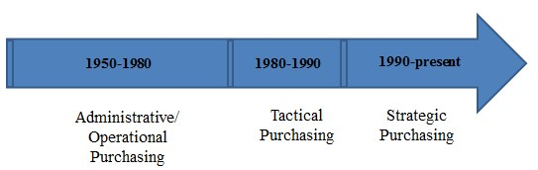

*Figure 1.1 the evolution of strategic purchasing*

**1.5 Strategic purchasing**

The evolution of purchasing makes clear that traditionally purchasing was intended to “buy the materials of the right quality, in the right quantity, from the right source delivered to the right place at the right time at the right place” (Kenneth & Lysons, 2006). This approach however conveys a rather reactive strategy of purchasing where the focus is on transactions rather than on relations and also more on operational or tactical level rather than on a strategic one.

In our module **strategic purchasing** will be defined as:

The process of planning, implementing, evaluating and controlling strategic and operating purchasing decisions for directing all activities of the purchasing function toward opportunities consistent with the firm’s capabilities to achieve long term goal.

This definition overcomes the weaknesses of the traditional approach as it shows the reactive, strategic, relational, and long-term characteristics of strategic purchasing. It embodies purchasing as a critical driving force which does not only comprise the achievement of the cheapest price, but rather focuses on a close link to the supply base, an early supplier involvement, and the involvement of logistical activities throughout the value chain. Building relationships with the suppliers is used in order to jointly pull costs out of the product or service and hence reaching mutually advantageous goals. What is more, it shows that the function goes far beyond the formerly short- term orientation of cutting costs.

Bailey (2008) identified three purchasing roles on various management levels. He distinguishes purchasing on a strategic level, on a tactical/managerial level and an operational level and applies distinctive activities and considerations to the various levels. This can be extracted from the table below. It can be seen the strategic level is long-term oriented, whereas the operational level deals with the daily business of a purchasing department.

|  |  |  |
| --- | --- | --- |
| **Strategic Level** | **Tactical/ Managerial Level** | **Operational Level** |
| Purchasing research | Buying methods | Expediting |
| Long range planning | Negotiations | Recods and systems maintenance |
| Predicting availability | Budgeting | Invoice clearance |
| Policy determination etc. | Contracting | Requisition handling |
|  | Cost reduction techniques etc. | Inquiries/ quotations |
|  |  | Price determinations etc. |

*Figure 1.2 Purchasing Roles (adapted from Bailey et al., 2008)*

**1.6 Strategic Purchasing Process**

The purchasing process separates distinctive elements and activities. Much research has been done in the field of purchasing and as a consequence, many different kind of models emerged. Generally, these models are all based on distinctive activities within the purchasing process. However, there are differences in the denomination as well as the grouping of the particular elements in the various models. Some models describe 4 different stages, whereas others examine more. Monczka, et al (2009) for instance identified four phases of a purchasing process:

* Developing and analyzing requirements
* Preparing request for quotations (RFQ)
* Analyzing quotations
* Committee-supplier negotiations
* Post - negotiation evaluation and reporting.

The number of four stages however, is too little, as it does not give enough description of the phases. That is why Weeles (2010) process model which describes six stages. The model shows the interconnectedness of the activities, meaning that the output of one stage has an impact on the input of the subsequent stage. For example, an insufficient specification of the requirements can lead to a poor quality of goods that does not meet the requirements of internal customers. The model itself is intended to help managers to structure the purchasing process in decision making as well as operations.

**1.7 The Phases of the Purchasing Process**

#### **Specification Phase**

During the first phase, the internal customer specifies the requirements for the main product or service which are needed. Naturally two distinct types of specification are separated: Detailed (technical) and functional specification.

* **Detailed Technical -** This is used to set up detailed characteristics of the good being it technical pre-settings or supplier’s activities.
* **Functional Specification-** Functional specifications describe the range of capabilities the purchase needs to have rather than a detailed prescribed approach. This has some advantages. First, the supplier being an expert in his field, can decide about the best achievable solution without being restricted by the buyer. Which leads directly to the second point, innovation is encouraged. It is important that specifications embody the needs of the whole business organization. Thus, need to express the requirements of both internal customers and end customers (Johnsen et al., 2014). If the specifications are not made properly due to lack of communication with internal customers, the response of the prospective supplier will present an inappropriate offer in return.

#### **Selecting Phase**

After highlighting the specifications, the selection process can be started. Mainly, it is about searching for a range of prospective suppliers in the market fulfilling the basic requirements. Subsequently, the number of suppliers is diminished bit by bit until the best fitting partner in terms of quality, cost, terms, delivery, service, and experienced performance on previous orders is identified (Johnsen, et al., 2014).

#### **Contracting phase**

Contracts set the legal framework of the buyer supplier relationship by which contractual trust is established between the participating parties. Contracts represent the first stage of a successful new purchasing relationship and help to avoid and regulate the hazard of noncompliance. Main clauses that are mainly included are price and terms of delivery, terms of payment, warranty conditions and penalty clauses (Johnsen, et al., 2014). Contracting represents an important element in the purchasing process. It is not only about signing the contract but rather additional effort is needed to manage the contracts.

#### **Ordering and Expediting Phase**

Following that, ordering takes place. The purchaser specifies the purchase information such as an order number, delivery time, unit price and volume of ordered units, delivery address and invoice address. Once the supplier receives it, he usually sends a confirmation in order to approve the order (Johnsen, et al., 2014). Expediting implies that the process is monitored. The aim is to guarantee that the ordered goods are delivered in the right quality within the time stipulated, with the right and appropriated packaging and last but not least, at the right location.

#### **Evaluating Phase**

The final state represents the evaluation. Not only does the suppliers’ performance need to be followed up but also the performance of the product that was delivered. This implies penalty clauses, warranty claims, invoice administration, but also positive actions can be considered here in order to keep the suppliers motivated.

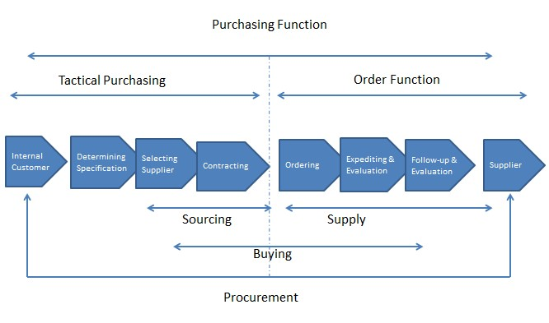

*Figure 1.3 Purchasing Process Model (adapted from Van Weele, 2010)*

**1.8 Characteristics of Strategic Procurement Management**

1. **Spend Analysis:** procurement officers examine the amount of money they spend in each category of goods and services and use this analysis to identify opportunities for improvement.
2. **Supplier Relationship Management:** procurement officers measure supplier performance and regularly spend time meeting with their most important suppliers to implement improvements.
3. **Technology Implementation:** procurement officers frequently update and add technologies that measurably reduce costs, decrease cycle time, and make the purchasing process more efficient.
4. **Developing Project Plans:** procurement officers use project management practices to map out both recurring activities and one-time projects.
5. **Enterprise-wide Contracts:** procurement officers consolidate spends across all parts of their organizations and enter into contracts with a limited supply base to serve the needs of the entire organization.
6. **Forecasting:** procurement officers regularly document changes that they foresee in price levels, availability, and markets to ensure a competitive advantage for their organizations.
7. **Involvement in Specification Development:** procurement officers involve themselves in the early stages of specification development, lending specialized knowledge in material availability, cost drivers, standard parts, and reliability of supply.
8. **Development of Productivity Tools:** procurement officers develop tools (e.g., RFP templates) so repetitive tasks can be done more quickly and error-free.
9. **Supplier Development:** procurement officers don't blindly accept the suppliers and products that are currently available. They work with suppliers to develop new capabilities or products that will improve cost or quality.
10. **Work Responsibility Refinement:** procurement officers constantly identify ways to automate, delegate, or eliminate tactical, non-value-added work.

**1.9 Strategic Purchasing Strategies for Different Products**

1. **Strategic items-**These products represent a considerable value to the organization in terms of a large impact on profit and a high supply risk. Examples are engines and gearboxes for automobile manufacturers, turbines for the chemical industry and bottling equipment for breweries. Often strategic products can only be purchased from one supplier (single source), causing a significant supply risk. There commended purchasing strategies for strategic items are;

i) ***Maintain strategic partnership;***In order to counter-balance the supply risk, firms will aim at building a partnership relationship with its supplier. The mutual trust and commitment that is associated with an intensified relationship is likely to reduce the supply risk to a minimum. A close and lasting co-operation with suppliers will lead to improvements in product quality, delivery reliability, lead times, product development, product design, and it will result in cost reduction This situation can be characterized as one with balanced power. Buyers and suppliers are both heavily involved in the partnership; therefore mutual dependence is expected to be high. Total interdependence is high as well, since the relationship is very intense.

**ii) *Accept a locked-in partnership:***This strategy often occurs when the buyer is subject to unfavorable conditions of the supplier and is unable to pull out of the situation. The locked in position might be caused by the fact that the supplier holds the patent to a certain product and therefore has monopoly power to some extent. This situation can be characterized as one dominated by the supplier.

**iii) *Terminate a partnership;***this strategy is employed when a supplier’s performance has become unacceptable and incorrigible. The buyer will try to reduce his dependence on the supplier. One way of achieving this is to search for alternative suppliers. In this situation the buyer still depends on the supplier, so we expect to find supplier dominance, although to a lesser extent than when the lock-in partnership is accepted. Also the involvement of both parties in the relationship is expected to be the lowest in this situation compared to the ones described above, leading to the lowest total interdependence

1. **Bottleneck items;** These products have a moderate influence on the financial results of a firm; however, they are vulnerable with regard to their supply. Suppliers have a dominant power position for these products. The purchasing strategy that is commonly recommended for these products is; primarily based on acceptance of the dependence and reduction of the negative effects of the unfavorable position. An alternative strategy suggested by purchasing practitioners is to find other suppliers and move towards the non-critical quad-rant.

**i) *Accept dependence, reduce negative consequences:***The main focus of this strategy is to assure supply, if necessary even at additional cost. Examples of this strategy are keeping extra stocks of the materials concerned or developing consigned stock agreements with suppliers. By performing a risk analysis firms can identify the most important bottleneck products and consider the implications. A possible action for dealing with unexpected bad dependence positions for certain products is to employ contingency planning.

**ii) *Reduce dependence and risk, find other solutions:***This strategy is geared towards reducing the dependence on the supplier. The most common way to achieve this is to broaden the specifications of the product or to search for new suppliers.

**c) Leverage items-**In general, leverage products can be obtained from various suppliers. These products represent a relatively large share of the end product’s cost price in combination with a relatively low supply risk. The buyer has many possibilities and incentives for negotiation, since small percentages of cost savings usually involve large sums of money. At the same time the supply risk is minimal. These characteristics justify an aggressive approach to the supply market (e.g. Van Weele, 2000). Frequently, a purchasing strategy directed towards exploitation of the buying power is pursued. Practitioners also identify an additional strategy in this quadrant, which is intended to change the current situation: develop a strategic partnership.

**i) E*xploit buying power*:** In this strategy the firm pursues competitive bidding. Since suppliers and products are interchangeable, there is no need for long-term supply contracts. In general, a coordinated purchasing approach is adopted that has the form of a centrally negotiated umbrella agreement with preferred suppliers. Call-off orders are then placed as an administrative formality. The buying power is actively used to get better deals with interchangeable suppliers. This scenario is therefore characterized by buyer dominance.

**ii) *Develop a strategic partnership*:** In a few cases practitioners choose to abandon the leverage position and opt for a strategic partnership with a supplier. This cooperative strategy is only pursued when the supplier is willing and able to contribute to the competitive advantage of the buyer’s firm. Hence, this role is only attainable for technologically advanced suppliers. In this scenario we expect to find a balanced power position between the buyer and supplier.

d) **Non-critical items-**These products usually have a small value per unit. In addition, many alternative suppliers can be found. From a purchasing point of view, these items cause only few technical or commercial problems. As a rule of thumb routine products require 80% of the purchasing department’s time, while they often represent less than 20% of the purchasing turnover. In general, in this situation purchasers are advised to pool purchasing requirements. In addition Gelderman and Van Weele (2003) identify the strategy of individual ordering and pursue of efficient processing.

**i) *Pool purchasing requirements;***the handling of non-critical products requires a purchasing strategy aimed at reducing the logistic and administrative complexity. A system contracting is generally advised as the way of doing business with suppliers of routine products. The main idea is to enhance purchasing power by standardization and bundling of purchasing requirements.

**ii) *Individual ordering, efficient processing;***whenever it is not possible to pool the purchasing requirements, professional purchasers adopt some kind of individual ordering, for instance by means of a purchase card. This strategy is aimed at reducing the indirect purchasing costs that are associated with administrative activities, such as ordering and invoicing.



**Activity 1.1**

1. Evaluate the general definition and issues regarding strategic purchasing.
2. Define strategic purchasing
3. Explain the current purchasing state.
4. Explain the changing role of purchasing
5. Discuss the characteristics of strategic procurement management
6. Describe strategic purchasing strategies for different products.

**summary**

**1. 10 Summary**

Congratulation for having reached the end of the unit, I know it has been a marathon, but worth it right!! I can confidently say that by now, you should be able to define strategic purchasing, give an overview of the current purchasing and explain the purchasing process.

**Unit Two: Purchasing strategy the internal and external aspect**

## 2.1 Introduction

Now that we have shed more light on what strategic purchasing is, we then proceed to a very important and exciting topic, which is to analyse the internal strategic aspect of purchasing in an organisation. The aim of this unit is to clarify and discuss internal aspects, such as procedures, decisions and strategic alignments that build the basis for any decisions that are made throughout the purchasing process. Additionally, purchasing involvement will be presented.

Outcomes

**2.2 Learning Outcome**

1. discuss internal aspects
2. evaluates the alignment of organizational strategies
3. discuss the strategic alignments.

Time

**2.3 Time Frame:** In this unit you are expected to spend approximately;

* 2 hour 30 minutes’ study time
* 2 hours in class

**2.4 Content**

Purchasing is considered a strategic function with the highest long-term profitability impact.

It becomes clear that the strategic alignment is an important issue when considering purchasing strategies. This is the case because strategic purchasing supports the overall corporate strategy in its market and value proposition through its proactive and long-term management of the firm’s supplier relationships. The internal aspect of strategic purchasing mainly considers the internal alignment of the departments.

**Internal alignment** is defined as the set of commitments, strategies, policies, systems and behaviors that support integrated customer decision making based on suppliers’ commercial and ethical commitment and performance. Therefore, both the vertical and the horizontal internal alignment are important to consider. Vertical internal alignment means the alignment of functional strategies with corporate strategies. Horizontal internal alignment however, deals with the alignment across the different departments.

Internal alignment, independent of the horizontal or vertical alignment has four different aspects. According to Sisco and Wong (2008) the first aspect of internal alignment requires the executive commitment, which means that the corporate culture needs to communicate common goals and behaviors. The second aspect considers integrated policies, strategy and structure (Sisco & Wong, 2008). Corporate wide it needs to be clearly communicated how products are purchased. Products can be purchased either central, de-central or as a combination of both which is called hybrid, the unit will go into depth in the decision making of the way of purchasing. Moreover, the make or buy decision referred to as a strategic decision that has both implications for the internal purchasing strategy as well as the overall corporate strategy of the organization. Communication is a large part of the internal alignment; for this reasons the consistent internal communication is the third aspect that requires consideration. For example, if a corporation chooses for decentralized purchasing, a consistent communication is required. As a fourth aspect, the reporting and information needs to be thought of, and questions need to be answered whether information will be centralized or whether the internal alignment needs to be evaluated for example through cross functional evaluation.

## 2.5 Vertical Internal Alignment

The vertical internal alignment refers to the top-down alignment within an organization. Top down alignment in this sense means that it deals with the alignment of strategies, as well as the influence of decisions on the purchasing department.

### 2.6 Organizational strategies

When looking at organizational strategies in this part of the unit a basic, but sometimes referred to as an outdated model, Porters’ Generic Strategies Framework is used for general understanding. It is used to define different strategies and their roles within the organization. In order to build on Porter’s framework, product leadership and operational excellence have extended it. Porter’s generic strategies framework consists of four strategies.

**2.6.1 Porters Framework**

**Cost Leadership**

This strategy allows firms to stay profitable while the competitors make losses. When following the cost advantage strategy, the purchasing department is required to reduce costs as much as possible and continuously exploit cost advantages. Furthermore, this allows the purchasing department to increase corporate profits, as well as to ensure a cost efficient production. The advantages of cost leadership are the access to capital, which allows for investments while competitors face difficulties. This also creates entry barriers to competitors that try to enter the market.

**Differentiation Strategy**

The second part of Porter’s model is the `differentiation strategy´. According to Clegg et al. (2011), the differentiation strategy explains that the product is unique and stands out from other similar products. In general this means that the firm tries to deliver valuable products in the changing environment and changing market conditions. The differentiation strategy focuses on building a sustainable competitive advantage by designing a unique product that is difficult for competitors to imitate (Clegg et al., 2011). In this case the purchasing department takes the role of exploitation of the market in terms of exclusive and high quality products as well as continuous innovation that assists in developing long-term supplier relations. Internally, this leads to a high demand in the alignment of the R&D, marketing as well as production department with the purchasing department, to further develop new opportunities. The reason for this is that the purchasing department can be seen as an internal supplier to its internal customers

**Focus**

The third and the fourth part of the framework can be summarized to focus. This means that the company will focus on a niche market. Within the niche market the organization can choose to either follow the strategy of cost leadership or the differentiation strategy

However, three further strategies that complement the generic strategies of Porter we brought out. Treacy and Wiersema (1997) explain these strategies as operational excellence, customer intimacy and product leadership. Operational excellence is a philosophy of leadership, teamwork, and problem solving resulting in continuous improvement throughout the organization by focusing on the needs of the customer, empowering employees, and optimizing existing activities in the process.

The operational excellence strategy can be used to extent the cost leadership strategy of Porter, as the aim of operational excellence is cost leadership. However, the main focus in this strategy is on the automation of processes and not, compared to the model of Porter, the movement to more cost efficient areas. Operational excellence theory therefore, focuses on transaction focused and standardized production. Leading organizations in the area of operational excellence are mostly centralized firms. This means that when the organization follows an operational excellence strategy the purchasing department has to focus on operational purchasing and not on the desired strategic purchasing. Companies that follow the product leadership strategy want to create superior products and introduce uniqueness to the markets. Market prices therefore, tend to be in the premium range.

Firms that follow the product leadership see teamwork and problem solving as key to their success. The customer intimacy strategy can be compared to Porter’s focus strategy. Customer intimacy focuses in offering a unique set of products and services that allows the organization to customize their products. The aim of this strategy is to meet different customer needs. While Porter only concentrates on the area where a potential firm could be involved in and then divides only between cost leadership and product differentiation, Treacy and Wiersema (1997) point out that the strategy of customer intimacy is more about creating a network with suppliers and extensive knowledge about customer needs. According to the authors, true customer intimacy can only be achieved by aligning the product development, manufacturing, as well as administrative and executive functions such as purchasing. Organizations that follow the strategy of customer intimacy most likely tend to be decentralized organizations, as the structure allows for fast learning and adaptation.

However, every organization follows a different strategy. The strategy it follows is the basis for decisions and strategies within departments.

### 2.7 Aligning strategies

The purchasing strategy needs to be aligned with the organizational strategy. This is the case because each of the organizational strategies includes a different management and investment approach referring to resources, planning or personnel skills. The internal responsibility of the purchasing department is to combine the different choices of external resources. The alignment of the organizational strategies to the departmental strategies as of purchasing strategies can be achieved in a vertical setting through, for example, the mission or vision statement as well as corporate values. According to Williams (2008), the mission statement in general defines the customers and the products or services the customers will be provided with. Furthermore, the mission statement plays a key role in aligning the corporate strategies as well as there exists a moderating effect of the mission statement on firm performance. The vision statement takes the scope a bit further and focuses on the long-term goals of the firm. While the corporate values influence all corporate activities both internally and externally. The mission, vision and corporate values build the center of each organization and assist in ensuring to align different strategies. For example if the mission statement states to provide the highest quality, the purchasing department strategy needs to make sure that the focus is on quality and not on price.

### 2.8 Make or Buy – Decision

After the organization has decided for a corporate strategy, which has been aligned to the purchasing strategy through mission or vision statements, the organization needs to decide whether they make or buy. The question whether to make or buy basically means that the company needs to clarify their core competencies and decide what portion of their business they want to make and which parts they should buy.

**2.9 Vertical Integration**

Vertical integration is the degree to which a firm owns the subsidiaries that provide products or services to the final product. A vertically integrated firm is engaged in different parts of the production such as manufacturing, marketing or transporting. However, three different types of vertical integration exist. The first one is the so called backward vertical integration, which means that the firm owns or controls the subsidiaries that produce parts of the final product. By controlling these subsidiaries, the firm ensures a consistent supply and quality. Forward vertical integration is the second way of vertical integration. The forward vertical integration means that the firm controls distribution centers and retailers. A third type is the combination of the forward and backward integration.

According to Burt, Dobler and Starling (2003) products or services should only be outsourced if they are not critical to success, do not need specialist skills and do not fit into the core competencies of the firm. According to Burt et al. (2003) items that fulfill one of these issues can be seen as strategic items. Therefore, the strategic purchasing department needs to be aware of managing their internal core competencies. Furthermore, an effective implementation and optimization of the strategic items needs to be ensured, to be able to assist the organization in achieving a competitive advantage.

From a strategic point of view, outsourcing mirrors a strategic issue, as it includes the changing ownership of the resources and assets that are outsourced, to another firm, which needs to be managed through long-term contracts. However, if the organization decides to outsource, the purchasing department can save for example costs by deciding on the right sourcing strategy, which will be elaborated more closely in the next unit. Moreover, if a firm outsources, the flexibility for example in low market development phases is higher than if the company integrates the area.

Linking back to the alignment of strategies, a firm that chooses for outsourcing needs to make sure that the suppliers also act according to the strategies of the firm. Nevertheless, the purchasing department supplies the internal customer and therefore, some parts are for example required to be purchased on short-notice or in line with corporate strategy, such as when the corporation decided to focus on local products. Depending on that, the organization needs to decide whether to purchase centralized or decentralized.

### 2.10 Centralized or decentralized purchasing

After having decided whether to make or buy certain parts of a product or service, organizations need to clarify their structure depending on the corporate strategy. For example, in terms of whether the purchasing department will be centralized, decentralized or a combination of both, hybrid. Centralized purchasing means that the headquarters will purchase all products for the organization. Internally, this centralized structure allows for more control and efficiency in the usage of products and inventory. Furthermore lower costs of labor occur. However, due to a centralized purchasing department, the transportation cost could increase especially in a global organization where distances play a key role whereby it is more difficult to react on short-notice orders (Hu, 2004). Moreover, it is harder to react on external influences from another country; it will take longer for the organization to adapt (Hu, 2004).Furthermore, a centralized purchasing department requires well-established communication lines between the departments to avoid for example maverick buying.

In case of decentralized purchasing, where, for instance, every subsidiary purchases on its own, the efficiency is lower, due to the fact that some parts will be needed in every subsidiary, and centralized purchasing proves to be cheaper. However, the transportation cost and risk will be lower. Furthermore, local purchasing departments can look for so-called Local suppliers. Local suppliers are firms and brands, which have a high reputation and high market-share in one region but are not present in the global market. These firms would not be taken into consideration by a centralized purchasing department.

## 2.11 Horizontal Internal Alignment

After having discussed the vertical alignment of strategies within the organization, horizontal internal alignment deals with the alignment between the departments. This part discusses the role of purchasing within the organization as well as organizational performance and purchasing.

### Introduction to the Value Chain and the Position of the Purchasing Department

Adding more value to customers in such a way that a competitive advantage can be gained is the goal of almost every organization. How departments are able to add value to the organization can be seen in Porter’s value chain. Instead of describing an organization in departments, Porter takes a process view of the firm: the value chain. In 1985, Porters describes organizations in terms of the primary and support activities that are performed to create, deliver, and support a product or service. The primary activities of inbound logistics, operations, outbound logistics, marketing and sales, and service are chained together in sequences that describe how an organization transforms its raw materials into value-creating products. The value chain is supported by common activities, shared across all the primary activities.

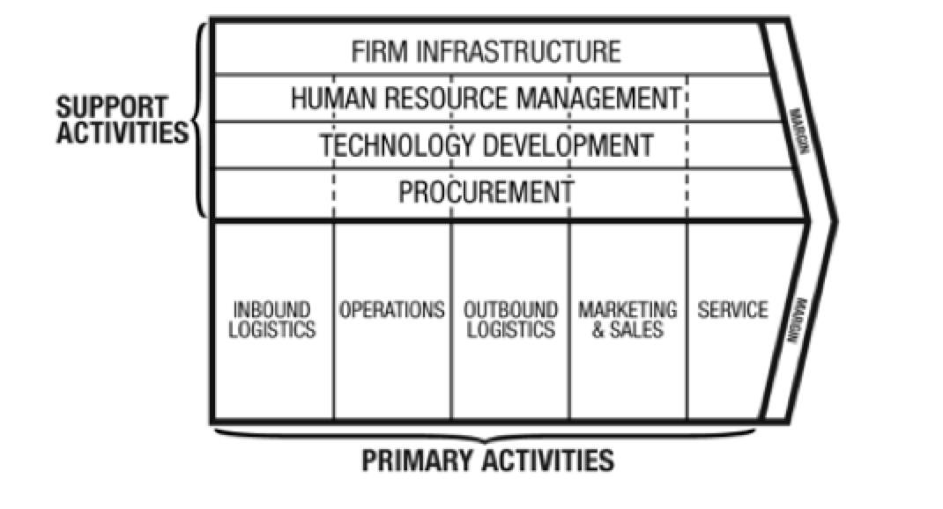

*Figure 2.2: Value chain (Porter, 1985)*

These primary and supporting activities can be seen as the building blocks to gain competitive advantage. However, it is not a set of independent activities but a system of interdependent activities. According to the value chain, the purchasing department as a supporting function, as it can have an important role in each primary activity. The purchasing department could for example, support operations with certain activities, which will be more closely investigated throughout this unit. The value activities are related within the value chain by so-called linkages. These linkages can be described as relationships between the performance of one activity and the performance of another. Therefore, as the activities are interdependent these should be horizontally aligned with each other.

## Horizontal Integration and the Role of Purchasing

Companies perceive the integration of internal organizational functions and processes as challenging. A key issue here is that the strategic purchasing function nowadays is expected to not only integrate with other internal functions, but also to align with their supply chain activities (Cousins et al., 2006). However, the horizontal alignment of the different business functions in the value chain will lead to organizational success. Consequently, the integration of one function with other functional units has been identified as a means to achieve strategic consensus, resulting in an ability to participate in further strategic activities and to contribute to the competitive position of the firm. If an organization poorly integrates purchasing with the activities of other functions it often results in slow problem solving, poor information exchange and low levels of firm performance, while high levels of integration can improve business performance

**Cross-functional integration** within the context of purchasing could be defined as the interaction and collaboration of the purchasing function with other functions, such as product development, production, manufacturing and marketing. However, to explain the contribution of the purchasing department in the cross functional integration, the value chain will assist in the development of an explanation. The integration of the purchasing function with other function is a prerequisite to effectively address the supply market objectives that support the organizations in achieving its overall competitive targets. As mentioned earlier, a poor integration of the purchasing function will have negative consequences for the organizational as a whole. The purchasing function may, for example, pursue a low cost strategy through multiple bidding rounds or volume concentration to leverage its bidding power. While according to the marketing and product development function, the success of the organization’s overall strategy may be strongly defined in terms of quality improvement and product innovation (Foerstl et al., 2013). In this situation, a misalignment between the functions is apparent and no overall goal is achieved. Such misalignment could lead to selecting the wrong suppliers and providing the wrong incentives to these suppliers, with damaging effects on purchasing performance in terms of quality and innovation (Foerstl et al., 2013) and indirectly on the whole organizational performance.

How then should purchasing integrate with other departments, on what issues and with which departments? Achieving integration of purchasing with other departments can be pursued in several ways: purchasing representation in top-level management, integrated cross-functional teaming, and measurement and reward systems based on contributions to competitive goals

As the vertical alignment is discussed above, the horizontal, cross-functional teaming is described here. A cross-functional team is composed of those individuals from different functional departments whose competencies are essential in achieving an optimal evaluation, and including the purchasing department. To fully take advantage of such cross-functional teams a clear communication to the stakeholders and internal team communication is very important. Furthermore, such integration of purchasing with other functional departments concerns organizational change, develops strong internal relationships through membership in strategy development teams, information sharing, and joint decision-making activities.

More specifically, the purchasing department integrates with the manufacturing department. integrating the purchasing department with the manufacturing department will have a measurable impact on the achievement of the manufacturing goals. Moreover, purchasing plays an important role in product development. Cross-functional teams are for example increasingly used in product development, were the teams are composed of individuals from marketing, R&D, manufacturing and purchasing. In addition, the purchasing department can have an important contribution to the marketing department. The purchasing department can ensure funds are spent properly, improving the quality of advertising and communication and save time and money.

### 2.13 Internal drivers of the purchasing department

To receive an overall view of the purchasing function, its performance and the internal drivers, Foerstl et al. (2013) model will be used. More particularly, this model incorporates the two internally focused practices, cross-functional integration and functional coordination. In addition, it assesses and compares their individual impact on purchasing performance and, indirectly, on organizational performance (Foerstl et al., 2013). The relative impact of cross-functional integration and functional coordination on purchasing performance. Cross-functional integration does not only seems to have impact on performance, but also on the competitive advantage. Moreover, according to Parker (2003) cross functional integration also gains competitive advantages for the firm such as, speed, complexity, customer focus, creativity, organizational learning. The focus of this part is the coordination of functions and departments within the organization. Functional coordination within the purchasing department could be defined as the common management of processes, products and services, and suppliers across the worldwide purchasing organization . It seems to also take a more global perspective. Functional coordination enables synergy potentials from global purchasing operations to be realized in form of economies of scale, scope, process and learning. functional coordination is a difficult challenge when differentiation is high. In such a situation, functional integration acts as the glue that supports coordination and guarantees high performance.

Furthermore, there seems to be a total impact of talent management and a mediated impact of performance management on purchasing performance (Foerstl et al., 2013). Within the purchasing function, **talent management** is defined as a combination of selective staffing, comprehensive training, and appropriate job structures within the strategic purchasing function. According to Foerstl et al. (2013) talent management plays an enabling role in achieving cross-functional integration and functional coordination through developing opportunities, adequate career paths, and the separation of roles within the function foster cross-functional integration and functional coordination. Moreover, Reinecke, Spiller and Ungerman (2007) recognize that talent matters in purchasing. Reinecke et al. (2007), further identified three talent dimensions, including:

* The involvement of capabilities of the purchasing units themselves
* The way purchasers view their roles
* Involving purchasing executives more broadly in the business planning



**2.14 Activities**

1. discuss internal aspects
2. evaluates the alignment of organizational strategies
3. discuss the strategic alignments.

summary

**2.15 Summary**

Congratulation for having reached the end of the unit, I know it has been a marathon, but worth it right!! I can confidently say that by now, you should be able to discuss internal aspect of strategic procurement.

**Chapter Three: Sourcing Strategies**

**3.1 Introduction**

We have looked at the internal aspect of strategic purchasing in unit two. Now we turn our attention to the external aspect of strategic purchasing which will be centered on sourcing strategies. This includes global sourcing, which focuses on offshoring, nearshoring, inshoring and backshoring. Furthermore, category management is critically reviewed as a strategic approach. Additionally, the portfolio models are discussed in relation to different strategies including best value procurement and low-bid procurement. Then the supplier selection is addressed with supply base, sourcing and scouting, and single versus multiple sourcing. In the end, selection criteria are discussed.

Outcomes

**3.2 Learning Outcome**

By the end of the unit you should be able to;

* discuss global sourcing
* describe category management
* illustrated strategic purchasing portfolio model
* explain the supplier selection and selection criteria

Time

**3.3 Time Frame:** In this unit you are expected to spend approximately;

* 2 hour 30 minutes’ study time
* 2 hours in class

**3.4 Sourcing Strategy**

Nowadays, suppliers do not solely have impact on reducing costs and improving quality of products or services, but suppliers are also more involved and integrated in processes such as the product design and development. The selection of the right suppliers and composing the optimal supply base has become one of the most challenging parts of strategic purchasing, due to the continuous changing and a highly competitive environment, higher expectations and requirements of customers, the uncertainty and risk collaboration of buying companies grows. Moreover, collaboration with different suppliers around the world entails a global focus and view of many industries nowadays. However when done right and effectively, it is a strategic tool to gain or maintain a competitive advantage. Therefore carefully considered strategic decisions about which and how many supplier(s) to select is very important in order to deal with these external trends in most sectors and eventually could lead to higher quality of products and services, lower costs, greater customers satisfaction and at the end higher profits.

**3.5 Place Sourcing Strategy in the Corporation**

Strategic sourcing is defined by Anderson and Katz (1998) as a wide range of activities namely creating an overall strategy for sourcing, evaluating and selecting suppliers, procuring materials/services and managing supplier relationships. Similarly, Weele (2010) defines **sourcing** as the part of the purchasing process that aims at selecting and managing suppliers aligned with strategic organizational goals and objectives. Thus, sourcing strategy includes procurement of materials and/or services as well as selection and management of suppliers aligned with organizational strategy. Sourcing has increased in popularity, generally taking a prominent place in the purchasing process of companies.

Figure 3.1 below envisions the latter definitions. The sourcing process, which is circled red, includes the strategy in place for specification, selection and contracting, which is aligned with the corporate strategy as well as the business strategy. It is important to consider the fact that corporate strategy, business strategy and purchasing strategy are interrelated and can influence on another. Thus, the purchasing strategy could possibly also trigger changes in the business strategy or even corporate strategy meaning that alignment is not solely determined in a top-down manner.

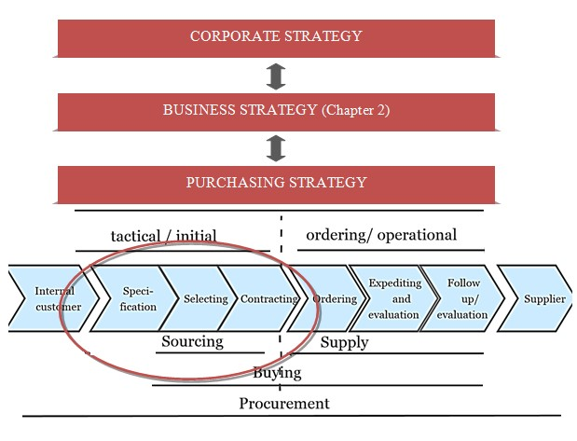

*Figure 3.1 Sourcing strategy defined. Adapted from van Weele (2010) and Johnson & Howard (2014)*

## 3.6 Global Sourcing

After discussing the make or buy decision in unit two by discussing in-sourcing as well as out-sourcing, the out-sourcing will be elaborated on by extending it with a view on global sourcing. Global sourcing can be identified as seeking for foreign supply sources to including in the overall purchasing strategy. In other words, it involves the geographical decision regarding outsourcing made during the sourcing process.

There are many definitions of outsourcing, the one used in unit two stating that **outsourcing** is the use of outside agency to manage a function formally carried out inside the company is just one of many. Common ground in all these definitions is the external agent executing the outsourcing activity. When one considers a more global perspective on outsourcing, the term offshoring or offshore outsourcing comes forth. This is similar to outsourcing except that the specialized capabilities are accessed from external agents across geographical borders. This is, therefore, also referred to as global outsourcing. Different incentives are of interest when outsourcing globally compared to the outsourcing in proximity. The main incentive for most multinationals is cost reduction especially due to low labour cost. Even though this can lead to lower cost, companies are more exposed to facing quality problems due to differences in standards and lack of control. Additionally, cost reduction due to economies of scale, experience and higher quantities of production of suppliers can reduce the cost per unit of production (Hollensen, 2008). Besides the cost perspective, it can be aimed to tap into capabilities that are unavailable or supplement the existing capabilities of the firm. This could be in terms of knowledge, innovation capabilities, access to technologies and other resources (Hollensen, 2008), access to skilled labor pools and competitive pressure. Thus, offshoring is often used as source of corporate transformation and business renewal.

Besides the possible benefits to offshore, one should take into consideration that sourcing multiple activities from multiple suppliers from different global locations increases the complexity and cost of management. Moreover, the increase of complexity makes it harder for managers to consider all factors relevant for decision-making prior to offshoring, increasing the chance of cost estimation error and unexpected cost. Therefore, the factors for selection of suppliers are provided taking into consideration for decision-making, namely strategic and organizational factors. The metrics for strategic performance are based on competitive priorities, which are cost, quality, time, flexibility and innovativeness. The organizational factors are more focused on firm characteristics and capabilities, more specifically on culture, technology and relationships. This can be found in figure 3.2.

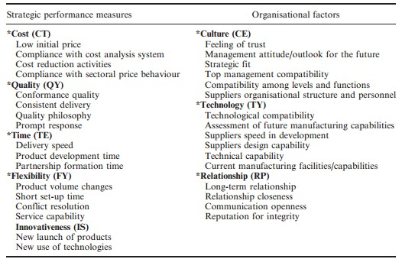

*Figure 3.2 Performance measures vs. Organizational factors (Adapted from Sarkis and Talluri, 2002 & Chan, 2003 in Dou & Sarkis, 2010)*

Outsourcing activities that are less globally oriented are nearshoring and inshoring. Inshoring is when the job is relocated domestically (Liao, 2012), thus does not cross the border similarly, nearshoring is characterized by relocation of tasks to locations in close geographical proximity of the firm, thus crossing the border, but staying relatively close. Lastly, a new trend is backshoring, which is bringing back offshoring to the domestic country. This could happen after evaluation of the supplier, but also for sustainability reasons.

## 3.7 Category Management (CM)

In traditional brand management, individual brand-oriented buyers search to improve their economic performance by procuring large quantities of product on deals and then relying on retail pricing, promotions, and merchandising activities to deplete brand-level inventories as quickly as possible. However, increasing complexity of procurement activities concerning increasing range and number of products, competition forcing to work effectively, customer segmentation, diversity of competitors due to globalization as well as increasing ranges of products, and abundance in availability of technology and information, leads to the need for a different approach.

**Category management** is an alternative to the traditional approach and is defined as a process for managing entire product categories as strategic business unit with the focus on delivering consumer value. In other words, category management moves away from determining performance of individual brands and towards performance of categories of products by recognizing interrelation of products. It is aimed to provide a win-win-win situation where suppliers, purchasers and consumers benefit from category management.

In theory, the outcomes of all parties can be enhanced as category management provides opportunities to operate a category as a business where purchasing and selection of the optimal product mix is executed per category in order to meet customer needs. It is believed to aid achieving cost reductions and effective consumer-oriented practices. Additionally, increase in profit is assumed. Furthermore, category management is aligned with customer decision-making and the manner customers define their needs helping firm to take a selling perspective and get closer to the customer’s point of view. Moreover, it is stated that sales-building opportunities as well as strategic issues can be addressed more effectively at the category level.

However, results are still somewhat contradictory and some claim that these benefits are exaggerated. More specifically, the definition claims that deliverance of consumer value is key of the approach, whilst category management can lead to higher retail prices and limited product choice as most profitable items are solely provided. Furthermore, category management might not directly change customer satisfaction and therefore not directly increase profit.

Category management can be achieved without collaboration of suppliers, but results will be enhanced when collaboration takes place due to the use of complementary knowledge. Furthermore, purchasers can have a large range and quantity of products across many categories, making it impossible to intensively manage all the categories. Hence, the firm can select a lead supplier or category captain to tap into capabilities and resources. **A** **lead supplier** is defined as the supplier to the category that has the most influence (relative to other suppliers) over the retailer’s CM decisions and actions. One step further is the **category captain** in which a supplier, often the category leader, takes on a significant role in the retail management of the category, including the brands of competing suppliers. This approach is, however, controversial and comes with risks. The lead supplier or category captain can behave opportunistically by favoring own brands thereby excluding or increasing cost of competing suppliers. In other words, it also influences competing supplier relationships and decreases competition possibly leading to increase in prices, decreased variety of products and decreased focus on innovation leading to a decrease in consumer value.

In order to gain from lead suppliers or category captains, purchasers should monitor its suppliers continuously with clear guidelines for detection and punishment and motivate all suppliers to report opportunistic behavior (Gooner et al., 2011). Furthermore, it is expected that the performance benefits of being lead supplier or category captain outweigh the short term benefits of opportunistic behavior.

## 3.8 Portfolio Models

Definition **Portfolio model**: A tool that combines two or more dimensions into a set of heterogeneous categories for which different (strategic) recommendations are provided.

As is already been said above, purchasing has evolved from a clerical buying function to a strategic business function. Therefore managing the products and supplier relations is important. Using portfolio models can do this. In this part of the unit, the goal is to get more insight in the strategic part of defining a portfolio model and where in the model to put your products. The place of the products in the portfolio model divides your product portfolio into different kind of product groups. Since the place in the model affects how we deal with products, the division of the products must be executed carefully. This division in the product portfolio links to the strategic goals of the company. Over the years, many kinds of matrices are developed. Since, 50% of the responding small companies and 85% of the big companies use Kraljic. The Kraljic matrix will therefore be discussed. In figure 3.3 an overview of different purchasing portfolio models that are developed over the years can be.

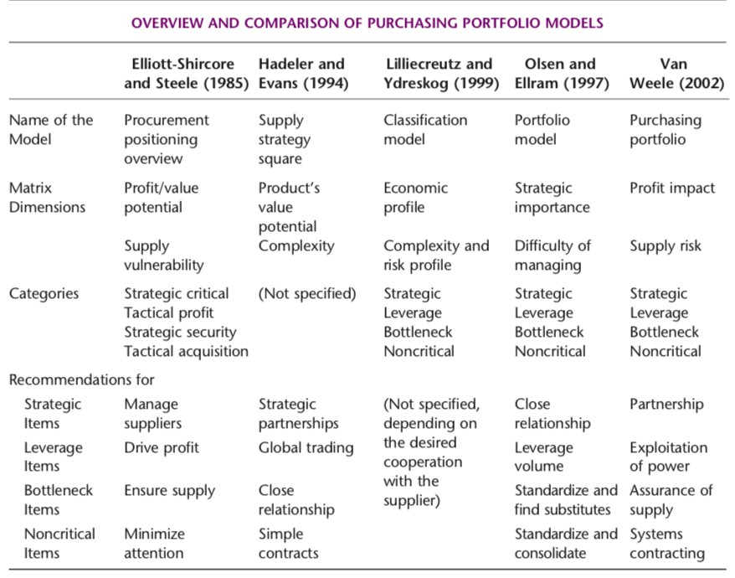*Figure 3.3 Overview of different purchasing portfolio models (Gelderman & Van Weele, 2005)*

## 3.9 Kraljic Matrix

The matrix that almost every purchaser knows is the Kraljic matrix. Kraljic first introduces this model in the article ‘Purchasing must become Supply management’ from 1983 (Kraljic, 1983). This matrix consists of two axes, to divide products of the company in a portfolio model. The first axis is the supply risk, the second axis the profit impact. In figure 3.4 the matrix can be seen. The two axes result in four quadrants that represent different forms of products: noncritical items, leverage items, bottleneck items and strategic items.

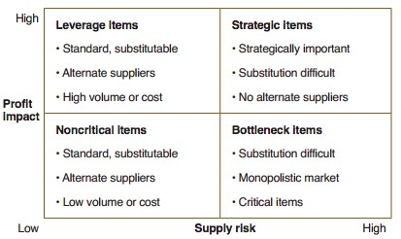

*Figure 3.4 Kraljic matrix (Kraljic, 1983)*

Supply risk is affected by three factors:

* Market risk: this is a measure for the availability of potential suppliers for the products, type of market (monopoly, oligopoly) and entry barrier of new suppliers to the market.
* Performance risk: a measure for the quality and performance delivered by suppliers. This can include things as access to new technologies.
* Complexity risk: the complexity of the products affects the supply risk. Standardization and product specifications affect this factor.

Profit impact can be defined with the use of three factors:

* Impact on profitability: this factor is the profit that is typically yielded on the purchase of each product.
* Importance of purchase: this addresses the importance of the product to the company.
* Value of purchase: this is a measure for the tangible and intangible costs the products brings with them.

These two factors result in a two-by-two matrix with four product groups: non-critical items, bottleneck items, leverage items and strategic items (Kraljic, 1983). The four product groups differ in the power position between buying company and supplier. Since the Kraljic matrix focuses on the view from the buying company, it can be used to minimize the supply vulnerability and make use of potential buying power. The four types of products each have their own characteristics and therefore need a different purchasing approach. The non-critical items are ordered frequently and thus cause high transactional costs. Therefore, the strategy must be focused on reducing costs. Bottleneck items causing supply problems and should therefore be handled with care, such that the supply risk is minimized. The leverage items have a low supply risk and a high profit impact (Kraljic, 1983). Therefore, the procurement of these products should be managed in such a way that the purchasing company will exploit its buying power. For the strategic items the supply risk and profit impact are high.

### 3.9.1 Strategic implementation Kraljic matrix

Kraljic’s matrix comes with three strategies with respect to risk and power in the buyer-supplier relation: “exploit”, “diversify” and “balance” (Kraljic, 1983). The strategies and their corresponding quadrant can be seen in figure 3.5 (Kraljic, 1983). In figure 3.5 the company strength is equal to the profit impact and the supply market strength is equal to the supply risk.

These three strategies will be discussed in detail in this part.

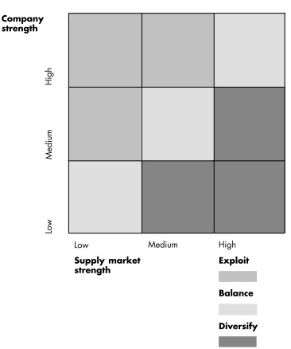

Figure 3.5 Strategies in the Kraljic matrix

**Exploit Strategy**

The exploit strategy can be used for the leverage items of the Kraljic matrix. For these items enough suppliers are available, since the supply risk of these products is low. The profit impact to the buying company is high, this means that a big amount of money is spend on these kinds of items. The exploit strategy is a strategy that is based on the fact that the buying company is in the dominant position. This means that the buying company has more power than the supplier. Due to this dominant position, the buying company can use a more aggressive way of negotiating with the suppliers. The buyer can define the price it wants to pay for the leverage items and select suppliers based on the price they want for their products. Thus, this strategy aims for searching and selecting suppliers on the lowest price. However, this means that there is a constant pressure on price reduction by exploiting the bargaining power of the buying company.

#### **Diversify strategy**

The diversify strategy can be used for the bottleneck items. These items are known for their high supply risk and low profit impact. The difference with the products in the leverage items is that the supplier is in a dominant position, since there are not many suppliers available for the bottleneck items and therefore there are no negotiations possible on the price. Although the profit impact on the buying company is low, the company still relies on these products to maintain their business. The focus of the diversify strategy is therefore to ensure the supply of the bottleneck items and reduce the dependency of suppliers and risk regarding this bottleneck items. Increasing the stock of these products or having more suppliers to overcome the risks of losing the availability of the bottleneck items can achieve ensuring your availability of bottleneck items. However, since increasing the amount of bottleneck items in stock will increase the costs of your inventory, there is always a trade-off if this form of diversify-strategy is chosen. This trade-off is between having many bottleneck items in stock and having not enough bottleneck items available. The other option is having more suppliers. This will enhance the supply base complexity, since more suppliers are used. Thus, using the diversify strategy is always about weighting the possibilities and risks of losing the availability of the bottleneck items.

#### **Balance strategy**

The balance strategy can be used, according to Kraljic, for the noncritical and strategic items (Kraljic, 1983). The balance strategy is adapted for both of these kinds of items, however they share the characteristic that there is no dominant party, thus neither the buyer nor supplier can use their power.

The noncritical items are items that have a low profit impact and a low supply risk. The buying company is not in a dominant position since the profit impact is not high, suggesting that these products are not bought in big numbers or for high prices. The supplier is not in a dominant position since there are a number of other suppliers who are competing. Therefore, the balance strategy for noncritical items advises to have contracts with many suppliers, based on the price of the product and the amount of effort needed to sustain the relationship. By doing this, the company will overcome the problem of losing a few suppliers with losing the risk of not having noncritical items available.

For the strategic items, the buying company is not in a dominant position since the supply risk is high due to the low amount of suppliers available for these strategic items (Kraljic, 1983). The supplier is not in a dominant position, since the buying company will spend a lot of money on these products). The buying company will (probably) spend a lot of money because these items are of strategic value to the company. Therefore, the supplier cannot risk losing this client. The balance strategy for strategic items therefore aims for long-term cooperation between the company and their supplier(s) (Kraljic, 1983). This cooperation can be fulfilled in different ways:

* Joint research & development projects; in this case the supplier can be seen as an extension of the company.
* Having contracts with a small amount of suppliers. These contracts should take multiple criteria into account, which will be covered later on in the supplier selection paragraph.

Thus, the balance strategy for strategic items aims for a long-term relationship between the company and the suppliers (Kraljic, 1983). Due to this long-term focus, the company cannot sustain contracts with a lot of suppliers for these strategic items, since this will take too much effort.

### Negative aspects Kraljic matrix

There are several portfolio models established after Kraljic modeled his matrix in 1983.

However, Kraljic matrix is still the dominant one that is used. Some of the other models can be seen in figure 3.3. However, these models show more similarities than differences in comparison to the Kraljic matrix.

While the Kraljic matrix is a well-known and often used tool, an often-heard regard is that it only takes into account the buyer point of view. Another heard regard of the Kraljic matrix is that the strategies only focus on approaches that can handle the different characteristics of the four quadrants.

A mismatch between buyer and supplier may occur if the point of view of the supplier has not been taken into account. Partnering is only possible if both parties aim for partnering. Therefore, there is also a model that takes the suppliers’ point of view as a starting position. This model is developed by van Weele and can be seen in figure 3.7. In this model the products can be divided, based on two axes. The axes of this model are, account attractiveness and relative value of the business. The account attractiveness is a measure for how important the buying company is to the supplier. The relative value of the business is a measure for the value of the products to the buying company.

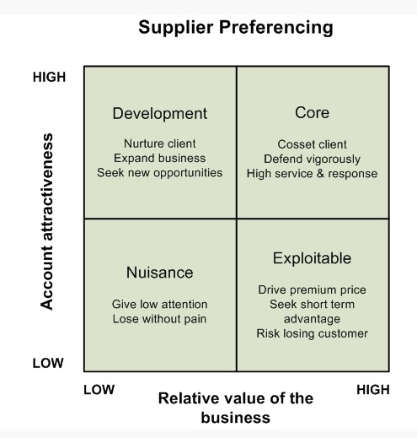*Figure 3.7 Supplier preferencing matrix (Van Weele, 2003)*

Another heard regard of Kraljic is that the strategies that are proposed are at a quite rough level. The selected procurement strategy that companies use, will differ depending on business strategy, the competencies - e.g. the skills of the employees and the power of the company. To be a world-class competitor, the expertise and commitment of the supplier must be used. Other authors have mentioned that using the expertise and commitment of the supplier is called best value procurement; this form of purchasing will be discussed now.

### 3.10 Best value procurement

Procurement is often characterized by either a more traditional bidding (low-bid) or a best-value structure. Therefore, despite other procurement methods, these will be the methods that will be discussed in this part of the unit.

Traditional bidding considers prices as main focus, where the lowest cost proposal is aimed for. The firm provides minimum standards and squeezes the suppliers on discounts. Whilst this approach suggests monetary savings, economic-envisioned end-results or best value are not always reached. This approach could trigger the suppliers to provide unrealistic low bids as well as improperly balanced risk allocation, which could lead to unwanted economic end-results. Furthermore, the supplier is forced to implement strict cost-cutting measures to comply with the standards set by the firm instead of focusing on quality enhancing measures which reduces the chance of delivery of optimum quality projects. This is confirmed in practice as Bax (2014) states that the focus on price will lead to reduction of quality, as is also mentioned earlier in the unit. Due to all the standards, there is less freedom for the supplier to implement knowledge and expertise to come to the best solution. The circles embody criteria from the firm, when more criteria is added, the freedom to find solution decreases leading to focus solely on the standards and failure of deliverance of quality.

The low-bid approach is best to be used in a price-based industry with high competition were the focus is on the best deal for the short term (Koopmans, Adjust). As it is focused on the short term, it will be harder to create sustainable long-term relationships. It is best to link to leverage products as these items provide low supply risk, but are a relatively large share of the price of the end product. Therefore, a minor change in cost has a relatively strong effect in the price of the end product, whilst refraining from taking a lot of risk. Furthermore, leverage products provide room for negotiation and possibilities to switch from suppliers making the short-term and cost focused nature appropriate for this type of product. Next to this narrow focus on economical aspects and control of the requirements, the best value procurement (also referred to as performance information procurement system or PIPS) exists. Best-value procurement does not solely considers price, but also takes into consideration technical criteria and qualifications and claims that in order to increase efficiency the need for management needs to decrease contrary to traditional bidding. The main vision is to increase the value added for each monetary unit added, thus to provide optimal combination of price and performance. As the concept is still fairly ambiguous, there is no commonly agreed definition for value-procurement. However, van de Rijt and Santema (2012) provide a compact description of **best value procurement**, namely that it is a procurement process where ‘’the risk is shifted to the vendors to show value through dominant expertise, knowing that experts minimize both risk and cost, thus providing the best value for the lowest cost’’. Thus, the buyer/client relies on the expertise of the vendor for the highest performance and minimizes technical decision-making and management by the buyer/client by transferring control and risk to the vendor. More specifically, the responsibility regarding completion of the project and performance are left to the expertise and experience of the supplier without specification, direction and inspection. Solely, the quality assurance is done by the buyer/client, whilst the suppliers control the quality and manages the risk. The control of the project as well as the fact that the supplier is set at risk will stimulate the supplier to deliver quality projects. Furthermore, the supplier will be rated in the end on performance, which will influence the chance of obtaining work in the future.

When applied correctly, the process will reward innovative proposals that increase quality or proposals that provide quality for lower cost leading to increased quality or a better price-quality ratio. This is confirmed in practice by Hans Bax stating that a focus on quality leads to a reduction in price. Furthermore, management efforts will decrease significantly by 80 to 90 per cent and completion of projects will increase by a tenfold from a supplier perspective, the best value procurement provides the opportunity to maximize their profit by working in an efficient as well as handle projects faster leading to the possibility to handle more project during the same time span. However, there is also a significant chance of using best value procurement incorrectly as evaluation of the proposal is proven difficult, especially because there are no standards for scoring proposals. Buyers/clients should base it solely on measurable value-adding aspects to the project as well as a focus on transparency in plans of both the parties to ensure no information is hidden and diminish the element of subjectivity. The best value procurement can be linked to strategic products in the Kraljic matrix, as van Weele (2010) states that strategic products should be managed with performance based partnerships. However, in practice, it was more broadly applied, as stated that the company uses best value for routine products.

### 3.11 Movements inside Kraljic matrix

The three strategies (exploit, balance and diversify) are rather generic and only provides rough guidelines. Another disadvantage of Kraljic its approach is that it does not provide guidelines for moving commodities or suppliers around the different categories, provided some extra guidelines for the different quadrant that do take into account the moving commodities around the different categories, these will now be discussed. The possible strategies that are mentioned by Gelderman & van Weele can be seen in figure 3.9.

|  |  |  |
| --- | --- | --- |
| **Strategy** | **What is it?** | **Result** |
| Capacity deal | The purchasing department focuses on one supplier that is the approved supplier. This gives the buying company a better negotiating position. | Bottleneck items can be moved to “better bottleneck items”. |
| Pooling | Business units agree on standardization, such that the one standard product can be bought instead of different forms of the same product. | Bottleneck or non-critical items move to leverage items. |
| De-complex | Make the end product less complex, but still match with the needs of the business group or client involved. | Bottleneck items move to non-critical items. |
| Purchase card | Specific products that cannot be pooled are purchased on a transactional basis. | Non-critical items become even more non-critical. |
| Strategic partnership | Assessment of the supplier is executed on key buying criteria that are specified by the buyer itself. If trust in the performance of supplier is high enough, strategic partnerships can be considered. | Move leverage items to strategic items.  For strategic items: it is recommended to use this strategy. |
| Partnership of convenience | When a supplier does not qualify as a strategic partner, the focus will be on efficiency and cost reduction. | Leverage items stay leverage items. However, costs can be reduced. |
| Supplier development | In the case of non-optimal strategic partnership with under-achieving partners, supplier development can help by increasing the quality of the supplier by training. | Strategic items become leverage items. |

*Tablee 3.9 Possible strategies to move commodities inside Kraljic matrix(Gelderman & van Weele, 2002)*

## 3.12 Supplier Selection

Purchasing, including sourcing, scouting and selecting suppliers as stated earlier, has developed from a tactical and more operational function to a strategic function, which influence the degree to which a focal organization will be a success or a failure. The process of purchasing, including selecting and establishing partnerships with external suppliers consists of a five-stage model and correspondents with the purchasing process model of van Weele (2010). The 5 stages of Ellram are:

* Establish strategic needs, form team, confirm top management support
* Identify potential partners
* Screen and select
* Establish relationship: provide high attention level and give prompt feedback.
* Evaluate relationship: continue, expand, or reduce

### 3.13 Sourcing & scouting for suppliers

The process of strategic sourcing can only start when the organizations have determined the importance and potential profits of products, components and services. The different items a company wants to outsource and the potential supply risk is estimated by scaling the goods in one of the quadrants of the already mentioned purchasing portfolio of Kraijlic (1983). When the company knows in which quadrants the different products are, the process of strategic sourcing continues with deciding whether to source for new and unknown suppliers outside the existing supply base. Another option is to choose suppliers, which have supplied the organization in the past or are still supplying. In other words, it is about the decision whether to do a complete new purchase, modified rebuy or straight rebuy . Depending on the variables of Kraijlic and the complexity of the goods the buying organizations needs to choose between these 3 options. The differences between the options will be shortly described below

***New purchase:***This situation occurs when an organization starts with a complete new product, component or service. The organization has not purchase goods in this area of the supply market before and therefore needs to walk through the whole purchasing process again and decide from which supplier they will buy the new product or service. This takes a lot of time and effort to establish and the uncertainty and chance of disruptive events are relatively high.

***A modified repurchase:*** In this situation the organizations decides either to buy the new product, component or service from a supplier the organization already knows and worked with before or scout for a completely new supplier. In addition it is also possible that in the case of a modified rebuy that the buying organization bought a good from a certain supplier in past, but decides not to purchase from anymore because the characteristics of the product have changed or a negative evaluation of the supplier.

***A straight rebuy:***In this case the organization buys an existing product, component or service from a known supplier. Costs such as transaction costs can be kept low and the level of risk and uncertainty is low due to the fact the purchase is from a repetitive nature.

In figure 3.10 the relation as described above, about the newness of the goods and the supplier and the level of risk and uncertainty this involves is shown. Nowadays most organizations are aware that scouting and selecting new suppliers is a costly and risky investment and having a supply base which have shown to be trustful, reliable and long-term relationship are therefore in most cases preferred. In paragraphs below the complexity and the importance of the composition of the supply base and the selecting criteria will be further discussed.

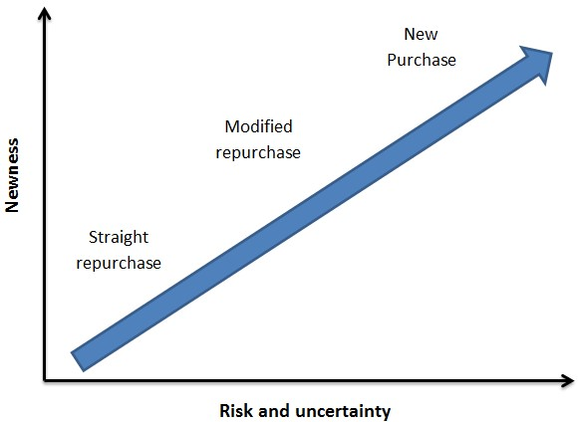

*Figure 3.10 New, modified and straight repurchase (Johnsen et al, 2014).*

### 3.14 Supplier base

“**Supply base** is a definition of the part of supply network which is actively managed and controlled by the buying company”. This means that the focal organization manage, controls and buy from the suppliers on the supply side, including both suppliers directly and indirectly linked to the focal organization. The schematic representation how the focal organization is related to first-tier (directly linked) and second and third-tier suppliers (indirectly linked) is shown in figure 3.11 . In the drawing the blue lines indicate the partnerships of the first tier supplier with second and third tier suppliers. For example is it possible that second or third tier suppliers that are contracted by the focal company will not directly deliver their goods or services to the focal organization but instead to other suppliers in the supply base before it reaches the focal organization.

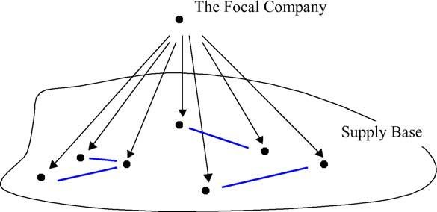

*Figure 3.11 Supply base (Choi & Krause, 2006)*

To manage and control the suppliers the focal company, contracts must be concluded with the suppliers about purchasing products, components, raw materials and services. The complexity of the supply base is an important managerial aspect, which includes 3 dimensions that needs to be considered by the focal organization:

* The number of suppliers in the supply base.
* Degree of differentiation among these suppliers.
* Level of relationships among the suppliers.

Due to the increased search for lower costs and higher quality nowadays, purchasing organizations expand their scope to outsource and purchase different goods all around the world. The result is that the complexity of the supply base has become even more difficult to manage for most focal organization. The global nature of trading have made it for the buying organization critical to take the supply base complexity dimensions of very seriously in order to compete in the highly competitive global markets. Furthermore, the complexity and composition of the supply has major impact on the focal organization and affect the height of the (transactions) costs, the degree of supply risk, suppliers responsiveness and the degree the focal organization perceives the supplier(s) as innovative. For instance the smaller the number of suppliers and the closer the relationship the more it reduces the potential of risk, the negotiation costs and stimulates the supplier to be innovative (Johnsen et al, 2014). Therefore it is an essential to take these dimensions into account in the strategic supplier selection

The supply base includes the number of suppliers where a focal organization buys from and the degree the characteristics suppliers differ with respect to the focal organization. Other new suppliers need to be taken into consideration when selecting suppliers. Due to the trend of outsourcing globally, the focal organization needs to take in account the different environmental and cultural circumstances and differences of the suppliers and need to assess the potential risks of those suppliers. This means that a certain skill is needed. The more suppliers you have and the more they differ from each other, the more complex it is to manage and control the partnership. This is caused due to the fact that suppliers are more involved nowadays in the new product design process and the decision-making about how to reduce costs or improve quality of products or services. Therefore many different suppliers with different influences and backgrounds are impossible to manage for most of the buying organizations. Furthermore it is necessary that the focal organization reduces and optimizes the number of suppliers and buys higher quantities from only a few suppliers in order to reduce unnecessary (negotiation) costs and to be competitive.

However, when the focal organization decides to reduce the supply base, the focal organization must be aware that the management style needs to be more strategically focused. For instance by reducing the supply base to only one or a few suppliers, there is a potential risk that the supplier(s) have the upper hand in the negotiations and decisions. This should be avoided by focal organization at all cost. Therefore strategic elements such as coordination, cross-functional work, clear agreements and close collaboration of the focal company with its supplier(s) is needed in order to not lose the bargaining power in partnerships with only a few suppliers. Thus, is it important that the focal organization develops new skills and competences in order to have a healthy partnership. The influence the number of suppliers has on the focal organization will be discussed more in depth in the next paragraph and topics such suppliers relationship, contracts and required purchasing skills.

## 3.15 Single Vs Multiple Sourcing

The number of suppliers is related to the decision whether the organizations will follow the single or multiple sourcing strategies. A focal organization does not only have to decide about the number of suppliers it wants to purchase from, but also needs to assess which influence this decision has on the probability of risk and what consequences this could have for the organization, for example financially (Constantino & Pellegrino, 2009). All the advantages and disadvantages of single and multiple sourcing are shown in figure 3.12 (Costantino and Pellegrino 2009).

|  |  |  |
| --- | --- | --- |
|  | **Single Sourcing** | **Multiple Sourcing** |
| *Advantages* | * Partnership between buyers and suppliers allows cooperation, shared benefits and long-term relationship based on high levels of trust. * Reduction of risk of opportunistic behavior. * Large Commitment of the supplier that is willing to invest in new technology or new facilities. * Lower purchase prices resulting from reduced production costs, due to better knowledge of the manufacturing process by supplier and achieved economies of scale. | * Alternative sources of materials in case of delivery stoppage by a supplier. * Reduced probability of bottlenecks due to insufficient production capacity to meet peak demand. * Increase competition among suppliers leads to better quality, price, delivery, product innovation, and buyer’s negotiation power. * More flexibility to react to unexpected events that could endanger supplier’s capacity. |
| *Disadvantages* | * Great dependency between the buyer and the supplier. * Increase vulnerability of supply. * Increased risk of supply interruption, especially for asset specific products. | * Reduced efforts by supplier to match buyer’s requirements. * Higher costs for the purchasing organization (greater number of orders telephone calls, records and so on). |

*Table 3.12 (Dis)advantages of Single & Multiple sourcing strategies (Costantino & Pellegrino, 2009)*

The concept of single sourcing evolved since the Just in Time (JIT) and lean philosophies were introduced and are characterized by long-term and closely related partnership with only one or a few suppliers. Both the focal organization and the supplier(s) are striving for mutual benefits in a highly cooperative manner. This creates an environment where the suppliers is stimulated and assisted to deliver high quality products, to invest in new technologies to ensure production and partnership in the future. Lower prices are obtained with single sourcing due to the fact that the local organization purchase higher quantities from one or few suppliers (Johnsen et al., 2014). However due to the high reliability of the focal organization of only one or a few suppliers, these organizations are more vulnerable in a case of disruptive events occur than with multiple sourcing. This could lead to the inability to meet the demand and associated catastrophic financial losses where a focal organization possibly cannot retrieve from (Johnsen et al., 2014).

In a multiple sourcing strategy, a focal organization decides to purchase the same products, components or services from multiple suppliers (Johnsen et al., 2014). Multiple sourcing is characterized as short-term focused and less collaborative than single sourcing. Suppliers are competing with each other to get the order, which leads to low prices for the focal organization and if necessary the focal organization is able to switch between suppliers, this can be useful in the non-critical quadrant of Kraljic its matrix. By using this way of sourcing, the risk is spread in case something happens to suppliers and therefore the company is always able to meet the demand. Risk prevention is the main reason to choose for multiple sourcing, especially due to the global orientation of focal organizations.

Despite the clear (dis)-advantages of both single and multiple sourcing and reducing the supply base is necessary to stay competitive, many authors do not agree whether just only the single or multiple sourcing should be used. Even though many leading organization see single sourcing as the best alternative, a single sourcing strategy does not always contributes to quicker customers responsiveness, reduced costs or improved product quality in a global and high competitive environment. Insufficient amount of suppliers could lead to higher costs, lower quality of product, incapability to meet the demand and react to disruptive events.

Multiple sourcing is seen, in a world of globalization, as an effective way to prevent the focal organization of disruptive events at the suppliers. Most suppliers are much more flexible and effective to meet demand changes nowadays. It is therefore not always necessary to have only close and long-term partnership with supplier(s). While on the other hand, believe that due to the global nature of trade the supply base should be reduced in order to be able to manage the complexity in the continues changing markets, customer requirements and environment. Thus, just a decision between single or multiple sourcing strategy is in some case insufficient, but an optimal composition of the supply base, depending on the circumstances of both the suppliers and the focal organization could be a serious option for many focal organizations.

### 3.16 Selection criteria

After the focal organization has determined which goods it wants to outsource, the importance of the goods to the organization, the newness and complexity of these goods, the required number of suppliers and the degree suppliers differ from each other, the organization needs to decide on which criteria it will use to select the suppliers. These criteria are used to reinforce and improve the selection process.

Different researchers disagree on whether focal organizations should use a more traditional criteria approach for selecting suppliers or go for the new modern approaches. The traditional approach is based on the trade-off between the price, costs, quality and speed of delivery Price, costs, quality and delivery performance of suppliers. The traditional criteria are still fundamental criteria used to make a solid judgment about suppliers. The selection of suppliers mainly based on cost or quality is no longer acceptable in today’s complex and globalized world. Therefore modern approaches that also keep the dynamic and competitive environment in account are needed. The current trend that leading organizations are mainly focusing on long-term relationship with only one key or few suppliers creates an increase in dependency on those suppliers. These factors should be evaluated even more carefully before the buying company can select a suitable supplier.

The modern approaches are looking in more detail at the specific costs such as transaction, transport and inventory costs. Furthermore also the capabilities, financial situation and environmental record of a supplier are taken into account. Most criteria are based on only quantifiable measures, while qualitative factors such as the culture of the focal organization can cooperate with the culture of the supplier. This should be taken into consideration as well. Nevertheless, it is essential that the buying organizations still receive the products, components or services for an acceptable price in the right quantity. Therefore, these traditional criteria should not be forgotten traditional criteria and are more suitable for short-term relationships and multiple sourcing strategies. On the other hand, too many different criteria will make it complex, instead of efficient and effective selection of suppliers. The criteria formulated by Kahraman, Cebeci and Ulukan (2003) and Saunders (1994) make use from both the traditional and modern criteria and is a good starting point to evaluate different suppliers. These criteria are as follow:

* *Financial:* The financial stability and strong economic performance in the past is needed for every form of partnership, especially long-term and trustful relationships. This way continuity and reliability of the partnership is secured and performance standards, the quality and the delivery of goods can be maintained.
* *Organizational culture and strategy:* With this criterion, both parties share the same values and views towards the future. They perceive mutual trust and there is a strategic fit between both the focal organization and the supplier. Besides the degree of education & training, safety records, working environment for employees, supplier infrastructure, location of facility and legal circumstances are fields where the buying organization will look into as well. Especially in a global market where the suppliers around the world differ quite significantly on these matters. Furthermore, the global market is controlled by the international laws and regulations.
* *Technical capabilities:* The suppliers should have the capabilities to provide a continuous and consistently flow of products, components and services according to the agreed level of quality, quantity, price and delivery. Furthermore the ability of the supplier to meet the necessary future improvements, design changes and the speed in development are important aspect of the technical criteria. In case of a new purchase an ability to develop innovative and unique technology could be a criteria as well.
* *Support resource:* The supplier its resources need to be adequate to support product or service development production and delivery. Criteria need to consider the supplier its facilities, information systems and provisions for education and training. When considering international suppliers, a firm needs to carefully examine the industrial infrastructure that supports the supplier. With international suppliers, a firm also needs to establish appropriate mechanisms to handle financial transactions and product deliveries, as well as any related legal or regulatory matters.
* *Risk involving globalization and localization*: The buying organization should examine the advantages or disadvantages of local and global suppliers. Moreover, this includes potential different forms of risks or disruptive events occurring for specific suppliers in different locations. There should be decided whether these risks can be mitigated, the change of occurring and whether advantages for a specific supplier and location weigh more than these potential risk.



**Activities 3.1**

* discuss global sourcing
* describe category management
* illustrated strategic purchasing portfolio model
* explain the supplier selection and selection criteria

**summary**

**3.18 Summary**

Congratulation for having reached the end of the unit, am sure by the end of this unit, you have vested knowledge on this topic and you will be able to apply in any given situation.

**Unit Four: Supplier Relations and Contract Management**

**4.1 Introduction**

Supplier Relationships and Contract Management are essential in the process of strategic purchasing. This unit focuses on the essence of supplier relationships in a purchasing environment. All aspects of Supplier Relationships and Contract Management including relationship management, contract management, supplier involvement and the key drivers and barriers of relations in strategic purchasing will be addressed.

**Outcomes**

**4.2 Learning Outcomes**

By the end of this unit, you should be able to;

* explain relationship management
* illustrate supplier networks
* explain contract management
* discuss supplier development
* describe supplier involvement

Time

**4.3 Time Frame:** In this unit you are expected to spend approximately;

* 2 hour 30 minutes’ study time
* 2 hours in class

**4.4 Content**

In strategic purchasing one of the aims is to minimize the amount of suppliers. With these suppliers, a long-term relationship is the goal. To be able to maintain and control long-term relationships, supplier relationship management is necessary. To make long-term relationships work, organizations often involve the supplier in different organizational processes, and also the other way around. The involvement of suppliers can be crucial to make supplier relationships successful. After the development and the involvement of suppliers, contracts are signed. But this is not where it ends for the purchasing department concerning the contact with the supplier. After the signing of the contract, the contract needs to be managed, also called contract management. Contract management concerns the monitoring and evaluation of suppliers in the purchasing activities. Not all relationships with suppliers work as planned, this can be caused by several aspects, such as cultural differences, trustworthiness of supplier, etc.

## 4.5 Supplier Relationship Management

The changes in the markets, the complexity of products, diversification of customer needs and efficient supply management influence the competitiveness of firms. Efficient supply chain management demands a well-organized and performing purchasing function as the costs of purchasing and outsourcing comprise a larger part of the total costs of the manufacturing process (Park et al. 2006). Therefore, supplier relationship management has become increasingly important in the environment of today. **Supplier relationship management** ‘’is the process of engaging in activities of setting up, developing, stabilizing and dissolving relationships with in-suppliers as well as the observation of out-suppliers to create and enhance value within relationships’’*(*Moeller et al, 2006, p. 73*).* Trent (2007) argues that it is important to build a set of sustainable supplier relationships instead of switching continuously between them. Switching between suppliers was a commonly used practice back in the day; today increased competition and cost pressure in the sales markets require sustainable supplier relationships. After supplier selection, organizations should immediately switch to supplier relationship management. Firms can achieve a competitive advantage by focusing on long-term rather than short-term buyer–supplier relationships with key suppliers of the firm.

Key suppliers are extremely important to organizations; they create value through their deep knowledge of the supply market, prior experiences and early involvement in developing new products. Therefore, it is important to maintain a healthy relationship with suppliers to develop a sustainable competitive advantage. Buyer-supplier relationships can emerge in different structures. Today, not only the direct suppliers are important but also indirect supplier relationships and the relationship among suppliers. Supply networks currently play an important role in how the strategic purchasing is organized. Harland (1999) has defined 4 different kinds of buyer-supplier relationships (see figure 4.1).

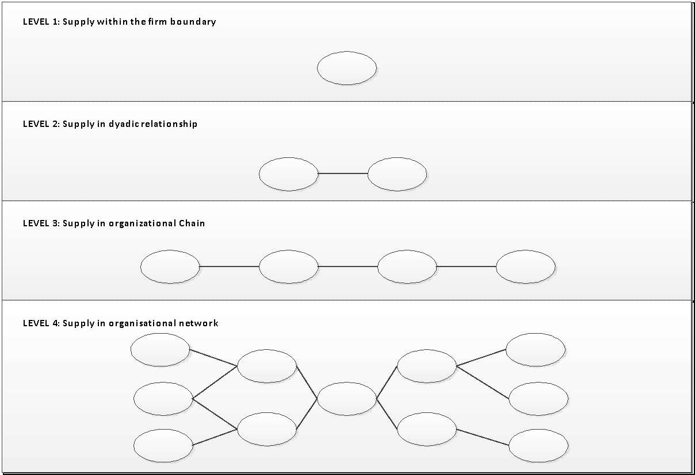

*Figure 4.1: Supply networks (Harland, 1999)*

Level 1 defines only the supply within the firm, here no suppliers are involved.

Level 2 encompasses the Dyadic relationship between buyer and supplier; this is the most concrete relationship in the purchasing process.

Level 3 shows the supply of the goods from the perspective that before a product will arrive at the customer; it has been along several steps (suppliers) from raw material to the final good in a supply chain (Harland, 1999). Organizations should maintain a relationship with these second and third-tier suppliers to establish a reliable purchasing process.

Level 4 defines the supply in an organizational network of suppliers and buyers. This organizational structure defines the complex structure of multiple relationships between suppliers and buyers, from the raw materials to the final end customers (Lambert & Cooper, 2000). Due to the globalization of supply networks, purchasing activities have become more complex, this asks for a strict relationship management.

The following sections will cover the levels of the Harland (1999) model in more detail.

Central in supplier relationship management is the social capital theory that acknowledges the value and value creation of social structures like relationships, networks, groups and individuals. Many scholars argue that organizations gain access to and leverage resources residing in their relationships through social capital. Also, social capital reduces conflicts and enhances collaborative behavior through creating a shared vision, trust and social ties. Consequently, they can lead to both operational and, more important, to strategic benefits for organizations.

Social capital can be divided in 3 different forms:

* Cognitive (e.g., shared culture and goals),
* Relational (e.g., trust, friendship, respect, and reciprocity)
* Structural (e.g., social ties)

All 3 forms can influence outcomes and performance in different ways. However, there are also downsides of social capital, which could reduce the flexibility to adapt to the changing needs of the market. If social capital accumulates, several negative factors could occur: loss of objectivity, risk of opportunism, ineffective decision-making, costly investment compared to the gains which could ultimately danger the buyers performance.

### 4.6 Supplier Classification

Trent (2007) developed a framework that describes these different buyer-supplier relationships, called the four C’s of supplier relationships. This framework creates a stronger and deeper understanding of relationships between the buyer and suppliers, which is vital for effectively managing them. The four C’s can be divided into 2 groups:

* Transactional relationship (counterproductive relationships & competitive relationships).
* Collaborative relationships (cooperative relationships & collaborative relationships).

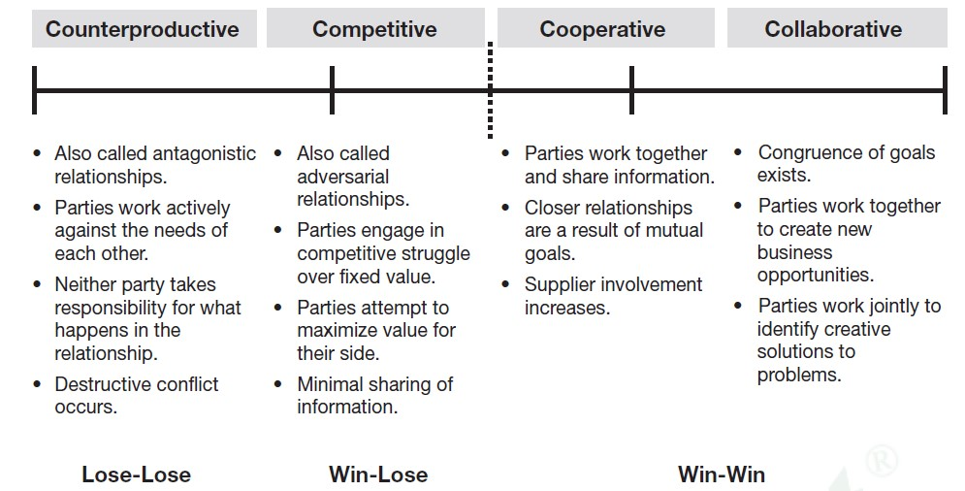

*Figure 4.3: The four C’s of supplier relations (Trent, 2007)*

**Counterproductive Relationship**

Counterproductive relationships are characterized by a lose-lose situation, where buyer and supplier are working against each other. These relationships are highlighted by short-term focus, conflict and nobody takes responsibility for whatever happens in the relationship. This scenario not only fails to create new value, it is detrimental to short and longer-term success. Trent, (2007) characterize counterproductive relationships as buyer controlled, constant search for price reductions by threatening to change supplier or actually changing supplier and poor information sharing. Buyers and supplier only trade when they can gain as much as possible from every transaction. They see themselves operating in two different industries.

**Competitive Relationship**

Competitive relations are win-lose relationships. Buyer and supplier only focus on their own profitability and compete for existing value instead of creating new value. Trent (2007) states that, most buyer-supplier relationships should be competitive. It is argued that the total value of the goods and services provided by these suppliers usually does not make up a majority of total expenditures. In competitive relationships, the buyer profits the most because he can demand price reductions without compensating supplier. The buyer exploits the purchasing leverage. This could lead to a hostile attitude of the supplier, which reduces investments in resources at the buyer.

**Cooperative relationships**

Win-win relationships: cooperative relationships and collaborative relationships. Cooperative relationships are characterized by close interaction between buyer-supplier, long-term focus (long-term contracts) and there is a culture of open information sharing. There is a continuous interaction between buyer and supplier about how to improve performance (e.g. quality, costs, packaging and inventory management). Suppliers are often included in the process of new product development. Dialogues resolve conflicts and both parties see business exchanges as equitable.

**Collaborative relationships**

Finally, organizations with collaborative relationships have a very limited supply base that accounts for the vital products and services because these relationships require lots of resources and commitment. Buyer and supplier both want to improve current operations and compete in the marketplace, the collaboration is very intensive. These relationships are characterized by joint strategy development sessions, executive-to-executive interaction and sharing of resources. Collaborative approaches lower operating costs and acquisition through this joint effort. Both relationships have more trust between the buyer and supplier, later in this unit trust will be elaborated extensively. Buyer-supplier relationships should not always be collaborative because they, like mentioned before, require lots of resources and commitment. On top of that, there could even be diminishing returns in investments between entities in a supply chain in collaborative relationships. Furthermore, it is perfectly acceptable that firms perform arm’s length transactions when the situation is appropriate. In this context, the degree of criticality of the supplier is important. This is the way the buying firm views the supplier as a critical factor for success. Also strategic importance to the firm and complexity are factors that determine the buyer-supplier relationship selection.

**Complexity**

Complexity can be financial (i.e. a significant kwacha commitment) or commercial (e.g. intertwined and/or interdependent technology, joint production processes, shared development). If strategic importance and complexity are low, buying firms would use open market negotiations to press prices and get the best deal, competitive relationship are common in this context. While collaborative relationships are used when strategic importance and complexity are high. Cooperative relationships are often used in situations where strategic importance is low but complexity high. Like stated before, counterproductive relationship are never desirable. Fransoo (2009) states that, characteristics of the market, product and partners influence the decision which buyer-supplier relationship to apply in a specific context. There is no “one size fits all” combination that characterizes a specific relationship. It is however important that organizations reduce uncertainties and exploit opportunities within their supply base by identifying which suppliers creates the most value and leverage their capabilities throughout the entire supply chain.

## 4.7 Supply chain networks

**Supply Chain Network Level 3**

Level 3 defines the supply in the organizational chain (figure 4.4). In the organizational chain there are a couple of suppliers who deliver to each other, before the end product is being delivered at the purchasing party.

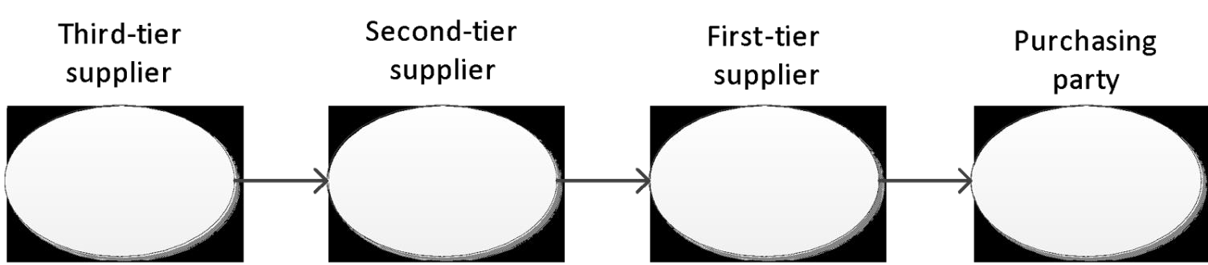

*Figure. 4.4 Supply in inter-organizational chain*

As for example, when a purchasing party orders from the first-tier, the ordered products are manufactured by the first-tier supplier. But the parts used by the first-tier supplier, can be produced by the second tier-supplier. And this can go further to the third-tier supplier and so on. For the purchasing party it is also important to maintain relationships with their second and third tier suppliers. When a second/third-tier supplier falls out of the chain, this will affect the purchasing party. They will not get their goods, because the first-tier supplier will not have the materials to produce the goods. Consequently, the reliability of the other suppliers in the chain is of great importance. A good example of the importance of maintaining relationships with the other suppliers in the chain is to know where your goods come from. Take for example the chocolate producers; they buy their cacao from suppliers, without considering how this cacao has been retrieved. While often there is child labor involved. This could harm the image of the organization. However there are also some chocolate suppliers who are involved from the retrieving of cacao till the selling of the chocolate.

**Supply Chain Network Level 4**

Level 4 is the supply in inter-organizational networks; these are complex networks of suppliers and buyers, which interact with each other. A good description of **supply networks** was given by Harland et al. (2001): “Supply networks are nested within wider inter-organization networks and consist of interconnected entities whose primary purpose is the procurement, use, and transformation of resources to provide packages of goods and services”. While strategic purchasing aims at limiting the amount of suppliers, it is often inevitable to have more than one supplier. It is rare for a firm to have just one dyadic relationship; most firms have a supply chain that looks like a rooted tree with branches and roots. Those branches and roots represent the extensive networks of suppliers and customers. These extensive networks operations occur often outside national borders, and extend worldwide. For those operations that extend the national borders often long-term alliances are developed with a small core group of suppliers; which is in line with strategic purchasing. The purchasing functions develop communication mechanisms like EDI and ERP, such that orders are placed automatically, and that the purchaser can put their focus on managing their relationships with their suppliers.

## 4.8 Supplier Involvement

Good supplier relations might lead to involving the supplier in the organization, but also the other way around. Supplier involvement is all about involving the supplier in different organizational processes. The topic has gained much interest lately because of the benefits it can have for companies by increasing effectiveness and efficiency. **Supplier involvement** is the resources (capabilities, investments, information, knowledge, ideas) that suppliers provide, the tasks they carry out and the responsibilities they assume regarding the development of a part, process or service for the benefit of a buyer’s current or future product development projects.

**ESI (Early Supplier Involvement)** has been advocated as means of integrating suppliers capabilities in the buying firm’s supply chain system and operations. The concept of supplier involvement is about exchange relationships between the buyer and supplier, this exchange relationship depends on the extent of the involvement of the supplier in co-designing and new product development processes. Supplier involvement can be a way of facilitating the speed of development and quality of new products and reduce production costs. Supplier involvement is according to Jayaram (2008) very important in New Product Development (NPD) since it:

* Improves project performance and
* Reduces overall development time.

A way to involve the supplier is by integrating the supplier into the processes of the organization. Jayaram (2008) found that the supplier integration practices can be grouped by three factors: communication and information sharing, design participation and infrastructure development of joint programs with key suppliers. The supplier involvement practices should, according to this author, be based on the stability of the market. As the effect of stability was different, i.e. in stable markets, the effect of supplier integration was higher while in unstable markets, the time-to-market was better when the supplier was integrated.

For supplier integration to happen, there are different steps to take. It will start with recognizing a need of the organization, which results in the need for a supplier. Here the supplier selection procedure starts. In the supplier selection stage, having thought about supplier involvement might be important since taking this into account might lead to different selections. There are several factors that result from supplier involvement, one of them is joint problem solving, which might be useful in involving the supplier.

### 4.9 Joint problem solving

Monczka et al (1998) found that the way in which conflicts are handled has an influence on the success of an alliance. According to these authors using joint problem solving can result in a “win-win” situation for the buyer and the supplier as well as for others involved. Using joint problem solving will lead to improved quality performance and reduced new product development time (Monczka et al., 1998). Adding to this, they found that managers should assess internal and external purchasing/supplier relationships and take action where necessary to increase communication, solve problems and increase general awareness of the relationship between internal and external service and product quality. They argue that the purchasing department should become the strategic player in the organization and use practices that will create the most value for the customer. It might thus be good to think about how conflicts are handled when involving a supplier. Implementing a joint problem solving strategy might have a positive effect on the relations of the buyer and the supplier. Important in the buyer supplier relationship when involving a supplier is to consider the relative power between the parties.

### 4.10 Relative power

Relative power indicates the differences in power between the buyer and the supplier. As power is of influence on any relationship, this is also important in the buyer-supplier relation and thus also in the case of supplier involvement.

According to Caniëls & Gelderman (2007) the (1) “difference between buyer’s and supplier’s dependence (net dependence) which corresponds to the relative power of each party and (2) the sum of buyer’s and supplier’s dependence (total interdependence) which indicates the intensity and development phase of the relationship between parties should be assessed. The relative power is dependent on the type of relationship defined by Kraljic.

As mentioned in the previous units, the Kraljic matrix is also important in the buyer-supplier relationships. The different categories defined by Kraljic should lead to different strategies so also the way the relationships are managed between the suppliers should be handled differently. Caniëls and Gelderman (2007) found differences in relative power related to the Kraljic matrix, the results can be seen in table 4.1. From these results it can be concluded that;

* For strategic and bottleneck items, the relationship with the supplier is mostly with dominant suppliers.
* Only for non-critical items, the relationship is balanced in power between both parties.
* For leverage items, the buyer has a dominant positive position with respect to the supplier.

An interesting finding is that buyers expect a relationship where the supplier is dominant when buying strategic items, the suppliers’ marketers should nurture this relation, but not exploit it. When exploiting this relationship, customers might look for substitute suppliers, however when nurtured, the buyers will not look for substitutes and feel good about the relation (Caniëls and Gelderman, 2007).

The different categories in the Kraljic matrix all have different levels of supply market complexity and importance of purchasing. Parker, Zsidisin, & Ragatz (2008) found that the strategic importance of an item is positively correlated with the integration of the supplier. This could thus mean that the strategic items in the Kraljic matrix should be bought from suppliers, which are involved /integrated in the buying firm.

### Relative power Total interdependence

|  |  |  |  |  |
| --- | --- | --- | --- | --- |
|  | Expected | Observed | Expected | Observed |
| **Strategic** | Balanced | Supplier dominance | Highest | Highest |
| **Bottleneck** | Supplier dominance | Supplier dominance | Moderate | Moderate |
| **Leverage** | Buyer dominance | Buyer dominance | Moderate | Moderate |
| **Non-critical** | Balanced | Balanced | Lowest | Lowest |

*Table 4.1: Comparison of relative power and total interdependence in the Kraljic matrix: theory and practice, from*

*Caniëls & Gelderman (2007, p. 227)*

As the integrative capability of suppliers will influence the effectiveness of the involvement relation, elaboration on this topic is necessary.

#### **4.11 Supplier integrative capability**

**Supplier integrative capability (SIC**) is a dynamic capability that contains processes to achieve effective and efficient product and information flows between buyers and suppliers, as well as the ability to adapt these processes to environmental change. SIC leads to process flexibility and cost efficiency. They also find that SIC enables buyers to sense changes in the supply environment by sharing information with suppliers, seize opportunities presented by establishing procedures to analyze this information and make long-term changes to existing processes. Complementary to this, Krause, Youngdahl, & Ramaswamy (2014, p. 401) find that “SIC enable buyers to transform existing processes that not only bring suppliers’ capabilities into alignment with the firm’s operational needs, but also bring about organizational learning that enhances the buying firm’s ability to adapt to a dynamic competitive environment”.

So the concept of supplier integrative capability is about aligning the suppliers’ capabilities in line with the buying organization’s capabilities to create a way to share information and be able to analyze and act upon this information. Thus having a high SIC means that changes in the supply market can be sensed earlier and acting upon this can also be done faster. This will reduce the risk when compared to having a lower SIC. To be able to effective manage the supplier involvement, portfolios are very useful.

#### **Supplier relationship portfolios**

Supplier relations can be managed with the use of portfolios. Good practice is to first, properly balance a portfolio of relationship adapted to product and market conditions and then effectively managing each type of relationships. Good management of relations should take into account the relationship requirements and relationship capabilities. Only two of the four quadrants in table 4.2 will lead to a successful relationship, i.e. only when there is a ‘match’.

### Relationship High Under designed Match requirements relationship

|  |  |  |  |
| --- | --- | --- | --- |
|  | **Low** | Match | Overdesigned relationship |
|  | **Low** | **High** |
|  |  | **Actual relationship capabilities** | |

*Table 4.2: Relationship requirements and actual relationship capabilities, from Bensaou (1990, p. 43)*

So the portfolios that are made should be balanced, adapted to the market and effectively managed. three key environmental factors to consider in managing the supplier relationship:

1. The product exchanged and its technology;
2. The competitive conditions in the upstream market
3. The capabilities of the supplier available.

A portfolio model based on the investments of the buyer and the supplier, resulting in four different profiles (see table 4.3).

### Buyer’s specific investments High Captive buyer Strategic partnership

|  |  |  |  |
| --- | --- | --- | --- |
|  | Low | Market exchange | Captive supplier |
|  |  | Low | High |
|  |  | Supplier’s specific investments | |

*Table 4.3: supplier portfolio (Bensaou, 1999, p. 36)*

1. The ***market exchange*** profile consists of products that do not require a strong relation between the buyer-supplier. This can be compared to the non-critical items of Kraljic.
2. The ***captive buyer*** profile is closely related to the market exchange, the difference in this is that the technologies used are stable, but the products need some customizations.
3. ***Captive supplier*,** consists of suppliers that deliver highly complex products, the suppliers develop technology to develop these products. The market is changing rapidly so supplier need to invest to keep up or else their buyers will change supplier.
4. A ***strategic partnership***is in place when there are highly customized components and integrated subsystems. These require great engineering capabilities and technology.

Each profile needs a different approach to manage the relationship. This can also be linked back to the differences in power (see *relative power*). In situations where the buyer has a high relative power, for example in the captive supplier situation, the supplier has to deliver upon the expectations of the buyer to be able to sell his products. It can also be argued that the four C’s of supplier relations can be found back in these profiles, however the counterproductive profile does not fit this portfolio model. There is always a need for at least cooperation. The market exchange profile requires the least of relationship management. A collaborative approach here would be sufficient. When a strategic partnership is required however, parties should have a collaborative focus.

Another portfolio model was developed by Wynstra & Pierick (2000) and is more specifically tailored to involving the supplier (see figure 4.4). The aim of their portfolio model is to help managers set priorities when deciding upon involving the supplier in new product development.

### Degree of development responsibility High Arm’s length Strategic held by the supplier development development

|  |  |  |  |
| --- | --- | --- | --- |
|  | **Low** | Routine development | Critical  development |
|  |  | **Low** | **High** |
|  |  | **Development risk** |  |

*Table 4.4: Supplier involvement portfolio, from Wynstra & Pierick (2000, p. 51)*

To find the required relationship, managers should first determine the degree of development responsibility held by the supplier. It should be determined whether the supplier is for example only given purchasing specifications or is the supplier accountable for the whole design and production of the product. To determine the development risk Wynstra & Pierick (2000) developed several questions that can be used, they examine the importance of the development to the buying organization. Table 4.4 shows how the different profiles should be managed. Each profile needs a different approach, i.e. different communication strategy, different intensity of the relation and different connections with the functions in the buying organization.

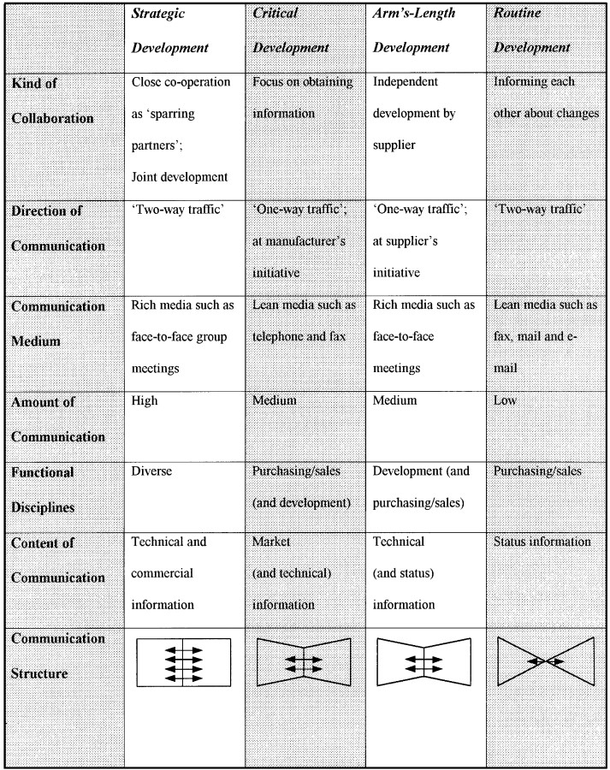

*Figure 4.4: Managing the relationships in the portfolio, from Wynstra & Pierick (2000, p. 56)*

#### **4.12 Techniques**

There are different techniques available to effectively integrate/collaborate with the supplier, as mentioned by Park, Shin, Chang, & Park (2010) the most important are: JIT (just-in-time), VMI (vendor managed inventory) and collaborative planning, forecasting and replenishment (CPFR). The techniques a buying firm uses are dependent on the goal it wants to achieve with the relation/involvement with the supplier. The fundamental objective of the JIT exchange relationship is to eliminate waste of all kinds from the production and delivery systems of the supplier and OEM organization. The connection of JIT with contract management lies in the intensity with which the relation is managed. JIT requires optimal cooperation of the supplier and the buyer to be able to deliver “just-in-time”. Therefore the performances should be evaluated continuously. Vendor-managed inventory (VMI) can improve supply chain performance by decreasing inventory levels and increasing fill rates. In contract management this has implications in the sense that good quality evaluations should be done by the buying firm. CPFR is an application to coordinate various activities between the buyer and supplier, these activities include planning, demand forecasting replenishment.

## 4.13 Contract Management

**Contract management** is the process of systematically and efficiently managing contracts from creation to execution, with the aim of maximizing the operational and financial supplier performance and reduction of risks. It is all about getting what you agreed. So contract management is about managing the contracts within an organization from the point the contract is created, evaluated and terminated.

Contract management consists of three steps: order, expedite and evaluate. Where these three steps also include the order and executing phase of the contract, the objective of contract management should be;

(1) performance evaluation,

(2) escalation problems and fundamental scope changes,

(3) indexing pricing and

(4) continuous improvement.

Continuous improvement, as a result of evaluation is important since it will result in better performance of the cooperating firms. According to Seshadri & Mishra (2004) contracts and relationships are complementary; they should always be managed in terms of relationship management. They also state that contracts provide an evolving governance structure for relationships. By providing the following framework (figure 4.5), the dynamics of markets, contracts and relationships are represented. This framework is useful when examining the type of relation that is applicable to the contract with a supplier. When for example the outcomes are unverifiable and actions are unobservable, the contract manager should use relationship marketing to manage the contract.

**4.14 Supplier Evaluation and Relationship Models**

#### **Evaluation & Monitoring**

Supplier evaluation is located at the end of the purchasing process but is however essential for buying firms in controlling and monitoring their suppliers. Evaluation is used to see if a supplier performs according to the agreements or preliminary assessment of potential new suppliers. The last few years, the importance of supplier evaluation increased due to globalization, changing in the preference of buyers and the complexity of buying decisions. Johnsen et al. (2014, p. 99) argues that buying firms should use key performance indicators (KPI’s) because suppliers will not perform according to the agreement, if they are not measured. Those KPIs should reflect the purchasing strategy of a firm. Research has shown that if buyers do not measure supplier performance, decision making becomes inconsistent and performance decreases to mediocre levels (Johnsen et al., 2014)

However, introducing KPI’s has a downside because it is assumed that suppliers will focus on the set of KPI’s and neglect aspects that are not included or could not be captured by KPI’s. One way to measure KPI’s and supplier development is through a balanced score card. KPI’s should be used to start a dialogue with supplier, jointly developed and used collaboratively instead of forcing them on the supplier. The clarity that it creates at the supplier could be used to address problems and improve supplier performance. Supplier evaluation is the basis of relationship development and important in developing buyer-supplier relationship. However, countries differ in the way they evaluate suppliers. For example, Japanese firms do not assess their suppliers with a formal rating system like American firms do. They evaluate suppliers on a regular basis and the degree of assistance from the buying firm is determined by the evaluation.

#### **4.15 Models of Buyer-Supplier Relationships**

Buyer-supplier relationship is perceived as static in most relationship models, in reality these relationships emerge, evolve, grow and dissolve over time. Improvements in performance will happen within the unique exchange relationships developed between the buyer and supplier firms. Organizations can develop their supplier relationships on 2 levels: a one-on-one basis between the buyer and one or multiple supplier or on a global level between a large customer firm and a network of its direct suppliers. Supplier development provides the basis of dynamic buyer-supplier relationship models. Krause (1997, p. 12) defines **supplier development** as “any effort of a buying firm to increase the performance and capabilities of the supplier”, which in turn will improve the buyer performance. There is a large set of supplier development activities that can be used like training programs for employees of the supplier, investments in the supplier and supplier evaluation.

## 4.16 Drivers and Barriers

There has been much research done on supplier relationship development, which revealed several drivers and barriers. One of those researchers are Humphreys et al. (2004), their research complemented the findings of Krause and Ellram (1997) about the importance of supplier development. Figure 5 shows a framework, from a buyer his perspective, which links supplier development practices to buyer-supplier performance improvement. Transaction-specific supplier development represents the direct involvement of the buying company in developing the supplier, the core practice of supply development (Humphreys et al., 2007). Infrastructure factors are requirements for the effective execution of transaction-specific supplier development activities and comprise the environment. The framework mentions 11 drivers and barriers for relationship improvement, which are mentioned in figure 4.8.

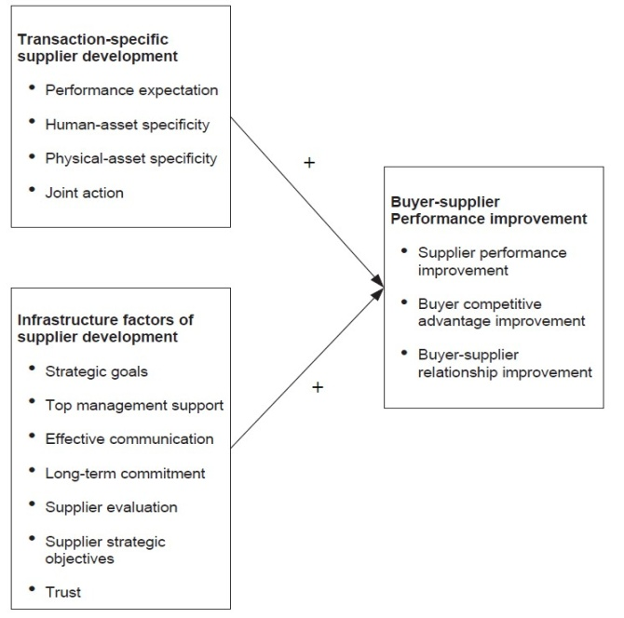

*Figure 4.8: Supplier development framework (Humphreys et al., 2004, p. 133)*



**Activities 4.1**

* explain relationship management
* illustrate supplier networks
* explain contract management
* discuss supplier development
* describe supplier involvement

**summary**

**4.17 Summary**

Congratulation for having reached the end of the unit, am sure by the end of this unit, you have vested knowledge on this topic and you will be able to apply in any given situation.

# **Unit Five: Strategic Service Purchasing**

**5.1 Introduction**

In terms of globalization and the growing importance of services regarding the buying process, a rethinking process of the purchaser has to be applied. Buying goods differs from services and furthermore, new circumstances require adapting new skills, attributes and even new strategies of buying services. With the growing globalization, a new era of ‘servitization’ is introduced. This means that services are being requested more often, get more attention, are bundled with goods and contain more uncertainties on the other side. They cannot be produced ahead, which makes it difficult to estimate or measure the potential or risk behind it. Subsequently, outsourcing of services is one option to get the desired objectives done and close relationships with the service consultant gain advantages out of good communication and team play. The service contract relies on good preliminary work to build upon future service projects. Consequently, studies have shown, that services are often classified as non-strategic decisions. Internal customers work their own contract with their supplier out and even negotiate with poor purchasing skills. Finally, bypassing the purchasing department leads to avoidable high costs and obstructs to release the full potential of buying services.

**Outcomes**

**5.2 Learning Outcomes**

By the end of this unit, you should be able to;

* explain the process of purchasing service
* discuss the importance of purchasing service
* explain the make-buy decision in service
* describe the value of service purchasing
* discuss the key challenges of service purchasing
* explain sourcing strategies in service purchasing
* evaluate six service quality dimensions
* explain the relevant skills required in service purchasing
* describe cultural aspect of the dimensions of service purchasing

Time

**5.3 Time Frame:** In this unit you are expected to spend approximately;

* 2 hour 30 minutes’ study time
* 2 hours in class

**5.4 Content**

Services are becoming increasingly important in many industries, because companies try to integrate the process of producing goods and providing services. Roodhooft and Van den Abbeele (2006) state that the process of purchasing services is also becoming more and more important, due to an emerging services industry context, deregulation and a common tendency of increased outsourcing in both the private and public sector. Therefore, it is important to find out if there are differences between purchasing services and purchasing goods, and how these differences have impact on the purchasing process. This unit will elaborate on the entire purchasing process that is described in depth in the previous units, but then with the focus on purchasing services instead of goods.

## 5.5 The Process of Purchasing Services

Services are different from goods in multiple ways. The main characteristics of services and goods are displayed in table below. These characteristics and differences will be briefly discussed, in order to serve as a base for the rest of the paragraph.

|  |  |
| --- | --- |
| Services | Goods |
| An activity | An object |
| Jointly produced | No interaction |
| Intangible | Tangible |
| Production, distribution and consumption are inseparable | Production and distribution are separated from consumption |
| Heterogeneous | Homogeneous |
| Perishable nature | Non perishable |

*Table 6.1: Services and goods characteristics*

A service is an activity rather than an object and services are often jointly produced. This means that most of the time, there is a direct link between the service and the person(s) that are providing the service. Furthermore, the client is often involved in the production process. Moreover, services are intangible in the way that they cannot be felt, touched or tasted. Therefore, it could be hard for the seller to communicate and for the buyer to test before they want to purchase a. Hence, with services the production, distribution and consumption are one process and cannot be separated. This is not the case with goods. Another difference is that services are heterogeneous in a way that it is hard to deliver exactly the same service as last time. This is due to for instance the human involvement in the ‘production process’. Finally, services and goods differ based on perishability. This means that services cannot be stored or kept in stock.

However, Vargo and Lusch (2004) state that these differences between services and goods are not that obvious. They mention for instance that many services can have very tangible results. Subsequently, for many brands that produce products, intangible things are equally or even more important than the tangible goods themselves. Van der Valk and Rozemeijer (2009) give the example of Apple and their brand name and image. This is even more important for Apple than just producing the computers and phones. Therefore, it can be hard for a purchasing department to actually purchase services according to the purchasing process for goods. This implies that the importance of service purchasing is growing.

## 5.6 Importance of Purchasing Services

As briefly stated in the introduction of this unit, service purchasing is becoming increasingly important because of multiple reasons. Services get a more relevant status for the purchasing process, because the simple product landscape has evolved into a more complex environment. This means that companies nowadays try to deliver more than just a product. This particular emerging trend is called ‘*servitization.* Servitization is defined as the increased offering of fuller market packages or bundles of customer focused combinations of goods, services, support, self-service and knowledge in order to add value to core corporate offerings.

Furthermore, Lindberg and Nordin (2008) distinguish two different types of logics that contain a view of purchasing goods and services. The first one describes the service-dominant logic. This view states that everything is centered on the exchange of services and that the focus has to be on the exchange of intangible resources instead of goods. The second view is called the goods-dominant logic and describes the objectification of services. This means the reduction process of services to the status of simple objects and aims at making services more tangible. So these are two separate directions of purchasing services, but Lindberg and Nordin (2008) also mention a third, more dynamic pattern. This shows that all services, no matter how complex they are, appear to undergo the objectification at a specific point in time during the purchasing process. Figure 1 shows this degree of objectification in the purchasing process. Therefore, and because of the increasing frequency and growing strategic importance of professional service purchasing, new things are asked from the purchasing department of a company.

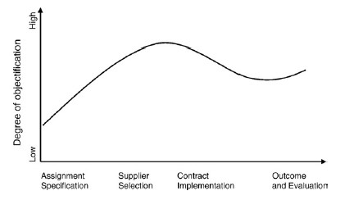

*Figure 6.1: Objectification in the purchasing process (adopted from Lindberg & Nordin, 2008)*

This unit is about purchasing, the purchasing process will be discussed in terms of purchasing services. The purchasing process starts with specification of the services and selecting suppliers, but before that process could actually start, the company needs to decide whether to make or buy services.

## 5.7 Make- Or Buy Decision in Services

The differences between goods and services have consequences for a company and the purchasing department, such as the intangibility and perishability of services. The first main decision a company needs to think about is the possibility to make or buy a service. This is called the make- or buys decision. The process and the internal effects of this decision are discussed in unit 2. However, this decision also has to be made for services. For instance, a company and the purchasing department have to think about in- or outsourcing the cleaning or transport activities. If they decide to outsource it, the purchasing department needs to select the right cleaning or transportation company that provides this service. This implies that possibly other selection criteria are important for purchasing services than purchasing goods. These selection criteria will be explained in detail in the following section of this unit.

As can be seen in figure 1, the degree of objectification is low before and at the assignment specification stage. So at the make- or buy decision, the relatively intangible needs that are identified by the potential internal users have a low degree of objectification. After the make- or buy decision this degree of objectification increases. The company furthermore needs to decide whether to purchase services centralized, decentralized or hybrid. Unit

Ellram, Tate and Billington (2007), mention that purchasing services has a decentralized nature. This is because the services that are identified as strategic and important, most of the time, are procured by non-purchasing specialists. Examples of people who mainly purchase these services are marketers and logisticians (Ellram et al., 2007). Furthermore, purchasing non-strategic services like for instance cleaning services can be purchased decentralized. For more strategic services, for instance a consulting service, it would be more appropriate to use a more centralized purchasing strategy, because this could help the entire company and supply chain in the way that these services are purchased at one place. This creates consistency and is therefore more easy to control and monitor for the entire company.

## 5.8 Value of Service Purchasing

A lot of examples of purchasing services can be distinguished. For instance, cleaning services or administration services are basic services that are purchased by a lot of organizations. Furthermore, consulting services or transportation services are examples of more strategic purchased services. The services are purchased from another organization that is specialized in executing this service and provides them for the buyer-organization.

Unit 3 already introduced purchasing portfolio models to categorize and manage products. Important portfolio models are for instance the Kraljic (1983) matrix shown in figure 3.4 of unit 3 and the van Weele matrix in figure 1.3 of unit 1**.** The figure below shows a matrix that is presented by Ellram and Tate (2015). The main difference between this matrix and those mentioned in unit 3, is that the matrix of Ellram and Tate (2015) is applied to purchasing services instead of goods. This matrix is presented below.

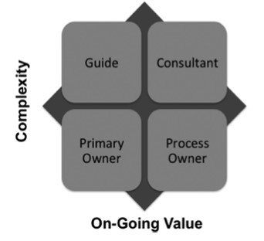

*Figure 6.2: Service purchasing matrix (adapted from Ellram & Tate, 2015)*

With the help of this matrix, different services can be classified according to the two characteristics ***‘complexity’***and *‘****on-going value’.*** This helps a company with categorizing the different services that need to be purchased and therefore with picking an appropriate strategy. With the ‘complexity’ of services, Ellram and Tate (2015) pay attention to the ownership of the budget for that service, internal and external political surroundings that services purchase, including the service beneficiary’s power, the ability to accurately specify the service and finally, the level of technical expertise needed to assess the service’s providers outcome. With the ‘on-going value’ of the service to the organization, Ellram and Tate (2015) consider the frequency of the purchase, the impact of the purchase on external customers, the kwacha value of the purchase and the importance of the service to the organization’s success.

The bottom left corner presents the *‘****primary owner’***services. These services are characterized as easy to specify, are often low kwacha value to the end customer and frequently used by many departments or people within the organization. Ellram and Tate (2015) call the services in this quadrant the ‘insignificant many’ items that will be a burden if they are not managed well. However, these services are not core to the organization’s competitiveness. Therefore, this quadrant shows similarities with the ‘*noncritical items’* of the Kraljic matrix and to a lesser extent to the ‘*nuisance items’* of the van Weele matrix. The similarities are that these products/services all have small value to the buyer-company, but Ellram and Tate (2015) mention that they will be a burden if they are not managed well. This is not the case at the van Weele matrix, because their category has no impact on the supplier or the buyer if they are not purchased any more.

The top left corner presents the *‘****guide’*** services. These are characterized by low on-going value to the organization, but by high complexity and may be relatively important to the user. The purchases of these services have a low kwacha value and they do not have an ongoing impact on the organization’s end customers. They may be important to a particular function, but in general these services are not a large part of the budget. This category can be compared partially to the *‘****leverage items’*** and *‘****development items’*** of the Kraljic- and the van Weele matrix respectively. This is because the *‘****guide’*** services are not really expensive for the company, but the two items of the other matrices do. However, the ***‘guide’*** may be relatively important to the user and this is comparable with the other matrices.

The top right corner presents the ***‘consultant****’* services. These services are characterized as complex, but are highly specified. Furthermore, these services often have emotional value because of the importance that the budget owner values them. Subsequently, they have a high on-going value, because these services have a high kwacha spend and a large impact on the internal customers and revenue. This category is highly comparable with the ***‘strategic value items’***and the *‘****core items’***of the other two matrices, because these items are strategically important, mainly complex and are of great value to the buyer-company.

The last category is the bottom right corner, which presents the *‘****process owner’*** services. The services are characterized by a low complexity (so they have relatively clear specifications), but have high on-going value in that they cut across business units and may have some external customer impact. This category can be compared to the ‘***exploitable items’***of the van Weele matrix, but to a lesser extent to the *‘****bottleneck items’***of the Kraljic matrix. This is because the ‘***exploitable items’***also have a high value to the company and the ***‘bottleneck items’***do not.

Unit 3 furthermore mentioned three different purchasing strategies from Kraljic (1983), namely the exploit strategy, the diversify strategy and the balance strategy. These strategies can also be applied to the Ellram and Tate (2015) matrix. The exploit strategy can be used for the ‘***process owner’*** services, because they are a large part of the total budget of the company but the complexity is low. Therefore, the buyer-company can try to search for multiple suppliers, which offer the best quality and pick the cheapest one. The diversify strategy can for example be used for the ***‘guide’*** services. This is because the ongoing value of these services is also low, but they have a high complexity. The balance strategy can be used for the ‘***primary owner’*** and ‘***consultant’***services. For instance, the buyer-company has to try to build up a long-term relationship with the suppliers of the **‘*consultant’***services and just has to make sure that the *‘****primary owner’*** services are delivered.

### 5.9 Key Challenges in service Purchasing

Purchasing services has several challenges, just like the purchase process of goods, although, these challenges do differ from the challenges of purchasing goods. This is caused by the different characteristics of services as explained before. One of the problems that purchasing departments of company’s encounter, is that services are hard to evaluate before the purchase has been done. This also influences the supplier selection negatively. Therefore, Axelsson & Wynstra (2002) suggest that issues like supplier staff competencies and ‘customer skills’ should be added to the current purchasing criteria. Furthermore, the costs of services may be a problem, because it is hard to put an agreeable price on a complex service. Consistent to this is the assessment of the value that is gained by the buyer-company from purchasing the service from the service provider. Another problem might be the demand and capacity management for the supplier. They need a clear understanding of the business processes of the buyer-company in order to deliver a good customized service.

Just like in purchasing goods, also in service purchasing there is a trust issue. Namely, if a company chooses to purchase services from a supplier they already know for a long time, this might cause ‘*overembeddedness’* (Uzzi, 1997). This causes that the buyer-company sticks to the same suppliers, because they build up a good relationship. However, then they ignore the possibility of cheaper and/or higher quality service providers (Pemer, Werr & Bianchi, 2014). However, this issue is a more important issue in service purchasing because of the human factor (Pemer et al., 2014). In services humans play a larger role and this is because of the interaction in the service process. This differs from purchasing goods, because the goods that are purchased are clearly specified and already finished when actually purchased.

## 5.10 Sourcing Strategies

### Specification

In unit 3 we looked at sourcing, several important aspects crystallized to the surface. Reductions of costs are aspired with the positive by-product of maintaining or even improving the quality of products/services. The understanding about sourcing strategies has to be available in order to improve the value-to-price relationship by achieving cost reductions for reaching improvement of quality of services. Supplier relationships have to be examined throughout the whole organization. It can be seen as hard to assess the quality of the services, because the buyer-organization does not know how the service process will develop. Measurement is not easy to define, but it might be a good approach to define some stages of service agendas. Mitchell (1994) mentioned that the “*purchase of services can involve a lot of time, money, and personnel without any guarantee of a successful outcome*” Most of the expertise, which is used for the buying process, is based on the knowledge of buying goods. This behavior can be seen very critical. The purchasing process of services differs from the process of goods essentially. More risk is involved in the selection of services and so it is more complex.

### Selection Process

Unit 3 already distinguished five selection criteria, namely: financial, organizational culture and strategy, technical capabilities, support resource, risk involving globalization and localization. The choosing of the right service depends more on those criteria factors. Furthermore they are defined into ‘*eight stages of problem solving’*. Stock and Zinszer (2010) introduced them in the industrial decision process for services, like a guideline for purchaser.

#### **1. Identify the problem**

Wilson et al. (1972) examined several reasons for hiring external consultants. First of all the demand for extraordinary skills must exist. According to Mitchell (1994), limitation to the own personnel or in-house capabilities is one of the most common reasons. In addition to that, legal requirements like auditing, demand of objectivity, freedom from internal pressures, absence of resources or equipment are just a few to name, to understand that this is quite complex (Wilson, 1972).

#### **2. Determine the problem for the dimension (internal/external)**

Someone within the organization has to define the objective, which has to be fulfilled and appoint an employee to “supervise the work continually”. In the long run, it might be wise to build up own expertise, to avoid high costs of services. Fisher et. al (1990) explained this effect with the use of lawyers. Costs of in-house lawyers are 40% cheaper than external law firms.

**3. Identify consultants**

The right consultant has to be chosen in order to fulfill their own expectations.

#### **4. Search for information about consultants**

The search for the satisfaction of the demand of solution leads the purchasing department to the gathering process of certain information: personal sources, independent consumer reports, news articles and advertising, in store material, distributor listings, packaging information and sampling.

#### **5. Evaluate and recommend consultants**

Like already mentioned, that services are not easy to measure or evaluate as they are intangible. The service quality is a subjective matter and increases the uncertainty in the purchaser’s buying decision. A lot of variation exists in the unknown outcome, but with the right experience and skills, risk can be decreased to an assessable level to evaluate the consultant.

**6. Select the right consultant**

When one desired consultant is chosen, contact will follow by email or telephone. Some organizations prefer the formal way of agreement, by sending drafts to the consultants. By this, they want to get first comments and first valuation of the objectives. Ulterior motive behind this is to lower the risk.

#### **Manage the project**

Accepted services within an organization may last several months or years, which requires a lot of commitment of the purchasing department (Mitchell, 1994). The duration of the project depends on it, to continue the work with the consultant.

#### **8. Review the performance**

Evaluation of professional services are difficult, because there is no right or wrong in fulfilling a service. A recommendation might be the best solution to estimate the outcome of the project and if the collaborative work has been successful.

Trust is one crucial aspect in selecting services, because the purchasing partner is relying on the best transformation of the desired wishes into the best services. The selection of the right supplier leads probably into a long-term orientated relationship. Buyer-supplier relationship depends on the selection and creation of the contract towards the goal of trust.

## 5.11 Relationship Management

### Relationships

For the procurement process of buying services requires more than just agreements of the work. Furthermore, the purchaser needs another perspective, not on equipment and goods, more on service, which need the attention of the management. The*“new direction should be on a relationship management, that secures the quality and level of series provided by the vendor”* (Abramson & Harris III, 2003, p.7). Like already stated before, that buying services is related to more uncertainties and complex structure, “old ways of operating” is no longer effective for complex activities. In the old way, fashioned way it was more like that the buyer had the full control, by forcing the supplier/consultant to the direction of lowering the costs. The supplier had no other choice than doing this, what was expected from him. This resulted in just an ordinary result but not the most efficient.

The “new way”, which should be entered with the supplier of service, should be a public-private partnership, where all participants interact as equals. Public-private partnerships is “an arrangement of roles and relationships in which two or more public and private entities coordinate/combine complementary resources to achieve their separate objectives through joint pursuit of one or more common objectives. A partnership should identify goals, which should be achieved together. Trust is such a key element in an efficient relationship, to realize innovative and creative ways of solutions. The relationship will evolve and even change over the time, like the same evolvement process for buying goods. Reaction should be to adjust the right amount of processes to enlighten the relationship, for long-term orientation. Best value procurement with trusting the organization that delivers the service is very important. This method notes that the service providers are the specialists, and therefore the buyer-organization needs to trust the proceedings of the service provider.

### 5.12 Internal customer

Like in general that only little research has been done in the field of purchasing services, the impact on the internal customer services quality is unclear as well. This paragraph will clarify the missing gap. Jun and Cai (2010) defined internal customer as the demanding employees within the organization for a services/goods in collaboration with the purchasing department. The satisfaction of the demand has to be served by the purchaser. Finn et. al (1996) argued that internal customers have the same importance level like the external customer does and a good service may lead to efficient organizational processes. This should result in the attempt of satisfaction and understanding of the need for services. Jun and Cai (2010) introduce the function role of the purchasing department as the following: The types of services vary from placing and tracking purchase orders, determining needs and specifications and helping to implement new technology. This exchange process between individuals of departments within an organization can be optimized to gain not just the best internal service quality, but an improvement for the external customer as well. It can be named ‘s*ervice-profit chain’* (SPC), that internal service quality directs to employee satisfaction and boosts not only loyalty but productivity and profitability.

Heskett et al. (2008) mention that profit is stimulated by customer loyalty, which results in customer satisfaction. Furthermore high-quality services leads to satisfaction, which is influenced by the value of services, offered. Value then is the end product of satisfied, loyal and productive employees. To avoid misunderstanding between internal customers and their supplier/purchaser, a common understanding of what good service quality should be, have to be developed. The perception of service quality depends on the beliefs and attitudes towards the received service. For this enterprise to understand different characteristics of internal departments, ‘*six service quality dimensions’* have been developed and identified by Jun and Cai (2010).

**5.12 Six Service quality dimensions**

#### Dimension 1: Customer intimacy

Customer intimacy is related to the quality attribute of building close relationships between the purchasing department and its internal customers. Further they analyzed factors which should exist in their relationship, like friendly and polite team play, personal attention in internal issues, trustworthy work and availability of employees.

#### Dimension 2: Reliability / Competence

This dimension from Jun and Cai (2010) emphasizes the abilities of employees to realize the promised service and of course the presence of required skills and knowledge for the service.

#### Dimension 3: Team-based continuous improvement

In this dimension of Jun and Cai (2010) a high quality service which is provided for the changing needs of internal customers, should meet internal customers’ changing needs, the purchasing department should continuously improve its purchasing practices particularly through a team-based approach.

#### Dimension 4: Requisition process

Purchasers have the knowledge about prices for items/services they purchase frequently and have access of previous requisitions (Jun & Cai, 2010).

#### Dimension 5: Communication

Jun and Cai (2010) mentioned that the purchasing department should “always help with price/quality options, search, selection” (Jun & Cai, 2010, p.217). It is one of the most important communication activities between the department and its internal customers.

#### Dimension 6: Tangibles

According to Jun and Cai (2010) it refers to “the appearance of physical, equipment, personnel and communication materials”.

For the organizations long-term success, those dimensions should be fulfilled in order to gain critical advantage out of it. Internal customer satisfaction is influenced by the internal service quality by the purchasing department one of the main differences of buying goods is obviously the communication and close elaboration with its internal customer. The purchasing department has to understand the dimensions of their consumers to estimate service quality, so they react to improve processes. All six dimensions should earn the same amount of attention but in terms of limited time and resources, it is recommendable that purchasing managers should focus particularly on customer intimacy, team-based continuous improvement, requisition process and communication. Jun and Cai (2010) considered that development of intimate relationships by offering services in a friendly and trustworthy way, establishing cross-functional teams, frequently interaction to gain synergistic effects in continuously improving purchasing’s service quality, might be the right way.

## 5.13 Contract Management

Buying services brings up risks of the unknown, which are considered to be higher than when buying goods. For managing contracts for services, those risks should be kept in mind. During the negotiating process with the service supplier, all unsure points should be addressed like specifying services, qualifying and selecting services and even evaluating of the performance. Surprisingly, some research projects researchers indicate that CEOs tend to the thinking that purchasing of services might be easier than the purchasing goods. Hence, new or inexperienced purchaser are assigned to handle with services contracts (Van Weele & Van der Valk, 2010). Van Weele and Van der Valk (2010) even observe a by-passing effect of the purchasing department, because most of companies notice services as non-strategic. When it actually comes to the process of buying strategic services, non-purchasing departments do the negotiating. The internal customers usually want to maintain close relationship with the business partners and do not want annoying purchaser to interfere in this matter. This particular example shows the potential of cost savings by modern organization structure.

### Evaluation and monitoring

One of the final stages of contract management is the evaluation and monitoring of the purchased services and of the actual purchasing process. Mitchell (1994) states that the post purchase evaluation of services is more difficult than for goods. This is because it might be very hard to determine whether or not the problem is fixed, because there is rarely a correct or incorrect solution (Mitchell, 1994). Furthermore, Mitchell (1994) mentions that it could be hard for the buyer-company to evaluate the purchase of the service. The reason for this is that the professional service might be so technical that the purchaser lacks knowledge or skill to evaluate satisfaction. On the other hand, there might be services that the buyer-company could easily do themselves. Despite this, these companies could decide to outsource these services, due to for instance limited resources or time constraints. If this occurs, the evaluation and monitoring process of the purchases can be executed well by the buyer company.

### 5.14 Cultural aspects of the dimensions

The Perception of service quality varies from individuals as well as among cultural group. Cultural dimensions have big influence on the perception of service quality and the understanding of customer satisfaction.

The six service quality dimensions provide a good insight of the different culture groups. It is useful, because with those dimensions, different approaches in allocation of resources and usage of services can be observed much better. In a case study of Winsted (1997), consumers in USA and Japan have been analyzed on how they evaluated perceived service. With behavioral based service encounter dimensions, it was possible to measure cross-cultural differences. US consumer dimensions have been categorized as civility, personalization, remembering, conversation, congeniality, delivery, and authenticity. Dimensions in Japan are civility, personalization, conversation, concern, and formality. The result of those dimensions showed up overall satisfaction with service encounter. Criticism to this case study result is that it is not suited to measure the differences towards level of importance for both countries. Mattila (1999) tried to find an answer to the theoretical frame-work relating culture and service satisfaction. Out of this case study, the discovery advised that western customers tend more to rely on tangible cues from physical environment than customers in Asia. Moreover enjoyment of consumption dimension is more relevant in the western world than in Asia.

Regarding Hofstede’s dimensions, “*powerful-weak customers*, *male-female service providers*, and *frequent-infrequent service situations* influence the relationships between culture and the relative importance of the service quality dimensions.” (Furrer, Liu & Sudharshan, 2000, p.358). With Mattila’s results (1999), statement is pretty clear that the customer have the power and control over service provider. Another case study from Donthu and Yoo (1998) argued the opposite, that service providers have the control (e.g. insurance, consulting). Control or power relate to its expertise, professional knowledge or even skills. For instance, Cultures with power distance accentuation have differences in social class, education level, and occupation.

Relative importance of different service quality dimensions will vary depending on relative power of demand and offer. Another important fact in buying service and cultural expectations is the gender role and its stereotypes, personality, and negotiation. In some masculine cultures it might be difficult to explain, that a women might come along to install several software updates. Mostly Arabian cultures tend to be the normality to expect male customer support, which is seen much more professional. Female service employees are expected to be more empathic. For the dimension of frequent services, customers already know the service process and its role. Infrequent service situations lead to uncertainty and ambiguity from the unknown situation. High uncertainty avoidance cultures might differ from the perception of the two types of frequency.

## 5.15 Skills

### Relevant Trends in Purchasing Services

Trends influence the importance of purchasing in general. There are some specific trends, however, that influence the strategic importance of purchasing services (Mulder et al., 2005). Each trend has a different impact and different relevance to purchasing services.

#### E-business

This trend is mostly based on the information society that human beings currently live in. All information is to be found online. Even though E-business has been a trend for several decades already, the consequences are only partly visible at this moment. The Internet makes it possible to ‘*communicate, compare, commission statements, and purchase goods and services online’.* The possibilities that the Internet offer us will increase significantly approximately 10 years from now. Imagination is the bottleneck in projecting the future. E-business is expected to peak in the near future. Hence, the possibilities in effectively purchasing will increase significantly due to the almost unlimited availability of information.

#### Focus on core competencies

The drift of focusing on core competencies has started in the 1990s and has continued ever since. More and more products are outsourced or bought from other firms in other to be able to focus on core competencies. The outsourcing of company sections is a form of buying services, and thus heavily important.

#### Globalization

An increasing number of businesses choose for mergers or international partners as a result of heavy competition by globalization. Partly due to the E-business trend, geographical distance is no longer an obstacle when selecting service suppliers.

Trends are relevant for both the procurement of goods and the procurement of services. Therefore, it is highly recommended taking these trends into account for the future job description of general purchasing skills as well.

### 5.16 Relevant skills for purchasing services

The skills for purchasing products and the skills for purchasing skills do, however, differ. Unfortunately, there is barely research conducted about the skills required to strategically purchase services. Yet, Sonmez and Moorhouse (2010) have conducted research on the decision criteria used to select a service provider. These decision criteria can be translated to skills required to purchase services.

**Key Competence**

|  |  |
| --- | --- |
| **Competence** | **Explanation** |
| Product features | Ability to identify whether service meets (internal) client needs |
| Reputation | Ability to identify reputation of service provider |
| International capability | Ability to estimate service’s international opportunities |
| Expertise / Experience | Ability to identify expertise of service provider, and have sufficient expertise in purchasing themselves |
| Ability to measure effectiveness | Ability to measure effectiveness of service |
| Relationship | Have background in other fields than purchasing |
| Organizational capability | Organizational capability of purchaser |
| Knowledge and understanding | Knowledge about (internal) client and industry in which firm operates |
| References | Ability to identify previous work of service provider (Word-of-mouth) |
| Product value | Ability to identify value of service delivered |
| Recommendation | Ability to value recommendation from professional contacts and non-professional contacts. |

*Table 6.2: Skills for purchasing services (adopted from Sonmez & Moorhouse, 2010)*

## 5.17 Globalization and its impact on Purchasing Service Skills

When taking the increasing globalization into account it is highly interesting to look at ways to enhance the skills in purchasing services, as well as the general skills in purchasing. The general skills are compared to cultural differences. It makes sense to compare the required skills to cultural differences. As indicated before those differences exist between general purchasing skills and skills required for purchasing services, it is relevant to know how they can be invigorated in modern globalized business by applying different cultural dimensions.

Hofstede’s cultural dimensions are the right tools to compare the skills. Even though there is a gap in literature regarding specific skills required for purchasing services in a heavily globalized world, some research conceptualized cultural differences. The majority of these researches used Hofstede’s dimensions as culture-related conceptualization (Pemer et al., 2014). Unfortunately, there is not much existing research on this topic yet. The evaluation in this unit is based on the cultural differences among all dimensions based on personal knowledge.

### Product features

The dimension that have influence on the product feature competence would be the ‘*Masculinity versus Femininity’* dimension. When a society is more inclined to masculinity, short-term achievement, heroism, assertiveness and material rewards. This affects product features in such a way that purchasers are more inclined to purchase services that deems most success for them personally, especially in the short term. However, this might collide with the (internal) client’s long-term needs. For instance, a purchaser might buy the cheapest law-firm service, which is beneficial in the short-term. However, in the long-term this cheap law service might result in bad advice that leads to significant losses for the company as a whole.

### Reputation

The dimensions that influence the reputation competence would be the ‘*Power Distance Index’* dimension. This dimensions indicated the degree to which less powerful members of a society accept and expect that power is distributed unequally. Hence, purchasers might not be able to objectively identify the reputation of the service provider because they heavily look up to this service provider.

**Expertise**

Here, the same dimensions and argumentation accounts as with reputation. A purchaser might have a blurred view of the service provider’s expertise on account of the service provider’s reputation.

### References

In individualistic cultures there tends to be a loosely knit social framework in which individuals mostly try to take care of themselves instead of consulting others. Hence, purchasers are most likely less sensitive for references given by business contacts through Word-of-Mouth.

### Recommendation

The ‘*Individualism versus Collectivism’* dimension also is relevant for the competence of evaluating recommendations from professional and non-professional contacts as purchasers in individualistic cultures will most probably try to evaluate delivered services themselves.



**Activities 5.1**

1. Explain the process of purchasing service
2. Discuss the importance of purchasing service
3. Explain the make-buy decision in service
4. Describe the value of service purchasing
5. Discuss the key challenges of service purchasing
6. Explain sourcing strategies in service purchasing
7. Evaluate six service quality dimensions
8. Explain the relevant skills required in service purchasing
9. Describe cultural aspect of the dimensions of service purchasing

**summary**

**5.18 Summary**

Congratulation for having reached the end of the unit, am sure by the end of this unit, you have vested knowledge on this topic and you will be able to apply in any given situation.

**References**

1. Anderson, M., G., & Katz, P., B. (1998). Strategic sourcing. *The international journal of Logistics management .*
2. Baily, P., Farmer, D., Crocker, B., Jessop, D., Jones, D. (2008) Procurement Principles and Management. (10th ed.) London: Pearson Education Limited.
3. Caniëls, M. C. J., & Gelderman, C. J. (2005). Purchasing strategies in the Kraljic matrix - A power and dependence perspective.
4. Caniëls, M. C. J., & Gelderman, C. J. (2007). Power and interdependence in buyer supplier relationships: A purchasing portfolio approach. *Industrial Marketing Management*,
5. Carter, J.R. & Narasimhan, R. (1996) Is Purchasing really strategic? *International Journal of Purchasing and Materials Management*.
6. Chan, F.T.S., 2003. Performance measurement in a supply chain. International Journal of Advanced Manufacturing Technology.
7. Chen I.J. Paulraj A., Lado A.A. (2004) Strategic purchasing, supply management, and firm performance, *Journal of Operations Management*
8. Choi, T., Dooley, K., & Rungtusanatham, M., (2001). Supply networks and complex adaptive systems: control versus emergence. *Journal of Operations Management.*
9. Choi, T., & Krause, D. (2006). The supply base and its complexity: implications for transaction costs, risks, responsiveness, and innovation. [*Journal*](http://www.sciencedirect.com/science/journal/02726963) [*of*](http://www.sciencedirect.com/science/journal/02726963) [*Operations*](http://www.sciencedirect.com/science/journal/02726963) [*Management.*](http://www.sciencedirect.com/science/journal/02726963)
10. Gadde, L.-E., & Håkansson, H. (1994). The changing role of purchasing: reconsidering three strategic issues. *European Journal of Purchasing & Supply Management*.
11. Gelderman, C. J., & van Weele, A. J. (2002). Strategic Direction through Purchasing Portfolio Management : A Case Study. *The Journal of Supply Chain Management*.
12. Gelderman, C. J., & Van Weele, A. J. (2005). Purchasing portfolio models: A critique and update. *Journal of Supply Chain Management*.
13. Johnsen, T., Howard, M., & Miemczyk, J. 2014. Purchasing and supply chain management: a sustainability perspective. New York: Routledge
14. Kenneth, Lysons, B. F. (2006). *Purchasing and Supply Chain Management* (7th edition). Essex: Pearson Education Limited.
15. Monczka, R. M., Handfield R.B., Giunipero L.C., & Patterson J.L. (2009). *Purchasing and Supply Chain Management*. Cengage Learning.
16. Quintens, L., Pauwels, P., & Matthyssens, P. (2006). Global purchasing: State of the art and research directions. *Journal of Purchasing and Supply Management*.
17. Saunders, M. 1994. *Strategic purchasing and supply chain management*. New York: Pearson Education Limited.
18. Trent, R. J., & Monczka, R. M. (2003). Understanding integrated global sourcing.
19. Van Weele A.J. (2010). Purchasing and Supply Chain Management: Analysis, Strategy, Planning and Practice, Fifth Edition. Hampshire: Cengage Learning.