

**.**

**CHALIMBANA UNIVERSITY**

**DIRECTORATE OF DISTANCE EDUCATION**

**BHT 3101: FOOD MICROBIOLOGY**

**FIRST EDITION 2022**

**AUTHOR:**

Julia Matimba

Copyright © 2022 Chalimbana University

All Rights Reserved

No part of this publication may be reproduced, stored in a retrieval system or transmitted in any form by means, electronic, mechanical, photocopying or recording or otherwise without prior permission of the copy write owner, Chalimbana University.

**Chalimbana University**

**P/Bag E 1,**

**Lusaka**

**Study Skills**

As a distance student, you should not expect to sit behind the chair and learn everything from the lecturer. You are expected to find time to study as an individual or as in a group from your area and or nearby areas. The lecturer is there as a guide each time you come for the contact sessions. Take advantage of the presence of lecturers and fellow students to cover as much work as possible.

**Need help**

Although most of distance learning is done through self-study, you are encouraged to make contact with your fellow students pursuing the same course and form study groups through available online platforms. WhatsApp groups have been very helpful as they provide interactive means of sharing information among students and lecturers thereby supporting each other in the process of learning. You are therefore encouraged to get in touch with your lecturer and your fellow students through this and other platforms available.

**Time Frame**

The course is expected to be covered in three residential sessions and it also includes continuous assessment in form of a test or an assignment.

**Assessment:**

Continuous Assessment……….…………………...…………….....50%

Laboratory Practical………………………….…………………….20%

Class Assignment……………………….…………………………10%

Class Test………………………………………………………….20%

Final Examination…………………………………………………50%

**Total……………………………………………………………….100%**

**TABLE OF CONTENTS**

**UNIT ONE: FOOD MICROBIOLOGY 1**

1.1 Introduction 1

1.1.1 Importance of food Microbiology 2

1.2 Microbiology 2

1.3 Food 3

1.3.1 Sources of food 3

1.3.2 Food Microbiology 3

1.4 Revision questions 3

**UNIT TWO: EVOLUTION OF FOOD MICROBIOLOGY 4**

2.1 Ancient Understanding of Food Microbiology 4

2.2 Era of Academic Research in Food Microbiology 5

2.3 Food Microbiology as it is known today 6

2.4 Application of Microbiology in the Food Industry 6

2.5 Revision Questions 7

**UNIT THREE: CATEGORIES OF MICROBES 8**

3.1 Viruses 8

3.2 Bacteria 8

3.2.1 Classification of Bacteria 9

3.2.2 Common Bacteria in Food 12

3.3 Fungi 12

3.3.1Yeasts 13

3.3.1.1Common Yeasts in Food 13

3.3.2 Moulds (Mold) 13

3.3.2.1 Some common moulds in food 14

3.3.3 Application of Fungi 14

3.4 Parasites 14

3.5 Revision Questions 14

**UNIT FOUR: COMMON SOURCES OF MICROBIAL CONTAMINATION FOR FOOD 15**

4.1 Soil 15

4.2 Air 16

4.3 Water 16

4.4 Sewage 16

4.5 Contamination during handling and processing 16

4.6 Revision 17

**UNIT FIVE: FACTORS THAT AFFECT MICROBIAL GROWTH 18**

5.1 Intrinsic Parameters 18

5.2 Extrinsic Parameters 20

5.3 Biologic Structures for Microbial protection 21

5.4: Revision Questions 22

**UNIT SIX: MICROBIAL GROWTH 23**

6.1 Lag Phase 24

6.2 Log phase 24

6.3 Stationary phase 25

6.4 Phase of decline 25

6.5 Revision Questions 25

**UNIT SEVEN: INDICATOR ORGANISMS 26**

7.1 Indicator of heat treated foodstuff: 26

7.2 Indicator of sanitary quality 27

7.3 Common Indicators of Sanitary quality 27

7.3.1 Coliform standards for foods 28

7.3 Choice of indicator organism 28

7.4 Revision questions 29

**UNIT EIGHT: DELETERIOUS EFFECTS OF MICROORGANISMS 30**

8.0.1. Food spoilage 30

8.0.1.1 Spoilage is caused by bacteria, yeasts and moulds. 31

8.1 Common foodborne diseases and their sources 31

8.1.1 Infection 32

8.1.2 Intoxication 32

8.2 Common food borne infections (Infection) 32

8.3 Food Poisoning (Intoxication) 34

8.4 significance of microorganisms in the food industry 36

8.5 Revision Questions 37

**UNIT NINE: PRACTICAL MICROBIOLOGY 38**

BASIC REQUIREMENTS OF A MICROBIOLOGY LABORATORY 41

PRACTICAL ONE: WASHING AND STERIZATION OF GLASSWARE 62

PRACTICAL TWO: PREPARATION OF MICROBIAL MEDIA 63

PRACTICAL THREE: SAMPLING FOR WORKING SURFACE BACTERIA 65

PRACTICAL FOUR: GRAM STAINING FOR BACTERIAL DIFFERENTIATION 66

**REFRENCES 68**

# UNIT ONE: FOOD MICROBIOLOGY

**Introduction**

The unit introduces food microbiology to help students understand the connection between the bacterial world and food processing. It therefore helps students to appreciate the role and importance of food microbiology in the area of food processing.

**Learning outcomes**

**After studying through this unit, students should be able to:**

* State the role food microbiology.
* Describe the importance of food microbiology
* Identify main food sources studied under food microbiology
* Define food microbiology
* Describe the main categories of microorganisms

## 1.1 The Role of Food Microbiology

* To understand the importance of microorganisms in the food industry and their interaction with food which is key in ensuring food safety.
* It is not enough that food should be nutritious and tasty but it should also be safe so that it does not cause any infection.
* This can only be achieved when food handlers study about microorganism in food microbiology.
* Food microbiology therefore plays a key role in ensuring food safety in the food industry.

### 1.1.1 Importance of food Microbiology

* Food Microbiology is important to food safety in the processes of production, processing, preservation, and storage of food
* Food microbiology students use a wide variety of modern technologies to test the raw materials, in processed and finished products to make sure that the consumers are safe to consume the food presented to them**.**
* It therefore helps in protecting the firm against frequent complaints and possible litigation from irate customers.

## 1.2 Microbiology

Microbiology is literally *the study of small lives* (from Greek μῑκρος, mīkros, small; βίος, bios, life; and -λογία, -logia) study or discourse.

This means it is the study of small or minute life that cannot be observed with the naked eye.

Organisms that are minute are referred to as ***Microorganisms*** and are classified in many groups according to their characteristics.

The term Microorganism is generally applied to any single-celled organism or organism consisting of cells that little or no differentiation.

That is microorganisms have no tissues, organs, or organ systems e.g. Liver, lungs, eyes, etc. Microorganisms perform all functions without specialization.

Microorganisms can only be seen with the naked eye when they are present in the same places in vast numbers (for some, several hundred millions together as in the example of spot or mould on bread, or slime or rotting meat or fish.

Microbiology is the science dealing with the life of organisms which are at least in some stage are single-celled and are of such small size that they require the use of a microscope for study.

## 1.3 Food

Food is the item which a person takes in their body (in addition to water and medicines). Food nourishes our bodies and makes us grow and keeps us healthy.

Therefore, the food must be safe and free from disease causing microorganisms.

### 1.3.1 Sources of food

The main sources of food are plants and animals. It is therefore important to understand the biological principles of the microbial flora associated with plants and animals in their natural habitats and their respective roles.

Considering the types of microorganisms associated with plants and animals, foods in their states, it is to predict the general types of microorganisms to be associated with food.

There are *three types* of microorganisms that are associated with food.

These are (i) Bacteria (ii) Yeast (iii) Moulds

### 1.3.2 Food Microbiology

This is the study of microorganisms which are found in food. These microorganisms can both be beneficial such yeast for baking bread or deleterious such as moulds.

## 1.4 Revision questions

1. *State and explain two reasons why it is important to study food microbiology.*
2. *Explain the relationship between food and microbiology.*
3. *What are the main sources of food?*
4. *Define food Microbiology.*
5. *What is the difference between microbiology and food microbiology?*

# UNIT TWO: EVOLUTION OF FOOD MICROBIOLOGY

**Introduction**

As a practice in peoples lives, Food Microbiology does not have a precise beginning. Events which stretched over several centuries ultimately led to the recognition of the significance and role of microorganisms in foods. This is because microorganisms were discovered to be at the centre of food borne diseases and food spoilage. Food borne disease and food spoilage have been part of the human experience since the dawn of our race.

**Learning outcomes**

**After studying through this unit, students should be able to:**

* Explain the Ancient Understanding of Food Microbiology
* Describe the Era of Academic Research in Food Microbiology
* Discuss Microbiology as it is Known Today
* Demonstrate the Application of Microbiology in the Food Industry

## 2.1 Ancient Understanding of Food Microbiology

Although the actual cause of these problems would remain a mystery for thousands of years, many early civilizations discovered and applied effective microbial methods to preserve and protect their food:

7000 BC – Evidence that the Babylonians manufactured beer (fermentation).  Wine appeared in about 3500 BC.  In early civilizations (and even today in underdeveloped countries where modern sanitation is lacking), alcoholic beverages like beer and wine were much safer to consume than the local water supply, because the water was often contaminated with intestinal microorganisms that caused cholera, dysentery and other serious diseases.

6000 BC – The first apparent reference to food spoilage in recorded history.

3000 BC – Egyptians manufactured cheese (fermentation) and butter (fermentation, low aw).  Again, fermented foods such as cheese and sour milk (yogurt) were safer to eat and resisted spoilage better than their raw agricultural counterparts.

Several cultures also learned to use salt (low aw) to preserve meat and other foods around this time.

1000 BC – Romans used snow to preserve shrimp (low temp), records of smoked and fermented meats also appear.

Even though early human cultures discovered effective ways to preserve food (fermentation, salt, ice, drying and smoking), they did not understood how these practices inhibited food spoilage or food borne disease.  Their ignorance was compounded by a belief that living things formed spontaneously from non-living matter (Theory of Spontaneous Generation).

## 2.2 Era of Academic Research in Food Microbiology

1683 –Academic Research in the Microbial world begins when **Anton van Leeuwenhoek** from the Netherlands developed the microscope to view the hidden world with strange but exciting creatures as he therefore examined and described bacteria through a microscope.

At about the same time, the Royal Society was established in England to communicate and publish scientific work, and they invited Leeuwenhoek to communicate his observations. He did so for nearly 50 years until his death in 1723. As a result, Leeuwenhoek’s reports were widely disseminated and he is justifiably regarded as the person who discovered the microbial world.

1765 – Italian named **Spallanzani** tried to disprove the theory of *spontaneous generation of life* by demonstrating that beef broth which was boiled and then sealed remained sterile. His work was criticized because they believed O2 was excluded O2, which they thought was vital to spontaneous generation.

1795 – The French government offered 12,000 francs to anyone who could develop a practical way to preserve food. A French confectioner named **Nicholas Appert** was issued the patent after showing that meat could be preserved when it was placed in glass bottles and boiled. This was the beginning of *food preservation by canning*.

1837 – **Schwann** demonstrates that healed infusions remain sterile in the presence of air (which he passed in through heated coils), again to disprove spontaneous generation. (Critics suggest heating somehow changed the effect of air as it was needed for

## 2.3 Food Microbiology as it is known today

The first person to really appreciate and understand the causal relationship between microorganisms in infusions and the chemical changes that took place in those infusions was **Louis Pasteur.**

Through his experiments, Pasteur convinced the scientific world that all fermentative processes were caused by microorganisms and that specific types of fermentations (e.g. alcoholic, lactic or butyric) were the result of specific types of microorganisms.

In 1857 he showed that souring milk was caused by microbes and in 1860 he demonstrated that *heat* destroyed undesirable microbes in wine and beer.

The latter process is now used for a variety of foods and is called pasteurization. Because of the importance of his work, Pasteur is known as the founder of Food Microbiology and Microbiological Sciences.

He demonstrated that air doesn’t have to be heated to remain sterile using his famous swan-necked flasks that finally disproved spontaneous generation.

## 2.4 Application of Microbiology in the Food Industry

In the U.S. many food industries hesitated to adopt industry wide microbiological standards until they were economically threatened by the publicity which surrounded outbreaks of food borne disease.

Several nasty outbreaks of botulism in the early 1920s finally prompted the U.S. canning industry to adopt a very conservative heat treatment, known as the 12D process, that reduces the probability of survival of the most heat resistant C. botulinum spores to one in a billion (10-12).

This practice continues today, and since 1925, the canning industry has produced more than a trillion containers with only 5-6 known incidents of botulism. Most of these incidents involved faulty containers, not under processing.

At about the same time, the dairy industry was driven to implement microbiological control over milk because of several notorious outbreaks of milk-borne typhoid fever, diphtheria, tuberculosis and brucellosis.

Public health authorities established requirements that addressed animal health, sanitation, pasteurization (which had an immediate and very effective impact on the problems), and refrigeration, with all of these steps reinforced by bacterial standards. As a result, pasteurized milk was one of our safest foods by the mid-1900s.

## 2.5 Revision Questions

1. *Outline the main evolutionary phases of food Microbiology?*
2. *What was the ancient understanding of food microbiology?*
3. *Explain the spontaneous generation theory.*
4. *What contribution did Louis Pasteur make to food Microbiology?*

# UNIT THREE: CATEGORIES OF MICROBES

**Introduction**

Both pathogenic (disease causing) and non-pathogenic (non-disease causing) microorganisms belong to one of the microbial major groups. The categorizing or placing of microorganisms into these main groups follows the normal biological classification that is based on shared characteristics.

**Learning outcomes**

**After studying through this unit, students should be able to:**

* Describe common features of Viruses
* Explain Bacteria and bacterial classification
* Identify Common Bacteria in Food
* Describe common forms Fungi
* Identify common features of parasitic microorganisms

These are categorized based of microorganisms or microbes are based on similarities and differences.

The main common categories include:

## 3.1 Viruses

These are the smallest microorganisms with a diameter in the range of 18-300 nm (nanometres).

Viruses cannot be seen by the light microscope and there are over 100 families.

## 3.2 Bacteria

These are larger than viruses and they are prokaryotes that is they lack membrane bound organelles such as nucleus etc. They are also unicellular or single celled which possess a great variety of characteristics.

They make up the largest group of microorganisms. Bacteria may be studied with the use of an ordinary light microscope as single cells.

When bacteria are grown in culture groups of cells or colonies they are visible to the naked eye. The majority of bacteria are saprophytic. Saprophytes use non-living nutrients (e.g. dead wood) and exist in a free living environment.

Although most bacteria are saprophytic many different species are able to adapt to life in or on the animal or human body (parasitic). These may be harmful to the animal or human body by producing diseases under certain circumstances or may be beneficial e.g. intestinal bacteria.

### 3.2.1 Classification of Bacteria

Bacteria is classified according to:

1. *Shape*

There are basically five basic cell shapes that classify bacteria that is:

* Rod shaped or bacilli,
* Spherical shaped or cocci
* Spiral or Spirilli.
* Comma or Vibrios
* Filamentous

1. *Cell arrangement*

In addition to their different shapes, their cell arrangement varies that is some microorganisms are cocci and are in pair (diplococci) others are arranged in chains (Streptococci). Others are bundled together in groups (Staphylococci).

Diplococci are the kind which cause Pneumonia. Streptococci are often associated with strep throat. Staphylococci are familiar to many as they cause staph infections and some types of food poisoning.

1. *Oxygen Requirement*

Microorganisms, including bacteria can also be grouped according to their oxygen requirements.

Some grow only in the presence of oxygen and are called **Obligate** **Aerobes**. In most cases, these bacteria require oxygen to grow because their methods of energy production and respiration depend on the transfer of electrons to oxygen, which is the final [electron](https://www.britannica.com/science/electron) acceptor in the electron transport reaction.

Others grow in the absence of oxygen and are called **Obligate** **Anaerobes.** Under natural conditions anaerobes grow only in places protected from the air, such as deep in the soil or under water. They can also grow under man made anaerobic conditions, such as in canned or vacuum-packed foods, which have not been processed or handled properly.

Obligate aerobes include *Bacillus subtilis*, *Pseudomonas aeruginosa*, *Mycobacterium tuberculosis*, and *Acidithiobacillus ferrooxidans*.

Bacteria that grow only in the absence of oxygen, such as Clostridium, Bacteroides, and the methane-producing [archaea](https://www.britannica.com/science/archaea) (methanogens), are called [obligate](https://www.britannica.com/science/obligate-anaerobe) [anaerobes](https://www.britannica.com/science/anaerobe) because their energy-generating metabolic processes are not coupled with the [consumption](https://www.britannica.com/science/tuberculosis) of oxygen.

In fact, the presence of oxygen actually poisons some of their key enzymes. Some bacteria (S. pneumoniae) are microaerophilic or aero tolerant anaerobes because they grow better in low concentrations of oxygen. In these bacteria, oxygen often stimulates minor metabolic processes that [enhance](https://www.merriam-webster.com/dictionary/enhance) the major routes of energy production.

[Facultative anaerobes](https://www.britannica.com/science/facultative-anaerobe) can change their metabolic processes depending on the presence of oxygen, using the more efficient process of [respiration](https://www.britannica.com/science/cellular-respiration) in the presence of oxygen and the less efficient process of [fermentation](https://www.britannica.com/science/fermentation) in the absence of oxygen. Examples of facultative anaerobes include E. coli and S. aureus.

1. *Temperature*

Another important method of classifying bacteria is by their ability to grow and reproduce under various temperatures.

**Psychrophiles**: these are cold loving bacteria and grow well under refrigeration. These groups grow at temperatures less than 100 C. these are responsible for many types of food spoilage in refrigerated foods such as slime formation on meats or ropiness in milk.

**Mesophiles:**

They grow only at moderate temperatures of 100C to 430 C. these group of microorganisms can cause spoilage in under-processed canned foods.

**Thermophiles:**

These are heat loving microorganisms and grow well at temperatures between 430 and 600C. These can also cause spoilage in under processed canned foods.

1. pH

pH is a measure of relative acidity and alkalinity. The range of pH is from 1 to 14. The pH 1-6 represents acidity, 7 is neutral and 8 -14 is alkaline. Bacteria is also classified according to pH.

**Acidophiles**

These are bacteria that grow thrive in in the acid environment that is from 1-6.

**Neutrophiles**

These are microbes that grow in the neutral figure of pH namely 7

**Alkalophiles**

These are bacteria that grow in the alkaline environment in this case 8 to 14.

**h) Gram staining**

This is adifferential double-staining method which forms the basis of most examinations and the preliminary identification of bacteria. It is a practical test that is done in the laboratory. In this method Bacteria is first stained with crystal violet and are then treated with Iodine. The bacterial wall will retain the first stain due to peptides in the wall making in gram positive while the other with no peptides will not, making it gram negative. Other steps in the procedure include the treatment with ethanol or acetone, which entirely remove the violet stain. This method therefore divides bacteria into gram negative and gram positive.

### 3.2.2 Common Bacteria in Food

Some of the most common genera of bacteria encountered in and on food are:

Bacillus Escherichia Shigella

Camplobacter flavobacterium Lactobacillus

Citrobacter Pseudomonas Staphylococcus

Clostridium

Salmonela Streptococcus

Erwinia Vibro Yersinia

## 3.3 Fungi

These are eukaryotic that is the cell contains the nucleus, endoplasmic reticulum, Golgi bodies and mitochondria. The fungi are a diversified group of microorganisms which can be considered into two groups. These are *Yeasts and Moulds.*

All fungi are actually plants which do have specialized tissues such as roots, stems and leaves. Fungi do not have chlorophyll and obtain their food from non-living organic matter or by feeding as parasites on living hosts. Yeasts and moulds are larger than bacteria and structurally more complex.

### 3.3.1Yeasts

Yeasts are always single-celled organisms and may reproduce either by budding or cell division. Yeasts may be differentiated from the common bacteria by their larger cell size, their oval, elongate, spherical cell shapes and by their production of buds during the process of division.

Yeasts produce pigments of many colours, with red, black pigments being common.

### 3.3.1.1Common Yeasts in Food

Some of the most common genera of yeasts encountered in and on foods include:

* Candida
* Saccharomyces

Yeasts have been known and used by man for a long time, before he was able to actually observe the yeast cell.

Very few types of yeast are dangerous to man, most of them being useful. For example yeasts are used for fermenting fruit juices into wine, for leavening bread and making certain foods more tasty and palatable.

### 3.3.2 Moulds (Mold)

These grow in masses that are referred to as ***Mycelium***. The mycelium is composed of branches or filaments which are referred to as ***hyphae***.

Moulds reproduce asexually by producing *sporangia* and *conidia.* Their spread throughout the environment is achieved principally by production of large numbers of spores or conidia.

Thus, whereas for bacteria and yeasts, number gives a reasonable indication of the amount of contamination of a food; the number of mould *colony forming units* (CFU) has very little relationship to the amount of contamination by moulds.

### 3.3.2.1 Some common moulds in food

Some of the most common genera of moulds encountered in and on foods are:

Aspergillus Mucor

Botrytis Penicillium

Fusarium Rhizopus

### 3.3.3 Application of Fungi

These are used in:

* In production of food additives that is vinegar, citric acid, and sources of enzymes in processing
* They are also used as food in their own right such as mushrooms and yeast extract.

## 3.4 Parasites

* These are unicellular and multi-cellular with a diameter from 1 to 10 meters in length.

## 3.5 Revision Questions

1. *Identify the main categories of microbes.*
2. *Outline and explain the Five (5) ways of categorizing bacteria.*
3. *State Five (5) examples of bacteria that is found in food.*
4. *Mention five (5) examples of fungal microorganisms*

# UNIT FOUR: COMMON SOURCES OF MICROBIAL CONTAMINATION FOR FOOD

**Introduction**

Microbial contamination is at the centre of microbial spoilage and food poisoning. Contamination during production can occur at any stage within the cycle of food production process. On the other hand, contamination can also come from the food handler and the environment. There are therefore so many sources of microbial contaminants as microorganisms are ubiquitous.

**Learning outcomes**

**After studying through this unit, students should be able to:**

* Explain Soil as a contaminant
* Describe Air contamination
* Explain Water as a contaminant
* Describe contamination from Sewage
* Demonstrate contamination during food handling and processing

## 4.1 Soil as a Contaminant

The soil contains the greatest variety of microorganisms of any source contamination. These microorganisms contaminate the surface of plants growth on or in the soil. Especially important are various moulds for example Mucor, Rhizopus and Fusarium species and the species of the bacterial genera such as Bacillus, Clostridium, Escherichia, Streptococcus and Psuedomanas.

Methods of food handling therefore, involves the washing of surfaces of food and hence the removal of much of the soil and the contaminating microorganisms.

## 4.2 Air Contamination

Spoilage microorganisms may come from air. Microorganisms in air are in the form of spores because air has no opportunity for their growth but merely persist there.

For example spore of moulds like Penicilium, Rhizopus and spores of bacteria like Bacillus and Clostridium are found in abundance in the air. Yeasts spores like candida are also found in air.

Once these spores land on a suitable media like food they germinate and cause spoilage.

## 4.3 Contamination from Water

Natural waters contain a large variety of microorganisms from soil and microorganisms from animals, sewage may contaminate water sources.

If the water is used for watering vegetables, washing food they are likely to contaminate the food.

## 4.4 Sewage

When untreated domestic sewage is used to fertilize vegetables there is a possibility that raw vegetables may become contaminated with human pathogens, especially with those causing gastrointestinal diseases.

Gastrointestinal diseases are those diseases that affect the gastrointestinal (GI) tract from the mouth to the anus.

*There are two types:*

**Functional** where the GI looks normal does not work properly and **structural** where the surface of the GI develops upsets or growth.

Some examples include nausea/vomiting, food poisoning, constipation and diarrhoea.

## 4.5 Contamination during food handling and processing

There are several genera of bacteria that are specifically associated with the hands, nasal cavities, skin and mouth.

Among these are the genera, Micrococcus, staphylococcus, Salmolla and shigella.

These are basically intestinal except staphylococcus that is deposited onto foods and utensils by food handlers if sanitary practices are not followed by each individual during processing.

## 4.6 Revision

* *Outline and explain the main sources of bacterial contamination.*

# UNIT FIVE: FACTORS THAT AFFECT MICROBIAL GROWTH

**Introduction**

Since our foods are of plant and animal origin, it is important to consider those characteristics of plant and animal tissues that affect growth of microorganisms. The plants and animals that serve as food sources have also evolved mechanisms of defence against invasion and proliferation of microorganisms and some of these remain in effect in fresh foods.

By taking these natural phenomena into account, one can make effective use of each or all in preventing or retarding the microbial growth leading to spoilage of products that are derived from them.

**Learning outcomes**

**After studying through this unit, students should be able to:**

* Describe Intrinsic Parameters of bacterial growth
* Explain Extrinsic Parameters of bacterial growth
* Describe Biologic Structures for Microbial protection

## 5.1 Intrinsic Parameters

These are parameters that are inherent in the microorganisms that affect their growth and they include:

1. *pH*

It is well established that most microorganisms grow best at pH values around 7.0 (6.6-7.5) while others grow below 4.0. Bacteria tend to be more fastidious to pH than moulds and yeasts.

Fruits, soft drinks, vinegar, wines have excellent keeping quality due to their low pH. However they can undergo mould and yeast spoilage.

Dairy products undergo bacteria spoilage

1. *Moisture Content*

All microorganisms require moisture to grow on food, and if the water can be made unavailable to them it is possible to prevent their growth.

Moisture can be bound chemically so that microorganisms cannot use it. For example, sugar in jam or salt in salted fish.

Freezing water into Ice can also make it unavailable to microorganisms in addition to the preservation achieved by low temperature drying or desiccation is the oldest methods of preserving food. Drying direct consequence of removal or binding water.

Water activity (aw) is water required to support microbial growth. Most fresh foods have aw above 0.99 thus are perishable foods. Bacteria require aw than fungi. Most spoilage bacteria do not grow below aw 0.91.

1. *Oxidation-Reduction potential (O/R,Eh)*

Microorganisms display varying degrees of sensitivity to Eh of their growth medium.

Eh is defined as the ease with which the **substrate** (chemical species) loses or gains electrons. A substrate is said to be oxidized when it loses electrons and reduced when it gains electrons.

Substrates that readily give up electrons are said to be reducing agents whereas those that readily take up electrons are known as **oxidizing agents.**

The more highly oxidized a substrate the more positive will be its electrical potential. The more highly reduced a substrate the more negative.

With respect to Eh requirements of microorganisms, some microorganisms require reduced conditions for growth initiation while others require a positive Eh for growth. In the former category are the anaerobic bacteria such as the genus of clostridium while the latter belong to aerobic bacteria such as the genus of Bacillus.

Most yeasts and moulds encountered in and on foods aerobic though a few tend to be facultative anaerobes.

1. *Nutrient Content*

In order to grow and function normally, microorganisms require water, energy, nitrogen, vitamins and minerals. With respect to nutrient requirements, moulds have the lowest nutrient requirement followed by yeasts, gram negative bacteria and gram positive bacteria. As sources of energy, food borne microorganisms may utilize sugars, alcohols and amino acids.

Some few microorganisms are able to utilize complex carbohydrates such as starches and cellulose as sources of energy.

1. *Antimicrobial Constituents*

The stability of some foods against attacks by microorganisms is due to the presence of certain naturally occurring substances that have been shown to have antimicrobial activity.

Some spices are known to contain essential oils that possess antimicrobial activity. Among these ae eugenol in cloves, allicin in garlic, cinnamic aldehyde and eugend in cinnamon.

Cow’s milk contains antimicrobial substances including lactoferrin, lactoperoxidase, casein and some free fatty acids and also eggs contain lysozyme.

## 5.2 Extrinsic Parameters

These are environmental factors that affect microorganisms. Those of greatest importance to the welfare of food-borne infections and include:

1. *Temperature*

Microorganisms grow over a wide range of temperature. These are seen in terms of their classification as Psychrophiles, Mesophiles and Thermophiles.

1. *Relative Humidity*

The relative humidity (R.H) of the storage environment is important both from the standpoint of water activity (aw) within food and the growth of microorganisms at the surface. When the water activity is set at 0.60, it is important that this food be stored under conditions of R.H that do not allow the food to pick up mosture from the air and thereby increase its own surface to a point where microbial growth can occur. There is a relationship between R.H. and temperature which should be borne in mind in selecting proper storage environment for the storage of foods. In general, the higher the temperature, the lower the RH and vice versa.

Foods that undergo surface spoilage from moulds, yeast and certain bacteria should be stored under conditions of low RH.

1. *Presence and Concentration of Gases in the Environment*

The storage of food in atmospheres containing increased amounts of Carbon dioxide (CO2) up to about 10% is referred to as *Controlled Atmosphere* (c-a) storage. CO2 has been shown to retard fungal rotting of fruits.

When O3 (ozone) is added to food storage environments, it has preservative effects upon certain foods. Since it is a strong oxidizing agent should not be used on high lipid content food because it can cause an increase in acidity.

Both CO2 and O3 are effective in retarding the surface spoilage of beef quarters under long term storage.

## 5.3 Biologic Structures for Microbial protection

The natural covering of some foods provide excellent protection against the entry by microorganisms and subsequent damage by spoilage organisms. In this category are such structures as

* Testa of Seeds
* Outer covering of fruits
* Shell of nuts
* Hide of animals
* Shells of eggs

## 5.4: Revision Questions

*1. Identify and explain Five (05) intrinsic factors that support bacterial growth.*

*2. Outline Two (02) intrinsic factors in bacterial growth and explain how these factors support growth.*

# UNIT SIX: MICROBIAL GROWTH

**Introduction**

The study of the stages of bacterial growth makes students understand the concept of growth in terms of cell numbers and not bacterial cell size. This is because the growth stages explains the kind of growth that involves the increase of bacterial cells against the time.

**Learning outcomes**

**After studying through this unit, students should be able to:**

* Describe the Lag Phase
* Identify the Log phase
* Explain the Stationary phase
* Explain the Phase of decline

In good favourable conditions there is bacterial growth. Bacterial growth is seen in the increase of bacterial cell numbers. The increase comes as a result of bacterial division in the process called *Binary Fission*. In this process bacterial cells divide into two with an interval of time.

The time taken for bacterial division is known as ***Generation Time***.

The generation time is seen in the following processes

* Bacterial cell division
* The replicating of the nuclear material (DNA).
* DNA dividing creating a *transverse septum*
* The bacterial cell divide into two daughter cells

Inoculation of the daughter cell in the media will result in bacterial growth of **Four Phases.**

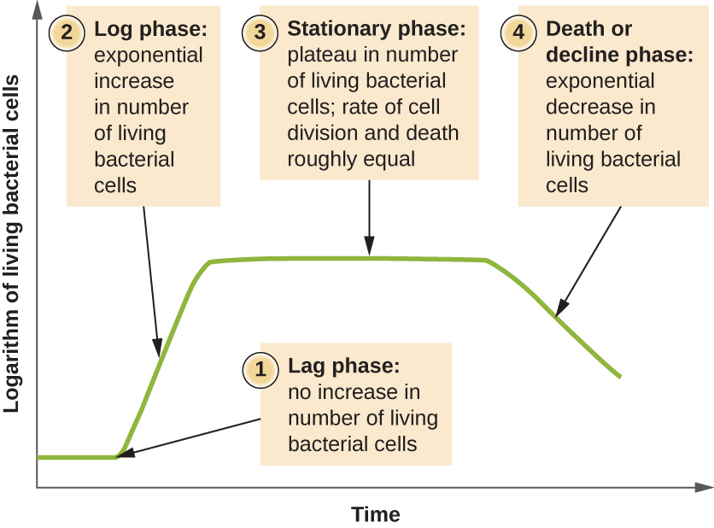

**Figure 6.0.1: Microbial growth, Source, Google Images, 2022)**

## 6.1 Lag Phase

* This is the inoculation of the culture in nutrient media and the bacteria cell is:
* Bacterial cells are very slow to grow
* The cells are adapting to the new environment
* The lag phase is very short
* Bacteria cell has to adapt to external factors needed for growth**.**

## 6.2 Log phase

* In this stage bacterial growth is exponential Growth i.e. 1, 2,22 23………
* There are low levels of waste products
* High nutrient content

## 6.3 Stationary phase

* Levels of waste become high reducing growth
* Nutrients become depleted
* Stagnation in growth resulting in Zero growth

## 6.4 Phase of decline

* Nutrients are depleted
* Increase in toxins
* Bacterial cells begin to die

## 6.5 Revision Questions

*1. Define the following terms:*

*a) Binary Fission*

*b) Generation Time*

*c) Transverse Septum*

*d) Logarithmic increase of bacterial cells*

*2. Briefly outline what is happening to the bacterial cells in the four phases of bacterial growth.*

# UNIT SEVEN: INDICATOR ORGANISMS

**Introduction**

Determining the sanitary requirements for food processing is critical in food safety. Safe food also include observing the right processing procedures that are seen in right temperatures and observing other parameters that are important to the presentation of safe food. Indicator organisms are useful in making sure that processing qualities in terms of correct microbial levels in food processing are adhered to and hence guarantee high levels of safety.

**Learning outcomes**

**After studying through this unit, students should be able to:**

* Identify Indicators of heat treated foodstuff:
* Describe Indicators of sanitary quality
* Apply understanding on indicators to select indicator organism

These are organisms whose presence or absence provides indirect evidence of the presence or absence of a particular feature or characteristic in a sample.

These are often associated with organisms of intestinal origin and also other groups that may act as indicators for other situations. This can be seen in:

## 7.1 Indicator of heat treated foodstuff:

The presence of the set Gram negative bacteria in heat treated foodstuff is indicative of inadequate heat treatment (relative to the initial numbers of these organisms) or of contamination subsequent to heating.

## 7.2 Indicator of sanitary quality

There are two groups of bacteria that are employed for this purpose, these are coliforms and enterococci. When their presence is in *high numbers*, it is *indicative of poor* hygiene conditions during food preparation and storage.

## 7.3 Common Indicators of Sanitary quality

**a) Coliform Bacteria**

Coliforms are gram negative rod shaped bacteria that ferment lactose with the production of gas. The primary coliform bacteria consist of E.coli and Enterobacter aerognes. E.coli are normally found in the gastrointestinal track of man or other animals where they normally do not cause disease. Whereas Enterobacter aerogenes is mostly found the GI track of man but it is also found in vegetation. This means that not all coliforms are faecal as E.coli is predominately in man but the Enterobacter aerogenes are also in vegetation.

**b) Faecal Coliforms**

These are distinguished from non-faecal coliforms by their use of high temperatures during incubation. The temperature optimal to the coliforms range from 44oC to 46oC, usually and specifically 44.5oC to 45.5oC. Faecal coliforms grow at higher temperature while non-faecal coliforms do not.

The coliform organisms are therefore used as faecal indicators that are originally proposed for water quality and dairy products in the dairy industry. Their use as indicators of food sanitary quality derives from their successful use for water.

The finding of large numbers of these organisms in foods and water is taken to indicate faecal pollution or contamination.

Since the waterborne diseases are generally intestinal diseases, the existence of pollution is taken to indicate the possibility that etiologic agents of these diseases may be present e.g. Salmonella

Whether or not intestinal pathogens are present, the presence of faecal matter in water and food is undesirable.

The presence of coliforms which are from the intestinal inhabitants should be taken to indicate a lack of cleanliness.

### 7.3.1 Coliform standards for foods

The presence of large numbers of coliforms in foods is highly undesirable but is also impossible to completely eliminate all these organisms completely in fresh and frozen foods. Therefore a low number of coliforms are permitted in many instances ranging 1 to not over 100/g or ml.

1. **Enterococci as indicators of food sanitary quality**

The enterococci are members of the genus streptococcus, which are gram positive cocci that produce long or short chains and differ from other gram-positive cocci in being catalase negative.

Like the coliforms, especially E.coli the enterococci are primary of faecal origin with S.faecalis and its varieties being associated more with human intestinal canal than of other animals. Hence their presence in food is an indicator as poor hygiene.

1. **Total viable counts as indicators of food sanitary quality**

Total counts more often Aerobic Plate Count (APC) on food products not only reflect *handling history*, *state of decomposition* or *degree of freshness*, they are also used to check levels of sanitary quality of food.

Aerobic Plate count most effectively evaluate the *sanitary quality of food* that does not support microbial growth e.g. dried or frozen foods. In foods of this type APC may be taken to indicate the type of sanitary control exercised in their production, transport and storage. Plate count rather than other indicators apply primarily to plant sanitation and critical process steps rather than merely or the finished products.

## 7.3 Choice of indicator organism

These organisms are chosen based on their characteristics. Some of the characteristics include:

* Specificity: that is the bacteria selected should be of specific genus
* They should occur in high numbers so as to allow dilutions during testing
* They should possess high resistance for extra enteral environment, pollution of which it is to be indicative.
* They should permit relative easy and fully reliable detection even they are present in low numbers.

## *7.4 Revision questions*

* *What are indicator organisms?*
* *Identify two main areas where indicator organisms are used in the food industry*.

# UNIT EIGHT: DELETERIOUS EFFECTS OF MICROORGANISMS

**Introduction**

The positive application of microorganisms in different levels of human life presents one side of microorganisms. In their existence, there are non-pathogenic in this case microorganisms that enhance human life and pathogenic microorganism whose effects are harmful. Understanding food safety means studying the deleterious effects of pathogenic microorganisms. These effects are mostly seen in everyday activities such as food spoilage and food poisoning. Food poisoning brings about various foodborne infections that are harmful to man. The unit further presents the positive side and common application of non-pathogenic microorganisms to offer a full appreciation in the study of microorganisms.

**After going through this unit, students should be able to:**

* Explain Food spoilage
* Describe Food poisoning
* Identify Common foodborne diseases and their sources

Deleterious effect refers to the ability by Microorganisms to reduce or alter the quality of food. Microorganisms can reduce the quality of foods in various ways.

They can change the *food organoleptically* so as to deter the potential consumer a condition known as *food spoilage*.

They can also make it capable of *causing diseases* that is *food borne diseases or food poisoning.*

### 8.0.1. Food spoilage

This is defined as the change in the food that makes it unsafe, less acceptable or unacceptable to the consumer for its original purpose. Food spoilage may be caused as a result of *physical, chemical or microbial contamination*.

Of all the agents involved in food spoilage, microbial contamination is the most complex as the agents are not easily detected by the naked eye.

### 8.0.1.1 Spoilage is caused by bacteria, yeasts and moulds.

Different kinds of microorganisms produce different types of changes in foods. The decomposition of food rich in *carbohydrates* results usually in various types of *fermentation*.

The action of microorganisms on *high-protein foods* results in *putrefactions*. The products of the former are usually harmless, where as those of the latter are harmful.

1. **Microbial contamination**

Food may be spoiled by being contaminated with disease-causing organisms that may not be organoleptically detected by the consumer or by the growth of microorganisms that may become manifested in a variety of ways.

1. **Process of microbial Spoilage**

Microbial spoilage of food starts when microorganisms’ gains access to the food at some stage and the particular food supports microbial growth.

Once the food is contaminated, under suitable conditions of growth, the microorganisms start to multiply making the food unacceptable to the consumer.

The most important genera of food poisoning are staphylococcus, Salmonella, Streptococcus and Clostridium.

## 8.1 Common foodborne diseases and their sources

Certain types of bacteria, which can grow, in food are the *principle causative agents* of food poisoning. Bacterial food poisoning is the *disturbance* of the gastro intestinal tract (GI) that comes with *abdominal pain* and *diarrhoea* and *usually vomiting*. The symptoms arise due to either (1) infection or (2) intoxication.

### 8.1.1 Infection

This is the *introduction of live disease producing bacteria* into the human gut. Between the ingestion of such bacteria and the onset of symptoms there is a *period of delay during which time the invading pathogens proliferate* in the body.

The examples of infective bacteria are Salmonella, Vibrio, Parahaemolyticus and Escherichia coli.

### 8.1.2 Intoxication

This is the *production of bacterial toxins* into the *human gut*. Food poisoning toxins are produced by types of bacteria different from those that cause infection.

Examples of toxin producing bacterial types include Clostridium, staphylococcus and streptococcus species.

## 8.2 Common food borne infections (Infection)

The common infections that are studied in microbiology include:

1. **Typhoid and Paratyphoid**

The disease presents symptoms in form of continuous fever with diarrhoea coupled with rose coloured spots on the body of a person.

The sources of the infection are mostly faecal matter and urine of an infected person or a carrier. The hands becomes directly or indirectly contaminated and they in turn contaminate the food, or the method of sewage disposal may allow the contamination of drinking water sources.

Flies can also transmit the causative bacteria (salmonella) from infected material to food. Typhoid is commonly associated with milk and milk products.

1. **Salmonellosis**

The sources of salmonellosis are similar to that of Typhoid that is faeces and urine of the infected person or carrier and by food or water contamination indirectly or directly by such people. The organisms may also be transmitted by flies and rodents.

Duck eggs and chicken eggs have been known to generally among the most frequently concerned foods with this type of food poisoning. The incubation period is between 6 -72 hours of ingestion of contaminated food.

The infection produces diarrhoea, vomiting and severe stomach pain. The illness last for several days and may be so severe that it may lead to dehydration.

1. **Shigella Dysentery**

Bacillary dysentery is caused by some species of bacteria of the shigella genus of which there are three main types namely S. sonnei, S. Dysenteriae and S. paradysenteriae.

The symptoms are diarrhoea, sometimes accompanied by fever. The incubation period may be from 2-3 hours to four days or less frequently up to seven days.

Shigella is an intestinal organism that cause dysentery. It is often spread by water rather than food and is infective in small doses.

When spread by food, the contamination arises directly or indirectly from an infected person or carrier. Flies also play an important role in the transmission of the disease.

**Control of shigella dysentery**

Shigella dysentery can be controlled by the following:

* Use of clean drinking water
* Not allowing sick staff with diarrhoea to handle food
* Cooking all foods thoroughly.

1. **Escherichia coli (E.coli)**

Escherichia is a normal inhabitant of the intestinal flora of man and animals. Certain serotypes are enteropathogenic and known to cause diarrhoea.

It is often ingested in contaminated foods and cause diarrhoea. Normally the pathogen enters the kitchen through raw food staffs and readily pass to cooked foods by the usual means of hands surfaces and containers and other equipment.

The incubation period is 1 to 3 days and the symptoms may resemble those of salmonella food poisoning or dysentery, when there is prolonged diarrhoea with a combination of blood and mucus in the stool.

**Control of E.coli**

* Avoiding cross contamination from raw foods to cooked foods. This means separating the preparatory spaces and practicing between activity hand washing.
* E.coli is also controlled by through cooking especially.

1. **Vibro parahaemoliticus**

The microorganism is very common in Asian countries such as Japan and China where it accounts to cause 50% and more of food poisoning incidents.

It is isolated in shellfish and other sea foods and from coastal waters. The organisms cause infection and the symptoms have been likened to those of both cholera and dysentery.

The average incubation period is about 12-24 hours, and there is rapid onset of illness with profuse diarrhoea often leading to dehydration, vomiting and fever.

**Control of Vibrio paraheamolyticus**

* The pathogen is controlled by avoiding cross contamination from raw shell fish to cooked ones.
* Cooking shell fish thoroughly.

## 8.3 Food Poisoning (Intoxication)

a) Staphylococcal food poisoning

Staphylococcal poisoning is rapid in its onset, occurring half an hour to four hours after the ingestion of contaminated food. The organisms are commonly found in boils, and similar suppurative conditions.

It should be noted that staphylococcal food poisoning carries very low cases of fatality with death occurring to individuals who have other complicating life-threatening factors.

The principle source of this condition is the S.Aureus that comes from the food handler. It is commonly on the hands, in the nose and throat of a large proportion of the population, and people with infected cuts, boils and ears, nose and throat discharge will be very serious sources of contamination.

The toxin is heat stable, and is produced in the food stuff by bacterial contamination usually directly due to unclean habits of the food handler. When the vehicle is milk product, it is also possible that an infected cow’s udder (animal suffering from staphylococcal mastitis) was the source. The severity of the symptoms depends upon the amount of toxin ingested.

**Control of staphylococcal food poisoning**

In order to control the pathogen the following measures should be followed:

* Avoid contamination especially from handlers touching ready to eat foods.
* Staff with infections should be kept off work
* Keeping food properly chilled until it is needed for service.

1. **Streptococcal Poisoning**

This is the food poisoning that come from causative agents for sore throat and scarlet fever. It is possible for contaminated food to cause typical symptoms of food poisoning as well sore throat and scarlet fever. Contaminated milk has in the past featured as a vehicle. It is also possible that a food handler with a sour throat can infect the food.

1. **Botulism**

Botulism is a very serious form of poisoning with a very high fatality rate. The causative organism which is found in the soil and the intestinal tracts of animals, is clostridium botulinum and produces an exotoxin. The incubation period varies from 24 hours or less to 72 hours.

The onset is sudden with disturbed vision, dizziness and sometimes headache, abdominal pain and physical exhaustion. This is followed by paralysis affecting speech and swallowing and later the heart or the respiratory system. Botulism is rare, but when it does occur, it is often fatal. The bacteria grow well in the absence of free oxygen e.g. in a vacuum packs or cans.

1. **Clostridium perfringens**

This produces a toxic substance which causes symptoms about 10-12 hours after ingestion. It causes distress in the lower intestine with pain, cramps, gas and diarrhoea. It is found in the soil and animal intestinal contents when the carcass is dressed after slaughter. Clostridium perfringens can form spores which are very resistant to heat and it prefers to grow in the absence of air, for example deep inside meat dishes or in vacuum pouches.

**Control**

* Food should be cooked too far in advance of service
* Pre-cooked food should be cooled quickly
* Food should be properly refrigerated until needed
* If served hot, food should be thoroughly heated.

1. **Bacillus cereus**

The spores from B. cereus are frequently present in cereals, and in the soil. They can survive light cooking and germinate into bacilli which grows to produce toxins in cooked food.

## 8.4 significance of microorganisms in the food industry

Microorganisms have a beneficial effect to the food industry as they are involved in several processes which enhance the quality of our food.

This can be seen in:

In manufacturing, the food industry uses microorganisms in cheese, yoghurt, bread, fermented beverages like munkoyo, Beer and wine, soy Sause, fermented fish and meat.

They are also used in the production of *food additives* such as *vinegar, citric acid,* *sodium glutamate,* as sources of enzymes for processing.

They are also used as food in their own right such *mushrooms, yeast extract.*

## 8.5 Revision Questions

*1. Differentiate intoxication and infection in food poisoning.*

*2. Explain food poisoning.*

*3. Discuss the main common forms of food poisoning.*

# UNIT NINE: PRACTICAL MICROBIOLOGY

**Introduction**

The study of microbiology ends in the isolation and identification of various pathogenic and non-pathogenic microbial species. This is done by conducting laboratory procedures that make the study of microorganisms visible. The unit therefore presents the process of bacterial culturing using plates and allowing bacterial colonies to form in great numbers making them visible. Microbial isolation and study is also done using bacterial staining procedures under a laboratory using one of the methods known as gram staining. The unit will therefore introduce students to the two methods that will enable them to appreciate the invisible bacterial world.

Before engaging in any laboratory procedure, safety of the student is of paramount importance and therefore this unit begins with acquainting the students with safety protocols to the microbiology laboratory. Safety prepares the students to work with any bacterial culture that is both pathogenic and non-pathogenic samples.

**After going through this unit, students should be able to:**

* Apply Safety principles in the Microbiology Laboratory
* Identify basic requirements of a microbiology laboratory
* Practice washing and sterilization of glassware
* Demonstrate knowledge in preparation of microbial media
* Practice sampling for working surface bacteria
* Demonstrate ability in culturing surface bacteria

**SAFETY IN MICROBIOLOGY**

Safety is done by following safety guidelines in this case the do and don’ts in the laboratory. These include:

1. **Wear protective clothing**

Protective gloves, eye gear and face masks are important in conducting microbial examination in the laboratory for the safety of the students

1. **Sterilize all equipment and material**

All the materials that are used in microbial examination should be sterilized before they are used.

Most items used microbiological examination include media, tubes, plates, loops, needles, pipettes and other items used in microbial culturing should be sterilized by either autoclaving and sterilization by other heat or chemicals.

The equipment used should be treated with utmost safety as prescribed in the laboratory manuals.

In the absence of safe methods, it is important to use commercially sterilized products that protects the end users.

1. **Disinfect work areas before after use**

In the process of cleaning surfaces, it is important to use disinfectant that will render safety. In this case, 70% alcohol especially ethanol is used to wipe down benches and work areas both before and after working with cultures.

Also be aware of the possible dangers of the disinfectant as 70% alcohol can catch fire around an open flame or any heat source.

The alcohol or bleach can be dangerous if splashed in the eyes. Students should therefore know where the nearest eyewash is located.

1. **Wash your hands**

Use a disinfectant soap to wash your hands before and after working with microorganisms. Non-disinfectant soap will remove surface bacteria and can be used if disinfectant soap is not available. Gloves may be worn as extra protection.

1. **Treat all microorganisms as potential pathogens.**

As most of the microorganisms are non-pathogenic to the humans and have never caused diseases, it is also true than under certain circumstances, a lot of non-pathogenic microorganisms can in fact be pathogenic. This means that all microorganisms in the laboratory should be treated as pathogens. This means that all cultures should be treated as pathogenic, this means that students should ensure that care is taken at all times to handle microorganisms.

1. **Never pipette by Mouth**

Use pipette bulbs or other pipetting devises for the aspiration and dispensing liquid cultures

1. **Do not eat or drink in the lab, nor store food in areas where microorganisms are stored.**

Never eat or drink in the laboratory while working with microorganisms. Keep your fingers out of your mouth and what your hands before and after the laboratory activity. Cover any cuts on your hands with a bandage. Gloves may be worn as extra protection.

1. **Label everything clearly**

All chemicals, cultures, disinfectant and media should be clearly and securely labelled with names and dates. If they are hazardous, label them with proper warning and hazardous information.

1. **Autoclave or disinfect all waste material**

All items to be discarded after a class such as cultures, tubes, culture plates, swabs, toothpicks, wipes, disposable transfer needles and gloves should be placed in a biohazard autoclave bag and autoclaved 30 minutes at 121oC.

If no autoclave is not available then 10% bleach can be used and the materials should be socked for at least 1 to 2 hours.

1. **Clean up spills with care**

Cover any spills or broken culture tubes with 70% ethanol or 10% bleach solution and clean with Malton cloth or paper towels.

After allowing the spill to sit with the cleaning solution, clean up the material and dispose it in the biohazard autoclave for a short time.

Never pick up glass fragments with your fingers and put in dust pan and the culture itself.

## BASIC REQUIREMENTS OF A MICROBIOLOGY LABORATORY

A microbiology laboratory requires well-built rooms equipped with glassware, tools and equipment. Some of the most important of these are described in this section and include:

1. **Common glassware**

The most important glassware used in the microbiological laboratory are test tubes, culture tubes, petri dishes, Erlenmeyer flasks, measuring cylinder, pipettes, glass spreader, volumetric flasks, screw capped glass bottles, e.tc.

1. Test tubes, culture tubes and screw-capped tubes
2. These are made up of glass, one end of which is closed and the other end is open.
3. If the side wall of the open end is slightly curved outside, it is called a test tube; if the side wall is smooth, it is called a culture tube. When the side wall of the tube has screws so that a plastic cap may be fitted, it is called screw capped tube.

The test tubes are used for testing chemicals such as pH, etc. culture tubes are used for the preparation of Agar slants and purification of microorganisms. The open end is plugged with non-absorbent cotton plug. Sometimes microorganisms are purified and preserved in screw-capped tubes.

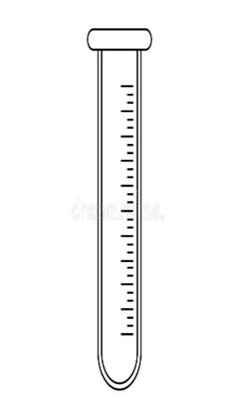

**Figure 9.0.1 : Test tube**

*(Source, Google Images, 2022*)

1. **Petri dish**

The petri dish consists of two shallow glass dishes, that is the upper half or lid and lower half or bottom half. These are used for cultivation of different types of microorganisms. According to the requirements, the diameter varies. Molten agar medium is aseptically poured on the bottom half of the sterilized petri dish and then covered with the upper half.

The petri dishes are sterilized by putting them in a petri dish container and in turn in an oven/autoclave.

They come in glass and disposable sterile plastic as disposables.

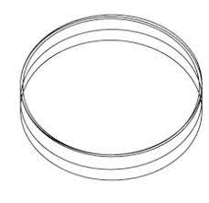

**Figure 9.0.2: Petri dish**

*(Source, Google Images, 2022*)

1. **Pipette**
2. It is a cylinder and graduated glass apparatus as shown
3. It’s one end that is the lower side tapers, while the end or mouth piece is normal. The middle portion is wider or of the same size as the mouth end.
4. It is graduated with numbers 1,2,…..10
5. It has different measuring capacity such as 0.1, 0.5, 1…..10ml etc. and hence measures different quantities.
6. It is used in transferring specific amount of liquids in containers.
7. It should be sterilized in an oven/autoclave before use by keeping in pipette container after being plugged with cotton.
8. From the safety point of view, the liquid should be sucked using pipette fillers or suckers which are attached at the normal end of the pipette.

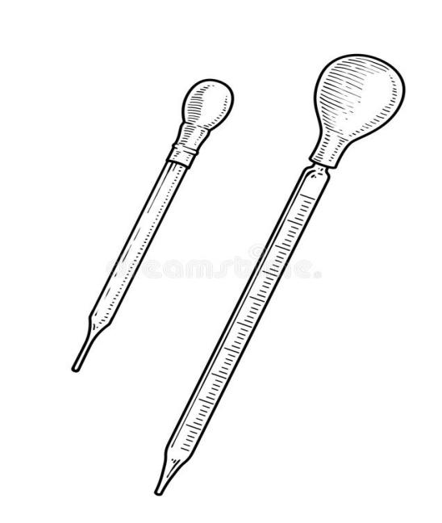

**Figure 9.0.3: Pipette**

(Source, Google Images, 2022)

1. **Pasteur pipette**
2. The Pasteur pipette is made by selecting a hollow glass tube of similar diameter as of standard pipette or graduated pipette of which one end is heated so as to blow the glass to form a narrow end similar to 10 ml pipette.
3. Pasteur pipettes are generally used once and then transferred into the disinfectant.

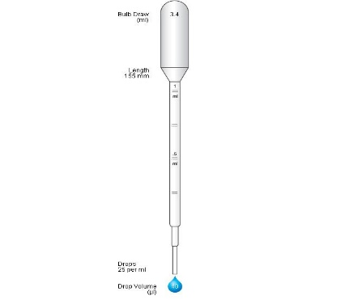

**Figure 9.0.4: Pasteur pipette**

(*Source, Google Images, 2022*)

1. **Erlenmeyer Flasks**

It has a narrow beak at top with an opening and a broad bottom.

The flasks are of different sizes, hence measure different volumes such as 100, 250, 500, 1000mls etc.

The flasks are round bottomed or flat.

Sometimes they are graduated to represent the volumes.

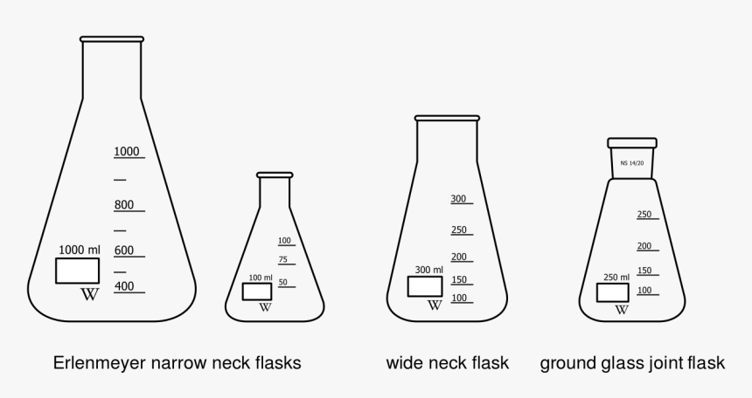

**Figure 9.0.5: Erlenmeyer Flasks**

*(Source, Google Images, 2022*)

1. **Volumetric flasks**
2. The shape is that of an Erlenmeyer flask.
3. It is used to prepare solutions of accurate strength
4. Its upper part is cylindrical and narrow and marked at a point. This mark denotes the water level to be maintained at this point.
5. The lower half is rounded and voluminous
6. Its base is flat so that it may be properly placed on the surface.

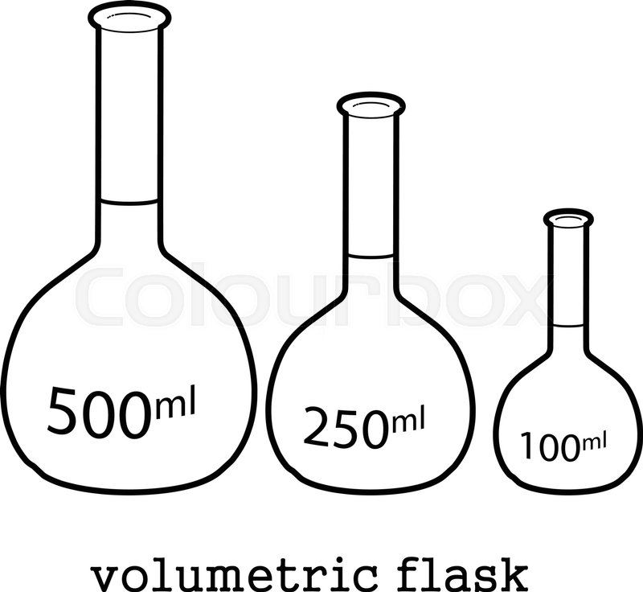

**Figure 9.0.6: Volumetric Flasks**

*(Source, Google Images, 2022*)

1. **Glass spreader**
2. The spreader is made by bending a glass rod and making a L-shaped structure as shown.
3. It is used to spread evenly the microorganisms on agar surface present in liquid medium.
4. The long arm is hold in hand and the small arm is flame-sterilized and put on agar surface.
5. It is brought forth and back so than microorganisms present in liquid may be dissociated and evenly spread on entire surface of agar.

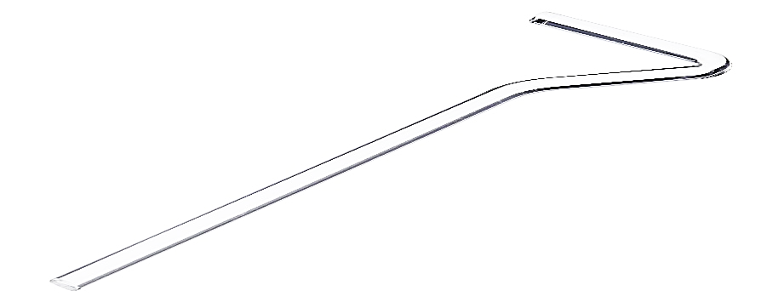

**Figure 9.0.7: Glass Spreader**

*(Source, Google Images, 2022*)

1. **Ocular micrometre**

The ocular micrometre is a circular disc graduated into several parts i.e. divisions marked from 0 to 100 as shown.

1. It is placed inside the eyepiece of the microscope
2. The distance varies according to the objective of the microscope.
3. The distance is easily determined by using a stage micrometre.
4. It is used to measure the accurate dimension of a microorganism, a cell or any microscopic material.

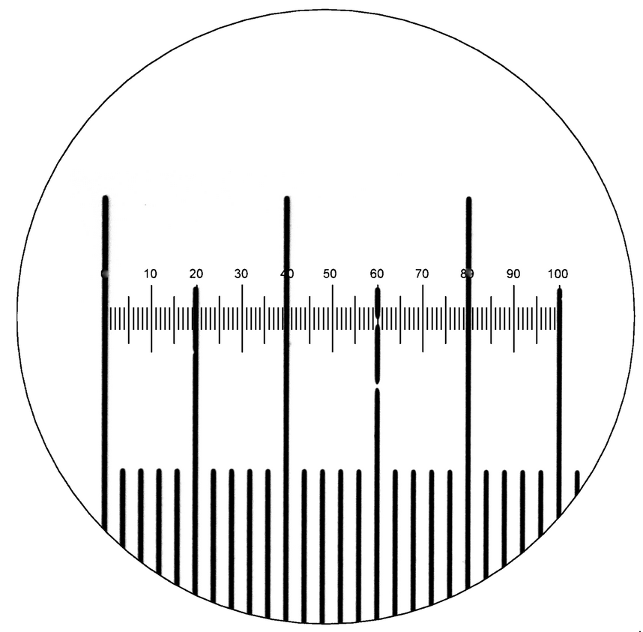

**Figure 9.0.8: Ocular micrometre**

*(Source, Google Images, 2022*)

1. **TOOLS AND EQUIPMENT IN THE MICROBIOLOGY LABORATORY**

The most common tools and equipment in the food microbiology laboratory include the following:

1. **Inoculation Needle and Inoculation Loop**
2. Inoculation needle/loop is made up of a long platinum wire fixed into a metallic rod as shown.
3. A wire loop has a handle with steel screw shaft in which nichrome or platinum wire is fixed.
4. The wire is then wrapped around a heat insulated objected like a pencil and twisted mechanically forming a loop. The loop is small so as to retain a small circular film by dipping it in the solution.
5. The straight wire has a wire instead of a loop and the open end is blunt. Both the loop and the straight wire are to be sterilized either by using a Bunsen burner or hot heating coil till the wire and loop become red hot. After loop or wire is cooled, it is used in the transferring of culture from liquid broth.
6. The needle is used to transfer culture from solid medium and also the smaller amount of liquid culture.
7. The loop and wire are also used for transferring small quantities of solid materials from a microbial colony and can be used to inoculate either a liquid or a solid medium. Both the loop and straight wire must be flamed immediately after use so that contamination is avoided.



**Figure 9.0.9: Inoculating loop and Inoculating needle**

*(Source,* *Google images, 2022)*

1. **Bunsen burner (Spirit lamp)**
2. The Bunsen burner is also called a spirit lamp due to its use of spirit for burning purposes.
3. The gas enters the burner at the base, and its supply is regulated externally by the gas cock. As the gas streams upwards, air is pulled in through the air intake holes above the base.
4. The amount of air can be controlled by rotating a sleeve that fits over the holes in the body of the burner.
5. To keep the flame from blowing out specials tips are used frequently to fit over the top end of the barrel.
6. Burners are used for sterilization of the inoculation needle/loop before inserting into the culture tubes or petri dishes.
7. They are also used during the transfer and purification of microbial cultures. Before opening the cotton plug, mouth of culture tubes or flasks are flamed so that the microorganisms if any present on mouth should be killed.
8. Sterilization of tools by using a spirit lamp is called ***incineration.***

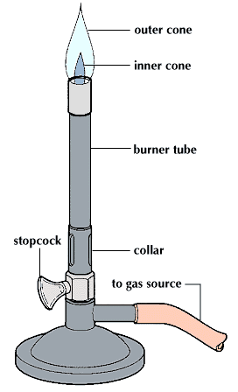

**Figure 9.0.10: Bunsen burner**

*(Source, Google Images, 2022*)

1. **Water bath**
2. Water bath is an equipment that is used to provide constant temperature to a sample.
3. It consists of an insulating box made of steel fitted with electrode heating coil.
4. The temperature is controlled by a thermostat
5. In some water baths, the plate form rotates which is called a water shaker.
6. The main use of a water bath is the incubation of samples at a desired and constant temperature.

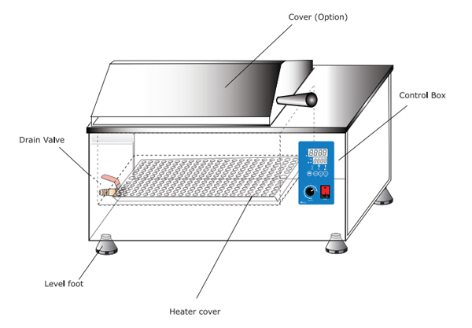

**Figure 9.0.11: Water bath**

*(Source, Google Images, 2022*)

1. **Autoclave**
2. The killing action of heat on the organisms can be done by using increase in the steam in a closed system. The water molecules become aggregated resulting in increase in their penetration. The water boils at 100oC and the steam accumulate in a closed container resulting in increase in pressure and thereby killing spores and cells of microorganisms.
3. The autoclave is usually of pressure cooker type made of metal sheets that are supported in Iron case.
4. It is closed by swing door which is fastened by radical bolts tightly.
5. The autoclave is operated at a temperature of 121oC and a pressure of 15 lb./inch2 to kill microorganisms.

***Precaution***

The level of water should be checked before operating. The air should be completely evacuated and the steam must have access to the materials to be sterilized.

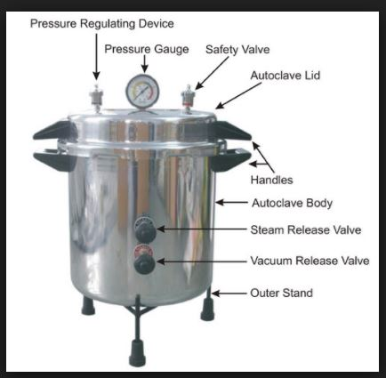

**Figure 9.0.12: Autoclave**

*(Source, Google Images, 2022*)

1. **Laminar air flow (Biohazard cabinet)**
2. This is an apparatus that consist of an air blower in the rear side of the chamber which can produce air flow with uniform velocity along parallel flow lines. There is a special filter system of high efficiency particularly air filter which can remove particles as small as 0.3mm.
3. In front of the blower, there lies a mechanism through which air is blown from the blower and produces parallel lines.
4. The laminar flow is based on flow of air current of uniform velocity along parallel flow lines which help in transferring microbial cultures in ascetic conditions. Air is passed through the filters into the enclosure and the filters do not allow any kind of microbe to enter the system.
5. Inside the chamber one fluorescent tube and the other UV tube are fitted. Two switches for these tubes and a separate one for the airflow control are fitted.
6. Initially, dust particles are removed from the surface of the laminar flow with the help of a smooth cloth containing alcohol. The UV light switched on for 30minutes will kill germs if they are present at a working area.
7. The front cover sheet of the apparatus is opened to keep the desired material inside. The air blower is set at the desired degree so that the air inside the chamber is expelled because the air inside the chamber may be contaminated or may bring contaminants.
8. All work related to pouring, plating, streaking are to be carried out in the flame zone of the burner or spirit lamp.

*Precaution*

Put off the shoes before entering to operate the apparatus. Wash hands with detergent or soap. One should not talk inside the chamber while performing microbial culture transfer, failing in these results in contamination.

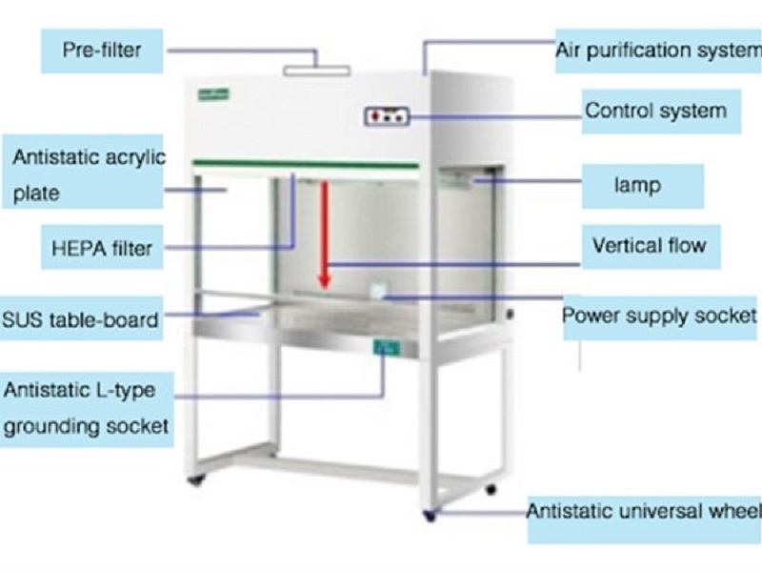

**Figure 9.0.13: Laminar Air Flow**

(*Source, Google Images, 2022)*

1. **Incubator**
2. An incubator is an instrument that consists of copper/steel chamber around which warm water or air is circulated by electric current or by means of small gas flame.
3. The temperature of the incubator is kept constant due to its control using a thermostat.
4. The incubator is made of double walled chamber adjusted to a desired temperature. It is done using an external knob controlling the thermostat system. The gap between two walls is insulated to check heat conduction. In olden ones, a thermometer is inserted from the top for recording temperature. Morden incubators come with automated temperature controls.
5. It is operated to allow microbial growth on a suitable media under the optimum growth temperature.

*Precaution*

The door of the incubator should be opened when necessary only. If the tubes are to be incubated at a high temperature or for a long time the media will become dry due to excessive evaporation.

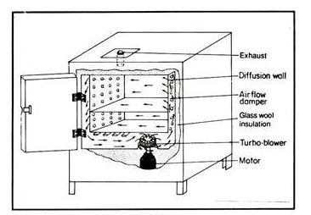

**Figure 9.0.14: Incubator**

*(Source, Google Images, 2022)*

1. **Colony counter**
2. It is a device used for counting the small or closely growing colonies on the surface of media
3. For accuracy the lens fitted or mounted in it helps to see the colonies
4. The lens is movable on the box and can be adjusted to see the colonies
5. The petri dish is kept on a slanting platform meant for it and illuminated with the help of light source from beneath.
6. The number of colonies are read out with the support of digital reading meter.

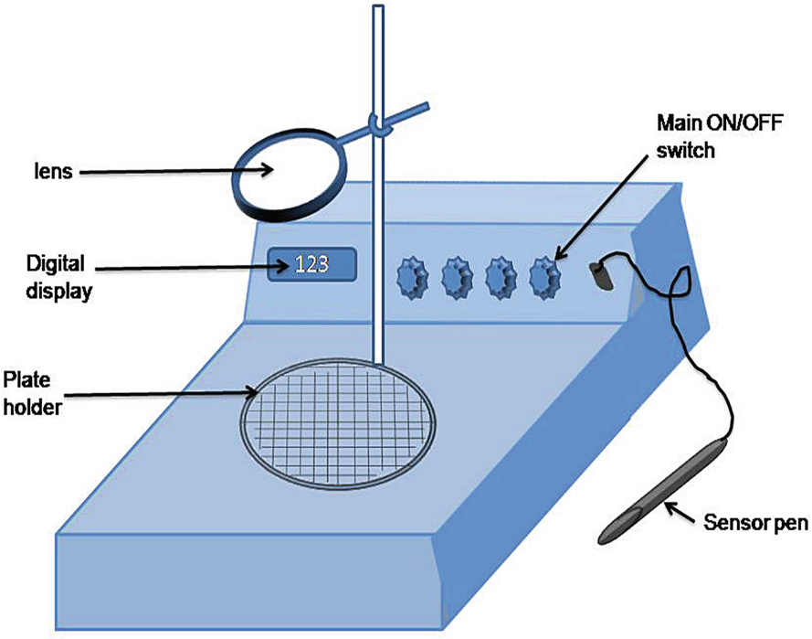

**Figure 9.0.15: Colony counter**

*(Source Google Images, 2022)*

1. **pH meter**
2. The pH meter measures the Hydrogen ion (H+) concentration in a solution.
3. It is defined as the negative log of hydrogen ions concentration
   * 1. pH=-log10 (H+) = 7
4. The meter measures the degree of acidity and alkalinity of a solution that is measured on a scale of 1 to 14.

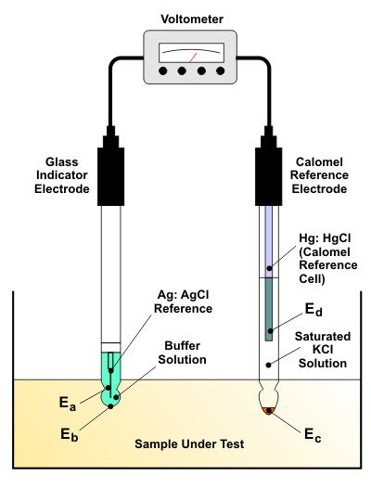

**Figure 9.0.16: pH Metre**

*(Source, Google Images, 2022*)

1. **Analytical Balance**
2. It is used to measure accurate amounts of chemicals to use in a microbiological analyses.
3. It should be noted that the balance should be calibrated before it is used to give correct quantities.

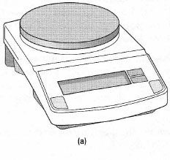

**Figure 9.0.17: Analytical Balance**

*(Source, Google Images, 2022*)

1. **Spectrophotometer**
2. This is an instrument that utilises light as a source of radiation and measures changes in the optical density or absorbance.
3. It has three basic principles that is the source of radiation, unit for dispersing radiation at different wavelengths and the device for detecting the amount of radiation at different wavelengths.
4. Spectrophotometer uses monochromatic (narrow wavelengths) radiation, whereas colorimeter uses broad wavelengths bands.

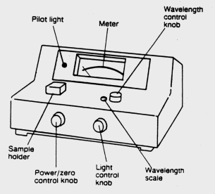

**Figure 9.0.18: Spectrophotometer**

*(Source, Google Images, 2022*)

1. **Centrifuges**
2. Centrifuges are instruments that operate on the principle of centrifugation technique.
3. Centrifugation technique is based on molecular mass, shape and density of the particles.
4. The rate or velocity at which particles sediment is proportional to the force rate and the velocity of sedimentation applied forces.
5. The application of the larger force more than the earth’s gravitational field increase the rate of sedimentation of particles.

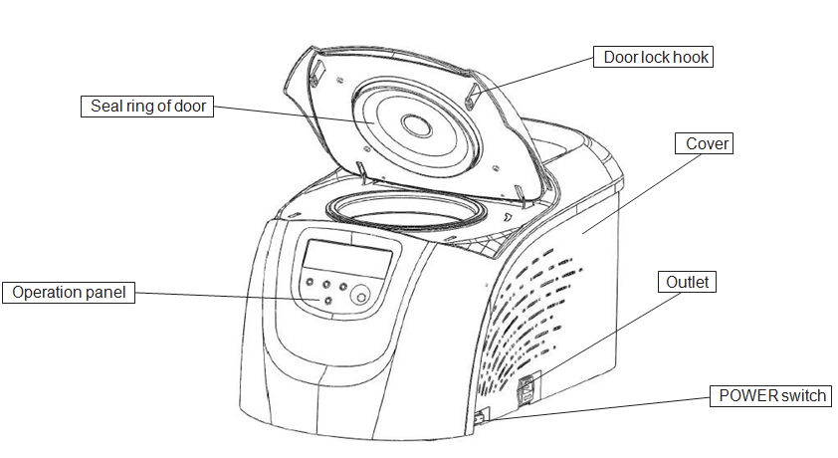

**Figure 9.0.19: Centrifuge**

*(Source, Google Images, 2022*)

1. **Microscope**

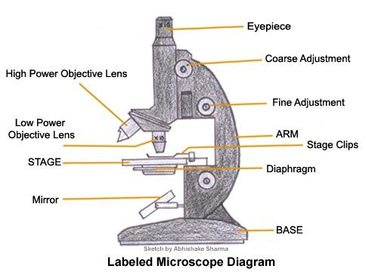

**Figure 9.20: Microscope**

*(Source, Google Images, 2022*)

For the study of food microbiology, the microscope becomes an important equipment. This is because microorganisms are not visible to the naked eye and hence require the microscope for their study. Some microorganisms are colourless, but the microscope with its phase contrast attachments tends to make them visible at high resolution.

The basic microscope consists of the eye piece (10X magnification) that is fitted into the microscope tube. The magnification varies in the ocular eyepiece. For identification, low power lenses known as objectives lenses are used with varying powers that is 10X, 40X).

For high magnification an oil immersion (100X) is also used. These are essential for the study of microbes at high magnification. The oil immersion brings the object closer into focus when rotated by the nosepiece carrier. The fine details are easily visible by the 100X objective. The microscope also has a stage with a mechanical holding device or simple clips.

Two kinds of preparations are done in using the microscope, that is wet mount and a stained smear on the surface of a slide under a cover glass are used for simple microscopy. The wet mount preparation is used under objectives (10X and 40X) while for the detailed examination an oil immersion (100X) is used. A stained slide is used to locate the specimen with dry objectives whereas a slide covered with immersion oil provides a clear and translucent image of the bacteria or microorganisms. The sequential steps in operating a basic microscope are:

Place the slide on the stage and focus the image

To observe the specimen with the aid of eyepiece and objective lens, during the initial stage keep the condenser up to the level of the stage of the microscope

Completely open the aperture diaphragm of the condenser and while tilting the mirror focus on the optical axis

Observe the image of the specimen with a sharp focus by using the coarse control of the objective lens. Most of the time flat mirror is used, whereas for low power, concave mirror is used

Adjust the position of the condenser to improve the illumination and the aperture diaphragm so as to get a sharp, contrast and best picture of the specimen.

Determine the position of the condenser best fitted for the focussing the smear by removing the eyepiece and look down into the tube at the visible illumination.

Set good illumination after adjusting the position of the condenser. Further tilting the mirror helps in illumination.

Reduce the scattered light from the lens by closing the aperture diagphragm of the condenser. It is simple to turn the nosepiece to any other objective lens and examine the specimen on the slide surface through the eye piece and focus to make final adjustment for the best illumination. It is noted that the focal position of one objective is nearly identical to that of others if the lenses are coming from the same source. Raise the tube as you are focusing from high power 40X or oil immersion (100X) into position.

Take great care while focussing in above objective lenses that can be adjusted by looking from the side and lower the objective slowly onto oil so as not to touch the oil. When the specimen is located, use the fine adjustment and raise the objective with the course adjustment knob. It is also convenient to apply the oil drop to the slide on the stage with the nose piece half rotated to the correct objective before putting the image into focus.

Generally, focussing the image in oil immersion requires practice. When the specimen is located use the fine adjusting knob for sharp focus and clear picture of the desired specimen. There is a high probability of the breakage of the slide during focussing in oil immersion. This means great care is required as the dull, dim and hazy picture indicate that something is wrong with the lenses. Therefore it is necessary to clean the objective with lens paper.

Sometimes it is necessary to look into the eyepiece and tubes as well as a common factor of hazy appearance is air bubble trapped in the immersion oil. It is possible to remove the bubbles by first raising the objectives, turning the eyepiece, wipe off the oil with lens paper and then turn back the objectives and refocus. Sometimes, closing the diaphragm also gives poor image.

*Activity*

* *Draw five common glassware in the food microbiology laboratory*
* *Identify common equipment in the food microbiology laboratory*

## PRACTICAL ONE: WASHING AND STERIZATION OF GLASSWARE

**Title:** To wash and sterilize Glassware by Autoclaving

**Theory**

Autoclaving is the best known method for sterilizing glassware before use in microbial culturing. This method allows items to be heated with both steam and pressure at a temperature which is beyond the temperature danger zone (TDZ). This is the temperature that supports microbial growth.

**Materials**

* Assorted microbiology glassware
* Teepol or glassware cleaning reagents
* Autoclave

**Procedure**

1. Wash the glassware with teepol or glassware washing detergent and rinse with tap water and lastly with distilled water
2. Place the glassware in steel baskets and dry them in the hot air over at 700C for one hour.
3. Sterilize the petri dishes by autoclaving at 1210C for 20 minutes and allowed to cool.
4. Clean the pipettes in disinfectants and cotton plug them and use hot air for sterilization.
5. Place the petri dishes in aluminium foil and sterilize them using hot air at 700C
6. The petri dishes should have a brown paper in between them during storage.
7. The spatulas should be wrapped in aluminium foil before being air dried at 700C
8. Cool the glass ware and pack them in cupboard for storage.

## PRACTICAL TWO: PREPARATION OF MICROBIAL MEDIA

**TITLE: TO PREPARE MEDIA FOR MICROBIAL GROWTH**

**Theory**

Nutritional requirements for bacterial growth differs according to each bacterial species. Although nutrient agar allows most of the bacterial species for growth, specific media for each species with specific growth requirements is needed for each bacterial species. The preparation of the media comes with the manufacturer’s instructions on the procedure of media preparation. Generally, the following procedure apply to most media.

**MATERIALS:**

* Growth Media
* Spatula
* Pyrex beaker or conical
* Flask and distilled water
* Analytical scale

**PROCEDURE:**

1. Weigh the require amount of growth media as prescribed from the concentrated sample into the Pyrex conical flask or beaker and the required distilled water.
2. Place a magnet in a conical flask or beaker to stir the mixture and stir the mixture using a hot plate with a magnetic stirrer to boil.
3. The mixture is then autoclaved at 121oC for 15 minutes and the mixture is put in the water bath at 460C before being poured on the petri dish for microbial culturing.

Result:

Media is observed to solidify after being poured on the plate and is therefore ready for culturing.

*Activity*

* *Prepare a laboratory Report on microbial media preparation.*

## PRACTICAL THREE: SAMPLING FOR WORKING SURFACE BACTERIA

**TITLE: TO SAMPLE LEVELS OF BACTERIA ON WORKING SURFACES OF THE FOOD PREPARATION AREA**

**Theory**

The working surface can be contaminated by microorganisms due to exposure to the environment for a long time. It is therefore necessary to conduct microbial tests on the levels microorganisms on working surfaces and determine the effectiveness of the cleaning method being employed.

**Materials**

* Sterile surface swabs
* Petri dishes
* Nutrient Agar

Procedure

1. Collect surface swabs for microbial culturing
2. Prepare the nutrient agar as directed
3. Pour the agar on the plate
4. Inoculate the bacterial cells from the swabs
5. Incubate the plates at 37oC for 24 hours

Result:

Observe the growth of the colonies and count them as colony forming units (CFUs) of bacteria present on the working surfaces

*Activity*

* *Prepare a laboratory report on sampling for working surface bacteria*

## PRACTICAL FOUR: GRAM STAINING FOR BACTERIAL DIFFERENTIATION

**TITLE: TO DIFFERENTIATE GRAM POSITIVE FROM GRAM NEGATIVE BACTERIA**

**Materials**

* Bacteria culture
* Crystal violet
* Iodine
* Ethanol 95%
* Safranine
* Bunsen burner
* Staining rack
* Glass slide
* Microscope

**Theory**

Gram staining is the most important differential technique used in bacteriology. There are two groups of microorganisms under gram staining that is gram positive and gram negative. The method was developed by Christian gram in 1884 and it basically involves passing the heat fixed sample on a slide in crystal violet and then being treated with iodine which acts as a mordant.

The crystal violet stains the slide with purple blue colour to the cells. In gram positive cells, this combines with peptidoglycan in the cell wall giving a fixed stain that is difficult to remove. The cell is then treated with ethanol which dissolves the lipid in gram negative cells and since the gram positive contains low lipid the stain remains as it comes off from the gram negative cells. The cell are then washed in a counter stain safranin which quickly gets fixed in the gram negative and is returned after the final wash which appears in the microscope.

**Procedure**

1. Prepare a bacterial slide by heat fixing the bacteria cell on the slide forming a smear.
2. The smear should not be too thick but relatively thin barely visible film.
3. Stain the slide in crystal violet for 2-3 min and remove the excess stain with distilled water
4. flood the slide in the iodine (mordant) for 1 minutes and remove the excess stain with distilled water
5. Dip the slide in 95% ethanol until the crystal violet fails to wash off the slide
6. Wash the slide in tap water and dip it into the counter stain safranine for 1 minute and wash again with distilled water.
7. Blot dry the slide and examine it under oil immersion on the microscope.

**Result**

The bacteria is classified according to the gram reaction and as such violet or blue indicates gram positive while pink or red indicate gram negative.

*Activity*

* *Prepare a laboratory report on gram staining*

# REFRENCES

1. Ayres J.C., Mundt J.O., Sandine W.E. (1980) *Microbiology of Foods* Freeman and company, San Francisco
2. Dubey R.C and Maheshwari D.K. (1999) *A Textbook of Microbiology* S.Chand & Company Ram Nagar, New Delhi
3. Dubey R.C and Maheshwari D.K. (2004) *Practical Microbiology* S.Chand & Company Ram Nagar, New Delhi
4. Elliot B.D. (2005) *Food Poisoning* Leonard Hill Books Limited, London.
5. Frazier W.C. (2006) *Food Microbiology* 2nd Edition McGraw Hill Book Company, New York.
6. Google (2022) *Inoculation loop and needle. Google images* [online] 02nd January 2022. Available at: <http://www.google.com> Accessed on 02nd January 2022
7. Jeanson S. and Thierry A. (2015) *Exploring Bacterial Colonies in solid Foods or Model foods using non-destructive techniques* Science Journal
8. Guthrie R.K.(1980) *Food Sanitation* 2nd Edition Avi Publishing Company Westport
9. Harrigan W.F. and McCane M.E (1983) *Laboratory Methods in Food and Dairy Microbiology* 4th Edition Academic Press London.
10. Hobbs C.B. (1976) *Food Poisoning and Food hygiene* 3rd Edition Edward Arnold Publishers London
11. Jay J.M. (2005) *Morden Food Microbiology* 7th Edition CBS Publishers & Distributors Delhi
12. Kent M. (2000) *Advanced Biology* London Press
13. NISIR (2012) *Laboratory Procedures and Techniques Used for Microbiological Examination of Food* Post Harvest Food Processing and Nutrition Program National Institute for Scientific and Industrial Research, Lusaka
14. Zulu R. (1984) *Microbial Spoilage in Storage/Conservation of Vegetables* Thesis Submitted in Partial Fulfilment of the requirement of BSc. Degree, University of Zambia Lusaka