

**Chalimbana University**

**Integrity. Service. Excellence**

**SCHOOL OF LEADERSHIP MANAGEMENT & GOVERNANCE**

***STRATEGIC MANAGEMENT***

**DTL 4100**

**First Edition 2021**

Chalimbana University

Private Bag E1

Lusaka

Zambia

Website: [www.chau.ac.zm](http://www.chau.ac.zm)

**Authors**

**Dr. Maxwell Phiri**

**Chalimbana University © 2021**

**All rights reserved**. No part of this publication may be reproduced, stored in a retrieval system, or transmitted in any form or by any means, electronic or mechanical, including photocopying, recording or otherwise without the permission of the copyright owners.

**ACKNOWLEDGEMENTS**

The Directorate of Distance Education wishes to thank Ms Euphrasia Ng’andwe for writing the Strategic Management.

**MODULE OVERVIEW**

**Pre-requisite: None**

**Introduction**

Welcome to the course ‘Strategic Management’ This course intends to equip you with knowledge, and business management skills, which are important elements for management of business enterprises. Hope you will enjoy the course and contribute positively to national development.

**Rationale**

Rapid changes are taking place in Zambia and the global environment. There is a shift from earning a living through formal employment to being innovative and earning a living through owning businesses. Acquiring entrepreneurial skills has become very essential in order to be relevant in this global and competitive business environment. Entrepreneurship and Innovation is responsive to technological advancements which has caused people to identify new needs and numerous consumer tastes seeking to be satisfied.

**Aim**

The aim of this course is to equip learners with the necessary knowledge, attitude and skills in entrepreneurship and innovation.

**Outcomes**

**Summary**

The module looks at entrepreneurship and innovation and the importance of acquiring business management skills. Further, the ways in which today’s businesses can remain relevant and competitive in this dynamic, global and competitive business environment.

**Prescribed Readings**

**Recommended Readings**

**STUDY SKILLS**

As an adult learner, your approach to learning will be different to that of your school days: you will choose when you want to study, you will have professional and/or personal motivation for doing so and you will most likely be fitting your study activities around other professional or domestic responsibilities.

Essentially you will be taking control of your learning environment. As a consequence, you will need to consider performance issues related to time management, goal setting, stress management, etc. Perhaps you will also need to acquaint yourself with areas such as essay planning, searching for information, writing, coping with examinations and using the internet as a learning resource.

Your most significant considerations will be *time* and *space* i.e. the time you dedicate to your learning and the environment in which you engage in that learning.

It is recommended that you take time now —before starting your self-study— to familiarise yourself with these issues. There are a number of excellent resources on the web. A few suggested links are:

<http://www.how-to-study.com/>

The “How to study” website is dedicated to study skills resources. You will find links to study preparation (a list of nine essentials for a good study place), taking notes, strategies for reading text books, using reference sources, test anxiety.

<http://www.ucc.vt.edu/stdysk/stdyhlp.html>

This is the website of the Virginia Tech, Division of Student Affairs. You will find links to time scheduling (including a “where does time go?” link), a study skill checklist, basic concentration techniques, control of the study environment, note taking, how to read essays for analysis, memory skills (“remembering”).

**TIME FRAME**

You are expected to spend at least 26 hours of study time on this module. In addition, there shall be arranged contact sessions with lecturers from the University during residential possibly in April, August and December. You are requested to spend your time judiciously so that you reap maximum benefit from the course.

**NEED HELP?**

In case you have difficulties during the duration of the course, please get in touch with your lecturer for routine enquiries during working days **(Monday-Friday)** from 08:00 to 17:00 hours on Cell: +260963804004**; E-mail:** [**adsikalumbi@gmail.com**](mailto:adsikalumbi@gmail.com)**; website:** [**www.chau.ac.zm**](http://www.chau.ac.zm)**.**You can also see your lecturer at the office during working hours as stated above.

You are free to utilise the services of the University Library which opens from 07:00 hours to 20:00 hours every working day.

It will be important for you to carry your student identity card for you to access the library and let alone borrow books.

**ASSESSMENT**

In this course you will be assessed on the basis of your performance as follows:

**Continuous Assessment 50%**

Assignment 10%

Project 15%

2 Tests of equal weight 25%

**Final Examination 50%**

**Total 100%**

Contents

UNIT 1: INTRODUCTION TO STRATEGIC MANAGEMENT 8

1.1INTRODUCTION 8

1.2THE STRATEGIC MANAGEMENT PROCESS 10

UNIT 2: THE ENVIRONMENT 13

2.1STRATEGIC ANALYSIS 14

2.2 THE GENERAL ENVIRONMENT (MACRO-ENVIRONMENT) 14

2.3SCENARIO PLANNING 15

2.4ANALYSING THE EXTERNAL BUSINESS ENVIRONMENT 17

2.5PESTEL FRAMEWORK 18

2.6THE PESTLE FACTORS 18

2.7THE INDUSTRY OR SECTOR (SCANNING COMPETITION) 20

2.8 THE PORTER’S FIVE FORCES MODEL 20

THE INDUSTRY LIFE-CYCLE 24

COMPETITOR ANALYSIS AND ‘BLUE OCEANS’ 27

UNIT 3: STRATEGIC CAPABILIITES 29

THE RESOURCE BASED VIEW OF STRATEGY 29

COMPETITIVE ADVANTAGE 33

THE BUILDING BLOCKS OF COMPETITIVE ADVANTAGE 33

THE VRIO FRAMEWORK 34

BENCHMARKING 35

FEATURES OF BENCHMARKING 35

VALUE CHAIN ANALYSIS 35

UNIT 4: STRATEGIC PURPOSE 44

VISION 44

MISSION STATEMENT 45

CHARACTERISTICS OF A MISSION STATEMENT 46

GOALS AND OBJECTIVES 47

VALUES 47

THE STRATEGIC POSITION(WHERE ARE WE NOW?) 48

STRATEGIC CHOICES/OPTIONS (HOW DO WE GET THERE?) 48

SOCIAL RESPONSIBILITY AND ETHICS 49

UNIT 5: STRATEGY AT THE FUNCTIONAL LEVEL 51

FUNCTIONAL-LEVEL STRATEGY 52

ACHIEVING SUPERIOR EFFICIENCY 53

ACHIEVING SUPERIOR QUALITY 53

ACHIEVING SUPERIOR INNOVATION 53

ACHIEVING SUPERIOR RESPONSIVENESS TO CUSTOMERS 53

BUSINESS-LEVEL STRATEGY 55

GENERIC CORPORATE STRATEGIES 56

DIFFERENTIATION 56

RISKS OF A DIFFERENTIATION STRATEGY 57

FOCUS 57

RISKS OF A FOCUS STRATEGY 57

COST LEADERSHIP 57

RISKS OF A LOW-COST STRATEGY 58

LEADERSHIP STRATEGY 58

STUCK IN THE MIDDLE **Error! Bookmark not defined.**

UNIT 7: STRATEGY AT THE CORPORATE LEVEL INTRODUCTION 60

CORPORATE LEVEL STRATEGY 60

MARKET PENETRATION 61

PRODUCT DEVELOPMENT 62

MARKET DEVELOPMENT 62

DIVERSIFICATION 62

IMPLEMENTING GROWTH STRATEGIES 62

DESCRIPTION OF THE BCG MATRIX 63

REFERENCES 68

# UNIT 1: INTRODUCTION TO STRATEGIC MANAGEMENT

## Introduction

This unit describes what a strategy is. The purpose of this unit is to introduce the concept of strategic management and to consider why it is important to every kind of organization. Finally, the unit will look at the strategic management process. The unit ends with a discussion of a strategic management framework which will be useful for navigating subsequent units.

 **Outcomes**

* Upon completion of this unit you should be able to:
* Explain what is meant by strategy
* Give the meaning of strategic management
* Describe of strategic management process
* Identify the characteristics of strategic decisions

**1.1 What is strategy?**

There are so many definitions of strategy. Originally the term was used to describe the patterns of decisions that determined a company’s goals produced the principle policies for achieving these goals and defined the range of businesses the company was to pursue.

One early definition of strategy was provided by Alfred D. Chandler, way back in 1962. He defined strategy as “the determination of the long-run goals nd objectives of an enterprise in the adoption of courses of action and the allocation of resource necessary for carrying out these goals”. Contributing to the definition, Kenneth Andrews (1987), states that “strategy is a pattern of decisions…the unity, coherence and internal consistency of a company’s strategic decisions that position a company in its environment and give the firm its identity, its power to mobilise its strengths and its likelihood of success in the marketplace”.

Barney etal (2012) define a firm’s strategy as its theory about how to gain competitive advantages”.

Strategy is simply an outline of how the business intends to achieve its goals.

Therefore, the strategy sets out the route to achieve the company’s objectives. Strategy as a decision-making process is defined as: Those decisions which have high medium-term to long-term impact on the activities of the organisation, including the implementation of those decisions, to create value for customers and key stakeholders and to outperform competitors

**1.2 Why have strategies?**

1. A genuine strategy is always needed when the potential actions or responses of intelligent opponents can seriously affect the endeavour’s outcome – regardless of that endeavour’s organisational level in the total enterprise.
2. Strategies may be looked at as either *a priori* statements to guide action or *a posteriori* results of actual decision making.

**1.3 What is Strategic management?**

If a strategy allows an organization to match its resources and capabilities to the needs of the external environment in order to achieve competitive advantage, the process of bringing about the strategy is what is called strategic management.

According to Cole (1997), Strategic Management is fundamentally about setting the underpinning aims of an organization, choosing the most appropriate goals towards those aims and fulfilling both over time. He therefore, suggests the following working definition “Strategic Management is a process, directed by top management, to determine the fundamental aims or goals of the organization, and ensure a range of decisions which will allow for the achievement of those aims or goals in the long-term, whilst providing for adaptive responses in the shorter term”.

From the above definitions, we note that Strategic management is concerned with making decisions about an organizations’ future direction and implementing those decisions. It is about analysing the situation facing the firm, and on that basis of this analysis formulating a strategy, implementing that strategy and finally evaluation of strategies.

## 1.4 The Strategic Management Process

Barney etal (2012) suggest that strategic management process is a sequential set of analyses and choices that can increase the likelihood that a firm will choose a good strategy; that is, a strategy that generates competitive advantages.

There are four essential phases of strategic management process. In different companies these phases may have different, nomenclatures and the phases may have different sequences, however, the basic content remains same. The four phases can be listed as below.

These phases are linked to each other in a sequence as shown in figure 1.1 below. It may not be possible to draw a clear line of difference between each phase, and the change over from one phase to another is gradual. The next phase in the sequence may gradually evolve and merge into the following phase. An important linkage between the phases is established through a feedback mechanism or corrective action. The feedback mechanism results in a course of action for revising, reformulating, and redefining the past phase. The process is highly dynamic and compartmentalization of the process is difficult. The changeover is not clear and boundaries of phases overlap.

## Figure 1.1. Strategic management process

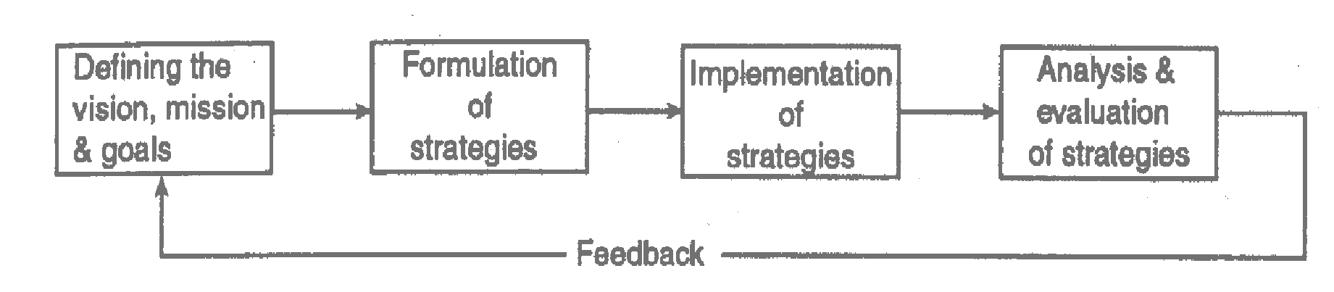

The elements of strategic management are co-dependent, i.e., in formulating a strategy an organization must also consider how the strategy will be implemented. Analysis, formulation and implementation all need to be considered if the organisation’s strategy is to meet the needs of its environment. The diagram below shows strategic management model in detail.

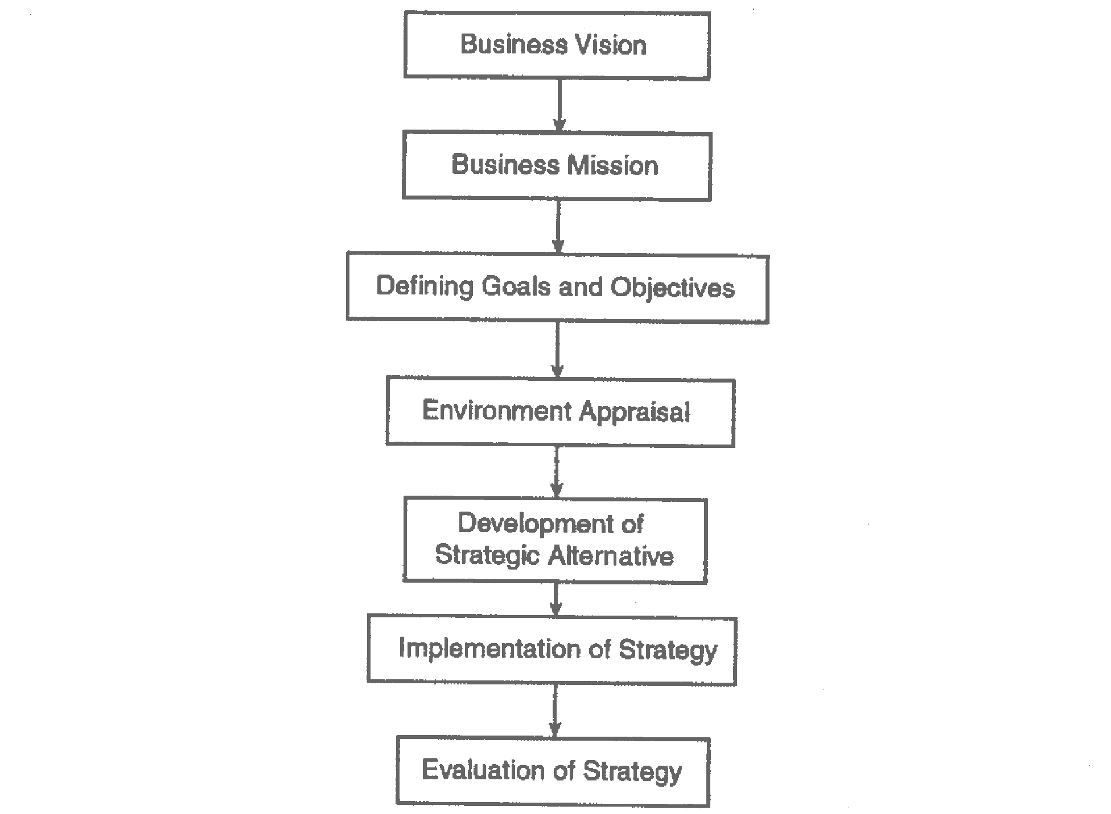

**1.5 What are the Benefits of Strategic Management?**

Studies have revealed that organizations following strategic management have outperformed those that do not. Strategic planning ensures a rational allocation of resources and improves co-ordination between divisions of the organization. It helps managers to think ahead and anticipate problems before they occur. The main benefit of the planning process is a continuous dialogue about the organization’s future between the hierarchical levels in the organization. In short, the most highly rated benefits of strategic management are:

* Clarity of strategic vision for the organization
* Focus on what is strategically important to the organization
* Better understanding of the rapidly changing business environment.

Summary

In this unit, we have learnt that a firm’s strategy is its theory to gain competitive advantages. A firm chooses its strategies through the strategic management process. This process is a set of analyses and decisions that increase the likelihood that a firm will be able to choose a good strategy.

**ACTIVITY**

1. Analyse, in detail, the any two definitions of strategy.
2. Describe the strategic management process.
3. Why is it important to consider the external and internal analyses in the strategic management process?
4. Discuss the importance of understanding a firm’s strategy even if you are not a senior manager in a firm.

# 

# UNIT 2: THE ENVIRONMENT

## 2.0 Introduction

The processes of strategic management take place in a complex environment of business, economic, technological, social and political influences. Hence, understanding this external environment is crucial to strategic decision makers. In addition, the foundation for successful strategy is the clear understanding of where the firm is now, its current position in its environment (most particularly the competitive environment) encapsulating its strengths and weaknesses, fully recognising the opportunities and threats that face it. This unit will look at how managers can analyse the uncertain and increasingly complex world around them by considering various layers of influence from macro-environmental issues to specific forces affecting the competitive position.

 **Outcomes**

By the end of this unit you should be able to:

* Analyse the Macro-Environment
* Define what constitutes the general environment
* Apply the PESTEL model to analyse the external environment
* Evaluate Porters five forces framework as a tool of competitor analysis
* Undertake and discuss a SWOT and Value Chain analysis
* Explain the role of resources, competencies and capabilities in helping an organisation achieve a sustainable competitive advantage.
* Evaluate shareholder and stakeholder perspectives for an organisation. ✓ Evaluate the balanced scorecard approach to an organisation’s performance.
* Define an Industry and Industry structure.
* Scanning and Industry Analysis
* Carry out Industry Life Cycle Analysis
* Competitor analysis and Blue Oceans

## 2.1 STRATEGIC ANALYSIS

Managers responsible for the success of the organization are concerned about the effect the factors in the external environment have upon it. They cannot control the external environment but they need to identify, evaluate and react to these forces outside the organization which may affect them.

## 2.1.1 The General Environment (Macro-environment)

General environment, also known as societal, remote, macro or indirect-action environment consists of those factors, which affect the business of a country, and, therefore, they have homogenizing effect. This environment consists of both a general and competitive environment. The competitive environment consists of the markets and the industry in which an organization competes. The changes that occur here have an effect that transcends firms and specific industries.

Barney etal (2012) states that the general environment consists of broad trends in the context within which a firm operates that can have an impact on a firm’s strategic choices.

Figure 2.1 below shows the relationship between the general environment, the competitive environment, and the organization. Henry (2008) suggests that, other things being equal the competitive environment has the most direct and immediate impact on the organization.

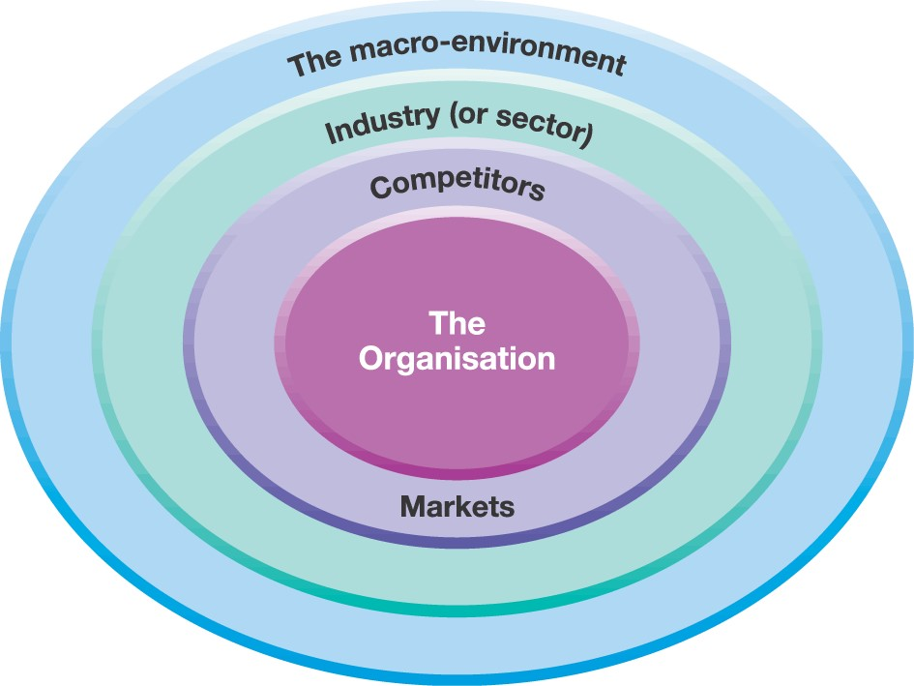

## Source: Hubbard (2008)

In the general environment, we can include natural and ecological factors at the first level. Natural factors are important to the economic activities of a country because either they

provide opportunities or threats to the economic system. For example, agriculture depends on nature (rainfall, climatic conditions, etc.); manufacturing depends on physical inputs; mining and drilling depend on natural deposits; transportation and communication depend on geographical factors; and so on. In the same way, ecological factors like environmental pollution, wildlife, greenery, and other factors are matters of concern for all organizations.

At the second level, comparatively, more influential factors come in the form of economic, political-legal, technological, and social-cultural factors. Taken together, they set forth the framework for organizations’ operations and determine the inputs which organizations can take from the environment, process these inputs in the form of outputs, and export these outputs back to the environment. Various characteristics of such factors may be favourable or unfavourable to the growth of organizations. Besides these factors, which exist within a country, international factors also become important because of globalization of economy of a country.

## 2.1.2 Scenario Planning

According to Schoemaker (1995), scenario planning is a disciplined method for imaging possible futures. It is an internally consistent view of what the future might turn out be (Porter 1985). Scenarios are a tool of analysis to help improve the decision-making process set against the background of a number of possible future environments.

Scenario planning is relevant to almost any situation in which a decision maker needs to understand how the future of his or her industry or strategic business unit might develop.

To do this our knowledge is divided into two areas:

* Things we think we know something about, and
* Things we consider uncertain or unknowable.

The first one is based on the past and continuity like making assumptions about the direction of the country’s demographic profile. The uncertainty elements include such things like future demand for the product, interest rates, foreign exchange rates, tax rate, outcomes of political elections etc.

Process for developing scenarios

* Define the scope. This involves setting the time frame and the scope (products, markets and geographical change) of analysis. The time frame can be determined by factors such as product life cycles and rate of technology.
* Identify the major stakeholders. These are people who can affect and are affected by the organisation’s decisions. The company needs to know their current levels of interests and power and how these have changed overtime.
* Identify basic trends which environmental factor(s) will have the most impact on issues in step 1. This will look at the impact on the current strategy.
* Identify key uncertainties. Which events that have an uncertain outcome will most affect the issues the organization is concerned with?
* Construct initial scenario themes. Once trends and uncertainties are developed; the organization has the basic building blocks for scenario planning. It can then identify extreme world views by putting all positive elements in one scenario and the negative elements in another broad scenario.
* Check for consistency and plausibility. Check to see if the trends identified are compatible with the chosen time frame. If they are not, then remove all the trends that do not fit the time frame.
* Develop learning scenarios the role is to develop relevant themes for the organization around which possible outcomes and trends can be organized. The scenarios can be given a name or title to reflect that they tell a story.
* Identify research needs. At this stage, further research (i.e. changes in technology) may be required to understand uncertainties and trends more fully.
* Develop quantitative models. Once further research has been gained, the organization may wish to revisit the internal consistency of the scenario and decide whether it might benefit from formalizing some interactions in a quantitative model.
* Evolve towards decision scenarios. The ultimate aim is to this process is to move towards scenarios that can be used to test its strategy formulation and help it generate new ideas.

**The diagram below shows the summary of scenario planning process.**

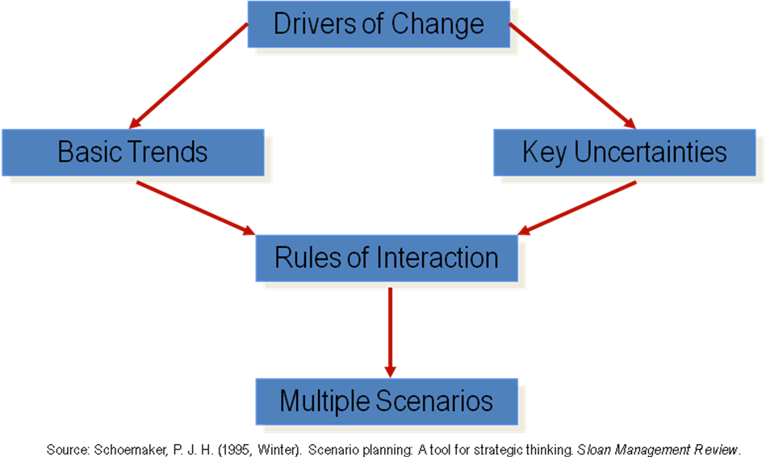

According to Henry (2008), if the scenarios are useful to the organization, they have the following characteristics:

* They address the concerns of individuals in the organization;
* The scenarios are internally consistent;
* They describe fundamentally different futures as opposed to being variations on a particular theme;
* Each scenario describes an equilibrium state that can exist for a considerable period of time as opposed to being merely short-lived.

Finally, Shoemaker (1995) described scenario planning as an attempt to capture the richness and range of possibilities, stimulating decision makers to consider changes they would otherwise ignore or organize into narratives that are easy to grasp and use than great volumes. Scenarios are aimed at challenging the prevailing mind-set.

## 2.1.3 Analysing the External Business Environment

The external analysis is comprised of the Macro-environment, Industry (or sector) with competitors.

The Macro environment

Macro environment refers to the uncontrollable aspects that comprise the exterior environment of marketing which include technological, natural, demographic, economic, socio cultural and regulatory forces. It consists of forces that come from outside of an organization, and usually cannot be revised by the actions of the organization.

The macro environment in which a company or sector operates will influence its performance, and the amount of the influence will depend on how much of the company's business is dependent on the health of the overall economy. Cyclical industries, for example, are heavily influenced by the macro environment, while consumer staples are less so.

Hence, when analysing the macro environment, PESTEL framework is used to understand the environmental factors (key drivers) which might aid or imping on the business strategy.

Key drivers for change are the environmental factors likely to have a high impact on the success or failure of strategy. For example, the birth rate is a key driver for those planning nursery education provision in the public sector. Typically, key drivers vary by industry or sector.

## Figure 2.1 PESTEL Framework

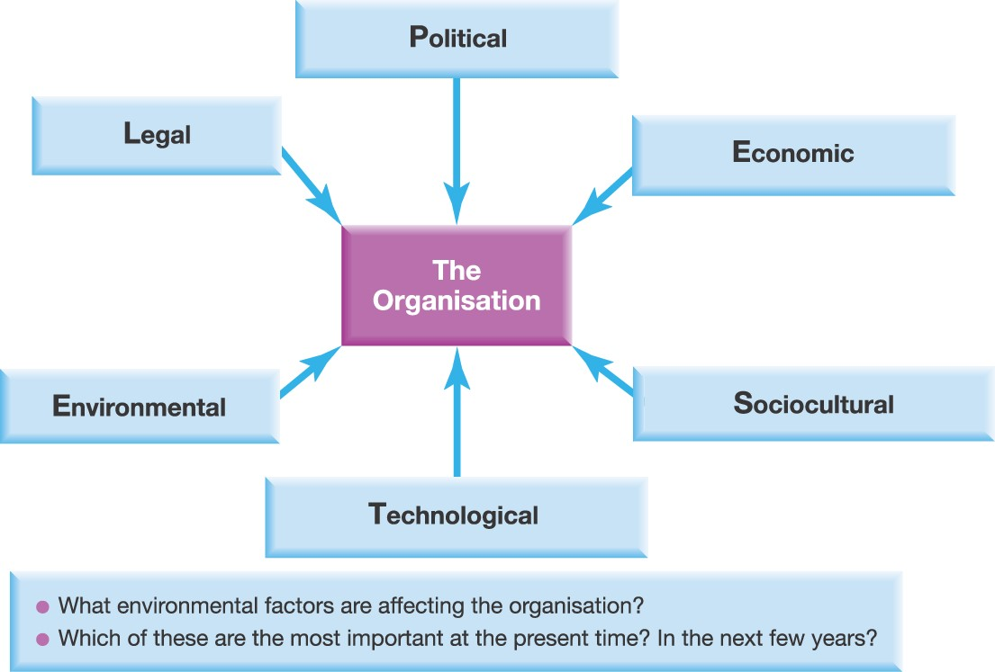

## 

## 2.2 The PESTLE Factors

**Political** - We start with the **Political forces**. First of all, political factors refer to the stability of the political environment and the attitudes of political parties or movements.

This may manifest in government influence on tax policies, or government involvement in trading agreements.

**Legal** - Political factors are inevitably entwined with **Legal factors** such as national employment laws, international trade regulations and restrictions, monopolies and mergers’ rules, and consumer protection. The difference between Political and Legal factors is that Political refers to attitudes and approaches, whereas Legal factors are those which have become law and regulations. Legal needs to be complied with whereas Political may represent influences, restrictions or opportunities, but they are not mandatory.

**Economic – these factors** represent the wider economy so may include economic growth rates, levels of employment and unemployment, costs of raw materials such as energy, petrol and steel, interest rates and monetary policies, exchange rates and inflation rates.

These may also vary from one country to another.

**Socio-cultural factors** represent the culture of the society that an organization operates within. They may include demographics, age distribution, population growth rates, level of education, distribution of wealth and social classes, living conditions and lifestyle.

**Technological factors** refer to the rate of new inventions and development, changes in information and mobile technology, changes in internet and e-commerce or even mobile commerce, and government spending on research. There is often a tendency to focus Technological developments on digital and internet-related areas, but it should also include materials development and new methods of manufacture, distribution and logistics.

**Ecological***-* stands specifically for ‘green’ environmental issues, such as pollution, waste and climate change. **Environmental impacts** can include issues such as limited natural resources, waste disposal and recycling procedures.Environmental regulations can impose additional costs, for example with pollution controls, but they can also be a source of opportunity, for example the new businesses that emerged around mobile phone recycling.

## 2.3 The Industry or Sector (Scanning Competition)

The impact of the general factors discussed above tend to surface in the more immediate environment through changes in the competitive forces surrounding organisations. An important aspect of this for most organisations will be competition within their industry, sector or market. An **industry** is a group of firms producing products and services that are essentially the same.In other words, organizations which are in the same line of business, or example the petroleum industry sector or the textile industry sector. Other examples are the automobile industry and the airline industry. Industries are also often described as

‘sectors’, especially in public services (e.g. the health sector or the education sector). Industries and sectors are often made up of several specific markets. However, a **sector** may refer to a group of closely related industries. For example, the computer sector comprises several related industries such as computer component industry, computer hardware industry, and computer software industry.

A **market** is a group of customers for specific products or services that are essentially the same (e.g. a particular geographical market). Thus, the automobile industry has markets in Africa, Europe and Asia, for example.

Having stated the above, the starting point of external analysis is to identify the industry that a company competes in. To do this, begin by looking at the basic customer needs the company is serving. This entails applying a customer-oriented view of the business as opposed to a product-oriented view. Here, an industry is the supply side of a market and companies in the industry are the suppliers. Customers, on the other hand, are the demand side of a market and are the buyers of the industry’s products. We need to note that the basic customer needs that are served by a market define an industry’s boundary.

### 

### 2.3 THE PORTER’S FIVE FORCES MODEL

Named after Michael E. Porter, this model identifies and analyses five competitive forces that shape every industry, and helps determine an industry's weaknesses and strengths. Porter’s five forces model helps in accessing where the power lies in a business situation. Porter’s Model is actually a business strategy toolthat helps in analysing the attractiveness in an industry structure. It lets you access current strength of your competitive position and the strength of the position that you are planning to attain.

Porter’s Model is considered an important part of planning tool set. When you are clear about where the power lies, you can take advantage of your strengths and can improve the weaknesses and can compete efficiently and effectively. Porter’s model of competitive forcesassumes that there are five competitive forcesthat identifies the competitive power in a business situation. These five competitive forces identified by the Michael Porter are:

1. Threat of substitute products
2. Threat of new entrants
3. Intense rivalry among existing players
4. Bargaining power of suppliers
5. Bargaining power of Buyers

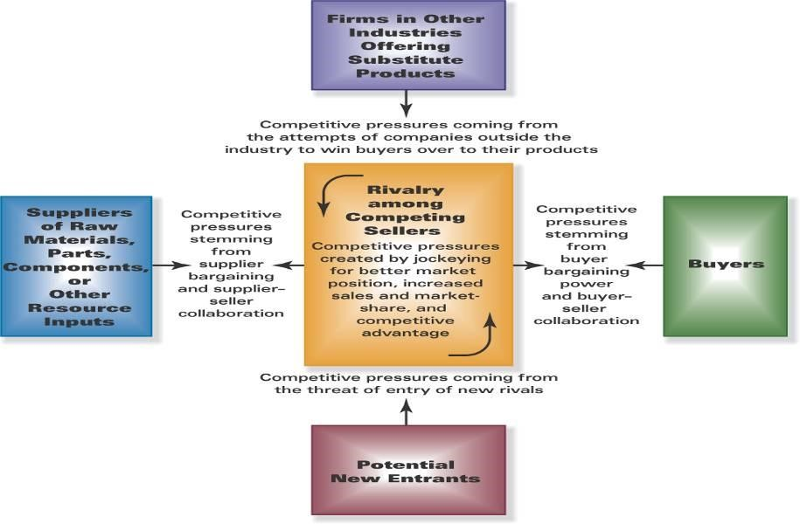

## Threat of substitute products

**Threat of substitute products** means how easily your customers can switch to your competitor’s product. **Threat of substitute is high** when: There are many substitute products available customer can easily find the product or service that you’re offering at the same or less price, quality of the competitors’ product is better. Therefore, to beat substitute product is by a company earning high profits so that it can reduce prices to the lowest level.

In the above mentioned situations, Customer can easily switch to substitute products. So substitutes are a threat to your company. When there are actual and potential substitute products available then segment is unattractive. Profits and prices are effected by substitutes so, there is need to closely monitor price trends. In substitute industries, if competition rises or technology

modernizes then prices and profits decline.

1. **Threat of new entrants**

A new entry of a competitor into your market also weakens your power. Threat of new entry depends upon entry and exit barriers. Threat of new entry is high when:

* Capital requirements to start the business are less
* Few economies of scale are in place
* Customers can easily switch (low switching cost)
* Your key technology is not hard to acquire or isn’t protected well

Your product is not differentiated. There is variation in attractiveness of segment depending upon entry and exit barriers. That segment is more attractive which has high entry barriers and low exit barriers. Some new firms enter into industry and low performing companies leave the market easily. When both entry and exit barriers are high then profit margin is also high but companies face more risk because poor performance companies stay in and fight it out. When these barriers are low then firms easily enter and exit the industry, profit is low. The worst condition is when entry barriers are low and exit barriers are high then in good times firms enter and it becomes very difficult to exit in bad times.

## Industry Rivalry

Industry rivalry means that the intensity of competition among the existing competitors in the market. Intensity of rivalry depends on the number of competitors and their capabilities. Industry rivalry is high when:

There are number of small or equal competitors and less when there’s a clear market leader.

* Customers have low switching costs
* Industry is growing
* Exit barriers are high and rivals stay and compete
* Fixed cost are high resulting huge production and reduction in prices

These situations make the reasons for advertising wars, price wars, modifications, ultimately costs increase and it is difficult to compete.

## Bargaining power of suppliers

**Bargaining Power of supplier** means how strong is the position of a seller. Assessment has to be done in terms of how much control your supplier has in increasing the Price of supplies. Suppliers are more powerful when suppliers are concentrated and well organized a few substitutes available to supplies. Their product is most effective or unique. When switching costs, from one supplier to another, is high then you are an important customer to the Supplier.

When suppliers have more control over supplies and its prices that segment is less attractive. It is best way to make win-win relation with suppliers. It’s good idea to have multi-sources of supply.

## v. Bargaining power of Buyers

Bargaining Power of Buyers means, how much control the buyers have to drive down your products price, can they work together in ordering large volumes. Buyers have more bargaining power when:

* Few buyers chasing too many goods
* Buyer purchases in bulk quantities
* Product is not differentiated
* Buyer’s cost of switching to a competitors’ product is low
* Shopping cost is low
* Buyers are price sensitive
* Credible threat of integration

Buyer’s bargaining power may be lowered down by offering differentiated product. If you’re serving a few but huge quantity ordering buyers, then they have the power to dictate you.

### 2.4 THE INDUSTRY LIFE-CYCLE

The industry life-cycle shown in figure 2.2 below suggests that industries go through four stages of development as shown below. Within an industry, different strategic groups may be experiencing different stages of the life-cycle. The life-cycle is frequently applied to product markets where a product life-cycle can be discerned which follow the same stages as the industry life cycle. The product life- cycle shown below (figure 2.2) allows organizations to vary its marketing mix to produce an appropriate response according to each stage in a product’s development.

Introduction

Growth

Maturity

Decline

**Growth**

**rate**

### Figure 2.2 Industry life cycle

The industry life cycle helps an organization to see how it is positioned in terms of the development of its market. The different stages of the industry life cycle will have an impact upon competitive conditions facing the organization. For example, one expects the level of competitive rivalry during the introduction stage, when the market is being opened up, to be different from that in the maturity stage, when the market is saturated and the market share comes at the expense of your competitors. There an organization can benefit from this by understanding the industry life-cycle and formulate the strategy to match the needs of its stage.

### Introduction stage

This is characterized: by slow growth in sales and high cost as a result of limited production. Profit will be negative as sales are insufficient to cover the capital outlay on research and development.

A lot of investment is made by an organization in R&D to make a new product. The advantage of being a first mover is that an organization may set the industry standards even in the face of a superior technology. However, the tendency is for the product life-cycle to be compressed, as each stage is cut by rapid change, which means that any first-mover advantage is quickly eroded. This means that the time scale to recoup capital expenditure for the first mover is shortened.

### Growth Stage

The stage is characterized by the following:

* Sales increase rapidly as the market grows, allowing companies to reap the benefits of economies of scale.
* Increase in sales brings greater profits which attracts new entrants.
* Focus on creating a brand and increase in spending on marketing activities.

The goal of the firm is not merely to attract new customers but to ensure that customers repeat their purchase.

### Maturity Stage

* Slowing in sales growth and profits as they become saturated.
* Organizations began leaving the industry.
* Low cost completion based on efficient production
* With exist barriers rivalry become more intense within the industry as marginal firms find it difficult to exist the industry.
* Product may be rejuvenated by finding new customers e.g. Johnson and Johnson baby oil and Drags deemed unacceptable on health grounds.

### Decline Stage

* Firms experiences a fall in sales and profitability
* Consumer loyalty shifts to new products based on technology
* Competition based on price as customers shun old products
* Firms continue existing the industry and consolidation may occur to achieve acceptable profits The knowledge of the industry life-cycle is useful to help an organization understand how each stage can affect its competitive environment. In line with its rivals, it must ensure that its strategy formulation is sufficiently robust to meet the needs of each sage of the cycle.

### Figure 2.3 Strategy and Issues in the Product’s Life

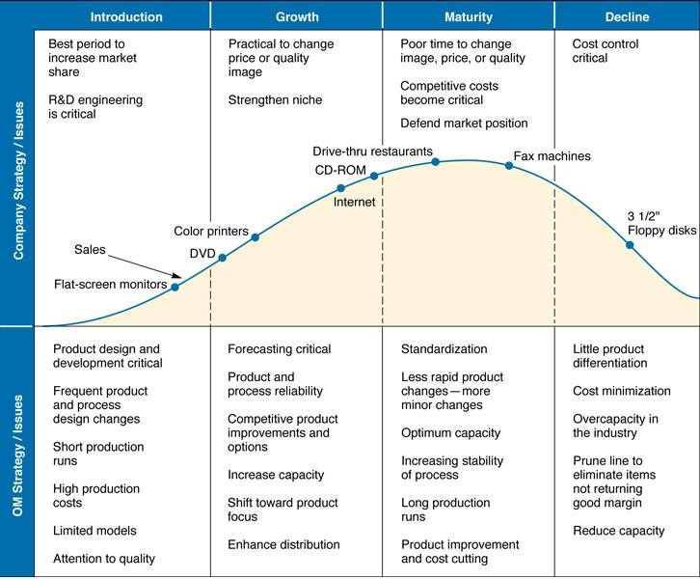

### 2.5 COMPETITOR ANALYSIS AND ‘BLUE OCEANS’

Any environmental analysis should also include an understanding of competitors. As Michael Porter’s five forces framework underlines, reducing industry rivalry involves competitors finding differentiated positions in the marketplace. W. Chan Kim and Renée Mauborgne proposed two concepts that help think about the relative positioning of competitors in the environment: the strategy canvas and ‘Blue Oceans’.

A **strategy canvas** compares competitors according to their performance on key success factors in order to establish the extent of differentiation.

**Blue Oceans** are new market spaces where competition is minimised. Blue Oceans contrast with ‘Red Oceans’, where industries are already well defined and rivalry is intense. Blue Oceans evoke wide empty seas. Red Oceans are associated with bloody competition and ‘red ink’, in other words financial losses. The Blue Ocean concept is thus useful for identifying potential spaces in the environment with little competition.

These Blue Oceans are *strategic gaps* in the marketplace.

### Summary

In this unit, we have learnt that analysis begins with an understanding of the firm’s general environment. The general environment has six major components: technological change, demographic trends, cultural trends, economic climate, legal and political conditions. Environmental influences can be thought of as layers around an organisation, with the outer layer making up the *macro-environment*, the middle layer making up the *industry or sector* and the inner layer *strategic groups* and *market segments.*

We have also an industry as a group of companies offering products or services that are close substitutes for each other. That is, services or products that satisfy the same basic customer needs. We have discussed that Porter’s Five Force Model is the main technique used to analyse competition in the industry environment. Finally, the industry life cycle model is a tool for analysing the effects of industry evolution on competitive forces. It identifies five sequential stages in the evolution of an industry.

## UNIT 3: STRATEGIC CAPABILIITES

### Introduction

In this unit we discuss strategic capabilities. It covers two key concepts underlying the strategic importance of the company’s strategic capabilities. The first is that organisations are not identical, but have different capabilities; they are ‘heterogeneous’ in this respect. The second is that it can be difficult for one organisation to obtain or copy the capabilities of another.

### Outcomes

After studying this unit, you should be able to;

* Explain the Resource based view of strategy
* Analysing the Internal Resources and Competencies
* Apply the VRIO framework, Benchmarking, The Value Chain analysis and SWOT
* Explain Competitive advantage
* Roots of Competitive Advantage
* The Building Blocks of Competitive Advantage

### 3.1 THE RESOURCE BASED VIEW OF STRATEGY

Sometimes labelled the ‘capabilities view’ was pioneered by Jay Barney (2012). It states **that the competitive advantage and superior performance of an organisation are explained by the** **distinctiveness of its capabilities**. Resource – or capabilities – views have become very influential. The RBV is a model of firm performance that focuses on the resources and capabilities controlled by a firm as sources of competitive advantage. **It deals with the competitive environment facing the organization but takes an inside-out approach. It starts with an organization’s internal environment.**

Resource based view of strategy emphasizes the internal capabilities of the organization in formulating strategy to achieve a sustainable competitive advantage in its market and industries. The internal capabilities determine the strategic choices the organization makes in competing in its internal environment and in some cases can allow an organization to create new markets and add value for the customer such as Apple’s I-Pod and Toyota hybrid cars.

Where an organization’s capabilities are seen as paramount in the creation of competitive advantage it will pay attention to the configuration of its value chain activities. This is so because it will need to identify the capabilities within its value chain activities (e.g. inbound, outbound operations etc) which provide it with competitive advantage. Resource based view of strategy draws upon the resources and capabilities that reside within an organization, or that an organization might want to develop in order to achieve a sustainable competitive advantage.

### Capabilities

These are a subset of a firm’s resources which are tangible and intangible assets that enable a firm to take full advantage of the other resources it controls. Jones & Hill (2010) state that

“capabilities refer to a company’s skills at coordinating its resources and putting them to productive use”. A company’s capabilities are generally the product of its organizational structure, processes, control systems and hiring systems.

### Distinctive Capabilities

Distinctive capabilities of an organization’s resources are important in providing it with competitive advantage. Organizations capabilities are only distinctive when they emanate from a characteristic which other firms do not have. Distinctive capabilities need to persist over time (sustainable) and must benefit primarily the organization which holds it rather than its employees, its customers, or its competitors (appropriable). These in turn are linked to relationships between an organization and its stakeholders.

These distinctive capabilities must derive from the three areas:

* Architecture Systems of relational contracts which exist inside and outside the organization.
* Reputation As a source of experience is important in those markets where consumers can only ascertain the quality of a product from their log-term experience.
* And innovation. An organization’s ability to innovate successfully is also a source of distinctive capability which is sustainable and appropriate. For example, innovative products like Apple with I-Tunes and I-Pod.

### Dynamic Capabilities

If they are to provide a basis for long-term success, strategic capabilities cannot be static; they need to change. University of Berkeley economist David Teece has introduced the concept of dynamic capabilities, by which he means **an organisation’s ability to renew and recreate its** strategic capabilities **to meet the needs of changing environments.**

### Strategic capabilities defined

These are the capabilities of an organisation that contribute to its long-term survival or competitive advantage. However, to understand and to manage strategic capability it is necessary to explain its components and the characteristics of those components.

**Components of Strategic capability**

There are two components of strategic capability: resources and competences.

### Resources

Resources can be thought of as inputs that enable an organization to carry out its activities.

They include tangible and intangible resources.

* Tangible resources refer to the physical assets that an organization possesses and include plant and machinery, finance and human capital. To add value these physical resources must be capable of responding flexibly to changes in the market place. For example, an organization of up to date technology and processes which possess the knowledge to exploit their potential will be at an advantage.
* Intangible resources may be embedded in routines and practices that have developed overtime within the organization; they comprise intellectual/ technical resources, organization’s reputation, its culture, its knowledge and its brand. Technological resources include an organisation’s ability to innovate and the speed with which innovation occurs, while intellectual resources include patents and copy rights which themselves may drive from the organisation’s technological resources. For example, an intangible resource of a manufacturer maybe its creative innovation of its founder.

### Competences

Availability of resources in an organization does not offer any benefits but the efficient configuration of resources provides an organization with the competencies. These are attributes that a firm requires in order to be able to compete in the market place. It may be useful to think of competencies as deriving from the bundle of resources that a firm has. For example, in order to compete in the automobile industry organizations must possess knowledge about design and engine and body manufacture. Without this knowledge the organization cannot compete effectively irrespectively of its resources.

### Core Competences

Resources and capabilities serve as the foundation upon which companies formulate and implement value creating strategies so that the company can achieve strategic competitiveness and earn above average returns. However, not all of a company’s resources and capabilities represent strategic assets, assets that have competitive value and the potential to serve as a source of competitive advantage. If the company has a deficiency in some of its resources, it may not be able to achieve strategic competitiveness.

For example, insufficient financial resources may prevent the company from implementing the processes or integrating the activities required to add superior value by limiting the company’s ability to hire workers with the necessary skills or to invest in the capital assets (facilities and equipment) that are needed. Thus, companies not only are challenged to scan the external environment to identify opportunities that can be exploited, but also to have an in depth understanding of company resources and capabilities. This will enable the company not only to develop strategies that enable it to exploit external opportunities but also to avoid competing in areas where the company’s resources and capabilities are inadequate.

When the company’s resources and capabilities result in a core competence, the company will be able to produce goods or services with features and characteristics that are valued by customers. This implies that companies can implement value creating strategies only when its capabilities and resources can be combined to form core competencies.

Therefore, core competence can be thought of as a cluster of attributes that an organization possesses which in turn allows it to achieve competitive advantage. It may simply be that an organization has configured its collection of resources in such a way that allows it to compete more successfully. A core competence is enhanced as it is applied and shared across the organization.

### Figure 3.1 Resource, Capabilities and Value Creation

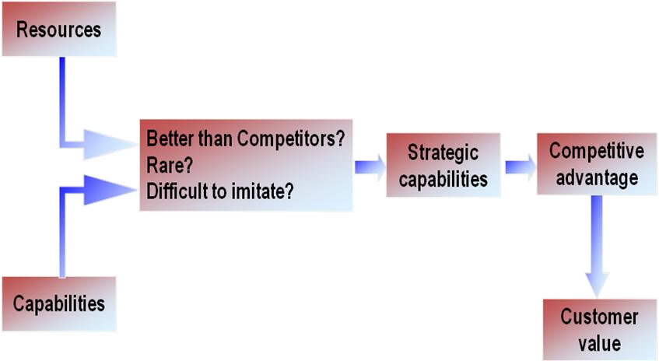

**Source: Hubbard (2006)**

### COMPETITIVE ADVANTAGE

This is the ability to create more economic value than competitors. All other elements of the strategic management process are aimed at achieving competitive advantage. However, there must be something different about a firm’s offering vis-à-vis competitors’ offeringsif all firms’ strategies were the same, no firm would have a competitive advantagecompetitive advantage is the result of doing something different and/or better than competitors. It leads to superior profitability.

### The Building Blocks of Competitive advantage

Four factors help a company to build and sustain competitive advantage. These are:

* Superior Efficiency – the simplest measure of efficiency is the quantity of inputs that it takes to produce a given output.
* Superior Quality – a product has superior quality when customers perceive that its attributes provide them with higher utility than the attributes of products sold by rivals,
* Superior Innovation – when innovation of products and processes lead to something unique for a company, competitive advantage is achieved.
* Superior Customer Responsiveness – here a company must do a better job than its competitors of identifying and satisfying its customers’ needs.

### THE VRIO FRAMEWORK

This is a primary tool for carrying out internal analysis about the potential of the resources and capabilities to generate competitive advantages. The tool provides four key criteria by which capabilities can be assessed in terms of their providing a basis for achieving such competitive advantages: **v** alue, **r** arity, **i** nimitability and **o** rganisational support – or VRIO.

* **V – value** of strategic capabilities Strategic capabilities are valuable when they create a product or a service that is of value to customers and if, and only if, they generate higher revenues or lower costs or both**.**
* **R**-**Rarity** rare capabilities are those possessed uniquely by one organisation or only by a few others. E.g. a company may have patented products, have supremely talented people or a powerful brand. Rarity could be temporary. E.g. Patents expire, key individuals can leave or brands can be de-valued by adverse publicity.
* **I**- **Inimitability** capabilities are those that competitors find difficult and costly to imitate, to obtain or to substitute. Competitive advantage can be built on unique resources (a key individual or IT system) but these may not always be sustainable (key people leave or others acquire the same systems). Sustainable advantage is more often found in competences (the way resources are managed, developed and deployed) and the way competences are linked together and integrated.
* **O – Organisational support** The organisation must be suitably organised to support the valuable, rare and inimitable capabilities that it has. This includes appropriate processes and systems.

### BENCHMARKING

Benchmarking is another tool, which can be used to generate competitive advantage. It is a process of identifying in systematic way superior products, services, and processes & practices that can be adopted in an organization to reduce costs; decrease operations cycle time, and provide greater customer satisfaction. This is done by comparing with those companies recognized as industry leaders.

Henry (2008) defined benchmarking as a process of measuring products, services and business practices against those companies recognized as industry leaders.

### Features of Benchmarking

* Benchmarking is based on the theme “see what others do and try to improve upon that.” Therefore, this implies some kind of measurement, which can be accomplished in two forms: internal and external. Both internal and external practices are compared and a statement of significant differences is prepared to identify the gap which should be filled.
* Benchmarking can be applied to all facets of a business; it includes products, services, processes, and methods. It goes beyond the traditional competitor analysis in the form of identifying strengths and weaknesses and includes clear understanding of how the best practices are used.
* Benchmarking is not aimed solely at direct product competitors but those organizations and businesses that are recognized as best or industry leaders.
* Benchmarking is a continuous process and not just one shot action. It is continuous because industry practices constantly change and a continuous monitoring of these practices is required to bring suitable change in the organization compared with either close competitor or industry leader

### VALUE CHAIN ANALYSIS

The second framework that companies can use to identify and evaluate the ways in which their resources and capabilities can add value is **value chain analysis**. Capabilities are processes, systems or organisational routines which the organisation uses to coordinate its resources for productive use.

A value chain describes the activities within an organisation that go to make a product or service. Therefore, the value chain analysis allows an organisation to ascertain the costs and value that emanate from each of its value activities. The value that's created and captured by a company is the profit margin:

### **Value Created and Captured – Cost of Creating that Value = Margin**

Understanding how your company creates value, and looking for ways to add more value, are critical elements in developing a competitive strategy. Michael Porter discussed this in his influential 1985 book ["**Competitive Advantage**,](http://www.amazon.com/Competitive-Advantage-Creating-Sustaining-Performance/dp/0684841460/ref=pd_bbs_sr_1?ie=UTF8&s=books&qid=1226480657&sr=8-1)" in which he first introduced the concept of the value chain. Value or margin is the difference between the total value received by the firm from the customer for its product or service and the total cost of creating the product or service.

The value chain system refers to the relationship between the value chain activities of the organisation and its suppliers, distributors and customers. Figure 2.2 below show the value chain.

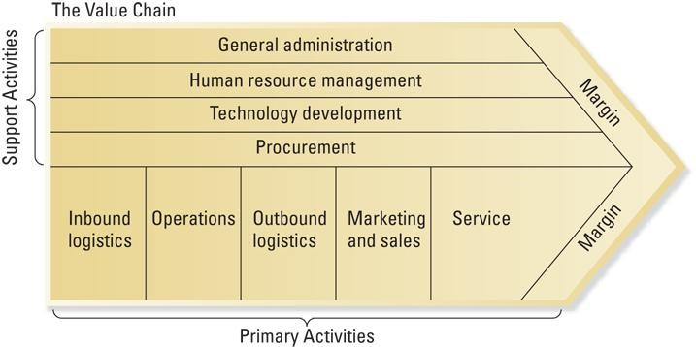

#### Source: Henry (2008)

The figure above illustrates how the value creating activities performed by the company can be separated into primary and secondary activities. Primary activities, shown vertically, represent traditional line activities such as inbound logistics, operations, outbound logistics, marketing and sales, and service. These are activities which are directly involved in the creation of a product or a service (Henry, 2008). While the support activities, shown horizontally, are represented by a company’s staff activities and include its financial infrastructure, human resource management practices, technological development, and procurement activities. They are activities which ensure that the primary activities are carried out efficiently and effectively.

The first step in value chain analysis is to carefully examine each of the company’s primary activities to determine the potential for creating or adding value.

**Primary Activities -** Primary activities relate directly to the physical creation, sale, maintenance and support of a product or service. They consist of the following:

* **Inbound logistics** – These are all the processes related to receiving, storing, and distributing inputs internally. Your supplier relationships are a key factor in creating value here.
* **Operations** – These are the transformation activities that change inputs into outputs that are sold to customers. Here, your operational systems create value.
* **Outbound logistics** – These activities deliver your product or service to your customer. These are things like collection, storage, and distribution systems, and they may be internal or external to your organization.
* **Marketing and sales** – These are the processes you use to persuade clients to purchase from you instead of your competitors. The benefits you offer, and how well you communicate them, are sources of value here.
* **Service** – These are the activities related to maintaining the value of your product or service to your customers, once it's been purchased.

#### Support Activities

These activities support the primary functions above. In our diagram, the dotted lines show that each support, or secondary, activity can play a role in each primary activity. For example, procurement supports operations with certain activities, but it also supports marketing and sales with other activities.

* **Procurement (purchasing)** – This is what the organization does to get the resources it needs to operate. This includes finding vendors and negotiating best prices.
* **Human resource management** – This is how well a company recruits, hires, trains, motivates, rewards, and retains its workers. People are a significant source of value, so businesses can create a clear advantage with good HR practices.
* **Technological development** – These activities relate to managing and processing information, as well as protecting a company's knowledge base. Minimizing information technology costs, staying current with technological advances, and maintaining technical excellence are sources of value creation.
* **Infrastructure** – These are a company's support systems, and the functions that allow it to maintain daily operations. Accounting, legal, administrative, and general management are examples of necessary infrastructure that businesses can use to their advantage.

Companies use these primary and support activities as "building blocks" to create a valuable product or service. Using the value chain framework enables managers to study the company’s resources and capabilities in relationship to the primary and support activities performed to design, manufacture, and distribute products, and to assess them relative to competitors’ capabilities. For these activities to be sources of competitive advantage, a company must be able to perform primary or support activities in a manner that is superior to the ways that competitors perform them.

Also perform a primary or support activity that no competitor is able to perform to create superior value for customers and achieve a competitive advantage. This implies that, given that individual companies are comprised of unique or heterogeneous bundles of activities, reconfiguring the value chain, or rebundling resources and capabilities, may enable a company to develop unique value creating activities. The managerial challenge is that the value creation process is difficult and there is no one best way to assess acompany’s primary and support activities or to evaluate the value creating potential of those activities either within the company or relative to competitors, because of incomplete or ambiguous data.

However, by being objective, managers may be able to use the value chain framework to identify new, unique ways to combine resources and capabilities to create value that are difficult for competitors to recognize, understand, or imitate. The longer a company is able to keep competitors “in the dark,” as to how resources and capabilities have been combined to create value, the longer a company will be able to sustain a competitive advantage. Companies can use outsourcing as an alternative to identify primary or support activities for which its resources and capabilities are not core competencies and do not enable the company to add superior value and achieve competitive advantage.

#### SWOT Analysis

SWOT analysis means analysing strengths, weaknesses, opportunities and it is a useful strategic planning tool and is based on the assumption that if managers carefully review internal strengths and weaknesses and external threat and opportunities, a useful strategy for ensuring organizational success can be formulated (Andrew 1971). It is a simple technique for getting a quick overview of a strategic situation so that such strategies can be formulated as to produce a good between the company’s internal competencies (strength and weaknesses) and environment (opportunities and threats).

It allows an organization to determine the extent of the strategic fit between its capabilities and the needs of its external environment.

#### Strengths

Strengths are areas where the organization excels in comparison with its competitor or strength” is a positive characteristic that gives a company an important capability. It is an important organisational resource which enhances a company, competitive position. Some of the internal strengths of an organisation are:

* Distinctive competence in key areas
* Manufacturing efficiency
* Skilled workforce, adequate financial resources Superior image and reputation
* Economies of scale
* Superior technological skills
* Insulation from strong competitive pressures
* Product or service differentiation
* Proprietary technology.

#### Weaknesses

A “weakness” is a condition or a characteristic, which puts the company at disadvantage. Weaknesses make the organization vulnerable to competitive pressures. Henry (2008) described the weaknesses as areas where the organization may be at a comparative disadvantage. The weaknesses are competitive liabilities and strategic managers must evaluate their impact on the organization’s strategic position when formulating strategic policies and plans. Weaknesses require a close scrutiny because some of them can prove to be fatal. Some of the weaknesses to be reviewed are:

* No clear strategic direction
* Outdated facilities
* Lack of innovation is Complacency
* Poor research and developmental programs
* Lack of management vision, depth and skills
* Inability to raise capital
* Weaker distribution network
* Obsolete technology
* Low employee morale
* Poor track record in implementing strategy
* Too narrow a product line
* Poor market image
* Higher overall unit costs relative to competition.

#### Opportunities and Threats

Opportunities and threats refer to the organisation’s external environment, over which the organization has much less control. An “opportunity” is considered as a favourable circumstance, which can be utilized for beneficial purposes. It is offered by outside environment and the management can decide as to how to make the best use of it. Such an opportunity may be the result of a favourable change in any one or more of the elements that constitute the external environment. It may also be created by a proactive approach by the management in moulding the environment to its own benefit. Some of the opportunities are:

* Strong economy
* Possible new markets
* Emerging new technologies
* Complacency among competing organizations
* Vertical or horizontal integration
* Expansion of product line to meet broader range of customer needs
* Falling trade barriers in attractive foreign markets

A “threat” is a characteristic of the external environment, which is hostile to the organisation. Management should anticipate such possible threats and prepare its strategies in such a manner that any such threat is neutralized. Some of the elements that can pose a threat are:

* Entry of lower cost foreign competitor’s cheaper technology adopted by rivals
* Rising sales of substitute products
* Shortages of resources
* Changing buyer needs and preferences
* Recession in economy
* Adverse shifts in trade policies of foreign governments
* Adverse demographic changes

SWOT analysis involves evaluating a company’s internal environment in terms of strengths and weaknesses and the external environment in terms of opportunities and threats and formulating strategies that take advantage of all these factors. Such analysis is an essential component of thinking strategically about a company’s situation.

#### Outsourcing

Outsourcing describes a company’s decision to purchase a value creating activity from an external supplier. Outsourcing has become important, and may become more important in the future, for two reasons:

* First, there are limits to the abilities of companies to possess all of the bundles of resources and capabilities that are required to achieve superior performance (relative to competitors) in its entire primary and support activities.
* Second, with limits to their resources and capabilities, companies can increase their ability to develop resources and capabilities to develop core competencies and achieve competitive advantage by nurturing only a few core competencies.

**Summary**

In this unit, we have learnt that *competitive advantage* of an organisation is likely to be based on the strategic *capabilities* it has that are valuable to customers and that its rivals do not have or have difficulty in obtaining. Strategic capabilities comprise both *resources and competences*. We saw that the RBV is an economic theory that suggests that firm performance is a function of the types of resources and capabilities controlled by firms.

**The competitive advantage** of an organisation is based on the strategic **capabilities** it has that are valuable to customers and that its rivals do not have or have difficulty in obtaining. Strategic capabilities comprise both **resources** and **competences**. The concept of **dynamic capabilities** highlights that strategic capabilities need to change as the market and environmental context of an organisation changes.

We have learnt that resources and capabilities can be diagnosed in many ways including: VRIO model, benching marking, value chain and SWOT analysis. Managers need to think about how and to what extent they can manage the **development of strategic capabilities** of their organisation by internal and external capability development and by the way they manage people in their organisation.

ACTIVITY

1. Discuss strategic capabilities in terms of organisational resources and competences and show how they relate to the strategies of organisations.
2. Describe the critical assumptions of the resource-based view.
3. Apply the VRIO framework to identify the competitive implications of a firm’s resources and capabilities.
4. Using value chain analysis, identify a firm’s valuable resources and capabilities

# UNIT 4: STRATEGIC PURPOSE

## Introduction

The previous units have looked at the importance of the external environment and internal capabilities for an organisation’s strategic position. This unit examines how external pressures and internal aspirations interact in the setting of organisational purpose. The unit warns that organisational purpose can rarely be reduced to a simple formula such as ‘profit maximisation’. Organisational purposes are typically complex and diverse. It is important to be clear about what purposes drive strategy, who influences such purposes and who monitors performance against them.

## Outcomes

After studying this unit, you should be able to;

* Explain Vision, Mission, Values and Objectives of an organization
* Describe Owners and Managers of a company
* State Stakeholder Expectations
* Discuss Social Responsibility and ethics

## Vision

Aspirations, expressed as strategic intent, should lead to an end; otherwise they would just be castles in the air. That end is the vision of an organization or an individual. It is what the firm or a person would ultimately like to become. For instance, some of you, say in 10 years, or may be even earlier, would like to become general managers managing an SBU in a large, diversified multinational corporation. Or some others among you would like to believe that you will be an entrepreneur in 2020, owning your own company dealing with IT services and employing cutting edge technology to serve global clientele. A firm thinks like that too. A vision, therefore, articulates the position that a firm would like to attain in the distant future. Seen from this perspective, the vision encapsulates the basic strategic intent.

A **vision** is often associated with the founder of the organization and represents a desired state that the organization aspires to achieve in the future.

In contrast with the goals and objectives, a vision does not change over time. A vision must tap into the personal goals and values of the organisation’s employees if it is to be internalized by them. When it

bears little resemblance to reality, disregards the capabilities of the organization, and the problems of the organization, it will be rejected by employees.

**What are the benefits of having a vision?**

Parikh and Neubauer (1993) point out the several benefits accruing to an, organization having a vision. Here is what they say:

* Good visions are inspiring and exhilarating
* Visions represent a discontinuity, a step function and a jump ahead so that the company knows what it is to be
* Good visions help in the creation of a common identity and a shared sense of purpose
* Good visions are competitive, original and unique. They make sense in the market place, as they are practical
* Good visions foster risk taking and experimentation ✓ Good visions foster long term thinking.
* Good visions represent integrity; they are truly genuine and can be used for the benefit of people.

## Mission Statement

While the essence of vision is a forward looking view of what an organization wishes to become, mission is what an organization is and why it exists. Drucker (1995) argues that a mission statement is the same as asking the questions: What business are we in? What will it be? And what should it be? These three questions, though simply worded, are in reality the most fundamental questions that any organization can put to itself. The answers are based on the analysis of the underlying needs of the society that any organization serves to fulfil. The satisfaction of that need is, then, the business of the organization.

Organizations relate their existence to satisfying a particular need of the society. They do this in terms of their mission. Mission is a statement, which defines the role that an organization plays in a society. It refers to the particular needs of that society, for instance, its information needs. A book publisher and a magazine editor are both engaged in satisfying the information needs of society but they do it through different means. A book publisher may aim at producing excellent reading material while a magazine editor may strive to present news analysis in a balanced and unbiased manner. Both have different objectives but an identical mission.

## Characteristics of a Mission Statement

Organizations legitimize themselves by performing some function that is valued by society. A mission statement defines the basic reason for the existence of that organization. Such a statement reflects the corporate philosophy, identity, character, and image of an organization. It may be defined explicitly or could be deduced from the management’s actions, decisions, or the chief executive’s press statements. When explicitly defined it provides enlightenment to the insiders and outsiders on what the organization stand for. In order to be effective, a mission statement should possess the following seven characteristics.

It should be feasible. A mission should always aim high but it should not be an impossible statement. It should be realistic and achievable its followers must find it to be credible. But feasibility depends on the resources available to work towards a mission. In the sixties, the US National Aeronautics and Space Administration (NASA) had a mission to land on the moon. It was a feasible mission that was ultimately realized.

* It should be precise. A mission statement should not be so narrow as to restrict the organization’s activities nor should it be too broad to make itself meaningless. For instance, ‘Manufacturing bicycles’ is a narrow mission statement since it severely limits the organization’s activities, while mobility business’ is too broad a term, as it does not define the reasonable contour within which the organization could operate.
* It should be clear. A mission should be clear enough to lead to action. It should not be a high sounding set of platitudes meant for publicity purposes. Many organizations do adopt such statements but probably they do so for emphasizing their identity and character.
* It should be motivating. A mission statement should be motivating for members of the organization and of society, and they should feel it worthwhile working for such an organization or being its customers. A bank, which lays great emphasis on customer service, is likely to motivate its employees to serve its customers well and to attract clients. Customer service therefore is an important purpose for a banking institution.
* It should be distinctive. A mission statement, which is indiscriminate, is likely to have little impact**.**
* It should indicate major components of strategy. A mission statement along with the organizational purpose should indicate the major components of the strategy to be adopted**.**
* It should indicate how objectives are to be accomplished. Besides indicating the broad strategies to be adopted a mission statement should also provide clues regarding the manner in which the objectives are to be accomplished.

## Goals and Objectives

The next step for the company, after formulating the mission statement, is the establishment of major goals. The goals designate specific results the businesses want to achieve. In this context, the purpose of goals is to specify, as accurately as possible, as to what is to be done, if the company is to attain its mission. They refer to qualitative intentions in the same time frame. Goals are more specific than the mission but less specific than objectives.

**Objectives** define and refine the goals further. The objectives refer to short and medium quantitative targets. Strategic goals help managers to establish end results of activities in general without getting bogged down in issues of measurement and timing.

## Values

Collins and Porras (1994) described a core ideology which made up of core values and purpose. The core values are organization’s essential and enduring tenets which will not be compromised for financial expediency and short-term gains. They do not shift as competitive conditions change but remain largely inviolate. It is what members expect to endorse and internalize as part of working for such organizations. More than that, it will attract individuals to these types of organizations in the first place.

Strategic management is also concerned with understanding the strategic position of an organisation, strategic choices for the future and managing strategy in action (Johnson et al, 2008).

## ACTIVITY

Write mission and vision statements for any of organisation of your choice, especially in your town and suggest what strategic objectives managers might set. Explain why you think these are appropriate.

### The Strategic Position(where are we now?)

This is concerned with identifying the impact on strategy of the external environment, an organisation’s strategic capability (resources and competences) and the expectations and influence of stakeholders.

### Strategic Choices/Options (How do we get there?)

According to Johnson et al (2008), strategic choices involve the options for strategy in terms of both the directions in which strategy might move and the methods by which strategy might be pursued. For example, an organisation might have to choose between alternative diversification moves (entering into new products and markets). As it diversifies, it can also choose the method of either developing the product itself or acquiring the organisation active in that area. Within the generic strategic option identified for the organisation, there are probably several directions, identified in the list at the beginning of this section, that are possible for the organisation to take in order to develop its competitive position. By what criteria can an organisation judge the relative merits of strategic directions? Johnson and Scholes (1999) propose the following categories of evaluation criteria:

* **Suitability**: how well does the strategy fit the situation identified by the ‘where are we now?’ analyses? How well does it match the findings of the SWOT analysis? How well does it match the culture of the organisation?
* **Feasibility**: is this strategy achievable in resource terms? Do we have the necessary expertise, technology, access to materials and so on?
* **Acceptability**: will this give the results that the stakeholders want? Is the level of risk acceptable?

Within each of these categories of criteria are many techniques that can be used to test the strategic options under consideration. In the classical perspective it is understood that carrying out these analyses will make the future more predictable and the choice of strategy more likely to be the ‘right’ one.

### SOCIAL RESPONSIBILITY AND ETHICS

Is the purpose of an organisation and its strategy for the benefit of a primary stakeholder such as the shareholders of a company, or is it there for the benefit of a wider group of stakeholders? In turn this raises the question of societal expectations placed on organisations, how these impact on an organisation’s purposes and, in turn, on its strategy. This section considers, first, *corporate social responsibility*: the role businesses and other organisations might take in society. Second, it considers the *ethics* of the behaviour and actions of people in relation to the strategy of their organisations.

#### Corporate social responsibility (CSR)

The sheer size and global reach of many companies means that they are bound to have significant influence on society. Further, the widely publicised corporate scandals and failures of the last two decades have fuelled a concern about the role they play. The regulatory environment and the corporate governance arrangements for an organisation determine its minimum obligations towards its stakeholders. However, such legal and regulatory frameworks set minimum obligations and stakeholders typically expect greater responsibility on the part of organisations.

CSR **is the commitment by organisations to behave ethically and contribute to economic development while improving the quality of life of the workforce and their families as well as the local community and society at large.** It is therefore, concerned with the ways in which an organisation exceeds its minimum legal obligations. Different organisations take different stances on CSR.

#### The ethics of individuals and managers

Ethical issues have to be faced at the individual as well as corporate level and can pose difficult dilemmas for individuals and managers. For example, what is the responsibility of an individual who believes that the strategy of his or her organisation is unethical (e.g. its trading practices) or is not adequately representing the legitimate interests of one or more stakeholder groups? Should that person leave the company on the grounds of a mismatch of values; or is *whistle-blowing* appropriate, such as divulging information to outside bodies, for example regulatory bodies or the press?

Organisations adopt different stances on *corporate social responsibility* depending on how they perceive their role in society. Individual managers may also be faced with ethical dilemmas relating to the purpose of their organisation or the actions it takes.

#### Strategy in Action

This is about ensuring that strategies are working in practice by considering the strategy development process, structuring, resourcing, strategic change and actual practice of strategy.

#### Summary

In this unit, we have learnt that an important managerial task is to decide how the organisation should express its strategic purpose through statements of *mission*, *vision*, *values* and *objectives*. The purpose of an organisation will be influenced by the expectations of its *stakeholders.* Values are important in strategy making process because they determine the goals the organization sets, the resources and capabilities it requires and the structures and processes necessary to achieve those goals. The framework of strategic management helps to structure our thoughts and navigates around the different aspects of strategic management.



1. Assess the *strategic purpose* of an organisation in terms of *mission, vision, values* and *objectives*.
2. Evaluate the implications for strategic purpose of the *shareholder* and *stakeholder models* of corporate governance.
3. Relate *corporate responsibility* and *personal ethics* to purpose and strategy.
4. Identify the key corporate social responsibility issues which are of major concern in an industry or public service of your choice. Compare the approach of two or more organisations in that industry, and explain how this relates to their competitive standing.
5. Mission statements are a passing fad with no real links with an organization’s strategy. Discuss.

## 

## UNIT 5: STRATEGY AT THE FUNCTIONAL LEVEL

### Introduction

Strategy is analysed at three levels functional, business and corporate. It is important to realize that strategies at all the three levels are interlinked in which a higher level strategy generates a lower-level strategy and a lower-level strategy contributes to the achievement of the objectives of higher-level strategy.

The diagram below shows the three types or levels of strategy.

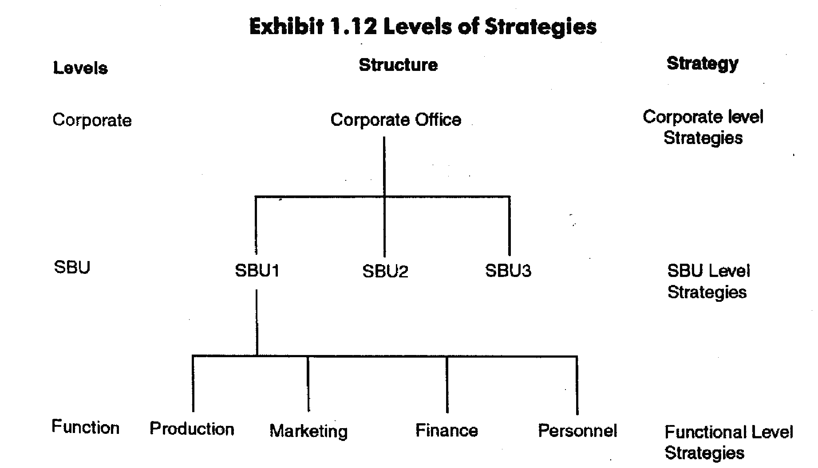

In this unit we take a look at functional level strategies. These strategies aim at improving the effectiveness of a company’s operations and thus its ability to attain superior efficiency, quality, innovation and customer responsiveness.

### Outcomes

After studying this unit, you should be able to;

* Achieving Superior Efficiency
* Materials Management, Just-in-Time and Efficiency
* Improvement Process
* Achieving Superior Innovation
* Show that strategic management activities are undertaken at three levels: corporate, business and functional.

### Functional-Level Strategy

Functional strategy, as is suggested by the title, relates to a single functional operation and the activities involved therein. This deals with decisions according to functional lines such as R&D, marketing, production, finance etc. Decisions at this level within the organization are often described as tactical. Such decisions are guided and constrained by some overall strategic considerations.

Functional strategy deals with relatively restricted plan providing objectives for specific function, allocation of resources among different operations within that functional area and coordination between them for optimal contribution to the achievement of the SBU and corporate-level objectives. Below the functional level strategy, there may be operations-level strategies as each function may be divided into several sub functions.

For example, in a marketing strategy, a functional strategy, can be subdivided into promotion, sales, distribution, pricing strategies with each sub function strategy contributing to functional strategy.

The following steps can be taken at the functional level to increase the company’s efficiency and thereby lower their cost structure.

### Achieving superior efficiency

A company is a device for transforming inputs (labor, land, capital, management and technological know-how) into outputs (the goods and services produced). The simplest measure of efficiency is the quantity of inputs that it takes to produce a given output; that is, efficiency= outputs/inputs. The more efficient a company is, the fewer the inputs required to produce a given output and lower its cost structure will be.

### Achieving superior quality

Quality can be thought of in terms of two dimensions: *quality as a reliability and quality as excellence.* High- quality products are reliable, in the sense that they do the job they were designed for and do it well, and are also perceived by consumers to have superior attributes. We also noted that superior quality gives a company two advantages. First, a strong reputation for quality allows a company differentiate its products from those offered by rivals, thereby creating more utility in the eyes of customers, which gives a company the option of charging a premium price for its products. Second, eliminating defects or errors from the production process reduce waste, increases efficiency, and lowers the cost structure of a company and increases its profitability.

### Achieving superior innovation

In many ways, innovation is the most important source of competitive advantage. This is because innovation can result in new products that better satisfy customer needs, can improve the quality (attributes) of existing products or can reduce the costs of making products that customers want. The ability to develop innovative new products and processes gives a company a major competitive advantage that allows it to (1) *differentiate* its products and charge a premium price, and/or (2) *lower its cost structure* below that of its rivals. Competitors, however, attempt to imitate successful innovations and often succeed. Therefore, maintaining a competitive advantage requires a continuing commitment to innovation.

### Achieving superior responsiveness to customers

To achieve responsiveness to customers, a company must give customers what they want, when they want it, and at a price they are willing to pay – so long as the company’s long term profitability is not compromised in the process. Customer responsiveness is an important differentiating attribute that can help to build brand loyalty. Strong product differentiation and brand loyalty give a company more pricing options; the company can charge a premium price for its products or keep prices low to sell more goods and services to customers. Either way, the company that is more responsive to its customers’ needs than its rivals will have a competitive advantage, all else being equal.

### Summary

In this unit, we have learnt that a company can increase efficiency through a number of steps. These steps are discussed as superior quality, superior efficiency, superior innovation and superior responsiveness

 **Self-test exercise**

1. Explain how an enterprise can use functional-level strategies to increase its: efficiency, quality, innovation and customer responsiveness.
2. Describe why innovation might be called the single most important building block of competitive advantage.

**UNIT 6: STRATEGY AT THE BUSINESS LEVEL**

## Introduction

This unit is about a fundamental strategic choice: what strategy should a business unit (or other organisational subunit) adopt in its market? Business strategy questions are fundamental both to standalone small businesses and to all the many business units that typically make up large diversified organisations.

### Outcomes

After studying this unit, you should be able to;

* Explain Business Level Strategy
* Distinguish between is cost leadership and Differentiation Strategies

### Business-Level Strategy

Business-level strategy is - applicable in those organizations, which have different businesses-and each business is treated as strategic business unit (SBU). The fundamental concept in SBU is to identify the discrete independent product/market segments served by an organization. Since each product/market segment has a distinct environment, a SBU is created for each such segment.

For example, Madison group of companies operates in insurance, general services, investment, financial services etc. For each product group, the nature of market in terms of customers, competition, and marketing channel differs. There-fore, it requires different strategies for its different product groups. Thus, where SBU concept is applied, each SBU sets its own strategies to make the best use of its resources (its strategic advantages) given the environment it faces.

At such a level, strategy is a comprehensive plan providing objectives for SBUs, allocation of resources among functional areas and coordination between them for making optimal contribution to the achievement of corporate-level objectives.

Such strategies operate within the overall strategies of the organization.

**What is business level strategy?**

Any given organization may comprise of a number of businesses, each operating in distinct market and serving different customers. Business level strategy is a means of separating out and formulating a competitive strategy at the level of the individual business unit. Competitive strategy is concerned with the basis on which an organization will compete in its chosen market. The role of business strategy is to devise a strategy which allows it to compete successfully in the market place and to contribute to the corporate strategy. The business unit managers must ultimately show that their business strategy contributes to the corporate strategy.

### Generic Corporate Strategies

Michael Porter identified three generic strategies:

* Differentiation
* Focus
* Cost leadership

Generic strategies can be applied to broad or narrow markets. These strategies can be seen as the value systems or philosophies of the business and should be applied to all activities of the organisation.

### DIFFERENTIATION

Differentiation involves the organization competing on the basis of a unique or different product which is sufficiently valued by consumers for them to pay a premium price. The product is different to that of competitors and makes it difficult to imitate. Many ways to differentiate a product or service;

* product quality
* product reliability
* product features
* product innovation
* service levels
* brand name
* distribution channels
* patent protection

### Risks of a differentiation strategy

* Difficult to maintain degree of differentiation
* Differentiation may not be worth enough to customer to pay premium price
* Can be ‘out-differentiated’ by ‘focusers’

### FOCUS

Focus strategy occurs when an organization undertake either a cost or differentiation strategy but within only a narrow segment of the market. E.g. Toyota for hybrid cars (Camry).

* Based on narrow markets
* Small organisations or niche marketing
* Can be cost-based or differentiation-based Focus can be achieved by:
* narrow product line
* customer segmentation
* geographic segmentation
* focused functional capability
* More easily applied in growth industries or fragmented markets

### Risks of a focus strategy

* Competition from broad market competitors
* Value offered is less than the cost differential

### COST LEADERSHIP

* A lower delivered cost structure than competitors
* Only one firm can be the lowest cost provider in an industry
* Low-cost strategy does not necessarily mean low prices

Can be achieved in many ways:

* no frills product
* simple product design
* cost control
* location advantage
* production innovation
* purchasing cheap assets
* government subsidies
* experience curve

### Risks of a low-cost strategy

* Narrow focus on cost control may limit opportunities
* Cost leadership may not be sustainable
* Competitors pursuing a focus strategy may be able to offer a lower price

### LEADERSHIP STRATEGY

A combined strategy of differentiation and low cost

* TQM enables companies to produce differentiated goods/services at low cost
* Principles of TQM not easily applied to an organisation
* Easier to add a differentiation focus to a cost focus
* Leader strategies increase competitive nature of an industry

Disadvantage of a leader strategy

* Difficult to achieve both differentiation and low cost
* Can get ‘stuck in the middle’

Alternative view to Porter’s generic strategies. Three ways of competing that lead to excellent performance:

* Operational excellence
* Customer intimacy
* Product leadership

Need to excel on one of these and be at industry standard on other two

### Summary

In this unit, we have learnt that business strategy is concerned with seeking competitive advantage in markets at the *business* rather than *corporate* level. Business strategy needs to be considered and defined in terms of *strategic business units* (SBUs). Porter’s framework and the Strategy Clock define various *generic strategies*, including *cost leadership*, *differentiation*, *focus* and *hybrid* strategies. Managers need to consider how business strategies can be sustained through strategic capabilities and/or the ability to achieve a ‘ *lock-in* ’ position with buyers.

 **ACTIVITY**

1. Define business level strategy.
2. Identify how cost leadership helps to neutralize each of the major threats in an industry.
3. Describe how product differentiation can be used to neutralize environmental threats and exploit environmental opportunities.
4. Using either Porter’s generic strategies, identify examples of organisations in your town following strategies of differentiation, low cost or low price, and stuck-inthe-middle or hybrid. How successful are these strategies?

## UNIT 7: STRATEGY AT THE CORPORATE LEVEL

## Introduction

The scope for this unit is concerned with how far an organisation should be diversified in terms of products and markets. An organisation may increase its scope by engaging in market spaces or products different to its current ones.

### Outcomes

After studying this unit, you should be able to;

* Corporate Level Strategy and the Multi business Model
* Horizontal Integration: Single Industry Strategy
* Vertical Integration: Entering New Industries to Strengthen the Core Business Model
* Strategic Outsourcing

### Corporate Level Strategy

The corporate strategy sets the long-term objectives of the firm and the broad constraints and policies within which a SBU operates. The corporate level will help the SBU define its scope of operations and also limit or enhance the SBUs operations by the resources the corporate level assigns to it. There is a difference between corporate-level and business level strategies. In other words, business strategy relates to the ‘how’ and corporate strategy to the ‘what’.

Corporate strategy defines the business in which a company will compete preferably in a way that focuses resources to convert distinctive competence into competitive advantage.’ Corporate strategy is not the sum total of business strategies of the corporation but it deals with different subject matter. While the corporation is concerned with and has impact on business strategy, the former is concerned with the shape and balancing of growth and renewal rather than in market execution.

Corporate level strategy occupies the highest level of strategic decision-making and covers actions dealing with the objective of the firm, acquisition and allocation of resources and coordination of strategies of various SBUs for optimal performance. Top management of the organization makes such decisions. The nature of strategic decisions tends to be value oriented, conceptual and less concrete than decisions at the business or functional level. Corporate strategy can be defined as the way a company creates value through the configuration and coordination of its multimarket activities.

Corporate level strategy answer the question of how an organization adds value across the business units that make up the organization which a role of corporate parenting. This is done by effectively managing the related capabilities in each business units, as well as leveraging its own management skills across these business units resulting into synergy. Synergy occurs when the total output from combining businesses is greater than the output of the businesses operating individually. It is often described mathematically as 2+2 =5.

**Growth Strategy**

There are four strategies that an organization might follow as shown below

Table 3.1 Ansoff Matrix (Strategic direction)

**Product/service**

**Present New**

|  |  |  |
| --- | --- | --- |
|  | * Market Penetration * Consolidation * Liquidation | ❖ Product Development |
| ❖ Market Development | ❖ Diversification |

### Market Penetration

The strategy of market penetration seeks to increase the market share in its existing markets by utilizing its existing products. It aims at attracting new customers and getting existing consumers to increase their usage of the product by improving the quality of the product, level of service and carrying out promotional activities.

### Product Development

This strategy involves developing a new product for the existing market. The ability to innovate is important for an organization to develop new products. This strategy is most commonly applied in electronic industry.

### Market Development

This strategy is concerned with entering new markets with your existing product. This may be done by targeting new market segments and new geographical areas or by devising new users for its products. The existing product may undergo slight modification to ensure that it fits these new markets better.

### Diversification

This occurs when an organization seeks to broaden its scope of activities by moving into new products and new markets. There are two types of diversification:

**Related** diversification is the movement into an industry in which there are some links with the organization’s value chain. Related diversification can be separated into vertical and horizontal integration. Vertical integration occurs when an organization goes upstream i.e. it moves towards its inputs or downstream, i.e. it moves towards its consumer. Horizontal integration takes place when an organization takes over a competitor or offers complementary products at the same sage within the value chain.

**Unrelated** diversification refers to a situation where an organization moves into a totally unrelated industry. It is sometimes called conglomerate diversification to reflect that it involves managing a portfolio of companies.

### IMPLEMENTING GROWTH STRATEGIES

The diagram below show the implementation of corporate growth strategies

Business Growth Strategy

Related

)

same industry

(

Unrelated

)

different industry

(

Vertical (different

stage in supply chain)

Horizontal (same

stage in supply chain)

Forward (control

over customer)

Backward (control

over a supplier)

Conglomerate (few or no

shared competences))

**THE BCG MATRIX**

### Description of the BCG Matrix

The now well-known BCG tool for portfolio analysis is based on the research by the Boston Consultancy Group, which investigated the relationships between low costs (gained from specialisation, scale and experience), market share and market growth. The ‘product portfolio’ diagram in Figure 3. 3 illustrate the relationships.

To ensure long-term value creation, a company should have a portfolio of products that contains both high-growth products in need of cash inputs and low-growth products that generate a lot of cash. The BCG matrix is a tool that can be used to determine what priorities should be given in the product portfolio of a business unit. It has 2 dimensions: market share and market growth. The basic idea behind it is that the bigger the market share a product has or the faster the product’s market grows the better it is for the company. Product portfolio

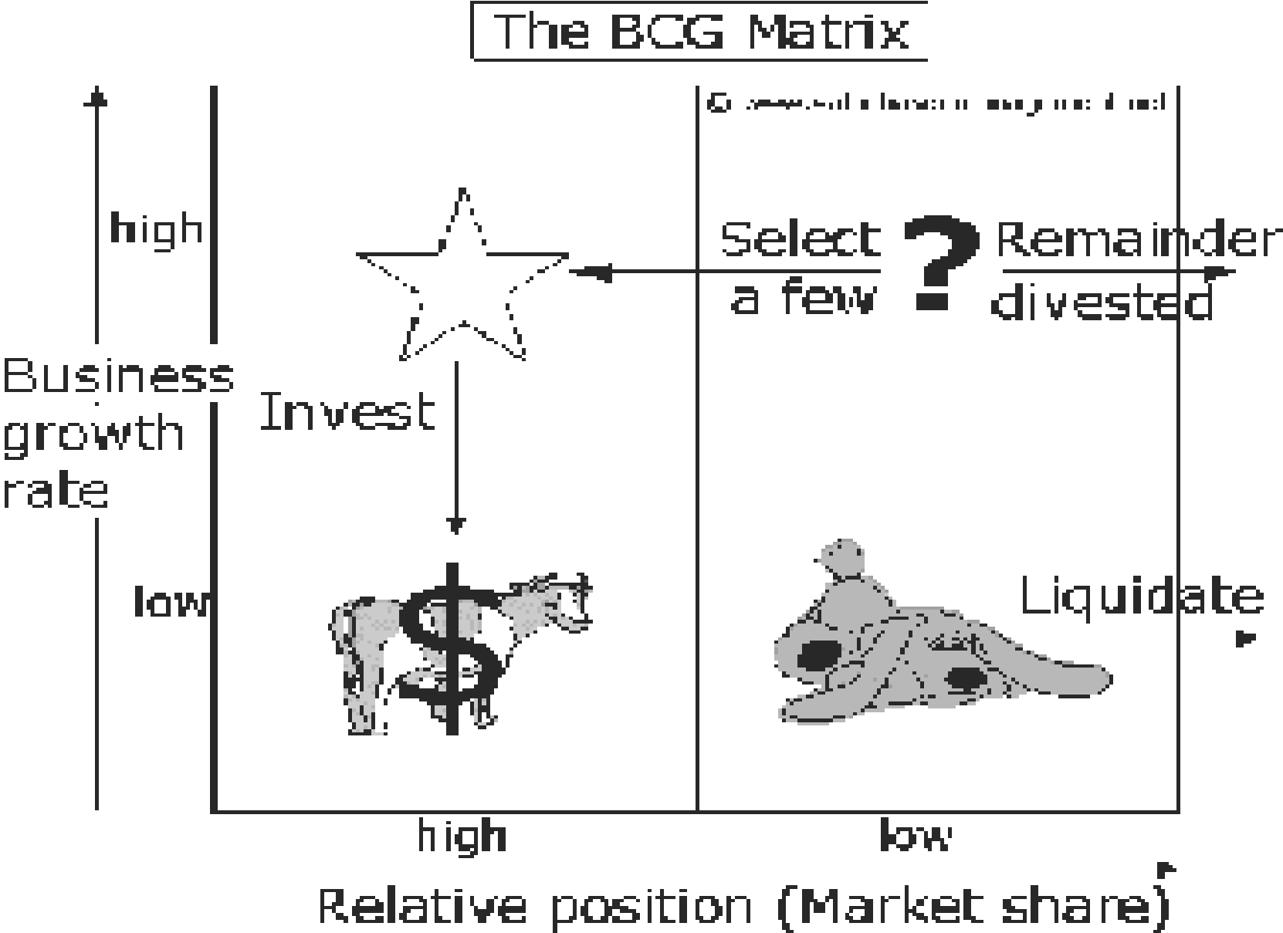method placing products in the BCG matrix results in 4 categories in a portfolio of a company:

**Stars (high growth, high market share)** High growth or high-market-share means that the organisation is gaining experience rapidly, and this experience, or learning curve, translates into lower costs of one sort or another. However, high growth and the achievement of a large market share also imply fairly heavy expenditure by the firm. The strategic manager will have to judge whether each product should be further supported, or whether it should be withdrawn.

* Stars use large amounts of cash and are leaders in the business so they should also generate large amounts of cash;
* Frequently roughly in balance on net cash flow. However, if needed any attempt should be made to hold share, because the rewards will be a cash cow if market share is kept.

**Cash Cows** (low growth, high market share). The ‘cash cow’, on the other hand, can bask in the security of a high market share already gained in a market where other competitors cannot learn very quickly it will provide cash for other projects.

* Profits and cash generation should be high and because of the low growth, investments needed should be low. Keep profits high
* Foundation of a company

**Dogs** (low growth, low market share) A low market-share in a low-growth market means that not much experience is being gained, so ‘dogs’ can be a drain on company resources.

* Avoid and minimize the number of dogs in a company.
* Beware of expensive ‘turn around plans’.
* Deliver cash, otherwise liquidate

**Question Marks** (high growth, low market share). The ‘problem child’ is just such project, a gamble that may or may not pay off, depending on whether the cost reductions gained from experience in a high growth market can offset the expenditure of trying to gain a greater market share. Question marks have the following characteristics:

* Have the worst cash characteristics of all, because high demands and low returns due to low market share
* If nothing is done to change the market share, question marks will simply absorb great amounts of cash and later, as the growth stops, a dog.
* Either invest heavily or sell off or invest nothing and generate whatever cash it can. Increase market share or deliver cash

Using the BCG Matrix can help understand a frequently made strategy mistake: having a one-size-fits-all-approach to strategy, such as a generic growth target (9 percent per year) or a generic return on capital of say 9.5% for an entire corporation. In such a scenario:

* Cash Cows Business Units will beat their profit target easily; their management has an easy job and is often praised anyhow. Even worse, they are often allowed to reinvest substantial cash amounts in their businesses, which are mature and not growing anymore.
* Dogs Business Units fight an impossible battle and, even worse, investments are made now and then in hopeless attempts to ‘turn the business around.
* As a result (all) Question Marks and Stars Business Units get mediocre size investment funds. In this way they are unable to ever become cash cows. These inadequate invested sums of money are a waste of money. Either these SBUs should receive enough investment funds to enable them to achieve a real market dominance and become a cash cow (or star), or otherwise companies are advised to disinvest and try to get whatever possible cash out of the question marks that were not selected.

### Summary

In this unit, we have learnt that many corporations comprise several, sometimes many, business units. Corporate strategy involves the decisions and activities above the level of business units. It is concerned with the scope of the organisation. Organisational *scope* is often considered in terms of *related* and *unrelated* diversification. Corporate parents may seek to add value by adopting different parenting roles: the *portfolio manager*, the *synergy manager* or the *parental developer*. There are several portfolio models to help corporate parents manage their businesses, of which the most common are: Ansoff’s Growth matrix, the *BCG matrix*, the *directional policy matrix* and the *parenting matrix*

**ACTIVITY**

1. What is corporate level strategy?
2. Discuss how vertical integration can create value by reducing the threat of opportunities.
3. Distinguish the following strategy options; market penetration, product development, market development and diversification.

Using the BCG matrix, identify and explain corporate strategic directions for any one of these organisations you are familiar with.

### REFERENCES

Anthony Henry, (2008). *Understanding Strategic Management*. New York: Oxford

University Press.

Barney, J. B., & Hesterly, W. S. (2012). *Strategic Management and Competitive Advantage.*

Amsterdam: Pearson Education Limited.

Cole, G. A. (1997). *Strategic Management.* Nottingham: South-western CENGANGE Learning.

Hills, C.W. L. & Jones, G.R. (2008). *Theory of strategic Management with cases***.** China:

South-Western Cengange Learning.

Johnson, G., Whittington, R., Scholes, K., Angwin, D., & Regner, P. (2014). *Exploring Strategy.* England: Pearson Education Limited.

Johnson, G., Scholes, K. and Whittington, R. (2008). *Exploring corporate Strategy.*

England: Pearson Education Limited.

Montgomery Collis, (2005). ***Corporate Strategy****, A resource based approach*. 2nd Edition.

New York: McGraw-Hill.

Wheeten, T.L. & Hunger, J. D. (2008). *Strategic Management & Business Policy.* Pearson International Limited.